UNITED STATES

SECURITIES AND EXCHANGE COMMISSION
Washington, D.C. 20549

FORM 8-K

CURRENT REPORT

Pursuant to Section 13 or 15(d)
of the Securities Exchange Act of 1934

Date of Report (Date of earliest event reported): August 26, 2013

XPO LOGISTICS, INC.

(Exact name of registrant as specified in its charter)

Delaware

001-32172

03-0450326

(State or other jurisdiction

of incorporation)

(Commission

File Number)

(I.R.S. Employer

Identification No.)

Five Greenwich Office Park, Greenwich, Connecticut 06831

(Address of principal executive offices)

(855) 976-4636

(Registrant’s telephone number, including area code)

N/A

(Former name or former address, if changed since last report)

Check the appropriate box below if the Form 8-K filing is intended to simultaneously satisfy the filing obligation of the registrant under any of the following provisions:

- Written communications pursuant to Rule 425 under the Securities Act (17 CFR 230.425)

- Soliciting material pursuant to Rule 14a-12 under the Exchange Act (17 CFR 240.14a-12)

- Pre-commencement communications pursuant to Rule 14d-2(b) under the Exchange Act (17 CFR 240.14d-2(b))

- Pre-commencement communications pursuant to Rule 13e-4(c) under the Exchange Act (17 CFR 240.13e-4(c))

Item 7.01. Regulation FD Disclosure.

On August 26, 2013, XPO Logistics, Inc. (the “Company”) released a slide presentation expected to be used by the Company in connection with certain future investor presentations, together with a corresponding script. Copies of the slide presentation and script are attached as Exhibit 99.1 and Exhibit 99.2, respectively, to this Current Report on Form 8-K.

The slide presentation and script should be read together and with the Company’s filings with the Securities and Exchange Commission (the “SEC”), including the Quarterly Report on Form 10-Q for the quarter ended June 30, 2013.

The information furnished in this Item 7.01, including Exhibit 99.1 and Exhibit 99.2, shall not be deemed “filed” for purposes of Section 18 of the Securities Exchange Act of 1934, as amended (the “Exchange Act”), or otherwise subject to the liabilities of that Section. This information shall not be deemed incorporated by reference into any filing under the Securities Act of 1933, as amended, or the Exchange Act, except to the extent that the registrant specifically incorporates any such information by reference.

Item 9.01. |  |  | Financial Statements and Exhibits.
(d) Exhibits
Exhibit
No. |  |  | Exhibit Description
99.1 |  | Investor Presentation, dated August 26, 2013.
99.2 |  | Investor Presentation Script, dated August 26, 2013.

SIGNATURE

Pursuant to the requirements of the Securities Exchange Act of 1934, the registrant has duly caused this report to be signed on its behalf by the undersigned hereunto duly authorized.

Date: August 26, 2013 XPO LOGISTICS, INC.

By: /s/ Gordon E. Devens

Gordon E. Devens

Senior Vice President and General Counsel

EXHIBIT INDEX

Exhibit
No. |  | Exhibit Description
99.1 | Investor Presentation, dated August 26, 2013.
99.2 | Investor Presentation Script, dated August 26, 2013.

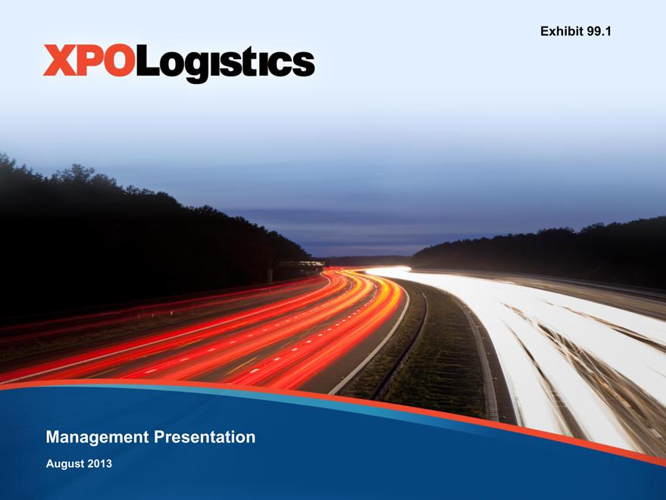

Exhibit 99.1
Management Presentation
August 2013

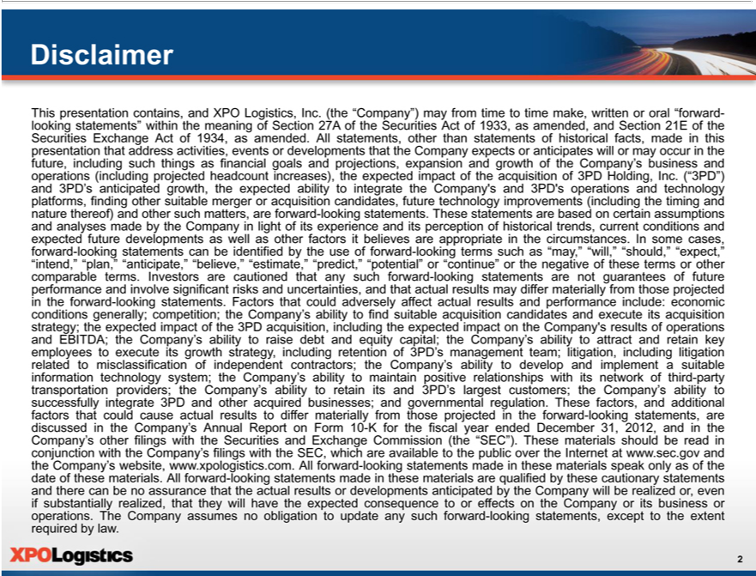

Disclaimer
This presentation contains, and XPO Logistics, Inc. (the “Company”) may from time to time make, written or oral “forward-looking statements” within the meaning of Section 27A of the Securities Act of 1933, as
amended, and Section 21E of the Securities Exchange Act of 1934, as amended. All st tements, other than statements of historical facts, made in this |  |  |  | that address activities, events or developments that the
Company expects or anticipates will or may occur in the future, including such things as financial goals and projections, expansion and growth of the presentationCompany’ |  |  |  | and operations (including projected headcount
increases), the expected impact of theacquisition of 3PD Holding, Inc. (“3PD”) and 3PD’s anticipated growth, the expected ability to integrate the Company’s andbusiness3PD’operations and technology platforms, finding
other suitable merger or acquisition candidates, future technology improvements (including the timing and nature thereof) and other such matters, are forward-looking statements. These statements are based on certain
assumptions and analyses made by the Company light of its experience and its perception of historical trends, current conditions and expected future developments as well as other factors it believes are appropriate
in the ircumstances. In some cases, forward-looking statements can be identified by the use of forward-looking terms such as “may,”“will,”“should,”“expect,” “intend,” “plan,” “anticipate,” “believe,” “estimate,”
“predict,” “potential” or “continue” or the negative of these terms or other comparable terms. Investors are cautioned that any such forward-looking statements are not guarantees of future performance and involve
significant risks and uncertainties, and that actual results may differ materially from those projected in the forward-looking statements. Factors that could adversely affect actual results and performance include:
generally; competition; the Company’s ability to find suitable acquisition candidates and execute its |  | strategy;the expected impact of the 3PD acquisition, including the expected impact
economictheCompany’conditionsresults of operations and EBITDA; the Company’s ability to raise debt and equity capital; the Company’ |  | ability to attract and retain key employees to execute its gr wth strategy, including retention
of 3PD’s management team; litigation, including litigation related to misclassification of independent contractors; the Company’ ability to develop and implement a suitable information technology system; the
Company’s ability to maintain positive relationships with its network of third-party transportation providers; the Company’acquisitionabilityto retain its and 3PD’s largest customers; the Company’s ability to successfully
integrate 3PD and other acquired | and governmental regulation. These factors, and additional factors that could cause actual |  | to differ materially from those projected in the forward-looking
statements, are discussed in the Company’businesses;Annual ^{the}Rport on Form 10-K for the fiscal year ended December 31, 2012, and in the Company’results other filings with the Securities and Exchange Commission (the “SEC”). These materials should be read in conjunction with Company’s filings with the SEC, which are available to the public over the Internet at www.sec.gov and the Company’s website, www.xpologistics.com. All forward-looking statements made in these materials speak only as of the date of these materials. All forward-looking statements made in these materials are qualified by these cautionary statements and there can be no assurance thatthe actualresults or developments anticipated by the Company will be realized_{statements,}oreven if substantially realized, that they will have the expected consequence to or effects on the Company or its business

2or operations. The Company assumes no obligation to update any such forward-looking except to the extent required by law.

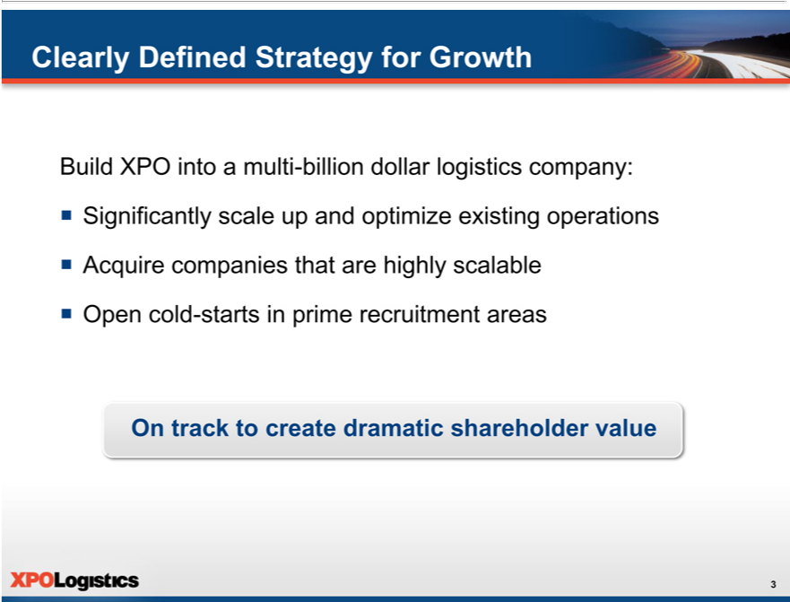

Clearly Defined Strategy for Growth
Build XPO into^{scale}multi-billion dollar logistics company:
^{ƒ} AcquireSignificantlycompaniesupthatandareoptimizehighlyscalableexisting operations
Open cold-starts in prime recruitment areas
3On track to create dramatic shareholder value

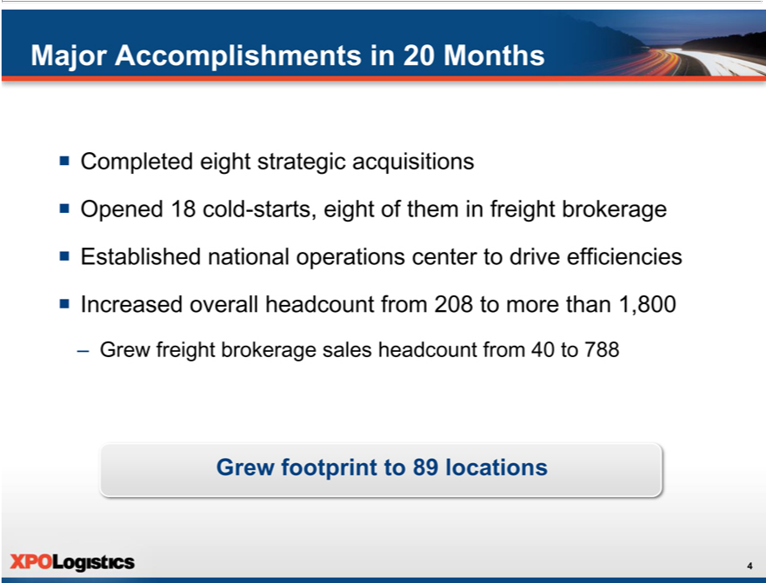

MajorCompletedAccomplishmentseightstrategicin 20acquisitionsMonths
^{ƒ} Opened 18 cold-starts, eight of them in freight brokerage
IncreasedEstablishedoverallnationalheadcountoperationsfromcenter208 toto moredrive thanefficiencies1,800

Grew–Grewfootprintfreight brokerageto89locationssales headcount from 40 to 788
4

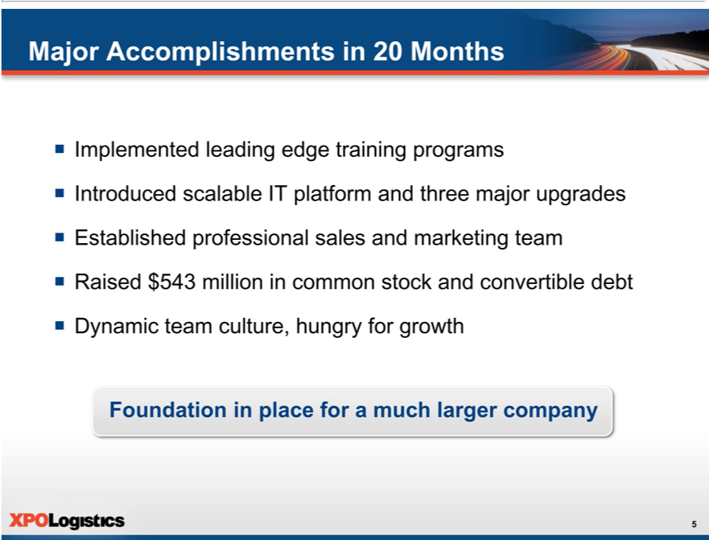

Major_{Introduced}mplementedAccomplishmentsleadingedgein20trainingMonthsprograms

EstablishedscalableprofessionalITplatformsalesandandmarketingthreemajorteamupgrades
^{ƒ}
DynamicRaised$543teammillionculture,in hungrycommonforstockgrowthand convertible debt
5Foundation in place for a much larger company

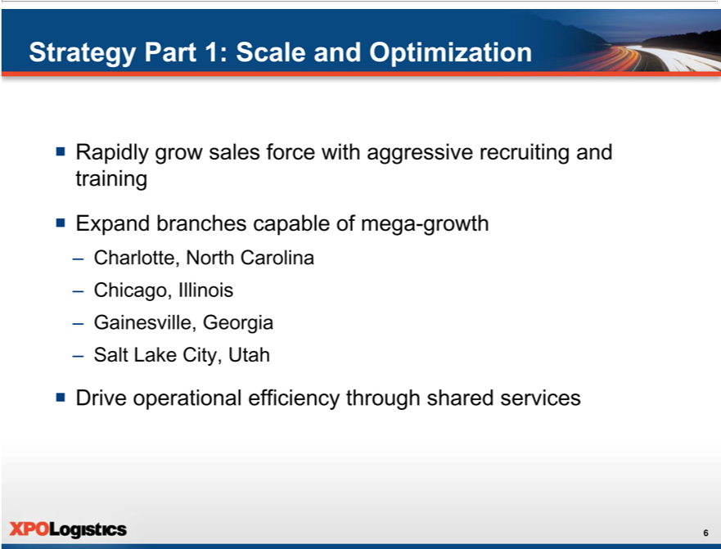

Strategy Part 1: Scale and Optimization
 | Ra idly grow sales force with aggressive recruiting and training
ƒ Expand branches capable of mega-growth
 | arlotte, North Carolina
 | Ch cago, Illinois
– | Gainesville, Georgia
– | Salt Lake City, Utah
6ƒ Drive operational efficiency through shared services

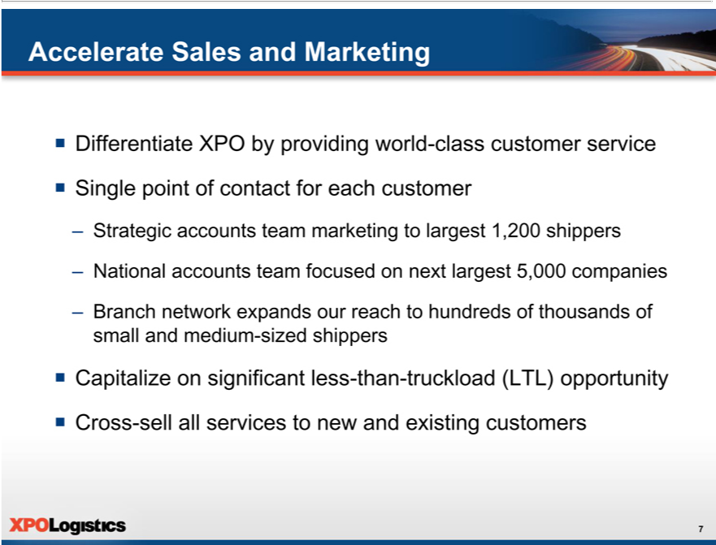

Accelerate Sales and Marketing
ƒ | Differentiate XPO by providing world-class customer service
ƒ | ingle point of contact for each
 | Strategic accounts team mark tingcustomerlargest 1,200 shippers
– | National accounts team focused on next largest 5,000 companies
– | Branch network expands our reach to hundreds of thousands of small and medium-sized shippers
ƒ Crossapitalize on significant less-than-truckload (LTL) opportunity
7 -sell all services to new and existing customers

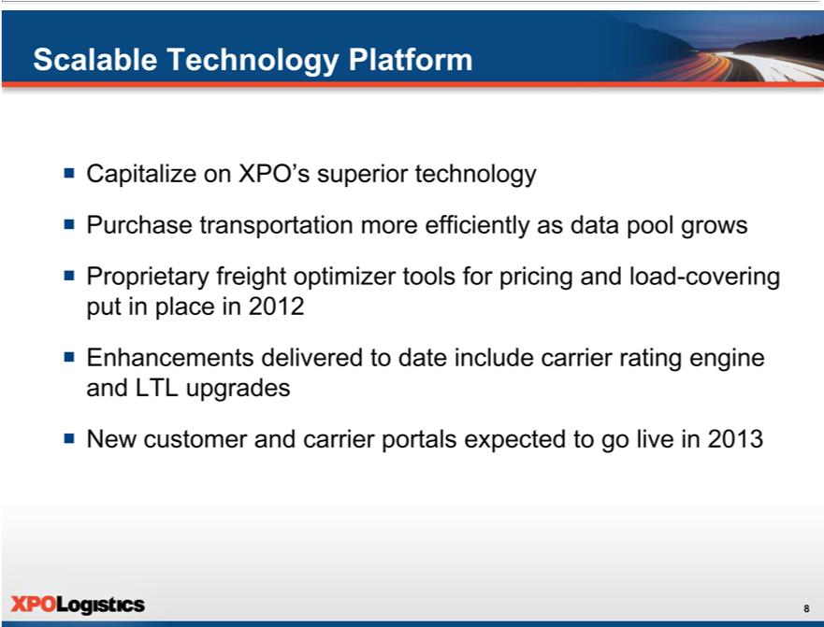

ScalableCapitalizeTechnologyonXPO’sPlatformsuperior technology
_{Proprietary}urchasetranspor_{freight}ation more efficiently as data pool grows
^{ƒ} Enhancements deliveredoptimizertodatetoolsincludeforpricingcarrierandratingloadengine-coveringandputLTLinupgradesplacein 2012
₈ New customer and carrier portals expected to go live in 2013

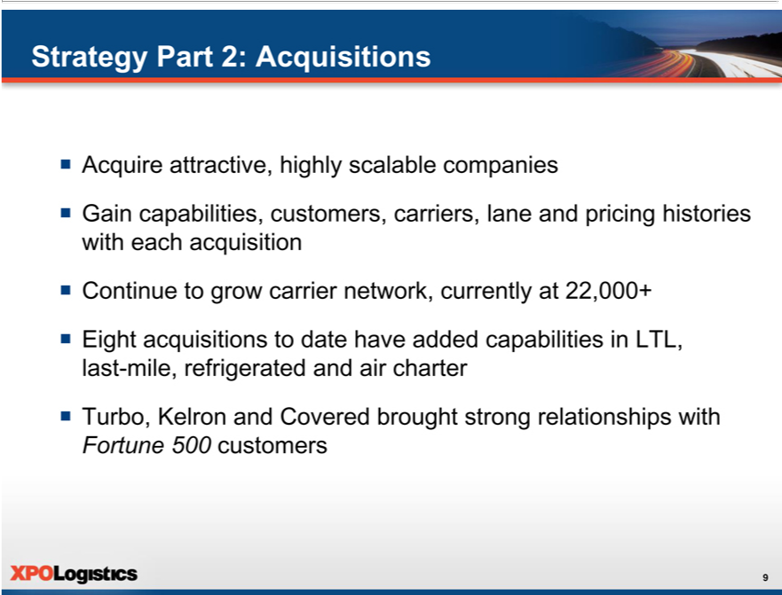

Strategy Part 2: Acquisitions
Acquire attractive, highly scalable companies
Gain capabilities, ^{carrier}ustomers, carriers, lane and pricing histories with each acquisition
Continue to grow network, currently at 22,000+
^{ƒ}
Turbo,EightacquisitionsKelronand toCovereddatehavebroughtaddedstrongcapabilitiesrelationshipsinLTL,withlast-mile, refrigerated and air charter
9Fortune 500 customers

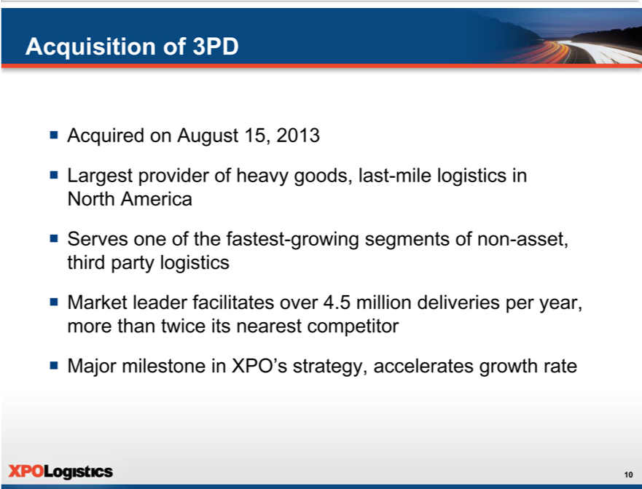

AcquisitionAcquired onof August3PD 15, 2013
Largest provider of heavy goods, last-mile logistics in North America
ƒ MajorServesrket oneleaderof thefacilitatesfastest-overgrowing4.5 millionsegmentsdeliveriesofnon-asset,peryear,thirdmorepartythanlogisticstwice its nearest competitor
10 milestone in XPO’s strategy, accelerates growth rate

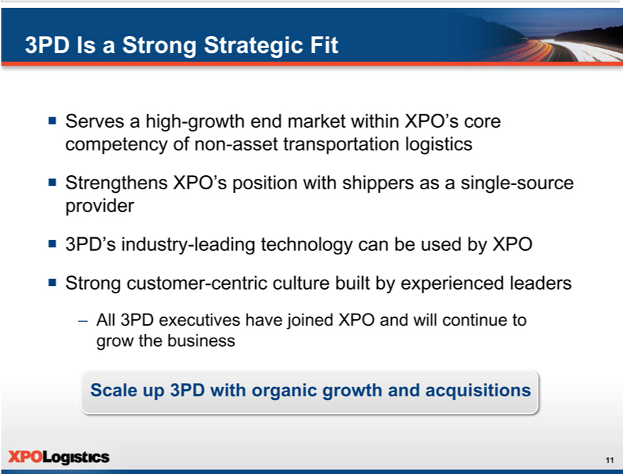

3PD Is a Strong Strategic Fit
_{Strengthens}ervesahigh-growth end market within XPO’s core competency of non-asset transportation logistics XPO’s position with shippers as a single-source provider
^{ƒ}
Strong3PD’ industrycustomer-leading-centrictechnologyculturebuiltcanbybeexperiencedusedbyXPOleaders
Scale–All 3PDup3PDexecutiveswithorganichave joinedgrowthXPOand acquisitionsandwillcontinue to grow the business
11

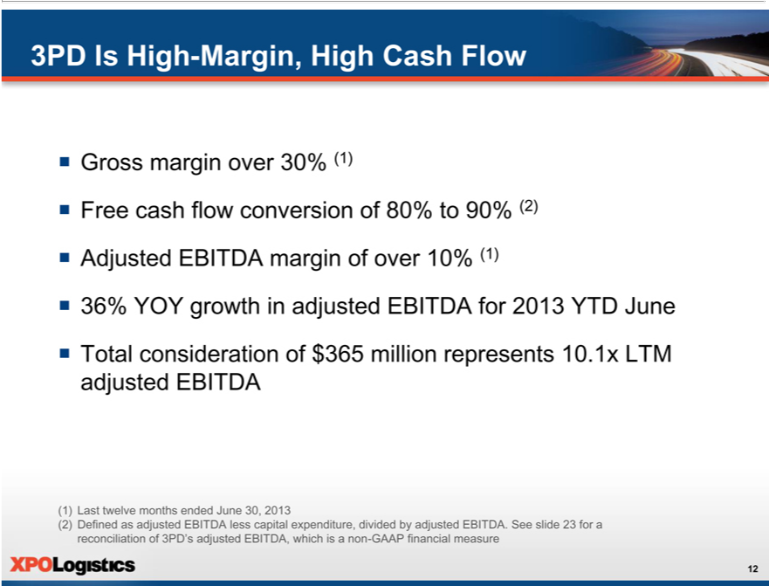

3PD Is High-Margin, High Cash Flow
FreeGrosscashmarginflowoverconversion30%(1)of 80% to 90% (2)
Adjusted EBITDA margin of over 10% (1)
ƒ Total36% YOYconsiderationgrowthinofadjusted$365millionEBITDArepresentsfor201310.1xYTDLTMJuneadjusted EBITDA
1) Last twelve mon hs ended June 30, 2013
12(2) Defined as adjusted EBITDA less capital expenditure, divided by adjusted EBITDA. See slide 23 for a reconciliation of 3PD’s adjusted EBITDA, which is a non-GAAP financial measure

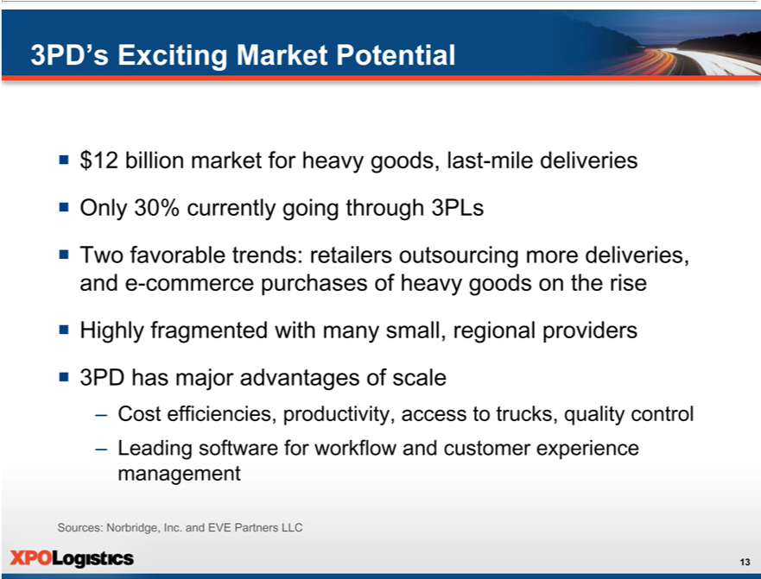

3PD’s Exciting Market Potential
Only$12billion30%currentlymarketforgoingheavythroughgoods,3PLslast-mile deliveries
Two favorable trends: retailers outsourcing more deliveries, and e-commerce purchases of heavy goods on the rise ^{ƒ} Highly fragmented with many small, regional providers
3PD has major advantages of scale
– Cost efficiencies, productivity, access_{customer}trucks, quality control
Sources:LeadingNorbridge,softwareforInc.workflowandEVEandPartners LLCexperience management
13

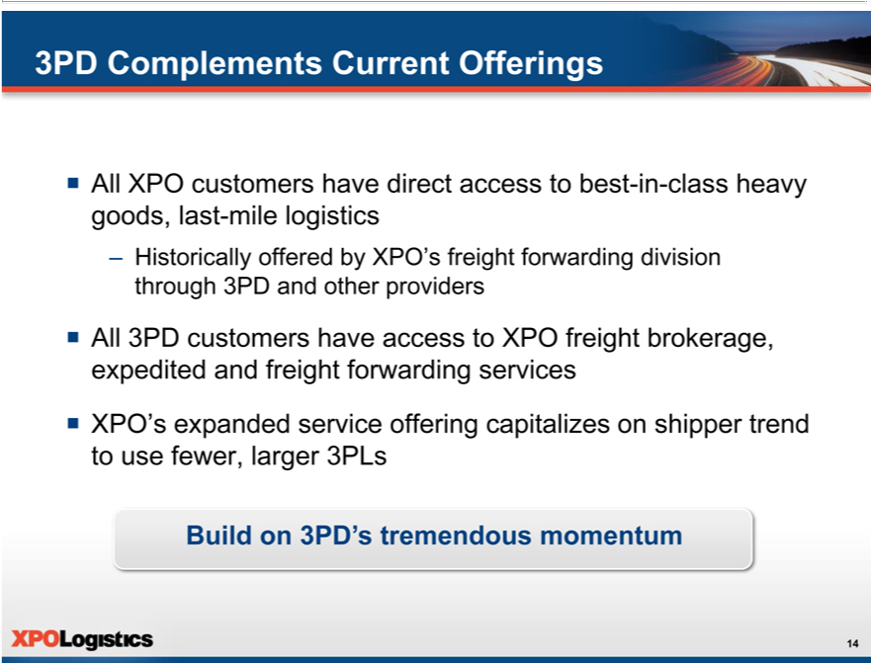

3PD Complements Current Offerings
ƒ All XPO customers have direct access_{forwarding}tobest--class heavy goods, last-mile logistics
– Historically offered by XPO’^{access}freight division through 3PD and other providers
^{ƒ} All 3PD customers have to XPO freight brokerage, expedited and freight forwarding services XPO’s expanded service offering capitalizes on shipper trend to use fewer, larger 3PLs
14Build on 3PD’s tremendous momentum

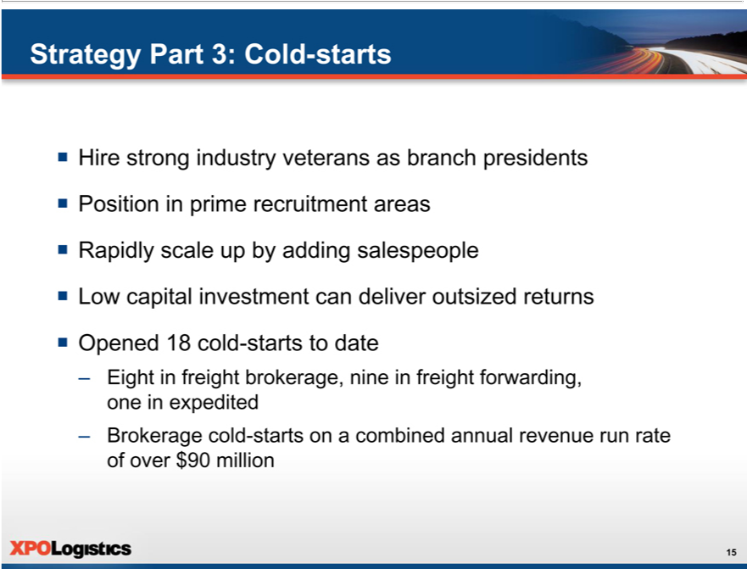

Strategy Part 3: Cold-starts
 | Hire strong industry veterans as branch presidents
 | Position in prime recruitment areas
 | Rapidly scale up by adding salespeople
ƒ | Low capital investment can deliver outsized returns
ƒ | Opened 18 cold-starts to date
– | Eight in freight | nine freight forwarding, one in expedited
– | Brokerage cold-brokerage,startson | combined annual revenue run rate of over $90 million
15

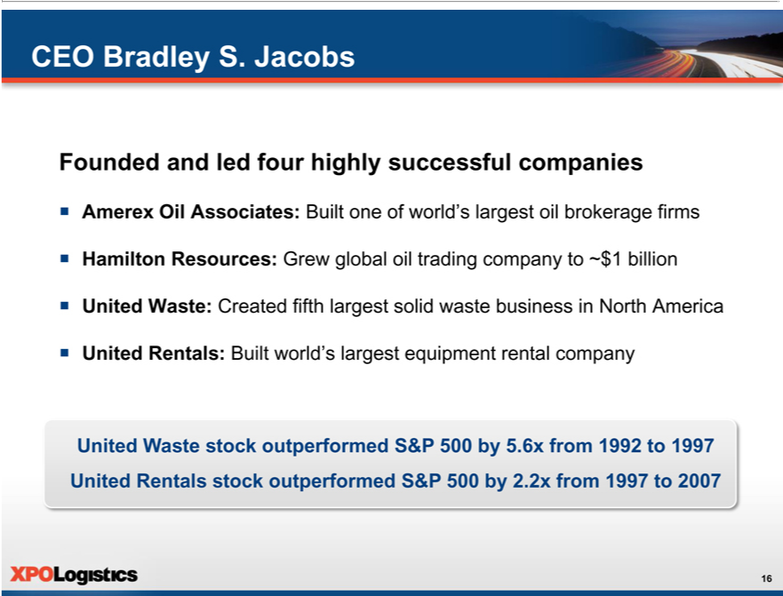

CEO Bradley S. Jacobs
Founded and led_{Associates:}furhighly successful _{companies}
HamiltonAmerexOilResources: GrewBuiltglobalone ofoilworld’trading largestcompanyoil tobrokerage~$1billionfirms
_{ƒ United} Rentals:Waste:CreatedBuiltworld’sfifthlargestlargestsolidequipmentwastebusinessrentalcompanyinNorth America
United Waste stock outperformed S&P 500 by 5.6x from 1992 to 1997 United Rentals stock outperformed S&P 500 by 2.2x from 1997 to 2007 16

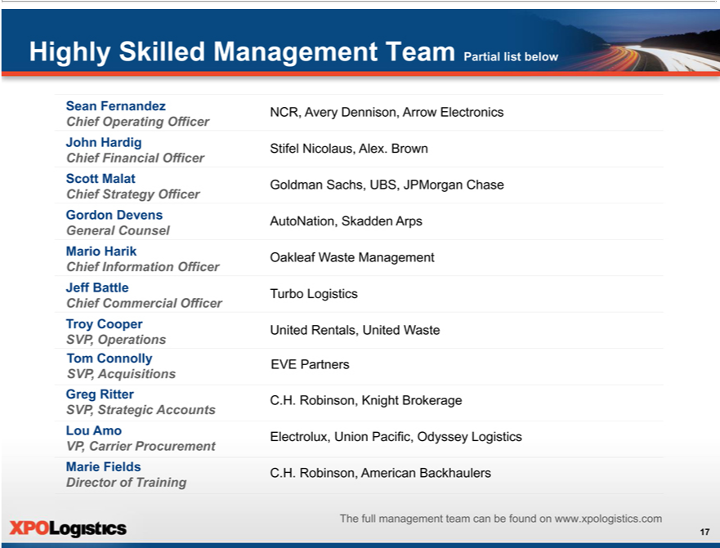

SeanHighlyFernandezSkilledManagement Team Partial list below
JohnChiefHardigOperating Officer
ScottChief MalatFinancial Officer
_{General}ChiefordonStrategyDevensOfficer
Counsel
Mario Harik
^{Chief}
Jef BattleInformation Officer
Troy CooperCommercial Officer
SVP, Operations
Tom Connolly
SVP, Acquisitions
Greg Ritter
LouSVP,AmoStrategic Accounts
VP, Carrier Procurement
Marie Fields
Director of Training
NCR, Avery Dennison, Arrow Electronics Stifel Nicolaus, Alex. Brown Goldman Sachs, UBS, JPMorgan Chase AutoNation, Skadden Arps Oakleaf Waste Management Turbo Logistics United Rentals, United Waste
EVE Partners
C.H. Robinson, Knight Brokerage
Electrolux, Union Pacific, Odyssey Logistics
C.H. Robinson, American Backhaulers
17The full management team can be found on www.xpologistics.com

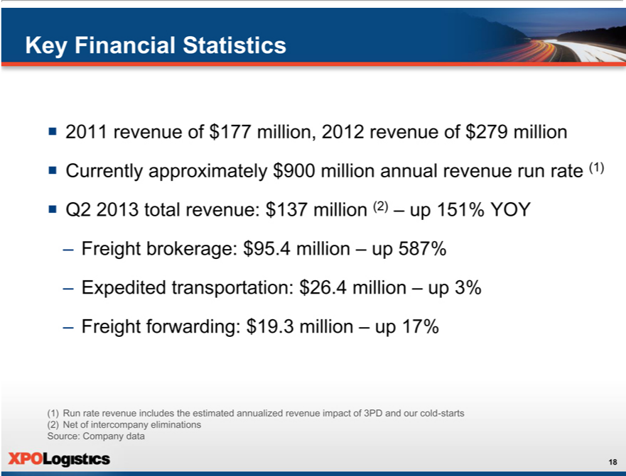

Key Financial Statistics
2011 revenue of $177 million, 2012 revenue of $279 million
^{ƒ}
Q2Currently2013totalapproximatelyrevenue:$137$900millionmillion(2)annual revenue run rate (1)
up 151% YOY
Freight brokerage: $95.4 million – up 587%
–
FreightExpeditedforwarding:transportation:$19.3 $million26.4million–up17%–up 3%
(1) Run rate revenue includes the estimated annualized revenue impact of 3PD and our cold-starts (2) Net of intercompany eliminations Source: Company data
18

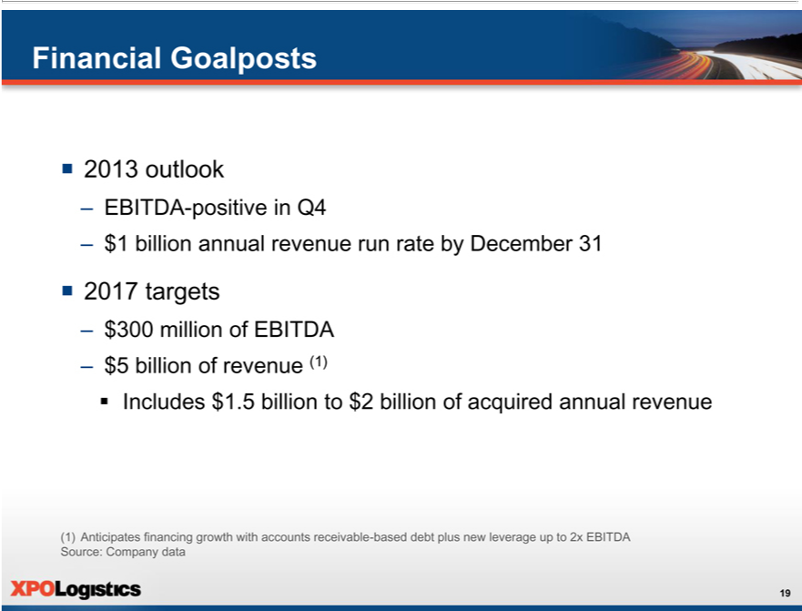

ƒFinancial2013outlookGoalposts
– EBITDA-positive in Q4
ƒ 2017$1billiontargetsannual revenue run rate by December 31
^{– $5}
300billionmillionof revenueofEBITDA(1)
??Includes $1.5 billion to $2 billion of acquired annual revenue
19(1) Anticipates financing growth with accounts receivable-based debt plus new leverage up to 2x EBITDA Source: Company data

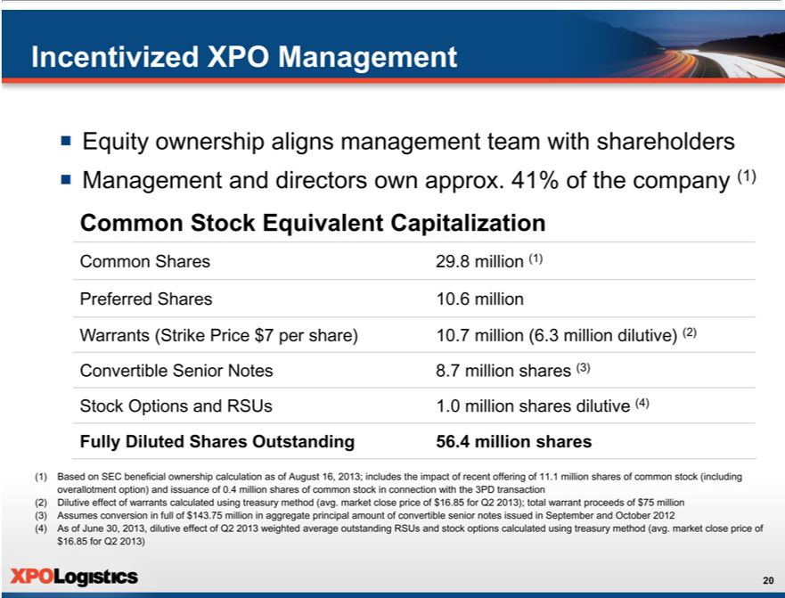

IncentivizedƒEquityownershipXPOManagementalignsmanagement team with shareholders
CommonManagementSharestockandEquivalentdirectorsCapitalizationownapprox. 41% of the company (1)
Preferred
FullyWarrantsDiluted(StrikeSharesPriceOutstanding$7pershare) Convertible Senior Notes Stock Options and RSUs
10.2968 million (1)
7 (6.3 million dilutive) (2)
18.07 million shares dilutive(3) (4)
(1)56.4Basedmillion sharesSECbeneficial ownership calculation as of August 16, 2013; includes the impact of recent offering of 11.1 million shares of common stock (including overallotment option) and issuance of 0.4 million
shares of common stock in connection with the 3PD transaction (2) Dilutive effect of warrants calculated using treasury method (avg. market close price of $16.85 for Q2 2013); total warrant proceeds of $75 million (3) Assumes conversion in full of $143.75 million^{using} aggregate principal amount of convertible senior notes issued in September and October 2012 (4) As of June 30, 2013, dilutive effect of Q2 2013 weighted average
$outstanding16.85forQ2RSUs2013)and stock options calculated treasury method (avg. market close price of
20

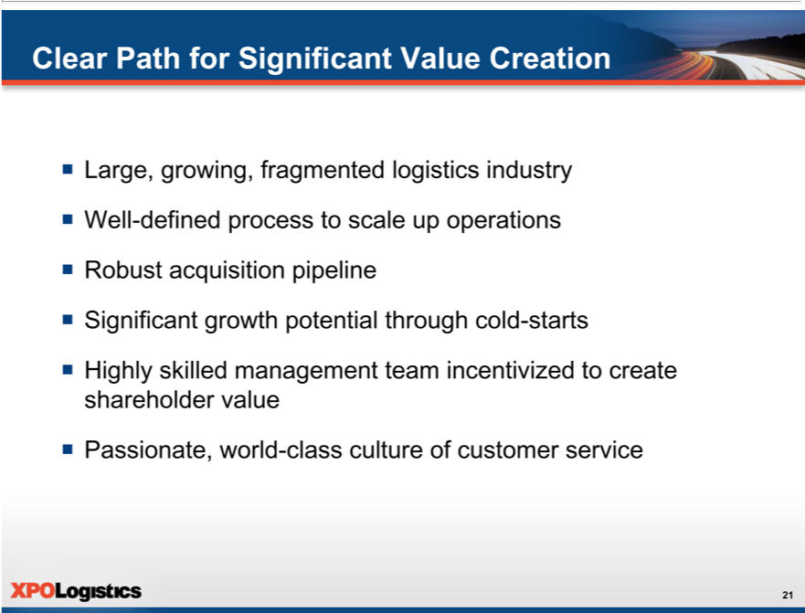

ClearLarge,Pathgrowing,forSignificantfragmentedValuelogisticsCreationindustry
RobustWell-definedacquisitionprocess_{potential}iptolinescale up operations
Significant growth through cold-starts
^{ƒ}
₂₁Passionate,Highlyskilledworldmanagement-classcultureteamof incentivizedcustomerservicetocreate shareholder value

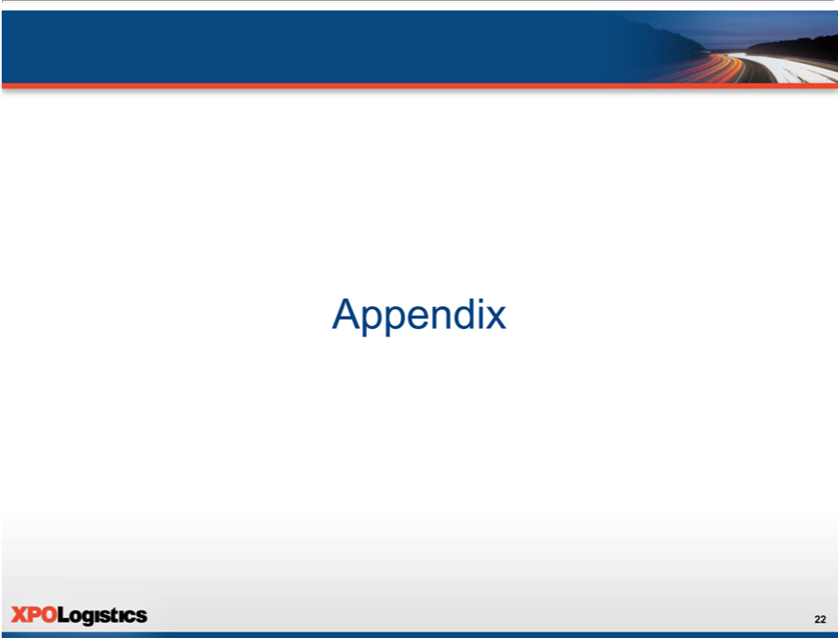

22Appendix

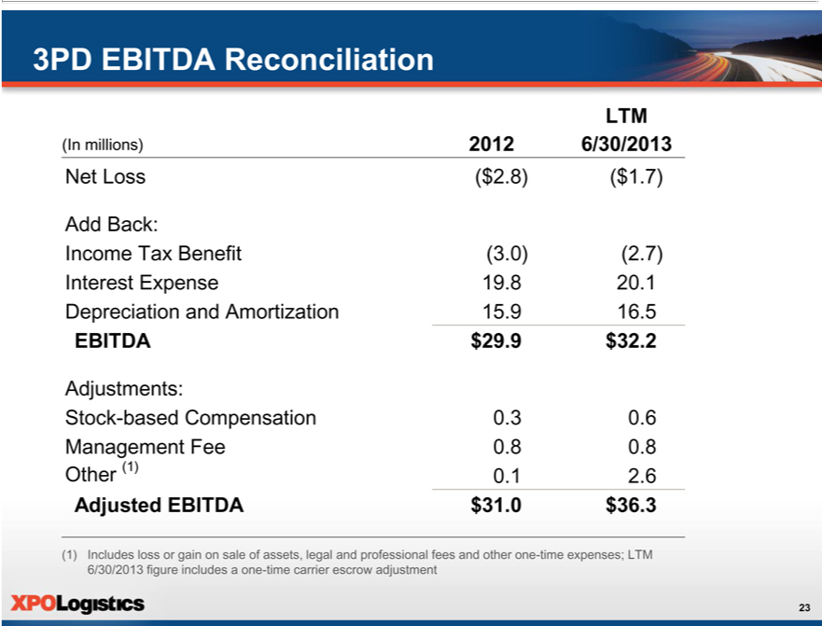

3PD EBITDA Reconciliation
LTM
Net(Inmillions)Loss($2.8)(2012$1.7)6/30/2013
Add Back:
_{Interest}come ExpenseTaxBenefit(3.0)(2.7)19.820.1
EBITDADepreciation$29.9and$32.2Amortization 15.9 16.5
Adjustments:
ManagementStock-basedCompensationFee0.80.8 0.3 0.6
Other (1) 0.1 2.6
Adjusted EBITDA $31.0 $36.3
23(1) Includes loss or gain on sale of assets, legal and professional fees and other one-time expenses; LTM 6/30/2013 figure includes a one-time carrier escrow adjustment

Exhibit 99.2


August 26, 2013

Investor Presentation Script

The following script should be read in conjunction with the accompanying slide presentation, which contains, among other information, source data for certain information set forth in the script.

Thank you very much for joining us. This month, we announced the completion of our acquisition of 3PD, the largest provider of heavy goods, last-mile logistics in North America. 3PD is a strong strategic fit for XPO, and we expect it to significantly accelerate our revenues and earnings. We’ll cover the compelling rationale for the 3PD transaction in a minute – but first, for those of you who might not be familiar with XPO, here’s some information about our company and the strategy that’s driving our growth.

Overview of XPO Logistics

XPO Logistics is one of the fastest-growing providers of transportation logistics services in North America. We offer freight brokerage, expedited transportation, freight forwarding, and now last-mile logistics. Our expedited business, which is a top five provider of expedite services in the U.S., has approximately 400 trucks under exclusive contract that are available to our shipper customers. And we have over 22,000 additional relationships with carriers that provide capacity, representing more than half a million trucks on the road.

In September of 2011, we took control of the company with the objective of growing the operations to several billion dollars in revenue over the next few years under the new brand of XPO Logistics.

We’re driving our growth with a clearly defined, three-part strategy. Part one is to significantly scale up and optimize our existing operations. That means we’re increasing the revenue and profitability of our current network of 89 locations in the U.S. and Canada. Part two is acquisitions – we’ll continue to acquire attractive companies that are highly scalable. And part three is cold-starts – we’ll continue to open greenfield locations in North America, and base them where we can recruit strong leaders and a large number of qualified salespeople.

We began executing this strategy in December of 2011, when the majority of our new leadership team was in place. It’s been a busy 20 months:

We completed eight acquisitions. We opened 18 cold-starts. We developed cutting-edge recruiting, training and onboarding programs. We grew our headcount from barely 200 employees in late 2011 to over 1,800 and counting. We introduced a scalable IT platform and released three major upgrades, with more coming this year. We raised $543 million through common stock and convertible debt offerings. We established a national operations center in Charlotte, North Carolina, to support a much larger organization. Our Charlotte center didn’t exist last March, and now it has over 300 people – about two thirds of them in carrier procurement. We took our freight brokerage division from a single location to the 17th largest

operation of its kind in North America – that’s the ranking we received from Transport Topics for 2012, and you can expect to see us ranked higher for 2013. Most importantly, we’ve instilled a high-octane, performance-driven culture focused on delivering world-class service to customers.

So we’ve made tremendous progress – and we’re just getting started. Now let’s take a closer look at each part of our strategy.

First is scale and optimization. We intend to grow all of our freight brokerage branches, including four that have the potential to be mega-branches: Charlotte, Chicago, Gainesville and Salt Lake City. We plan to supersize these branches and apply the same model to other areas where we can recruit strong leadership and sales talent. All of our branches are realizing a benefit from our shared services.

There’s a lot of runway ahead of us. Right now, we have more than 8,600 customers, primarily in manufacturing, industrial, retail, commercial, life sciences, and government-related accounts, yet we currently serve less than two percent of the estimated $50 billion addressable market for freight brokerage.

We’re working diligently to raise our profile in front of every prospective customer in our space. We’ve identified the 1,200 largest shippers in North America as strategic account targets. The next largest 5,000 shippers are our national account targets. In addition, there are hundreds of thousands of small and medium-sized customers who can use our services. Our branch network reaches out to them every day.

We recently launched a strategic accounts team led by Jeff Battle, one of the key executives who led the growth of Turbo Logistics over the last two decades. Jeff’s group is a powerhouse with deep industry experience. It includes Greg Ritter, who was president of Knight Brokerage before he joined XPO. Before that, Greg was with C.H. Robinson Worldwide for 22 years. Dennis McCaffrey and Pat Gillihan are also dedicated to strategic account development. Dennis has 20 years in the industry and most recently ran the outside sales organization for our expedited transportation group. Pat was one of three owners of Covered Logistics who built the business into a prime provider of logistics to the manufacturing, postal, and oil and gas sectors, with 4,000 carrier relationships, before we bought it in February.

We see huge growth potential in strategic accounts. We already provide access to over 22,000 carriers, and we’re growing our network with every acquisition. The one-on-one expertise of our strategic accounts team is getting a great response from large shippers – we recently won business with 26 large accounts representing the potential for over $75 million in annual revenue. This includes some major wins not just in truckload, but also in cross-border, less-than-truckload and expedite. We’re bidding on business with another 82 large accounts, and that’s just from our initial sales efforts.

Beyond strategic accounts, we’re very focused on growing our revenues through new business development and share of wallet with existing customers. All of our salespeople are on salesforce.com, where we’ve assigned a single point of contact for each customer. This gives us good visibility into the progress of sales activities, and it helps us cross-sell our services.

Less-than-truckload is another revenue stream that’s on our doorstep. We’re taking steps to tap into this business in a big way. Currently, less than $20 million of our company’s annual revenue comes from LTL – yet almost all of our 8,600 truckload customers have LTL business. Our acquisition of Interide in May brought us Sean Snow and a lot of LTL expertise, as well as an LTL technology platform that we’ve just rolled out in all of our sales offices. Sean ran Interide,

2

and now he’s leading the growth of our planned mega-branch in Salt Lake City. Before Interide, Sean was the president of England Logistics, a C.R. England subsidiary that he grew to approximately $300 million in revenue. Now that we’ve combined Interide’s carriers with our own network, we’re already getting better LTL rates. We’re very excited about the magnitude of the LTL opportunity.

Whether it’s truckload, LTL, urgent freight or international, we see an opportunity to differentiate XPO on the basis of superior service. Our company’s roots are in expedite, dating back more than 20 years – so a do-or-die mindset of meeting customer needs already existed when we took control. We’ve taken this culture to the next level and instilled a passion for customer service across all our divisions. Our culture is also the basis of our recruiting message: we’re constantly reaching out across our industry as well as to college graduates and experienced salespeople in other industries. In addition, our acquisitions bring hundreds of logistics veterans to our team.

In our experience, customers respond to one thing: results. They want on-time pickup and delivery. They want their goods to arrive safely. They’re very focused on making sure that service failures don’t happen. If there’s a problem, they want to know about it right away and they want to see a solution. We get that. If you walk into one of our branch offices, you’ll see that our people are professional, efficient and on top of things.

One of the ways we empower our employees to deliver world-class service is through our information technology. We’ve put a scalable IT platform in place across the company, with sales, service, carrier and track-and-trace capabilities. Our IT team has created algorithms that provide actionable pricing information and carrier analyses. Pricing should be a science, not a seat-of-the-pants process. As we acquire lane and pricing histories from the companies we purchase, that information gets added to our database and can be used by our salespeople.

We have a fast-paced IT development plan: we launched the platform in 2012, and followed it up with new pricing tools, load-covering capabilities, and the introduction of our proprietary freight optimizer software. This year, our IT team has already put out another major release that includes a carrier rating engine and LTL upgrades. Further enhancements planned for 2013 include expanded online functionality for our customer and carrier portals.

That’s an overview of part one of our strategy: scale and optimization. Part two is acquisitions. When we look at a potential acquisition, it’s more than just a financial transaction. We ask ourselves, what special value does this company bring to the table? How does it fit into XPO? Is this an operation that we can grow to many times its current size? Will the employees be exceptional additions to our organization?

We’ve looked at over 1,000 companies in the last 20 months and we’ve refined that list to the 100 most attractive prospects. Our acquisition team is constantly in dialogue with these targets. Many of the companies we’re talking to are eager to join XPO. They like our energy – they know we’re going places. For our part, we’re being very disciplined about seeking out strategically sound acquisitions that align with our core competency.

Each acquisition is a win-win for us by design. Our acquired operations can sell the services of our other divisions, and we gain more carriers, customers and expertise that we can use company-wide. For example, we’ve added capabilities in LTL, last-mile, refrigerated and expedited air charter to our range of services. Our acquisitions of Turbo, Kelron, and Covered Logistics increased our penetration with Fortune 500 companies. The added locations give us more real-time visibility into the ebb and flow of pricing in various lanes. As a result of these synergies, our salespeople can cover loads more effectively.

3

Our Acquisition of 3PD

On August 15, we acquired 3PD, another strong strategic fit for XPO. 3PD is the premier provider of heavy goods, last-mile logistics in North America. The company facilitates over 4.5 million deliveries a year, more than twice the number as its nearest competitor. This acquisition is a major milestone and will accelerate our growth rate.

3PD is strategically attractive to us for a number of reasons. In addition to being the clear leader in its space, 3PD serves one of the fastest-growing sectors of non-asset, third party logistics. The company provides a service that’s squarely within our core competency of non-asset transportation logistics. And that service is complementary to what we offer now – so it strengthens XPO’s position with shippers as a single-source provider. We can use 3PD’s industry-leading technology in other parts of our company. And they have a strong customer-centric culture built by experienced leaders. The entire management team of 3PD has joined XPO and will continue to lead the growth of the business.

3PD’s business model is compelling as well: it’s high-margin and high cash flow. Gross margins are around 30%. Free cash flow conversion is in the range of 80% to 90%. And adjusted EBITDA margin is approximately 10%. The company had 20% year-over-year growth in adjusted EBITDA for 2012, and 36% growth in adjusted EBITDA for 2013 through June.

We plan to scale up 3PD much larger than its current size through organic growth and acquisitions. The heavy goods, last-mile sector is ripe for that. It’s growing extremely fast. Retailers are choosing to outsource more and more of their last-mile deliveries, and consumers are making more purchases over the Internet. E-commerce as a retail channel is growing at a double-digit rate. Even with these trends in play, only approximately 30% of shipments in the heavy goods, last-mile sector are currently going through 3PLs, so it’s a high-growth landscape.

Customers who need heavy goods, last-mile logistics are being served by a highly fragmented group of providers. This gives 3PD major advantages of scale in terms of cost efficiencies, productivity, truck capacity, technology and quality control. In addition, the proliferation of small, regional logistics companies represents a robust pipeline of potential acquisitions.

Prior to purchasing 3PD, we had been outsourcing last-mile through our freight forwarding division. In fact, we were using 3PD as a provider. Now all of XPO’s customers have access to best-in-class last-mile delivery logistics as an in-house service. And the customers that came to us from 3PD have access to XPO truck brokerage, freight forwarding and expedite services.

Our expanded service offering capitalizes on an important trend in transportation logistics: many shippers are choosing to consolidate 3PL services with fewer and larger providers who have deep capacity and a broad range of services.

This brings us to the third part of our strategy, and an important one: cold-starts. As mentioned earlier, we’ve opened 18 cold-starts to date. Eight of those were freight brokerage, and they’re ramping up nicely. They’ve only been open about a year on average, and they already have a combined annual revenue run rate of about $90 million. We also opened nine cold-starts in freight forwarding and one in expedite.

4

Each of our freight brokerage cold-starts is led by a highly experienced branch president who has “been there and done that” before – someone who can inspire a team to build a branch up to tens or hundreds of millions of dollars in revenue. We locate these branches in prime areas for recruitment. Talent is the most important factor for cold-starts, both leadership talent and sales talent.

Cold-starts of any size can generate extremely high returns on invested capital, because the amount of start-up capital is relatively slim: generally a million dollars or less. And there’s a large component of variable-based incentive compensation.

That’s our business plan. Now it comes down to operational excellence: execution and management. So let’s spend a few minutes on our senior management team.

Our CEO, Brad Jacobs, started four highly successful companies from scratch prior to XPO Logistics, and built each of those companies into a billion or multi-billion dollar enterprise. Brad and the management teams he led created dramatic shareholder value. In the process, they completed nearly 500 acquisitions and opened 250 cold-starts.

The two most recent companies Brad led were United Waste Systems, which he built into the fifth largest solid waste management company in North America, and United Rentals, which he grew to be the largest construction equipment rental company in the world. From 1992, when Brad took United Waste public, to 1997, when he sold it for $2.5 billion to Waste Management, the earnings compounded at about 55% CAGR and the stock price outperformed the S&P 500 by 5.6 times. At United Rentals, over the 10 years he led the company, United Rentals stock outperformed the Index by 2.2 times.

Brad spent the better part of his first year with XPO assembling a team whose collective skill set is the perfect fit for our company’s ambitious growth strategy. For a competitor to successfully copy our business plan, it would need the deep bench of talent that we have – not just at the senior executive level, but in every key position. Here are just a few examples of our talent:

John Hardig, our chief financial officer, has been a significant presence in the transportation industry for nearly two decades. Before joining XPO, John was a managing director in the Transportation & Logistics group at Stifel Nicolaus Weisel, and an investment banker in the Transportation and Telecom groups at Alex. Brown. John has advised transportation and logistics companies on more than 60 M&A and capital market transactions. He lead-managed IPOs for C.H. Robinson and Hub Group, and he was an underwriter on equity offerings for Forward Air, Heartland Express and Knight Transportation.

Scott Malat is our chief strategy officer. He’s involved in all aspects of our company that require strategic thinking, including sales and marketing, operational benchmarking and equity market relationships. Scott knows our industry inside and out. He was the senior equity research analyst covering the air, rail, trucking and shipping sectors at Goldman Sachs prior to joining XPO. Earlier, he was an equity research analyst with UBS, and a strategy manager with JPMorgan Chase.

Mario Harik is our CIO. He was previously the CIO at Oakleaf Waste Management, a logistics provider that was sold in 2011. Mario has been tapped over the years by Fortune 100 companies for his expertise in building comprehensive IT organizations and proprietary platforms, similar to what we’re doing here at XPO. He’s put together a superstar team based primarily on the MIT campus, where he earned his degree. Mario and his team are using technology in innovative ways that tie directly to customer service. They’ve accomplished a huge amount in a short period of time.

5

Gordon Devens is our general counsel. Gordon is more than just a talented corporate lawyer. After working at Skadden, Arps, he spent 15 years with AutoNation, where he was associate general counsel, and later led AutoNation’s deal team. Gordon has completed over 250 M&A transactions during his career, and he brings all that experience to XPO’s growth strategy.

Troy Cooper is our senior vice president of operations. Before XPO, he was responsible for integrating hundreds of acquisitions for high-growth companies in three different industries – including United Rentals and United Waste. In addition to his strong financial skills, Troy brings a disciplined oversight to our operations.

On the carrier side, Lou Amo is our vice president of carrier procurement and operations. Lou has 16 years’ experience working on both the shipper side and the carrier side in senior positions with companies like Electrolux, Union Pacific and Odyssey Logistics. Lou’s team specializes in building relationships with small and medium-sized carriers, typically with fewer than 50 trucks. We treat our carriers respectfully and professionally, we give them miles at fair rates, and we earn their trust. In return, they work hard to make sure we fulfill our commitment to our customers: to pick up and deliver each shipment on time.

Marie Fields is our director of training. She has 16 years of industry experience, including 12 years with C.H. Robinson, where she managed training and on-boarding of new hires, systems training and sales development. Marie also worked for American Backhaulers as a dispatcher and a carrier sales rep. Her team has developed a highly effective training program that encompasses classroom instruction, structured simulation, on-the-job training, continuing education, mentoring and direct coaching by our branch presidents.

Moving on to the financial picture: we’ve more than quadrupled the size of the business in less than two years. We reported $177 million of revenue for 2011. We were at an annual revenue run rate of $500 million early this year. And with the 3PD acquisition, we’ve grown our run rate to approximately $900 million. For the second quarter of 2013, we reported a 151% year-over-year increase in total revenue. Freight brokerage revenue was up 587%, expedited transportation was up 3%, and freight forwarding was up 17%.

We have numerous opportunities to optimize our business mix. In addition to growing our current lines of business, we’re also looking at acquisitions and cold-starts in LTL, intermodal and managed transportation, as well as other areas of non-asset logistics. While each type of logistics has its own margin structure, our combined operations are right in line with our plan: we expect to be EBITDA-positive in the fourth quarter of this year, with an annual revenue run rate of a billion dollars by year-end.

As we move forward, we’ll continue to execute our plan of rapid growth – for 2017, we’re targeting $300 million of EBITDA and $5 billion of revenue, with $1.5 billion to $2 billion of that revenue coming from acquisitions. We expect to fund our growth with accounts receivable-based debt plus new leverage of up to 2 times EBITDA.

Finally, it’s worth noting that XPO management owns over 40% of the company’s shares, based on the SEC beneficial ownership rules. Our interests are entirely aligned with our public shareholders to create substantial long-term value.

6

So to sum it up – we’re on track or ahead of plan with our strategy to build XPO into a multi-billion dollar company with strong fundamentals for value creation. Our industry is large, growing, fragmented, and still in an early stage of consolidation. We have a robust pipeline of acquisition targets. We see significant potential for growth through cold-starts. We have a well-defined process for scaling up our operations. We’re thriving in a passionate, world-class culture of customer service. And we have an unusually talented management team intently focused on our goals. When we look ahead, we see a lot of room to grow the business. We’re excited about the future of XPO!

Thank you for your interest.

Forward-Looking Statements

This transcript and the accompanying presentation contain, and XPO Logistics, Inc. (the “Company”) may from time to time make, written or oral “forward-looking statements” within the meaning of Section 27A of the Securities Act of 1933, as amended, and Section 21E of the Securities Exchange Act of 1934, as amended. All statements, other than statements of historical facts, made in this transcript or the accompanying presentation that address activities, events or developments that the Company expects or anticipates will or may occur in the future, including such things as financial goals and projections, expansion and growth of the Company’s business and operations (including projected headcount increases), the expected impact of the acquisition of 3PD Holding, Inc. (“3PD”) and 3PD’s anticipated growth, the expected ability to integrate the Company’s and 3PD’s operations and technology platforms, finding other suitable merger or acquisition candidates, future technology improvements (including the timing and nature thereof) and other such matters, are forward-looking statements. These statements are based on certain assumptions and analyses made by the Company in light of its experience and its perception of historical trends, current conditions and expected future developments as well as other factors it believes are appropriate in the circumstances. In some cases, forward-looking statements can be identified by the use of forward-looking terms such as “may,” “will,” “should,” “expect,” “intend,” “plan,” “anticipate,” “believe,” “estimate,” “predict,” “potential” or “continue” or the negative of these terms or other comparable terms. Investors are cautioned that any such forward-looking statements are not guarantees of future performance and involve significant risks and uncertainties, and that actual results may differ materially from those projected in the forward-looking statements. Factors that could adversely affect actual results and performance include: economic conditions generally; competition; the Company’s ability to find suitable acquisition candidates and execute its acquisition strategy; the expected impact of the 3PD acquisition, including the expected impact on the Company’s results of operations and EBITDA; the Company’s ability to raise debt and equity capital; the Company’s ability to attract and retain key employees to execute its growth strategy, including retention of 3PD’s management team; litigation, including litigation related to misclassification of independent contractors; the Company’s ability to develop and implement a suitable information technology system; the Company’s ability to maintain positive relationships with its network of third-party transportation providers; the Company’s ability to retain its and 3PD’s largest customers; the Company’s ability to successfully integrate 3PD and other acquired businesses; and governmental regulation. These factors, and additional factors that

7

could cause actual results to differ materially from those projected in the forward-looking statements, are discussed in the Company’s Annual Report on Form 10-K for the fiscal year ended December 31, 2012, and in the Company’s other filings with the Securities and Exchange Commission (the “SEC”). These materials should be read in conjunction with the Company’s filings with the SEC, which are available to the public over the Internet at www.sec.gov and the Company’s website, www.xpologistics.com. All forward-looking statements made in these materials speak only as of the date of these materials. All forward-looking statements made in these materials are qualified by these cautionary statements and there can be no assurance that the actual results or developments anticipated by the Company will be realized or, even if substantially realized, that they will have the expected consequence to or effects on the Company or its business or operations. The Company assumes no obligation to update any such forward-looking statements, except to the extent required by law.

8

