UNITED STATES

SECURITIES AND EXCHANGE COMMISSION

Washington, D.C. 20549

FORM 8-K

CURRENT REPORT

Pursuant to Section 13 or 15(d) of the

Securities Exchange Act of 1934

Date of Report (Date of earliest event reported): November 29, 2011

XPO LOGISTICS, INC.

(Exact name of registrant as specified in its charter)

Delaware

(State or other jurisdiction of

incorporation)

001-32172

(Commission File Number)

03-0450326

(I.R.S. Employer

Identification No.)

429 Post Road, Buchanan, Michigan 49107

(Address of principal executive offices)

(269) 695-2700

(Registrant’s telephone number, including area code)

Not applicable

(Former name or former address, if changed since last report)

Check the appropriate box below if the Form 8-K filing is intended to simultaneously satisfy the filing obligation of the registrant under any of the following provisions:

- Written communications pursuant to Rule 425 under the Securities Act (17 CFR 230.425)

- Soliciting material pursuant to Rule 14a-12 under the Exchange Act (17 CFR 240.14a-12)

- Pre-commencement communications pursuant to Rule 14d-2(b) under the Exchange Act (17 CFR 240.14d-2(b))

- Pre-commencement communications pursuant to Rule 13e-4(c) under the Exchange Act (17 CFR 240.13e-4(c))

Item 7.01. Regulation FD Disclosure.

On November 29, 2011, XPO Logistics, Inc. (the “Company”) released a script expected to be used by the Company in connection with certain future investor presentations. A copy of the script is attached as Exhibit 99.1 to this Current Report on Form 8-K.

The script should be read in conjunction with the slide presentation described in Item 8.01 and with the Company’s Quarterly Report for the quarter ended September 30, 2011 and the Company’s other filings with the Securities and Exchange Commission (the “SEC”).

The information furnished in this Item 7.01, including Exhibit 99.1, shall not be deemed “filed” for purposes of Section 18 of the Securities Exchange Act of 1934, as amended (the “Exchange Act”), or otherwise subject to the liabilities of that Section. This information shall not be deemed incorporated by reference into any filing under the Securities Act of 1933, as amended, or the Exchange Act, except to the extent that the registrant specifically incorporates any such information by reference.

Item 8.01. Other Events.

On November 29, 2011, the Company released a slide presentation expected to be used by the Company in connection with the script described in Item 7.01. A copy of the slide presentation is attached as Exhibit 99.2 to this Current Report on Form 8-K.

The slide presentation should be read in conjunction with the script described in Item 7.01 and with the Company’s Quarterly Report for the quarter ended September 30, 2011 and the Company’s other filings with the SEC.

Item 9.01. Financial Statements and Exhibits.

(d) Exhibits

Exhibit No. Exhibit Description
99.1 Investor Presentation Script, dated November 29, 2011.

99.2 Investor Presentation, dated November 29, 2011.

SIGNATURE

Pursuant to the requirements of the Securities Exchange Act of 1934, the registrant has duly caused this report to be signed on its behalf by the undersigned hereunto duly

authorized.

Date: November 29, 2011 XPO LOGISTICS, INC.

By: | /s/ Gordon E. Devens
 | Gordon E. Devens
 | Senior Vice President and General Counsel

EXHIBIT INDEX

Exhibit No. Exhibit Description

99.1 Investor Presentation Script, dated November 29, 2011.

99.2 Investor Presentation, dated November 29, 2011.


November 29, 2011

Investor Presentation Script

[The following script should be read in conjunction with the accompanying slide presentation, which contains, among other information, source data for certain information set forth in the script.]

XPO Logistics today is a non-asset based transportation services company in the logistics industry. We don’t own trucks, airplanes or ships. We’re a middleman between shippers and carriers who outsource their logistics to us as a third-party broker.

Today, XPO is a relatively small company, with $175 million of revenue. We have a plan to aggressively grow the business into a multi-billion dollar company, and have put together a management team with the specific skill set necessary to execute that plan. Our strategy is to achieve profitable growth by making selective acquisitions that are very scalable, opening new locations throughout the country, and optimizing our operations.

Our chairman and chief executive officer is Bradley Jacobs, a career CEO. Brad has founded four companies from scratch, and each one of them became a billion dollar or multi-billion dollar enterprise. Two of them were public companies that, under his leadership, completed more than 400 acquisitions and over 250 coldstarts between them.

Brad’s first company was called Amerex Oil Associates. It was an oil brokerage firm with a non-asset business model, and it had many characteristics that are similar to XPO. He and his team built Amerex up to $4.7 billion of gross contract volume in four years and then sold it. He then moved to London and traded about a billion dollars a year of crude oil, transporting cargoes of crude oil in global markets. That was in the 1980s, a good time to be in the petroleum logistics business.

Brad moved back to the States in 1989 and built what became the fifth largest solid waste management company in North America. It was called United Waste Systems. His strategy with United Waste was to go into small markets, get a large share of those markets, and consolidate the trucking companies that served the landfills. That strategy worked very well. From the time of United Waste’s IPO in 1992, through the sale of the company in 1997, earnings grew at about 55% per annum and, not surprisingly, the stock had a similar CAGR. Brad sold the company in 1997 to Waste Management for $2.5 billion. From IPO to sale, United Waste’s stock outperformed the S&P 500 Index by 5.6x.

1

Brad’s next venture was United Rentals, which he co-founded in 1997 and built into the world’s largest equipment rental company in 13 months. At the peak of the cycle, United Rentals had $3.9 billion in revenue, with about 750 locations. Two-thirds of those locations came through acquisitions. The other 250 were coldstarts, and although they didn’t get much press, the locations started from scratch often showed the highest return on capital. During the time Brad led United Rentals, from 1997 to 2007, the company’s stock outperformed the S&P 500 Index by 2.2x.

On September 2, 2011, Brad took control of XPO Logistics as the company’s chairman and CEO, and its largest shareholder. One reason Brad picked the transportation logistics industry is because of its size. It’s over $3 trillion in annual transactions worldwide. Over $1 trillion in the United States alone. And $150 billion of freight forwarding worldwide. Of the $350 billion spent on ground transportation in the U.S. each year, only about $50 billion, or 15%, presently goes through brokers. The other $300 billion doesn’t go through brokers, but could. There’s a secular shift toward outsourcing the logistics to brokers, which works in our favor.

In addition to being large, the industry is fragmented. There are over 10,000 licensed truck brokers in the United States. Together they generate $50 billion of annual revenue, but only about 25 of them have revenue over $200 million. Literally 99% of those 10,000 licensed brokers in the U.S. are generating less than $200 million a year. Some of them have hit a ceiling because they lack the working capital to grow and the banks pulled back in 2008. We believe many are motivated to sell. In any case, there’s a huge acquisition universe.

The industry itself is also growing. The non-asset portion of transportation in the United States has been growing historically at 2x to 3x GDP. It’s highly scalable, mainly by adding salespeople. There’s an opportunity to grab market share at each level of scale, since no one company has dominant share by a long shot. And the business generally performs well in all parts of the economic cycle. Margins can actually expand during downturns, because carriers are willing to use and pay brokers to a greater degree in order to get freight.

If you look around you, every single thing in the room, including the clothes you’re wearing, the chair you’re sitting on, and the carpet on the floor, was transported in a truck at one point or another. Trucking is not something that’s going away. But, more often than not, transportation is purchased very inefficiently today.

We believe that both shippers and truckers will increasingly use brokers to transact freight because it makes economic sense. Shippers should use brokers in order to get access to the approximately 250,000 trucking companies that operate in the U.S., instead of calling just two or three trucking companies themselves, getting a quote, and thinking they’ve covered the market. Similarly, the trucking companies should use brokers more often, instead of just calling the 20 or 30 regular shippers in their rolodexes. Brokers can potentially give a trucking company access

2

to millions of shipments a year, which reduces empty miles. We’ve made a bet that the use of brokers will increase, and we feel very good about that bet.

So that’s the operating environment for XPO. There’s a lot of room to grow the company. And we have a three-pronged strategy that we believe will get us there.

First, we plan to target non-asset based logistics companies for acquisition. We’ll look at freight forwarders, expediters and intermodal companies, but our initial focus is primarily on truck brokers with a sweet spot of $30 million to $200 million in annual revenue. We should be able to scale each acquired company by expanding its sales force and focusing on ROIC. By rapidly growing the business, we can create value and effectively lower the purchase multiple.

In addition to acquisitions, we plan to do quite a few coldstarts. We’ve already identified 20 locations around the country where we want to plant an XPO flag, and we’ve hired Greg Ritter as our senior vice president of brokerage operations to lead that effort. Greg’s a ball of fire. He has 22 years’ experience with C.H. Robinson growing brokerage operations. He’s opening the first of our coldstarts in Phoenix this month. If we succeed at this rollout as projected, our investment will be in the tens of millions of dollars for coldstarts, while the revenues will be a major component of XPO’s multi-billion dollar growth.

The third prong has to do with optimizing our operations. We think there’s a lot of profitability to be captured by putting a strong performance-centric IT platform in place across the company, one that will focus everyone on the key performance indicators that will drive our growth. We also plan to adopt industry best practices on a consistent basis company-wide, and leverage our scale for greater efficiency and purchasing power.

So we think we’ve got an excellent strategy to capitalize on some very favorable industry dynamics, and we’ve taken great care to assemble a management team whose expertise matches the tasks at hand. We have two recent additions on the acquisition side: Tom Connolly, who comes out of EVE Partners, a leading M&A boutique for transportation logistics and a valuable resource for XPO; and Dick Metzler, who’s been in the business for 35 years with companies like Greatwide Logistics Services, FedEx, DHL and GE Capital.

Our chief operating officer is Sean Fernandez, who has over 20 years of operating experience with Fortune 500 companies, including NCR, Avery Dennison and Arrow Electronics. Importantly, Scott Malat is on board as senior vice president of strategic planning. Scott’s responsible for advising on our strategy and capital structure, and analyzing our growth opportunities. In addition, he serves as one of the contact points for the investment community. Scott comes from Goldman Sachs, where he was the senior equity research analyst covering the air, rail, trucking and shipping sectors. Earlier he was with UBS and JPMorgan.

3

A critical area of the business that touches on every arm of our strategy is IT. We’re committed to invest in developing one, integrated system for all of our business units, one that builds on the best tech practices in the industry today. We’ve hired Mario Harik to lead that effort. Mario is a career CIO. Most recently he was chief information officer for Oakleaf Waste Management, a 3PL that was sold a few months ago.

Troy Cooper, our vice president of finance, was previously at United Rentals where he was vice president and group controller responsible for field finance functions. Troy’s a very operationally focused controller. He’s establishing the KPIs and metrics to run the business, to measure performance, and to compensate our employees. And Gordon Devens recently joined us as general counsel. Gordon was 15 years with AutoNation where he was associate general counsel and, most recently, head of their acquisition program, and where he was involved with 250 acquisitions.

Moving on to our three operating segments, we currently do business in truck brokerage, expedited transportation and freight forwarding. Each of these businesses has its own growth strategy.

Let’s start with our truck brokerage unit, which is called Bounce Logistics, based in South Bend, Indiana. Bounce was a coldstart three years ago and today it’s nearly $30 million in revenue. It’s small, but it’s important to our strategy. It’s an example of the type of growth we believe we can get from small brokerage operations.

The third quarter was another good quarter for Bounce. Revenues were up 45%, and operating profit was up 78%. Bear in mind this is before the benefit of new IT and other optimization initiatives. We think Bounce illustrates the viability of our plan to increase our brokerage footprint. We believe we can scale small brokerage operations by adding more salespeople and by putting systems and processes in place to make them more productive.

Next is our expedited division, called Express-1. It’s currently our largest division, out of Buchanan, Michigan. Expedited truck brokerage services focus on urgent shipments that need to be picked up and delivered within a small window. It’s an owner-operator model, so it’s very relationship-driven. Express-1 is a nearly $90 million business operating in a market that’s roughly $5 billion. Even though we’re one of the top five expediters in the United States, there’s a lot of room to grow.

Our growth plan for Express-1 centers on capacity. Right now we have about 425 carrier partners to move our freight. We believe we can be of greater service to these carriers, and help them to be more efficient in the way they manage their routes. At the same time, we want to ramp up the number of carrier partners. We believe that if we add capacity, we can capture the sales to fill the trucks.

4

Another opportunity for Express-1 is within its current landscape. We believe there are two verticals that represent a lot of untapped opportunity for us: temperature-controlled loads and defense-related shipments. We have a presence in both verticals, and we’re actively looking at ways to grow our footprint. We think these two sectors could generate big business for us.

Our third business unit is called Concert Group Logistics, or CGL, out of Downers Grove, Illinois. CGL is our freight forwarding unit. It’s a small player in a $150 billion market. We’re only on a revenue run rate of about $70 million right now.

When we look at the relatively small size of CGL, we believe that we can grow the business by taking share, even if the economic cycle moves against us. Right now we have 25 offices. We’re targeting another 10 locations over the next two years. And we see an opportunity to capitalize on the growth of international freight forwarding, where CGL already has a presence through our operations in Tampa and Miami.

Now let’s take a look at some key financial stats. We’re currently a $175 million business based on the trailing 12 months of total revenue through September. We have about $72 million in cash and only about $2.5 million in debt. Our market cap is $175 million and our enterprise value is $106 million. These last two numbers are based on the closing share price of $9.10 on November 25, 2011, and other data as of September 30, 2011, without giving effect to the 10.7 million warrants.

Essentially, our first phase of growth is pre-funded. We have $72 million in the bank, and we may take on a moderate amount of debt. That should fund the bulk of our initial acquisitions. We’ll set aside some cash for infrastructure like IT and shared services, and some for organic expansion in the field, although coldstarts themselves don’t cost that much incrementally to open. And we’ll still have a sufficient cushion.

In summary, XPO is operating in a large, fragmented, growing industry. We’re committed to building the company into a multi-billion dollar business through a high-octane strategy centered on acquisitions, coldstarts and the optimization of our operations. We’re confident that we can scale up our acquisitions and coldstarts by adding salespeople, and then leverage that scale for greater value creation. And we have the right management team to implement our plan, which we think will work in different macro economies, as well as in an environment with limited access to capital. It’s all coming together very nicely.

Disclaimer

This script contains, and XPO Logistics, Inc. (the “Company”) may from time to time make, written or oral “forward-looking statements” within the meaning of Section 27A of the Securities Act of 1933, as amended, and Section 21E of the Securities Exchange Act of 1934, as amended. All statements, other than statements of historical facts, made in this script which

5

address activities, events or developments that the Company expects or anticipates will or may occur in the future, including such things as future capital expenditures (including the amount and nature thereof), finding suitable merger or acquisition candidates, expansion and growth of the Company’s business and operations and other such matters, are forward-looking statements. These statements are based on certain assumptions and analyses made by the Company in light of its experience and its perception of historical trends, current conditions and expected future developments as well as other factors it believes are appropriate in the circumstances. In some cases, forward-looking statements can be identified by the use of forward-looking terms such as “may,” “will,” “should,” “expect,” “intend,” “plan,” “anticipate,” “believe,” “estimate,” “predict,” “potential” or “continue” or the negative of these terms or other comparable terms. Investors are cautioned that any such forward-looking statements are not guarantees of future performance and involve significant risks and uncertainties, and that actual results may differ materially from those projected in the forward-looking statements. Factors that could adversely affect actual results and performance include, among others, potential fluctuations in operating results and expenses, government regulation, technology change, competition and the potential inability to identify and consummate acquisitions and arrange adequate financing. Additional factors that could cause actual results to differ materially from those projected in the forward-looking statements can be found in the Company’s Annual Report on Form 10-K for the fiscal year ended December 31, 2010, and in the Company’s other filings with the Securities and Exchange Commission (the “SEC”). This script should be read in conjunction with the Company’s filings with the SEC, which are available to the public over the Internet at www.sec.gov and the Company’s website www.xpologistics.com. All forward-looking statements made in this script speak only as of the date of this script. All forward-looking statements made in this script are qualified by these cautionary statements and there can be no assurance that the actual results or developments anticipated by the Company will be realized or, even if substantially realized, that they will have the expected consequence to or effects on the Company or its business or operations. The Company assumes no obligation to update any such forward-looking statements.

6

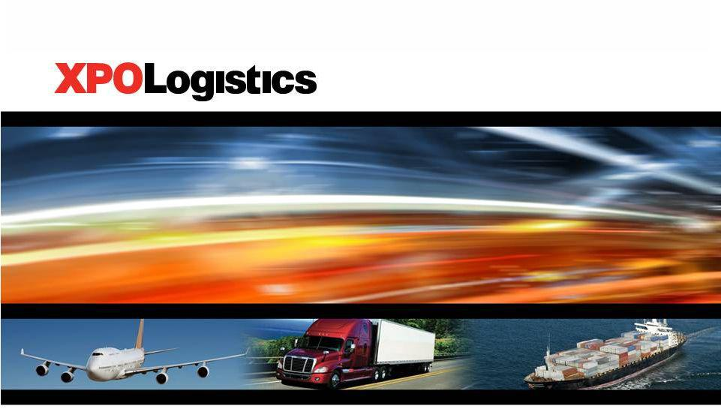

Investor Presentation

November 29, 2011

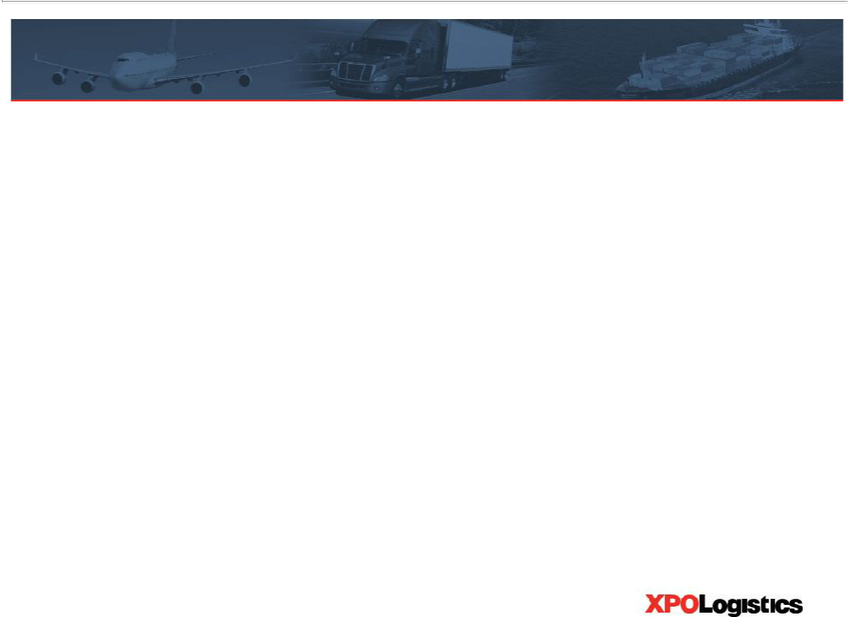
Disclaimer

This presentation contains, and XPO Logistics, Inc. (the “Company”) may from time to time make, written or oral “forward-looking statements” within the meaning of Section 27A of the Securities Act of 1933, as amended, and Section 21E of the Securities Exchange Act of 1934, as amended. All statements, other than statements of historical facts, made in this presentation which address activities, events or developments that the Company expects or anticipates will or may occur in the future, including such things as future capital expenditures (including the amount and nature thereof), finding suitable merger or acquisition candidates, expansion and growth of the Company’s business and operations and other such matters, are forward-looking statements. These statements are based on certain assumptions and analyses made by the Company in light of its experience and its perception of historical trends, current conditions and expected future developments as well as other factors it believes are appropriate in the circumstances. In some cases, forward-looking statements can be identified by the use of forward-looking terms such as “may,” “will,” “should,” “expect,” “intend,” “plan,” “anticipate,” “believe,” “estimate,” “predict,” “potential” or “continue” or the negative of these terms or other comparable terms. Investors are cautioned that any such forward-looking statements are not guarantees of future performance and involve significant risks and uncertainties, and that actual results may differ materially from those projected in the forward-looking statements. Factors that could adversely affect actual results and performance include, among others, potential fluctuations in operating results and expenses, government regulation, technology change, competition and the potential inability to identify and consummate acquisitions and arrange adequate financing. Additional factors that could cause actual results to differ materially from those projected in the forward-looking statements can be found in the Company’s Annual Report on Form 10-K for the fiscal year ended December 31, 2010, and in the Company’s other filings with the Securities and Exchange Commission (the “SEC”). This presentation should be read in conjunction with the Company’s filings with the SEC, which are available to the public over the Internet at www.sec.gov and the Company’s website www.xpologistics.com. All forward-looking statements made in this presentation speak only as of the date of this presentation. All of the forward-looking statements made in this presentation are qualified by these cautionary statements and there can be no assurance that the actual results or developments anticipated by the Company will be realized or, even if substantially realized, that they will have the expected consequence to or effects on the Company or its business or operations. The Company assumes no obligation to update any such forward-looking statements.

2

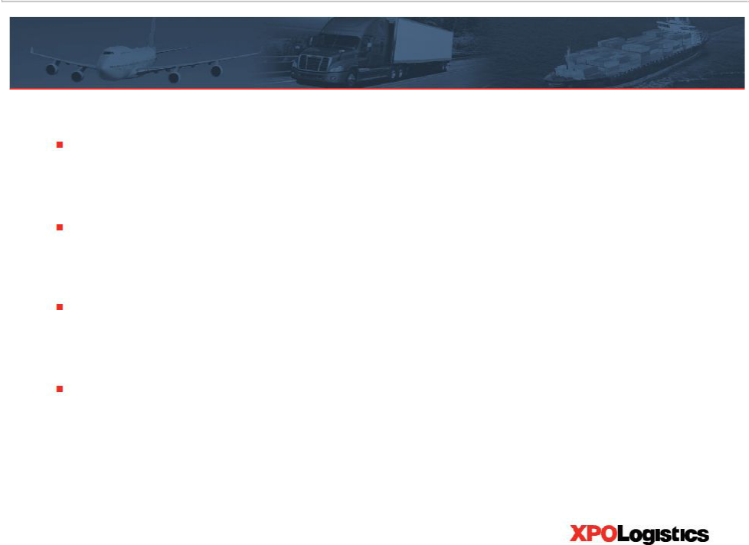
The XPO growth strategy

Build a multi-billion dollar third-party logistics business

Execute selective acquisitions and organic growth

Optimize operations company-wide

Apply best practices through highly skilled management team

3

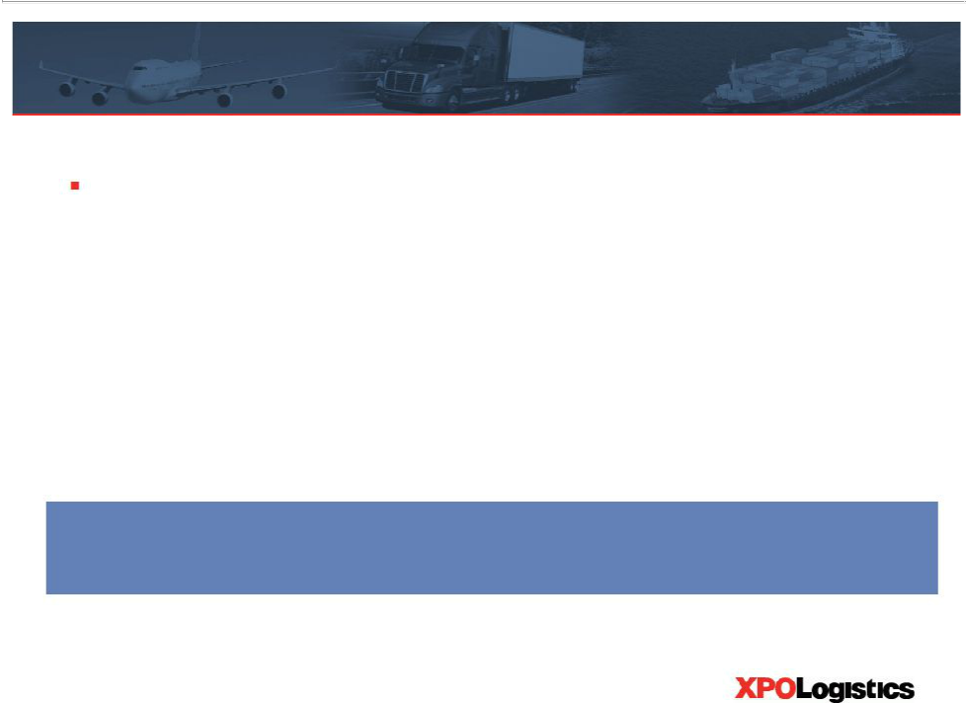
Bradley Jacobs

Founded and led four highly successful companies:

– Amerex Oil Associates: Built one of world’s largest oil brokerage firms

– Hamilton Resources: Grew global oil trading company to ~$1 billion

– United Waste: Created fifth largest solid waste business in North America

– United Rentals: Built world’s largest equipment rental company

United Waste stock outperformed S&P 500 by 5.6x from 1992 to 1997 United Rentals stock outperformed S&P 500 by 2.2x from 1997 to 2007

4

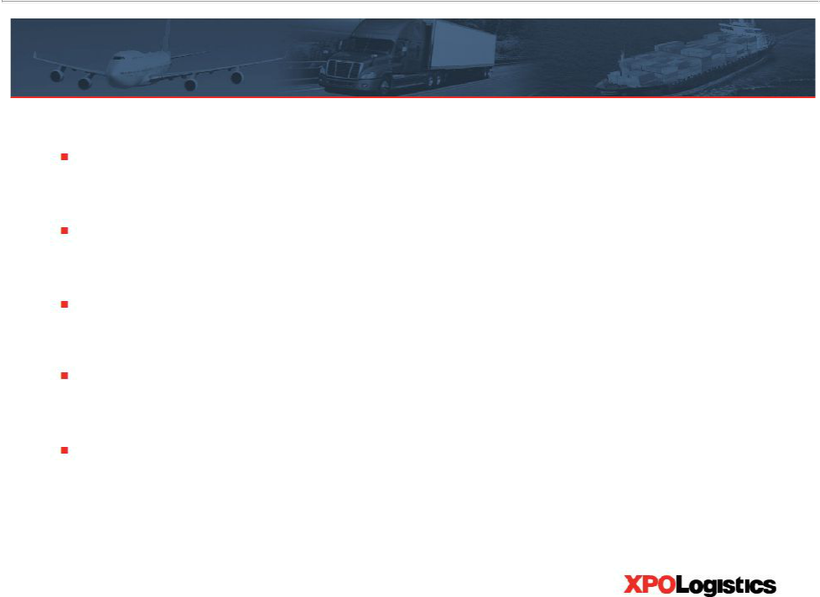
Transportation is a large industry

Worldwide logistics spend: | > $3 trillion
U.S. logistics spend: | > $1 trillion
U.S. trucking spend: | ~ $350 billion
Global freight forwarding spend: | ~ $150 billion
U.S. truck brokerage spend: | ~ $50 billion

Sources: American Trucking Association, Armstrong & Associates, EVE Partners LLC

5

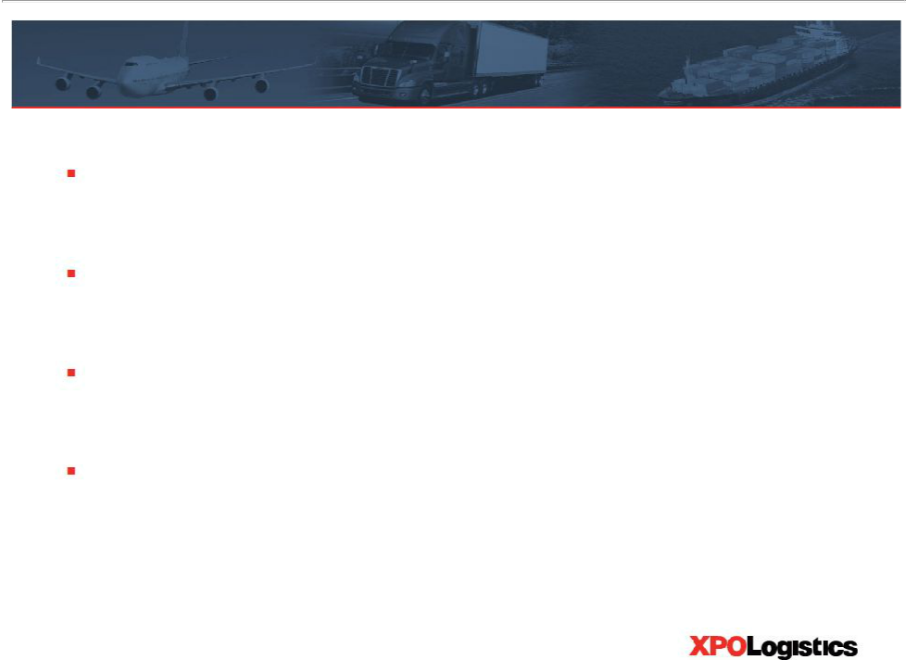
Truck brokerage is a highly fragmented market

More than 10,000 licensed truck brokers in the U.S.

Only about 25 brokers have more than $200 million in revenue

Large potential acquisition universe

Lack of working capital can motivate sellers

Source: Armstrong & Associates

6

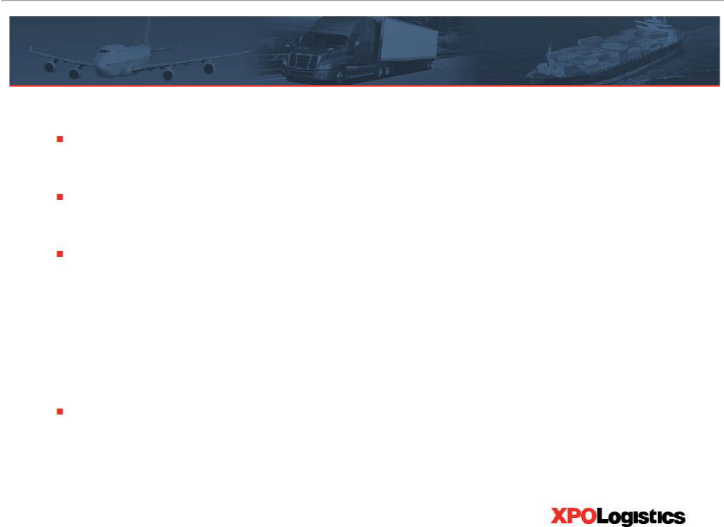
15% brokerage penetration likely to increase

Truck brokerage sector is growing at about 2x to 3x GDP

Long-term outsourcing trend

Brokers add efficiency to both shippers and carriers

– Shippers gain access to hundreds of thousands of carriers

– Carriers gain access to millions of shipments

$300 billion of loads a year presently do not go through brokers

Sources: American Trucking Association, Armstrong & Associates

7

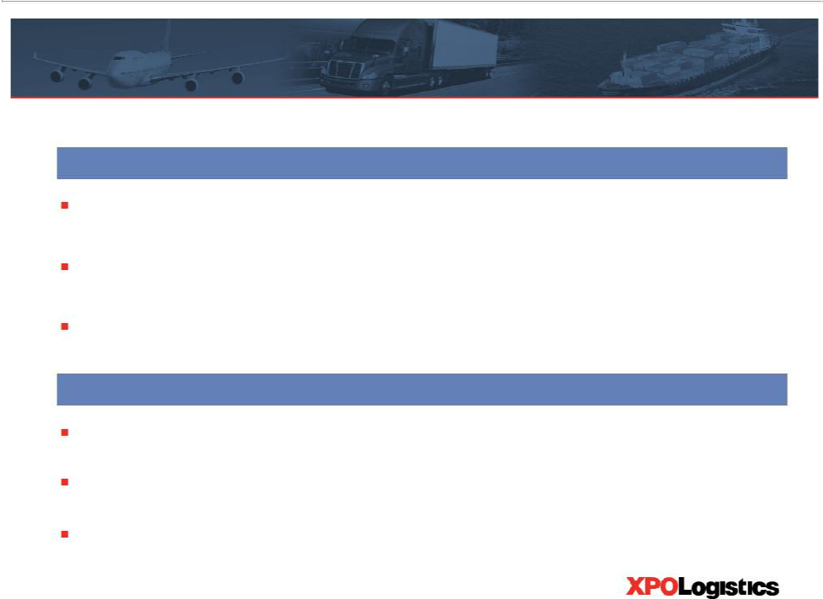
Acquisition and integration strategy

Attractive acquisition universe

Targeting non-asset based transportation companies Primarily focused on truck brokers

Initial sweet spot: $30 million to $200 million in revenue

Rapidly scale acquired companies

Aggressively expand sales force

Focus on ROIC

Grow the business to lower the effective purchase price multiple

8

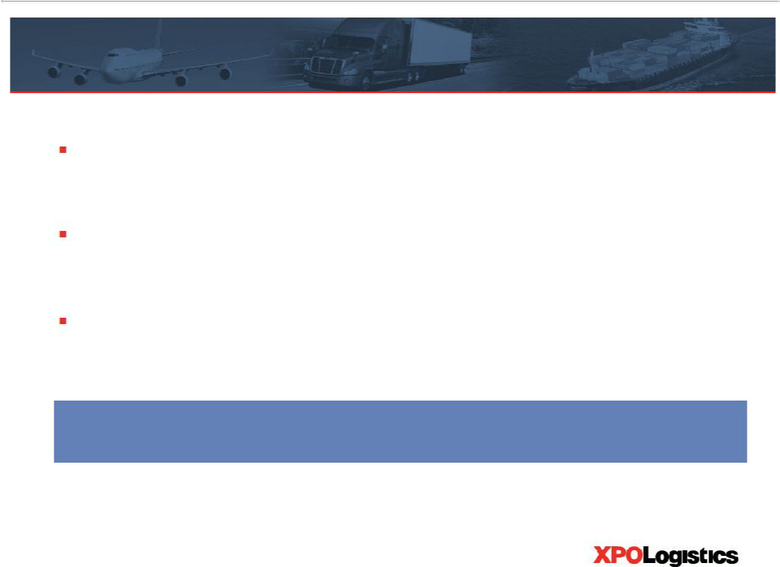
Coldstarts typically offer high returns

Targeting 20 greenfield locations within two to three years

Experienced management leading the roll-out

Phoenix is the first coldstart

Plan is for coldstarts to be a significant component of revenue over time

9

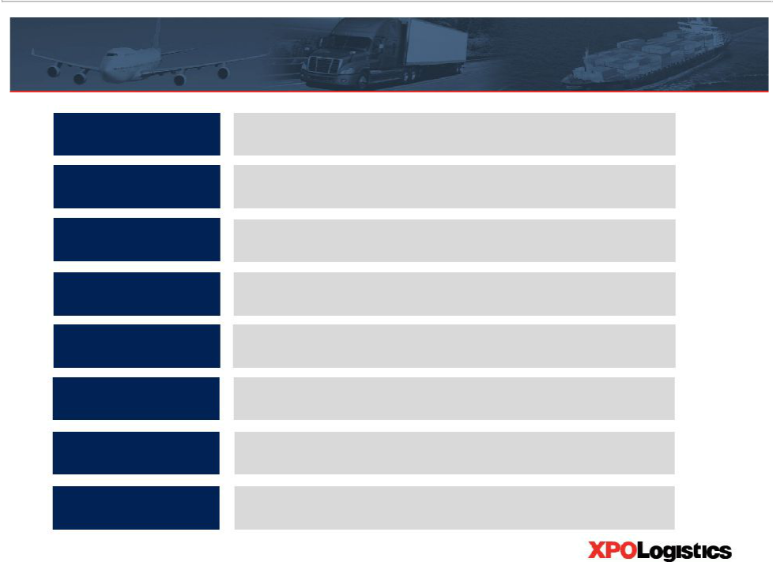
Highly skilled management team

Tom Connolly

SVP, Acquisitions

Dick Metzler

SVP, Acquisitions

Sean Fernandez

Chief Operating Officer

Scott Malat

SVP, Strategic Planning

Greg Ritter

SVP, Brokerage Operations

Mario Harik

Chief Information Officer

Troy Cooper

VP, Finance

Gordon Devens

SVP and General Counsel

EVE Partners

Greatwide Logistics, FedEx, DHL, GE Capital

NCR, Avery Dennison, Arrow Electronics

Goldman Sachs, UBS, JPMorgan Chase

C.H. Robinson

Oakleaf Waste Management

United Rentals

AutoNation, Skadden Arps

10

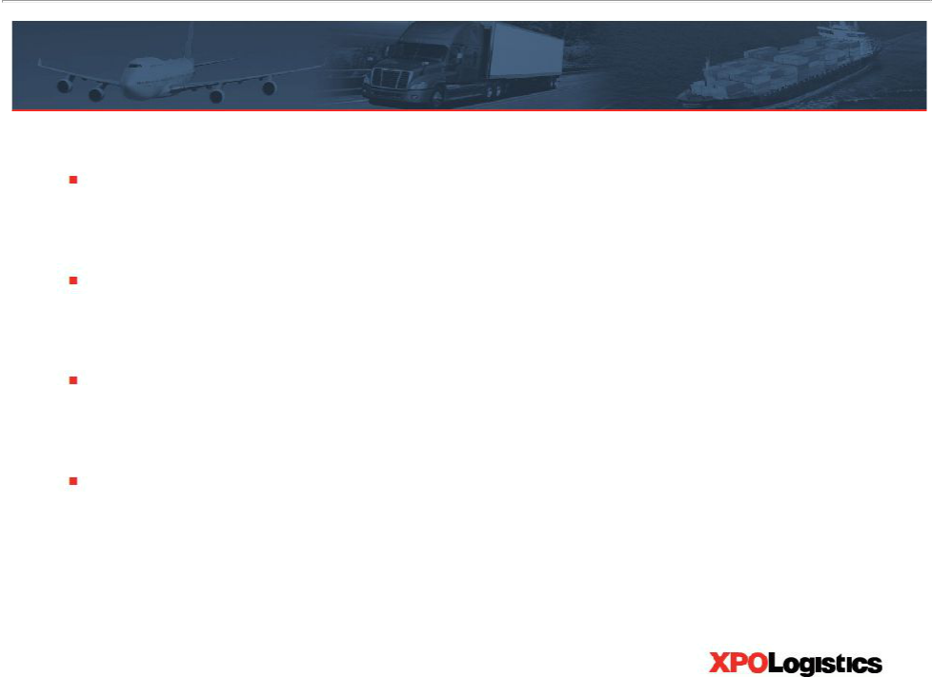
Truck brokerage (Bounce)

Good example of coldstart opportunity

Grew to nearly $30 million in revenue after three years

YOY growth of 45% in revenue and 78% in operating income in 3Q 2011

Growth plan: Increase sales force and apply best practices

11

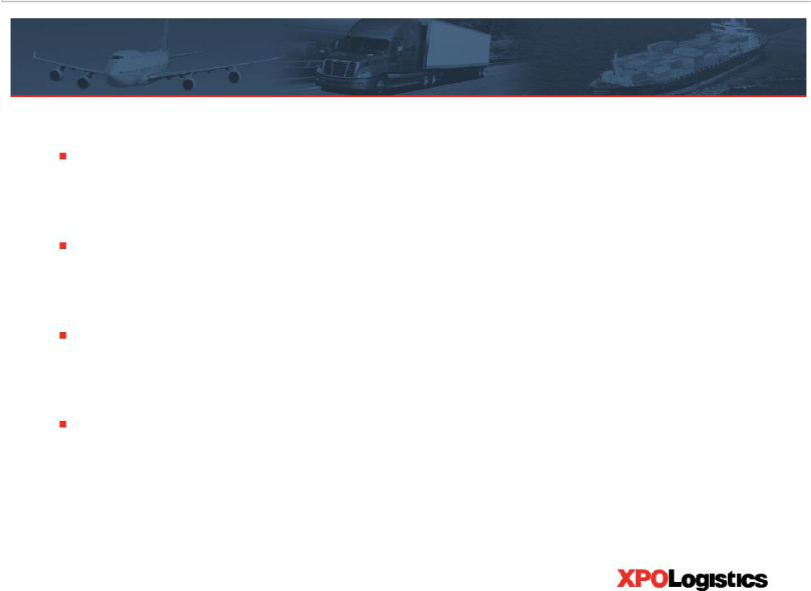
Expedited transportation (Express-1)

Gain more share of estimated $5 billion potential market

Capitalize on strong position

Increase current utilization of owner-operators

Recruit more owner-operators

Source: Company data

12

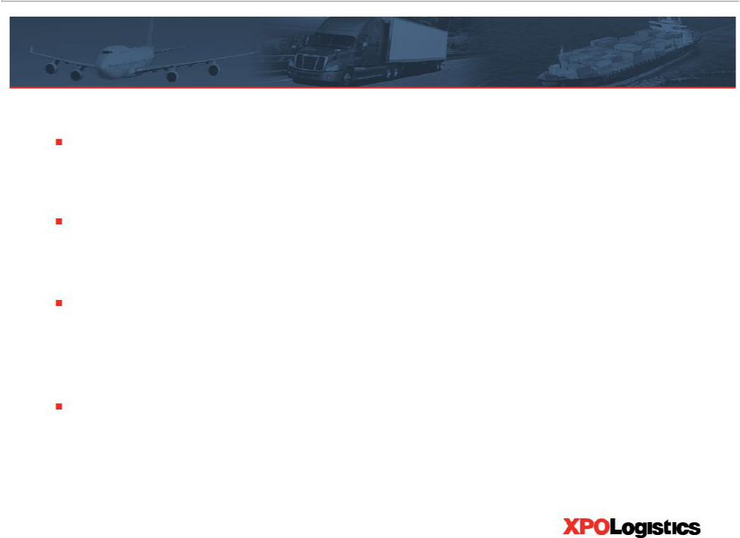
Freight forwarding (CGL)

Opportunity to grow by taking market share

Approximately $70 million player in a $150 billion market

Plan to grow footprint from 25 to 35 locations over two years with company-owned and independently-owned stations

Capitalize on presence in growing international market

Source: Company data

13

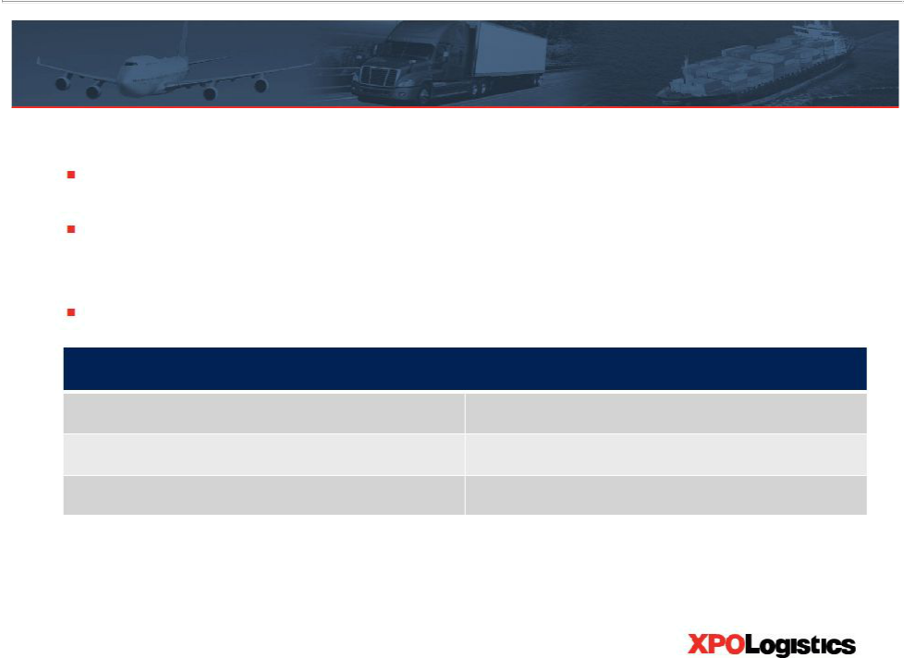
XPO key financial statistics

TTM revenue: $175 million

Diluted share count: 24.0 million (19.4 million excluding shares in respect of warrants)

$71.5 million cash; $2.5 million debt

XPO stock stats

Symbol

Market capitalization(a)

Enterprise value(a)

NYSE Amex: XPO

$175 million

$106 million

Note: TTM revenue is total revenue reported for October 2010 through September 2011; cash and debt are as of September 30, 2011

Note: Diluted share count is as of September 30, 2011; includes 4.6 million shares in respect of 10.7 million warrants priced at $7.00 per share; dilutive effect of warrants and options calculated using average closing market price of $12.20 per share for 3Q 2011

- Based on closing share price of $9.10 as of November 25, 2011 and other data as of September 30, 2011, without giving effect to the 10.7 million warrants

14

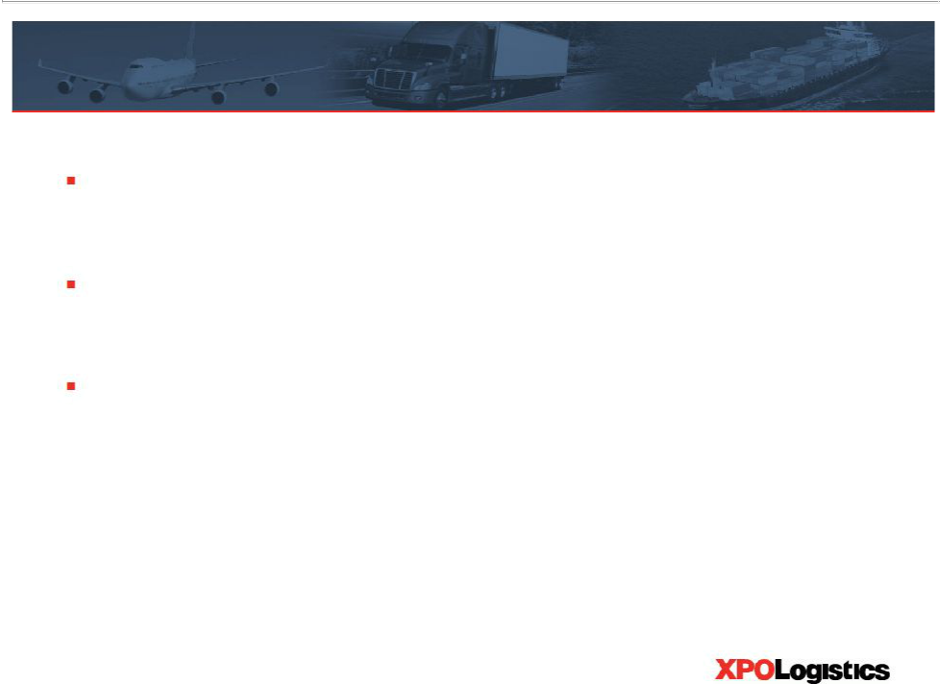
Financing growth

First phase of XPO’s growth is pre-funded

May expand credit line

Expect sufficient liquidity for first phase of acquisitions, coldstarts and infrastructure

15

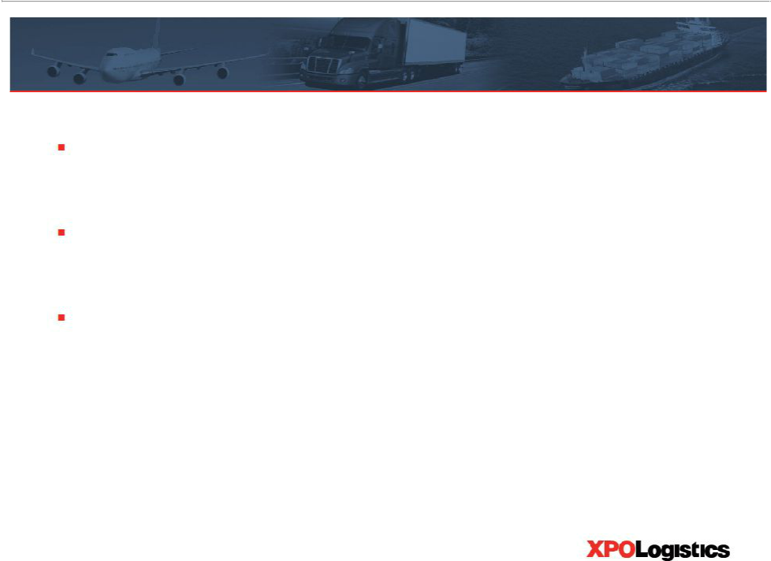
Summary of opportunities

Large, fragmented, growing industry

Create value with acquisitions and coldstarts

Business has potential to grow even in a downturn

16

