UNITED STATES

SECURITIES AND EXCHANGE COMMISSION
Washington, D.C. 20549

FORM 8-K

CURRENT REPORT

Pursuant to Section 13 or 15(d) of the

Securities Exchange Act of 1934

Date of Report (Date of earliest event reported): February 27, 2013

XPO LOGISTICS, INC.

(Exact name of registrant as specified in its charter)

Delaware

001-32172

03-0450326

(State or other jurisdiction

of incorporation)

(Commission

File Number)

(I.R.S. Employer

Identification No.)

Five Greenwich Office Park, Greenwich, Connecticut 06831

(Address of principal executive offices)

(855) 976-4636

(Registrant’s telephone number, including area code)

N/A

(Former name or former address, if changed since last report)

Check the appropriate box below if the Form 8-K filing is intended to simultaneously satisfy the filing obligation of the registrant under any of the following provisions:

- Written communications pursuant to Rule 425 under the Securities Act (17 CFR 230.425)

- Soliciting material pursuant to Rule 14a-12 under the Exchange Act (17 CFR 240.14a-12)

- Pre-commencement communications pursuant to Rule 14d-2(b) under the Exchange Act (17 CFR 240.14d-2(b))

- Pre-commencement communications pursuant to Rule 13e-4(c) under the Exchange Act (17 CFR 240.13e-4(c))

Item 7.01. Regulation FD Disclosure.

On February 27, 2013, the Company released a slide presentation expected to be used by the Company in connection with certain future investor presentations, together with a corresponding script. Copies of the slide presentation and script are attached as Exhibit 99.1 and Exhibit 99.2, respectively, to this Current Report on Form 8-K.

The slide presentation and script should be read together and with the Company’s filings with the Securities and Exchange Commission (the “SEC”), including the Quarterly Report on Form 10-Q for the quarter ended September 30, 2012.

The information furnished in this Item 7.01, including Exhibit 99.1 and Exhibit 99.2, shall not be deemed “filed” for purposes of Section 18 of the Securities Exchange Act of 1934, as amended (the “Exchange Act”), or otherwise subject to the liabilities of that Section. This information shall not be deemed incorporated by reference into any filing under the Securities Act of 1933, as amended, or the Exchange Act, except to the extent that the registrant specifically incorporates any such information by reference.

Item 9.01. |  | Financial Statements and Exhibits.
(d) Exhibits
Exhibit No. |  | Exhibit Description
99.1 |  | Investor Presentation, dated February 27, 2013.
99.2 |  | Investor Presentation Script, dated February 27, 2013.

SIGNATURE

Pursuant to the requirements of the Securities Exchange Act of 1934, the registrant has duly caused this report to be signed on its behalf by the undersigned hereunto duly authorized.

Date: February 27, 2013 XPO LOGISTICS, INC.

By: /s/ Gordon E. Devens

Gordon E. Devens

Senior Vice President and General Counsel

 |  |  | EXHIBIT INDEX
Exhibit No. | Exhibit Description
99.1 | Investor Presentation, dated February 27, 2013.
99.2 | Investor Presentation Script, dated February 27, 2013.
Exhibit 99.1
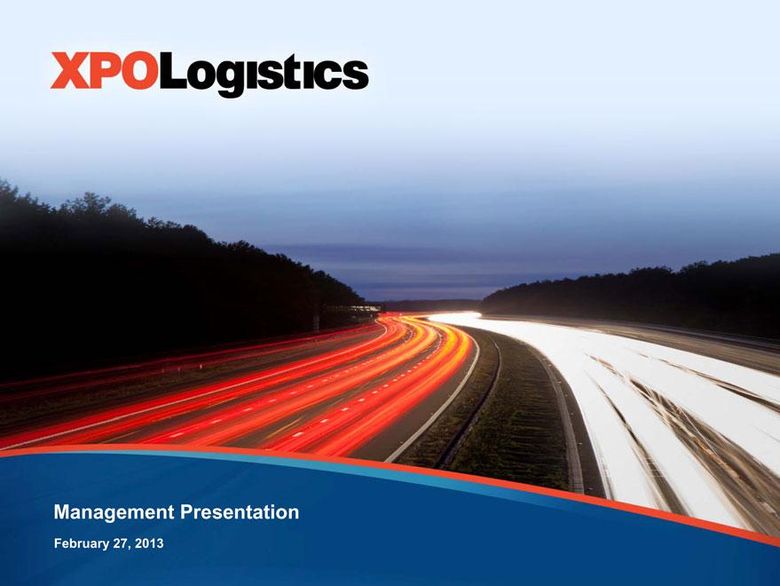

Management Presentation
February 27, 2013

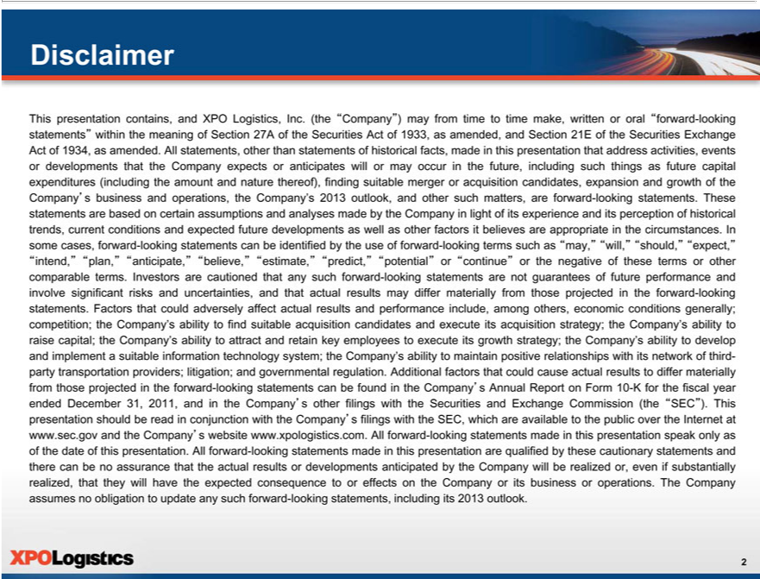

Disclaimer
This presentation contains, and XPO Logistics, Inc. (the “Company”) may from time to time make, written or oral “forward-looking statements” within the meaning of Section 27A of the Securities Act of 1933, as
amended, and Section 21E of the Securities Exchange Act of 1934, as amended. All statements, other than statements of historical facts, made in this presentation that address activities, events or developments that the
Company expects or anticipates will or may occur in the future, including such |  | future capital expenditures (including the amount and nature thereof), finding suitable merger or acquisition
expansion and growth of the Company’s business and operations, the Company’thingsas2013outlook, and other such matters, are forward-looking statements. These statements are based on certain assumptionscandidates, analyses
made by the Company light of its experience and its perception of historical trends, current conditions and expected future developments as well as other factors it believes are appropriate the circumstances. In
some cases, forward-looking statements can be identified by the use of forward-looking terms such as “may,”“will,”“should,”“expect,” “intend,”“plan,”“anticipate,”“believe,”“estimate,”“predict,”“potential” or
“continue” or the negative of these terms or other comparable terms. Investors are cautioned that any such forward-looking statements are not guarantees of future performance and involve significant risks and
uncer ainties, and that actual results may differ materially from those projected in the forward-looking statements. Factors that could adversely affect actual results and performance include, among others, economic
conditions generally; competition; the Company’s ability to find suitable acquisition |  | and execute its acquisition strategy; the Company’s ability to raise capital; the Company’ ability to attract and retain key
employees to execute its growth strategy; the Company’s ability to develop and implementcandidatessuitable information technology system; the Company’ ability to |  |  |  | positive relationships with its network of third-
party | providers; litigation; and governmental regulation. Additional factors that could cause actual results to differ materially from those projectedmaintaintheforward-looking statements can be found in the
Company’transportationAnnual Report on Form 10-K for the fiscal year ended December 31, 2011, and in the Company’s other filings with the |  |  | and Exchange Commission (the “SEC”). This presentation should beread
inconjunction with the Company’s filings with the SEC,which are available to thepublicover the Inter et at www.sec.gov and the Company’Securitieswebsite www.xpologistics.com. All forward-looking statements made in
this pr sentation speak only as of the date of this presentation. All forward-looking statements made in this presentation are qualified by these cautionary statements and there can be no assurance that the actual results
or developments | nticipated by the Company will be realized or even if substantially realized, that they will have the expected consequence to or effects on the Company or its business or operations. The Company
assumes no obligation to update any such forward-looking statements, including its 2013 outlook.

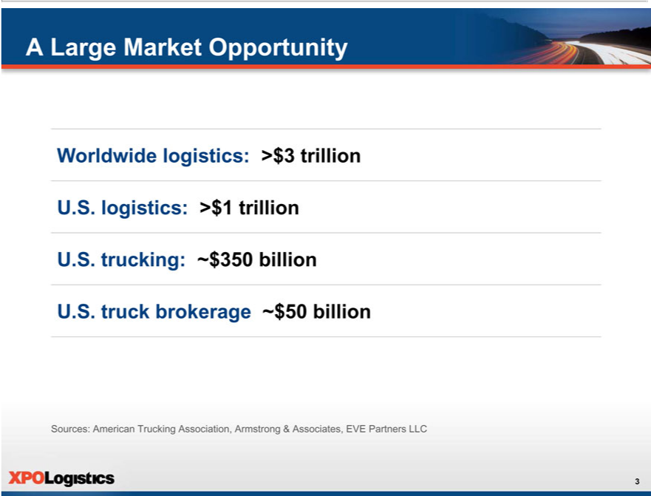

A Large Market Opportunity
Worldwide logistics: >$3 trillion U.S. logistics: >$1 trillion U.S. trucking: ~$350 billion U.S. truck brokerage ~$50 billion
Sources: American Trucking Association, Armstrong & Associates, EVE Partners LLC

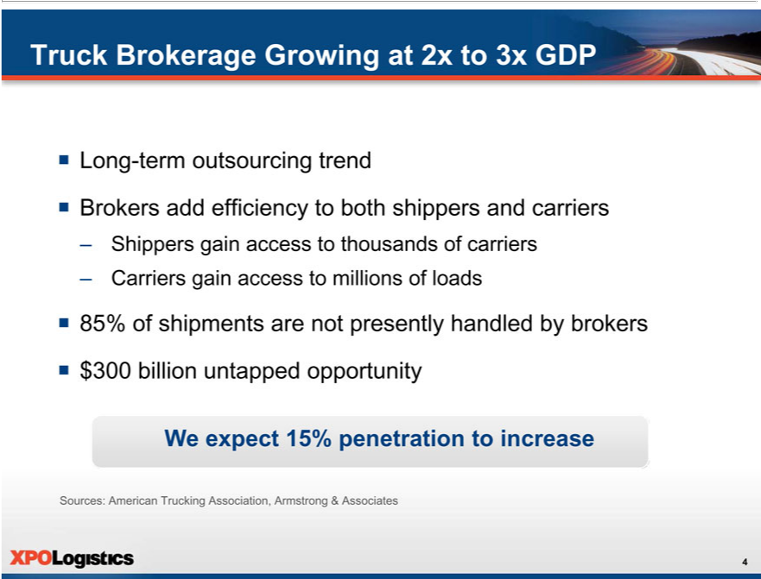

^{ƒ}TruckLongBrokerage-termoutsourcingGrowingtrendat2x to 3x GDP
Brokers add efficiency to both shippers and carriers
–
CarriersShippersgaingainaccessaccesstotomillionsthousandsof ofloadscarriers
^{ƒ}
$85%300 ofbillionshipmentsuntappedare notopportunitypresently handled by brokers
W_{Sources:}expect 15% penetration to increase
American Trucking Association, Armstrong & Associates

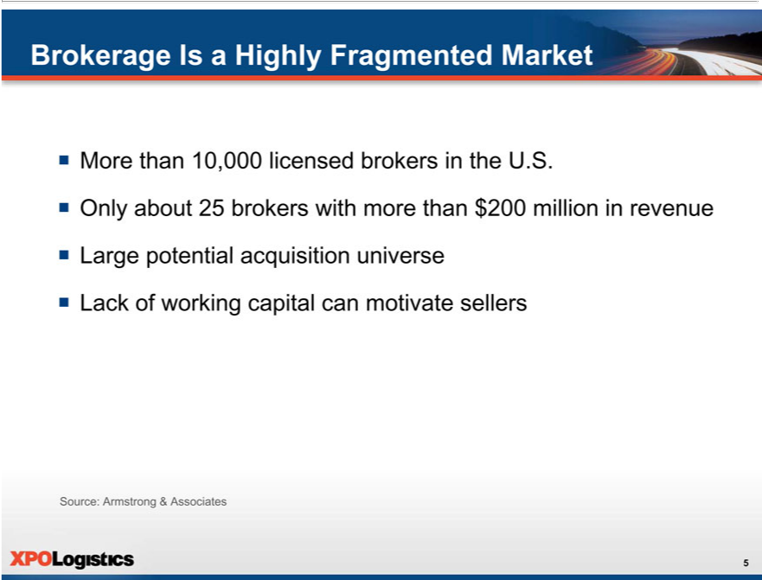

BrokerageMorethanIs 10,000aHighlylicensedFragmentedbrokersMarketinthe U.S.
^{ƒ Lack}Onlyrgeaboutpotential25brokersacquisitionwithuniversemorethan $200 million in revenue
Source:ofArmstrongworking capital&Associatescanmotivate sellers

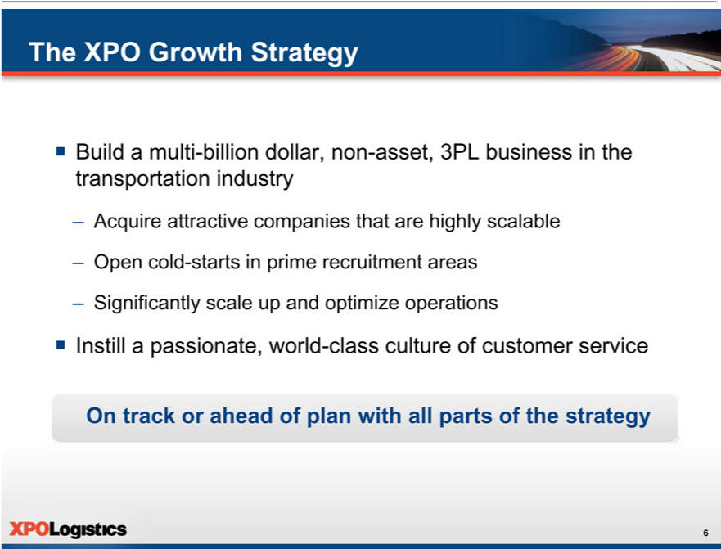

The XPO Growth Strategy
ƒ AcquireBuildamultiattractive-billioncompaniesdollar,nonthat-asset,arehighly3PLbusinessscalablein the transportation industry
–
_{Significantly}Opencold-startsscalein upprimeand recruitmentoptimizeoperationsareas
OnƒInstilltrack orpassionate,aheadof planworldwith-classall culturepartsofofthecustomerstrategyservice

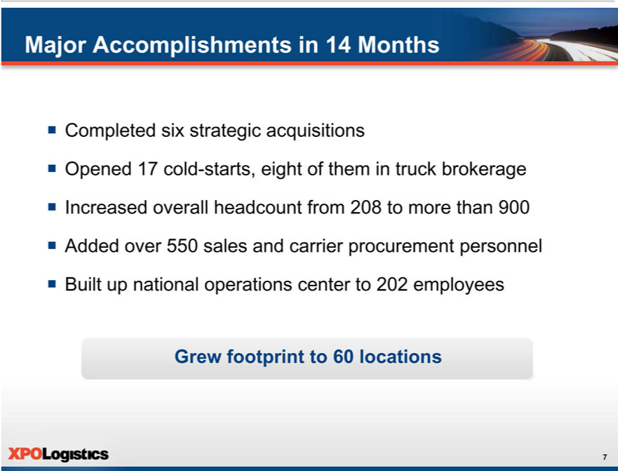

MajorCompletedAccomplishmentssixstrategicinacquisitions14Months
IncreasedOpened17overallcold-starts,headcounteight_{carrier}fofomthem208intotruckmorebrokeragethan900
^{ƒ}
BuiltAddedupovernational550salesoperationsand centerprocurementto202employeespersonnel
Grew footprint to 60 locations

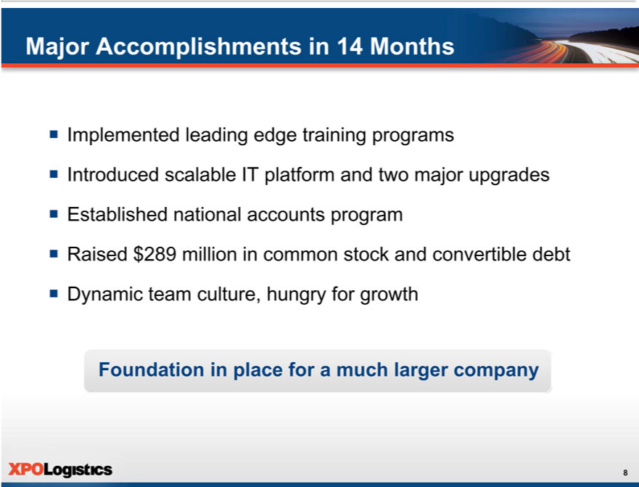

Major_{Introduced}mplementedAccomplishmentsleadingedgein14trainingMonthsprograms

EstablishedscalablenationalITaccountsplatformprogramandtwo major upgrades
^{ƒ}
DynamicRaised$289teammillionculture,in hungrycommonforstockgrowthand convertible debt
Foundation in place for a much larger company

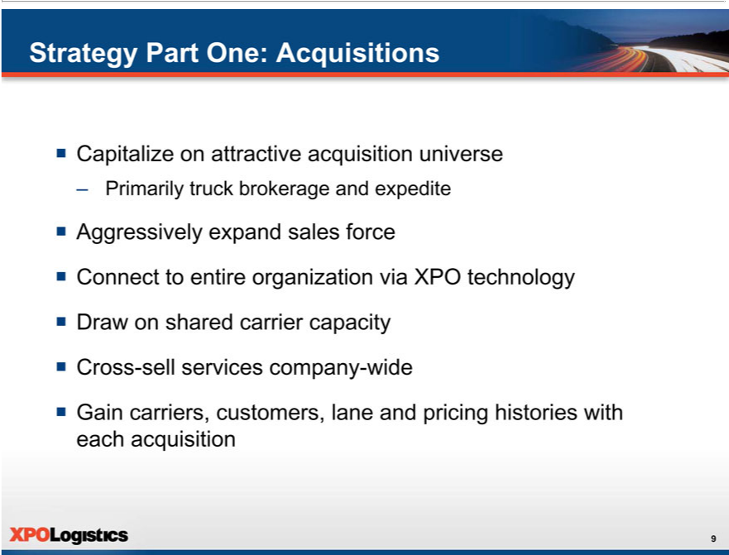

Strategy Part One: Acquisitions
ƒ Capitalize on attractive acquisition universe
– AggressivelyPrimarilytruckexpandbrokeragesalesandforceexpedite
DrawConnecton tosharedentirecarrierorganizationcapacityvia XPO technology
^{ƒ} Cross-sell services company-wide
Gain carriers, customers, lane and pricing histories with each acquisition

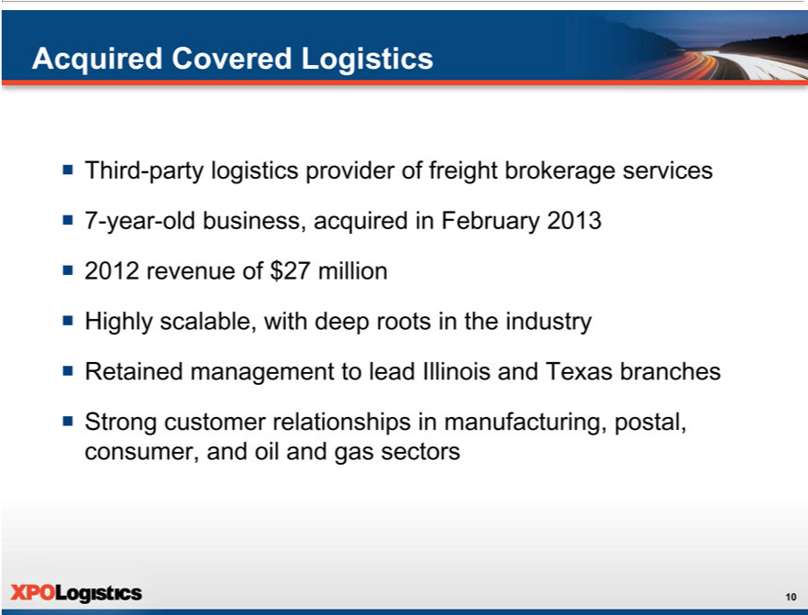

Acquired Covered Logistics
 | Third-party logistics provider of freight brokerage services
 | 7-year-old business, acquired in February 2013
 | 2012 revenue of $27 million | the industry
 | Highly scal ble, with deep roots | the industry
ƒ | Retained management to lead | and Texas branches
ƒ | Strong customer relationships Illinoismanufacturing, postal, consumer, and oil and gas sectors

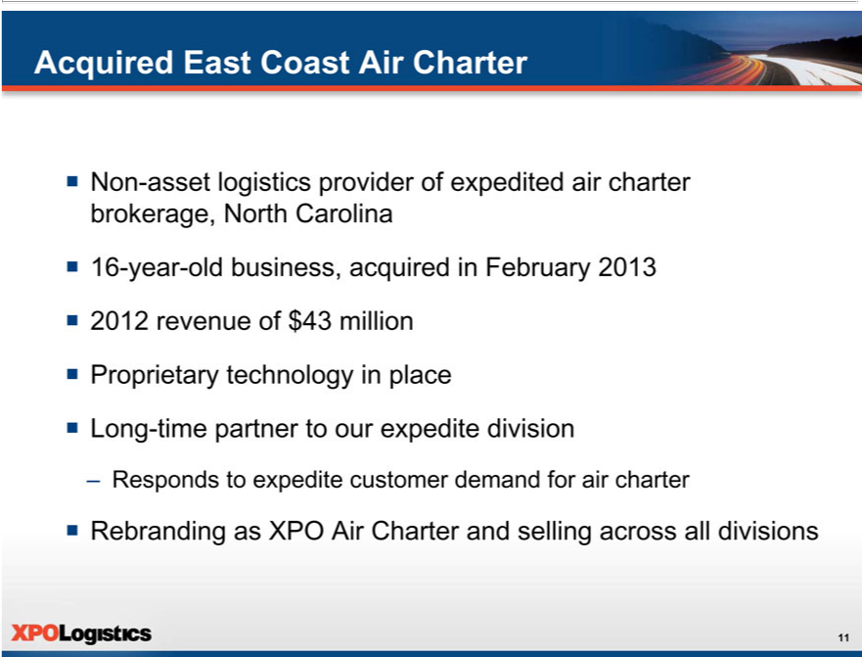

Acquired East Coast Air Charter
 | Non-asset logistics provider of expedited air charter brokerage, North Carolina
 | 16-year-old business, acquired in February 2013
 | 2012 revenue of $43 million
ƒ | Proprietary technology in place
ƒ | Long-time partner to our expedite division
– | sponds to expedite customer | for air charter
ƒ | Rebranding as XPO Air Charterdemandselling across all divisions

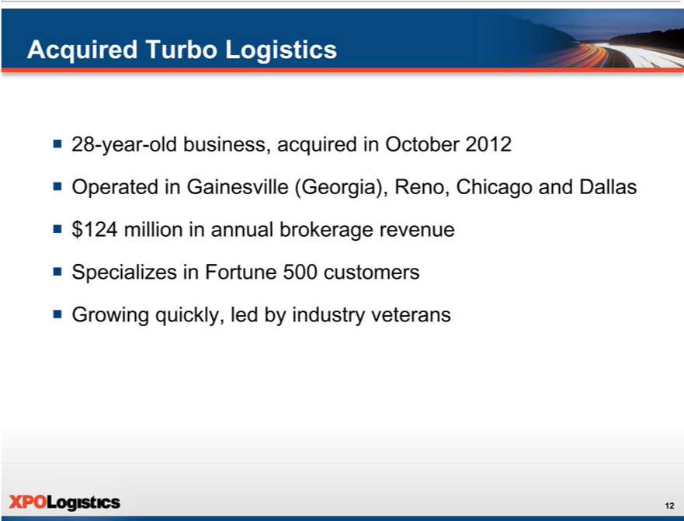

Acquired Turbo Logistics
28-year-old business, acquired in October 2012
$Operated124millionin_{Gainesville}annualbrokerage(Georgia),revenueReno,Chicago and Dallas
^{ƒ}
GrowingSpecializesquickly,inFortuneledby500industrycustomersveterans

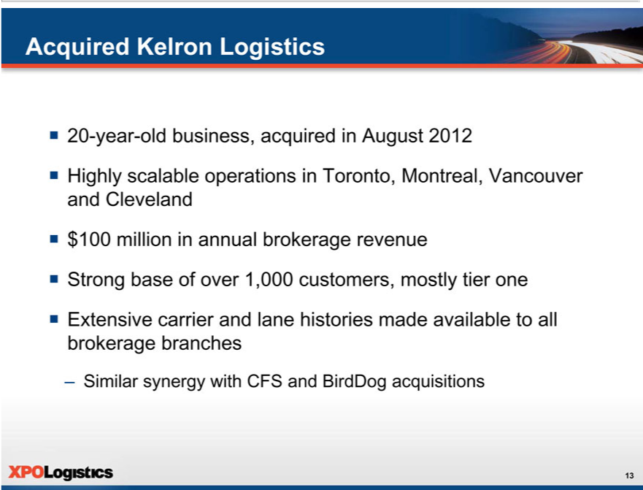

Acquired Kelron Logistics
20-year-old business, acquired in August 2012
$Highly100millionscalablein annualoperationsbrokerageinToronto,revenueMontreal, Vancouver and Cleveland
^{ƒ} Strong base of over 1,000 customers, mostly tier one
Extensive carrier and lane histories made available to all brokerage branches
– Similar synergy with CFS and BirdDog acquisitions

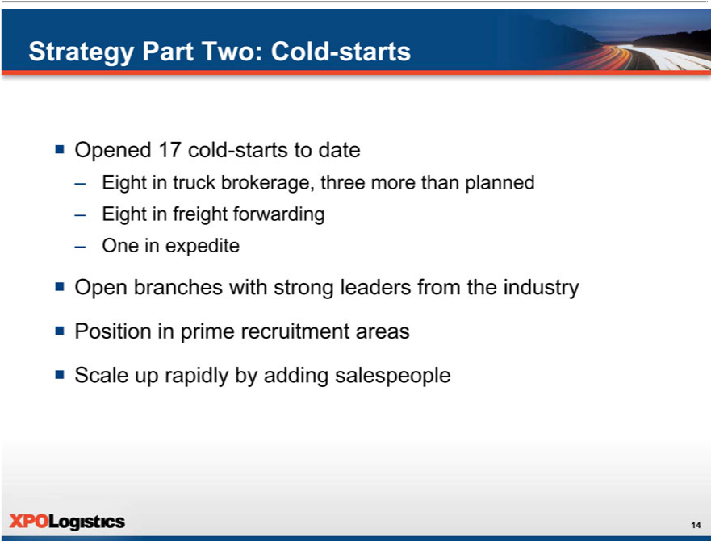

ƒStrategyOpenedPart17 coldTwo:-startsCold-tostartsdate
^{Eight in} truck brokerage, three more than planned
–
_{Open}nein expeditefreight forwarding
^{ƒ} Positionbranchesinprimewithrecruitmentstrongleadersareas from the industry
Scale up rapidly by adding salespeople

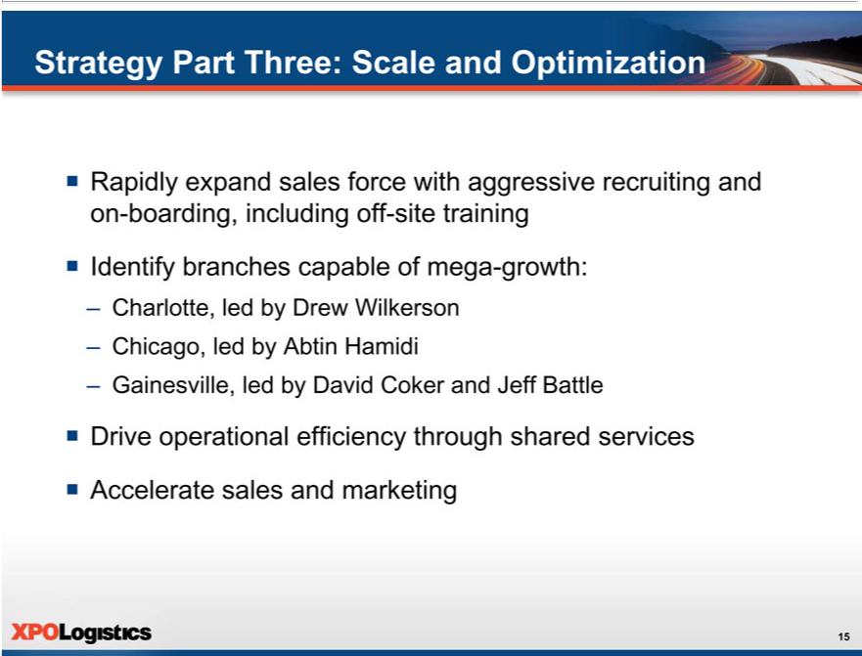

Strategy Part Three: Scale and Optimization
_{ƒ Identify}Rapidly expand sales force with aggressive recruiting and on-boarding, including off-site training branches capable of mega-growth:
_{Ch}arlotte,_{cago,} _{led} by Drew Wilkerson
_{– Gainesville,} by Abtin Hamidi
led by David Coker and Jeff Battle
^{ƒ}
AccelerateDriveoperationalsalesandefficiencymarketingthrough shared services

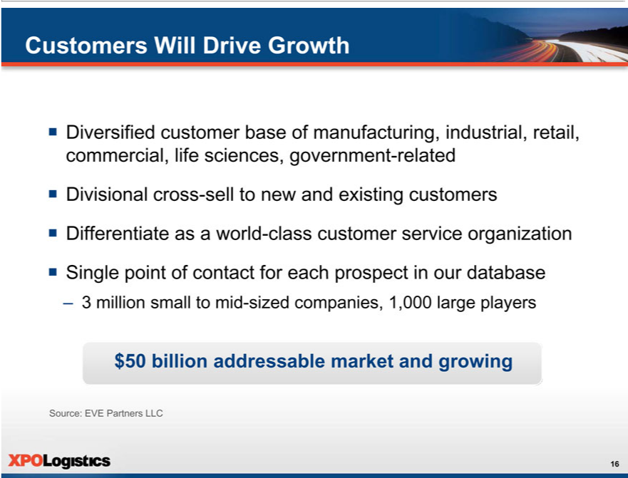

Customers Will Drive Growth
_{visional}ersified_{cross}cutomer base of manufacturing, industrial, retail, commercial, life sciences, government-related
^{Dif} -sell to new and existing customers
^{ƒ} ferentiate as ^{contact}world-class customer service organization
Single point of for each prospect in our database
$–503millionbillion addressablesmalltomidmarket-sizedcompanies,andgrowing1,000 large players
Source: EVE Partners LLC

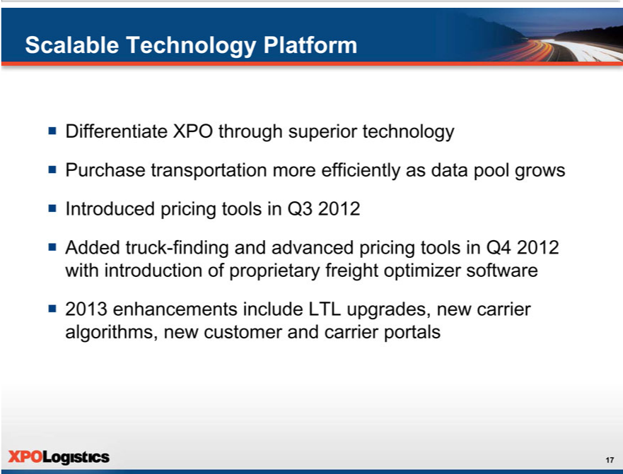

Scalable Technology Platform
Differentiate XPO through superior technology
IntroducedPurchasetransportationpricingtools moreinQ3efficiently2012 as data pool grows
^{ƒ} Added truck-finding and advanced pricing tools in Q4 2012 with introduction of proprietary freight optimizer software 2013 enhancements include LTL upgrades, new carrier algorithms, new customer and carrier portals

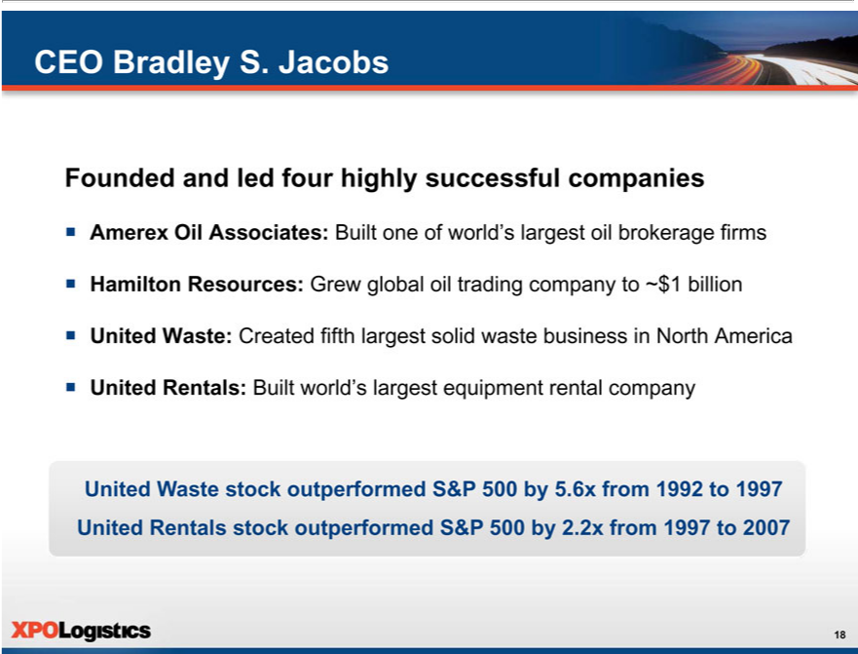

CEO Bradley S. Jacobs
Founded and led_{Associates:}furhighly successful _{companies}
HamiltonAmerexOilResources: GrewBuiltglobalone ofoilworld’trading largestcompanyoil tobrokerage~$1billionfirms
_{ƒ United} Rentals:Waste:CreatedBuiltworld’sfifthlargestlargestsolidequipmentwastebusinessrentalcompanyinNorth America
United Waste stock outperformed S&P 500 by 5.6x from 1992 to 1997 United Rentals stock outperformed S&P 500 by 2.2x from 1997 to 2007

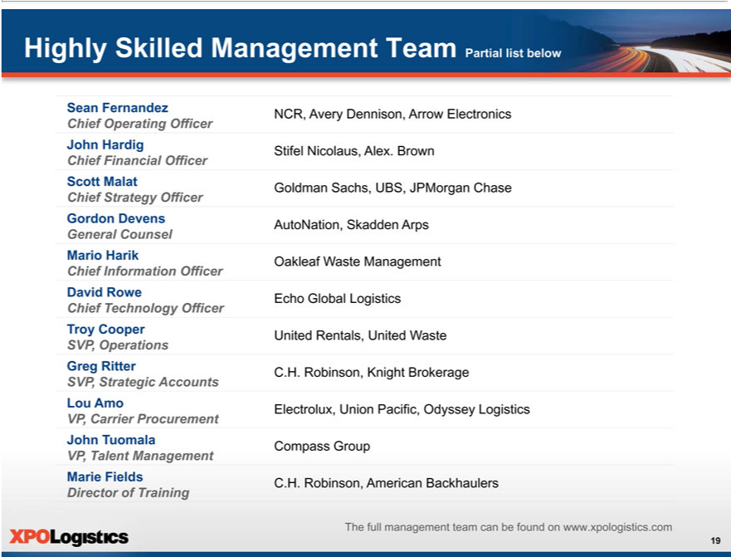

SeanHighlyFernandezSkilledManagement Team Partial list below
ChiefNCR, OperatingAveryDennison,OfficerArrow Electronics
John Hardig
^{Chief}Stifl Nicolaus, Alex. Brown
Scott MalatFinancial Officer
ChiefGoldmanStrategySachs,OfficerUBS, JPMorgan Chase
Gordon Devens
AutoNation, Skadden Arps
General Counsel
Mario Harik
Oakleaf Waste Management
DavidChief InformationRowe Officer
Echo Global Logistics
Chief Technology Officer
Troy Cooper
SVP,UnitedOperationsRentals,United Waste
Greg Ritter
SVP,C.H. Robinson,StrategicAccountsKnightBrokerage
Lou Amo
VP_{Electrolux,}Carrier UnionProcurementPacific, Odyssey Logistics
John Tuomala
Compass Group
MarieVP,TalentFieldsManagement
DirectorC.H.Robinson,ofTrainingAmerican Backhaulers
The full management team can be found on www.xpologistics.com

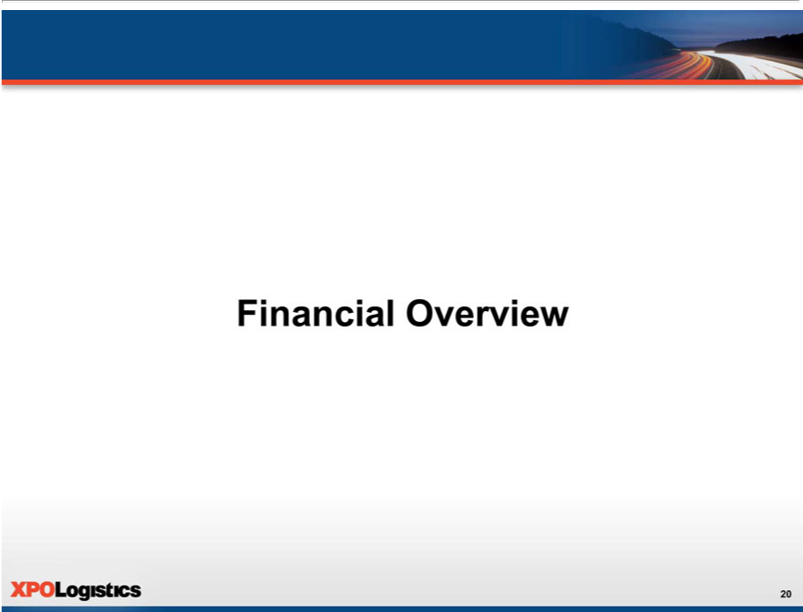

Financial Overview

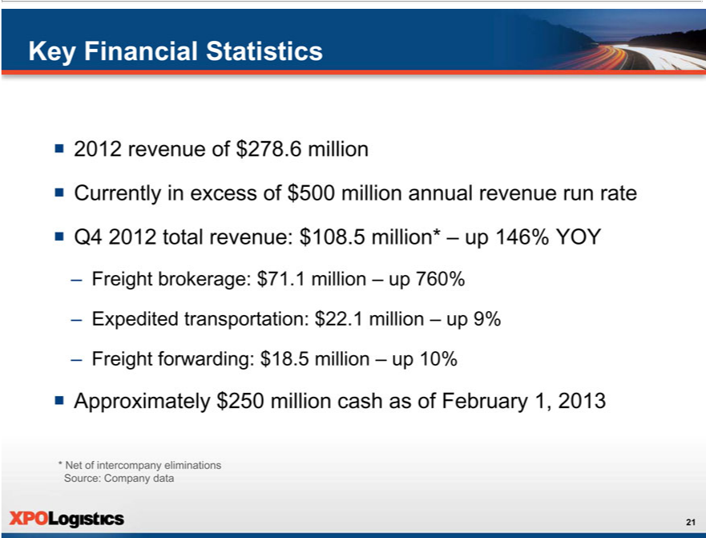

Key Financial Statistics
2012 revenue of $278.6 million
^{ƒ} Currently in excess of $500 million annual revenue run rate
FreightQ42012brokerage:totalrevenue:$71.1$108.5millionmillion*–up760%up146% YOY
–
FreightExpeditedforwarding:transportation:$18.5 $million22.1million–up10%–up 9%
ƒ Approximately $250 million cash as of February 1, 2013
* Net of intercompany eliminations Source: Company data

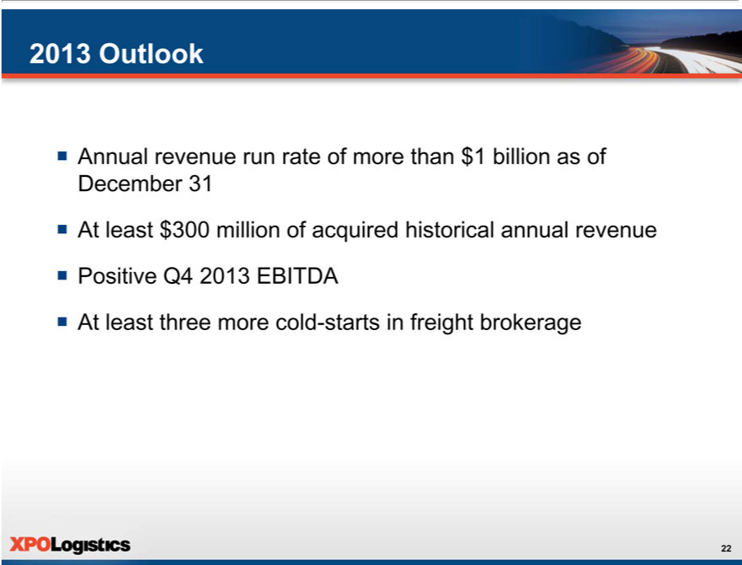

2013 Outlook
_{At}nnual revenue run rate of more than $1 billion_{annual}s of December 31
^{ƒ} Positiveleast $Q43002013millionEBITDAofacquired historical revenue
At least three more cold-starts in freight brokerage

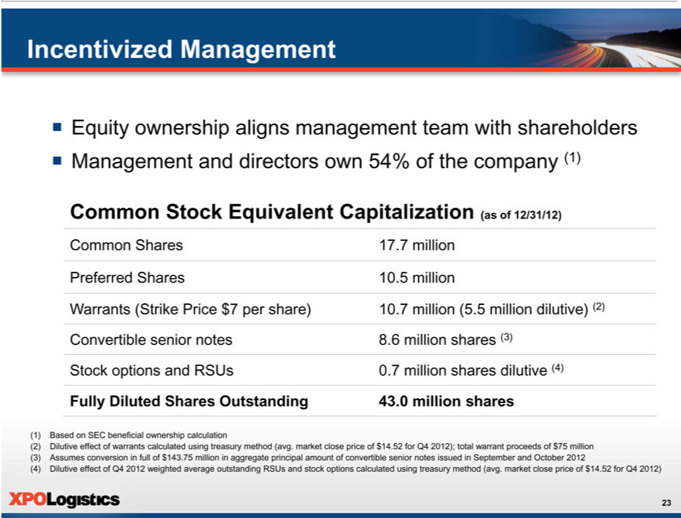

Incentivized Management
Equity ownership aligns management team with shareholders
ƒ Management and directors own 54% of the company (1)
Common |  | tock Equivalent Capitalization (as of 12/31/12)
 |  | 17.7
Preferred |  | Shares 10.5 million
Warrants (Strike Price $7 per share) .7 million (5.5 million dilutive) (2) Convertible senior notes 8.6 million shares (3) Stock options and RSUs 0.7 million shares dilutive (4)
Fully Diluted Shares Outstanding 43.10 million shares
(1) | Based on SEC beneficial ownership calculation
(2) | Dilutive effect of warrants calculated using treasury method (avg. market close price of $14.52 for Q4 2012); total warrant proceeds of $75 million (3) Assumes conversion in full of $143.75 million in aggregate
principal amount of convertible senior notes issued September and October 2012
(4) | Dilutive effect of Q4 2012 weighted average outstanding RSUs and stock options calculated using treasury method (avg. market close price of $14.52 for Q4 2012)

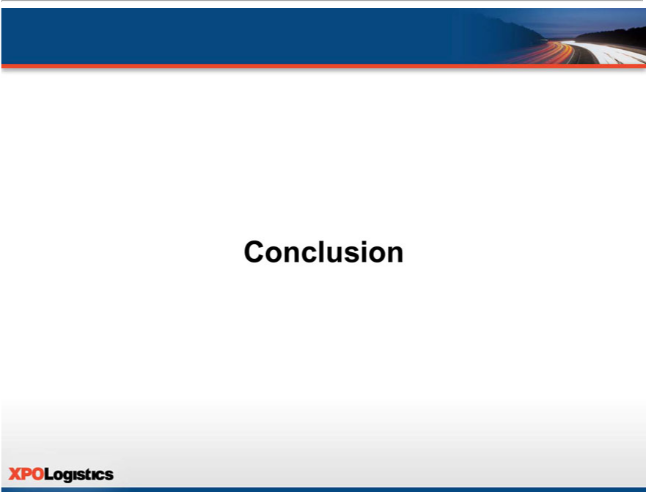

Conclusion

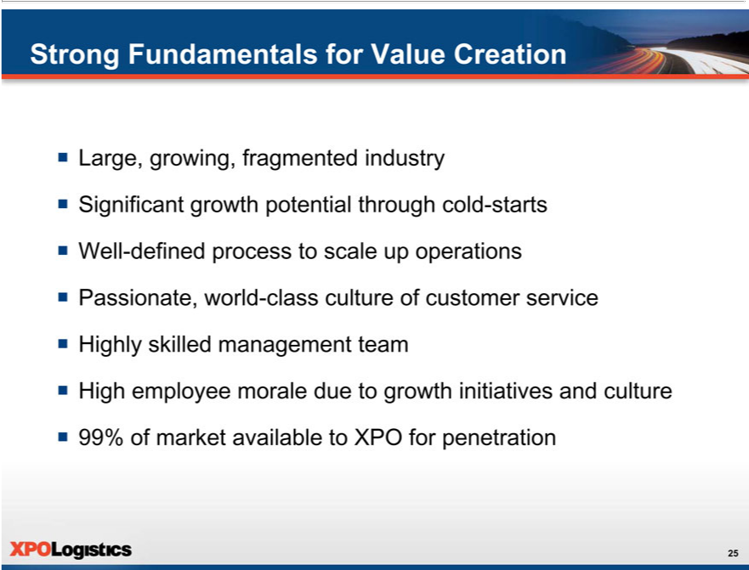

Strong Fundamentals for Value Creation
Large, growing, fragmented industry
WellSignificant-definedgrowthprocesspotentialtoscalethroughupoperationscold-starts
^{High}Passionate,lyskilledworldmanagement-classcultureteamof customer service
^{ƒ}
99% ofemployeemarket availablemoraledueto XPOtogrowthforpenetrationinitiatives and culture

Exhibit 99.2


February 27, 2013

Investor Presentation Script

The following script should be read in conjunction with the accompanying slide presentation, which contains, among other information, source data for certain information set forth in the script.

Thank you very much for joining us today.

XPO Logistics is a non-asset, third-party transportation service provider in the logistics industry. We have three service divisions: freight brokerage, expedited transportation and freight forwarding. We’re a middleman between shippers and carriers who outsource their freight needs to us because logistics is our core competency. While we don’t own the vehicles that carry the freight, we have over 22,000 relationships with carriers that provide that capacity. And our expedited transportation division, which is a top five provider of expedite services in the U.S., has more than 400 trucks under exclusive contract to be available to our customers.

If I had to sum up XPO in one phrase, it would be rapid, skillful execution. In the past 14 months, we completed six acquisitions and opened 17 cold-starts. We now have a footprint of 60 locations in the U.S. and Canada. We’ve grown our headcount from 208 to more than 900 employees since January 1, 2012. And we’ve expanded our freight brokerage division from a single location to the 17th largest operation of its kind in North America. That was the ranking we received from Transport Topics for 2012, and we’re going to continue to rise through the ranks this year.

We also implemented leading edge training and mentoring programs. We introduced a scalable IT platform and two major upgrades. We established a national accounts program to market to tier one customers. We raised $289 million through common stock and convertible debt offerings to fund our growth. And most importantly, we’ve instilled a high-octane, performance-driven culture. Our teams are hungry for growth. We now have the foundation in place to support a much larger company, and we’ve built that foundation with discipline, in line with our strategy.

We’re able to do this because we operate in an industry with favorable fundamentals that create significant opportunities for us. Our industry is large, growing and fragmented. Logistics worldwide is more than $3 trillion in annual revenues. In the United States alone, it’s about a trillion dollars. Over-the-road, for-hire trucking is about $350 billion, with an estimated 250,000 truckload carriers servicing millions of shippers. Truck brokerage, one of our primary focuses, accounts for just $50 billion of the $350 billion currently being spent with over-the-road carriers.

A critical factor, from our point of view, is that the logistics pie is expanding. Brokerage has been growing at about two to three times GDP, as opposed to asset-heavy trucking, which has been growing at around GDP. Still, the market is largely underpenetrated, with a 15% penetration rate of brokerage versus direct shipper-to-carrier cartage. Our bet is that the 15% is likely to increase substantially, and that our strategy will position our company to benefit from this long-term trend. We’re building XPO not just for the $50 billion that’s going through brokers right now, but for the $300 billion that’s currently going direct from shippers to carriers.

One thing that’s driving penetration is an outsourcing trend with both shippers and carriers. This is less about cycles and more about the fact that it makes economic sense for most companies to utilize third party logistics services – particularly small to mid-sized shippers and carriers. Typically, only the largest shippers have the freight volume to warrant in-house logistics. From the carrier’s perspective, a well-run broker can help increase utilization and decrease empty miles, giving the carrier a better return on assets. We believe that another motivating factor is the professionalization of the industry: as shippers and carriers become increasingly accustomed to superior levels of technology and service, they seek out supply chain partners who can provide these capabilities.

In addition to being large and growing, the logistics industry is also fragmented and in an early stage of consolidation. That makes it very appealing. There are over 10,000 licensed truck brokers in the United States, yet only about 25 of them – less than 1% – have revenue of over $200 million.

All of these dynamics create opportunity for us. We intend to grow our combined operations to several billion dollars in revenue over the next few years. In 2011, we had $177 million of revenue. A year later, we reported 2012 revenue of $279 million. And we’re currently at an annual revenue run rate of more than $500 million. So basically we’ve nearly tripled the size of the company in 14 months.

We’re driving growth with a three-part strategy that we put in place in September of 2011, when we took control of the company. Part one is acquisitions – we will continue to acquire attractive companies that are highly scalable. Part two is cold-starts – we will continue to open greenfield locations in North America, and base them where we can recruit strong leaders and a large number of qualified salespeople. And part three is to optimize our operations. This includes our acquired branches, our cold-starts, and the operations that were already in place in 2011. Let’s take a closer look at each part of this strategy.

First, there’s acquisitions, primarily in truck brokerage and expedite. We’ve looked at over 1,000 of the 10,000 truck brokers out there and we have a short list of about

- We have a full-time acquisition team that’s constantly in dialogue with these 100 targets, and we’ll probably do several more acquisitions this year. In some cases, a lack of access to working capital provides an incentive for owners to sell.

When we look at a potential acquisition, it’s more than just a financial transaction. We ask ourselves, what special value does this company bring to the table? How does it fit into XPO? Is this an operation that we can grow to many times its current size? Will the employees be exceptional additions to our organization?

When we find the right company, we can integrate it and scale it up very quickly. We put the branches onto our technology, which connects them to our entire organization. And we give them access to our carrier pool. It’s a win-win, because the acquired operations can sell the services of our other divisions, and we gain more carriers, customers, and lane and pricing histories that we can use company-wide. Our salespeople are able to bid on freight more intelligently and buy capacity more effectively when covering loads.

We’ve already completed two acquisitions in 2013, both of them in February. Most recently, we bought Covered Logistics, a third party truck broker with 2012 revenue of $27 million.

Covered has been in business for about seven years and has over 4,000 carrier relationships. It primarily serves customers in the manufacturing, postal, consumer, and oil and gas sectors. We really like the teams at Covered’s offices in Lake Forest, Ill., and Dallas, Texas. They have deep roots in the industry and they share our passion for growth. Co-founders Tuck Jasper, Paul Jasper and Patrick Gillihan will continue to lead the operations as XPO Logistics.

Also in February, we acquired East Coast Air Charter. East Coast has been a partner to our expedited division for more than a decade, so we know them well. They’re a specialist provider of expedited air logistics, which fits right in with our offerings. In fact, we’ve been providing air charter to our expedited customers through East Coast, and now we’ve brought that revenue stream in house.

East Coast Air Charter is based in Statesville, North Carolina, and had 2012 revenue of $43 million. We’re impressed with their proprietary technology. Bill McBane, who owned and ran the company, will be staying on to lead the operation. I’m pleased to say that as of this week, all 60 XPO offices can offer expedited air charter service.

In October of 2012, we acquired Turbo Logistics, a 28-year-old company that serves mostly Fortune 500 customers. When we bought Turbo, they were operating at four locations: Gainesville, Georgia; Reno; Chicago; and Dallas. They had trailing 12 months revenue of $124 million and 170 employees – including dozens of industry veterans who have been in brokerage for 15 or 20 years. They know all the ins and outs of this business, and they know how to service large customers.

We plan to scale up the Gainesville and Reno branches significantly. Gainesville, which has the physical space to accommodate hundreds of additional headcount, is located within an hour’s drive of 70,000 college students. With the Reno branch, we expect that a lot of those hires will come from the University of Nevada, which has 18,000 students nearby. The other two branches, Dallas and Chicago, have been combined with our existing operations in those cities.

Two months prior to Turbo, we purchased one of Canada’s leading truck brokerage companies, Kelron Logistics. Kelron had been in the brokerage business for 20 years, with offices in Toronto, Montreal, Vancouver and Cleveland. It was generating about $100 million of annual revenue when we bought it. One very positive aspect of the Kelron deal is that it added thousands of carriers and customers to our database, including some large shippers, which benefits the entire XPO network. Like Turbo, Kelron is sharing our capacity pool. We’ve already begun to scale up the operations by adding salespeople.

Covered, East Coast, Turbo and Kelron all fit our strategy for growth. They have synergies with our organization, and most of all they’re highly scalable. Our two other acquisitions, BirdDog Logistics and Continental Freight Services, have these same qualities as well.

This brings us to the second part of our strategy, and an equally important one – cold-starts. Our cold-start program is ahead of plan. As I mentioned, we’ve opened 17 cold-starts to date. Eight of those were freight brokerage, three more than planned. We also opened eight in freight forwarding and one in expedite. Each of our freight brokerage cold-starts is led by a highly experienced branch president who has “been there and done that” before – someone who can inspire a team to build a branch up to tens or hundreds of millions of dollars in revenue. We locate these branches in prime areas for recruitment. Talent is the most important factor for cold-starts, both leadership talent and sales talent.

When you get the right people in place, growth can happen quickly. Cold-starts can generate extremely high returns on invested capital, because the amount of invested capital is relatively slim: a million dollars or less. And there’s a large component of variable-based incentive compensation.

The third part of our strategy is scale and optimization. We have a robust framework of in place to expand the sales force at any location with rapid recruiting and on-boarding. This includes intense off-site training as well as on-site mentoring.

All of our locations are showing a lot of promise, but three of our truck brokerage branches have the potential to be mega-branches. Charlotte is a cold-start led by Drew Wilkerson. Drew came to us from a strong sales background with C.H. Robinson. Chicago is a cold-start led by Abtin Hamidi, who held senior roles in sales and operations with Echo Global Logistics.

In Gainesville, we have David Coker and Jeff Battle, each with about two decades of experience in the industry. David and Jeff are part of the exceptional management team that we retained in the Turbo Logistics acquisition. We plan to supercharge the growth in Gainesville, Charlotte and Chicago, and apply that same model to other markets where we have strong leadership and a large pool of talent that we can recruit.

So, there’s a lot of runway ahead of us. Right now, we have more than 7,750 customers in manufacturing, industrial, retail, commercial and life sciences, as well as government-related accounts – yet we currently serve only about one percent of the $50 billion addressable market. Our goal is to grow our share to 10 percent in the next several years.

We’re not going to get there alone; our customers are going to drive our growth. That takes equal parts sales and service. From a sales perspective, we’ve identified three million small and medium-sized businesses that we’re targeting, and about 1,000 large companies that have the potential to be major accounts. All of our salespeople are on salesforce.com, where we’ve assigned a single point of contact for each prospect. We have good visibility into the efforts we’re making to win new business.

We’ve just recently started marketing actively to large prospects, because we wanted to make sure we had the organization in place to serve them. Now, with the size of our footprint and the acquisitions that we’ve done, we have top shelf, experienced veterans in place who have been handling large accounts successfully for decades.

Our experience is that customers are very focused on making sure that service failures don’t happen. If there’s a problem, they want to know about it right away and they want to see a solution. We get that. If you walk into one of our branch offices, you’ll see that our people are intent, professional, efficient and on top of things.

We’ve instilled a culture across XPO that is passionate about providing world-class customer service. We train not only our salespeople, but also our operations people. We make sure that they know how to deal with customers on a professional basis. We see an opportunity to differentiate XPO by providing a consistently superior customer experience.

Now let’s talk about the backbone of our customer service organization: our information technology.

To grow at the pace we envision, we rely on great technology. We’ve put a scalable IT platform in place across the company, with sales, service, carrier and track-and-trace capabilities. We’re using it to find the right carrier for each load as our data pool grows. Our IT team has created algorithms that provide actionable pricing information and carrier analyses. Pricing should be a science, not a seat-of-the-pants process. As we acquire lane and pricing histories from the companies we purchase, that information gets added to our database and can be used by our salespeople.

We have a fast-paced IT development agenda: we launched the platform last March, released new pricing tools and truck-finding capabilities in July, and introduced our proprietary freight optimizer software in December. This year, our IT team is planning to roll out a number of enhancements, including LTL upgrades, sophisticated carrier analytics, and new customer and carrier portals.

So that’s our business plan. Now it comes down to operational excellence: execution and management. Let’s spend a few minutes on our senior management team. Our CEO, Bradley Jacobs, started four highly successful companies from scratch prior to XPO Logistics. He led teams that built each of those start-ups into a billion dollar or multi-billion dollar enterprise and created substantial shareholder value. In the process, they accomplished nearly 500 acquisitions and 250 cold-starts.

The two most recent companies Brad led were United Waste Systems, which he built into the fifth largest solid waste management company in North America, and United Rentals, which he grew to be the largest construction equipment rental company in the world. From 1992, when Brad took United Waste public, to 1997, when he sold it for $2.5 billion to Waste Management, the earnings compounded at about 55% CAGR and the stock price outperformed the S&P 500 by 5.6 times. At United Rentals, over the 10 years he led the company, United Rentals stock outperformed the Index by 2.2 times.

For XPO, Brad assembled a team of highly qualified individuals with skill sets that mesh with our company’s specific strategy for rapid growth. Here are a few examples:

Mario Harik is our CIO. He was the CIO at Oakleaf Waste Management, a 3PL that was sold in 2011. Mario has been tapped over the years by Fortune 100 companies for his expertise in building comprehensive IT organizations and proprietary platforms, similar to what we’re doing here at XPO.

Dave Rowe is our chief technology officer, reporting to Mario. Dave is one of the top names in logistics technology. He was CTO at Echo Global Logistics, where he led the design and development of the company’s highly regarded information systems, as well as the integration of 11 acquisitions.

On the carrier side, Lou Amo is our vice president of carrier procurement and operations. Lou has 15 years of experience working on both the shipper side and the carrier side, in senior positions with companies like Electrolux and Union Pacific. He’s in charge of our capacity, which currently stands at more than 22,000 carriers. It’s Lou’s job to see that the loads we’re covering get picked up on time and delivered on time. We specialize in small and medium-sized carriers, typically with fewer than 100 trucks. As long as we treat our carriers respectfully and professionally, and give them miles at fair rates, we should have a good chance of keeping them. Lou’s team is very good at building carrier relationships.

John Tuomala is our vice president of talent management. He is building a talented workforce of several thousand people over the next few years, which is something he did successfully on an even larger scale for Compass Group North America.

Marie Fields is our director of training. She has 15 years of industry experience, including 12 years with C.H. Robinson, where she managed training and onboarding of new hires, systems training and sales development. She has also worked for American Backhaulers as a dispatcher and a carrier sales rep. Marie is developing the XPO training platform using innovative techniques that reinforce the skill sets we need at XPO.

Moving on to the financial picture: XPO reported $279 million of revenue for 2012. In our most recent earnings report, for fourth quarter of 2012, our total revenue was up 146% year-over-year. Freight brokerage revenue was up 760%, expedited was up 9%, and freight forwarding was up 10% for the quarter. We’ve now surpassed a $500 million annual revenue run rate.

Our liquidity is strong. As of February 1, we had approximately $250 million in cash. We expect to use this cash as follows: $20 million earmarked for cold-starts, technology and a cushion, and the balance for acquisitions.

With respect to 2013, we’ve provided the following outlook. We expect to achieve an annual revenue run rate of more than $1 billion as of December 31. We plan to acquire at least $300 million of historical annual revenue this year. And we expect to generate positive EBITDA by the fourth quarter. In our freight brokerage division, we intend to open at least three more cold-starts.

And finally, it’s worth noting that XPO management owns over half of the company’s shares, based on the SEC beneficial ownership rules. Our interests are entirely aligned with our public shareholders to create substantial long-term value.

So to sum it up – we’re on track or ahead of plan with our strategy to build XPO into a multi-billion dollar company with strong fundamentals for value creation. Our industry is large, growing, fragmented, and still in an early stage of consolidation. We have a robust pipeline of acquisition targets. We see significant potential for growth through cold-starts. We have a well-defined process for integrating and scaling up our operations. We are building a passionate, world-class culture of customer service. We have a highly experienced management team intently focused on our goals. And employee morale is high, due in large part to our many growth initiatives. When we look ahead, we see a lot of runway to grow the business through market penetration.

Thank you for your interest in XPO!

Forward-Looking Statements

This presentation includes forward-looking statements within the meaning of Section 27A of the Securities Act of 1933, as amended, and Section 21E of the Securities Exchange Act of 1934, as amended. All statements other than statements of historical fact are, or may be deemed to be, forward-looking statements, including, without limitation, our 2013 outlook with respect to annual revenue, acquisitions, fourth quarter 2013 EBITDA and freight brokerage cold-starts. In some cases, forward-looking statements can be identified by the use of forward-looking terms such as “anticipate,” “estimate,” “believe,” “continue,” “could,” “intend,” “may,” “plan,” “potential,” “predict,” “should,” “will,” “expect,” “objective,” “projection,” “forecast,” “goal,” “guidance,” “outlook,” “effort,” “target” or the negative of these terms or other comparable terms. However, the absence of these words does not mean that the statements are not forward-looking. These forward-looking statements are based on certain assumptions and analyses made by us in light of our experience and our perception of historical trends, current conditions and expected future developments, as well as other factors we believe are appropriate in the circumstances. These forward-looking statements are subject to known and unknown risks, uncertainties and assumptions that may cause actual results, levels of activity, performance or achievements to be materially different from any future results, levels of activity, performance or achievements expressed or implied by such forward-looking statements. Factors that might cause or contribute to a material difference include, but are not limited to, those discussed in our filings with the SEC. Forward-looking statements set forth in this presentation speak only as of the date hereof and we do not undertake any obligation to update forward-looking statements, including our 2013 outlook, to reflect subsequent events or circumstances, changes in expectations or the occurrence of unanticipated events.

