UNITED STATES

SECURITIES AND EXCHANGE COMMISSION
Washington, D.C. 20549

FORM 8-K

CURRENT REPORT

Pursuant to Section 13 or 15(d) of the
Securities Exchange Act of 1934

Date of Report (Date of earliest event reported): February 24, 2016

XPO LOGISTICS, INC.

(Exact name of registrant as specified in its charter)

Delaware

001-32172

03-0450326

(State or other jurisdiction of
incorporation)

(Commission File Number)

(I.R.S. Employer
Identification No.)

Five Greenwich Office Park, Greenwich, Connecticut 06831

(Address of principal executive offices)

(855) 976-4636

(Registrant’s telephone number, including area code)

N/A

(Former name or former address, if changed since last report)

Check the appropriate box below if the Form 8-K filing is intended to simultaneously satisfy the filing obligation of the registrant under any of the following provisions:

- Written communications pursuant to Rule 425 under the Securities Act (17 CFR 230.425)

- Soliciting material pursuant to Rule 14a-12 under the Exchange Act (17 CFR 240.14a-12)

- Pre-commencement communications pursuant to Rule 14d-2(b) under the Exchange Act (17 CFR 240.14d-2(b))

- Pre-commencement communications pursuant to Rule 13e-4(c) under the Exchange Act (17 CFR 240.13e-4(c))

Item 7.01. Regulation FD Disclosure.

On February 24, 2016, XPO Logistics, Inc. (the “Company”) released a slide presentation expected to be used by the Company in connection with certain future investor presentations, together with a corresponding script. Copies of the slide presentation and script are attached as Exhibit 99.1 and Exhibit 99.2, respectively, to this Current Report on Form 8-K.

The slide presentation and script should be read together and with the Company’s filings with the Securities and Exchange Commission, including the Annual Report on Form 10-K for the year ended December 31, 2015.

The information furnished in this Item 7.01, including Exhibit 99.1 and Exhibit 99.2, shall not be deemed “filed” for purposes of Section 18 of the Securities Exchange Act of 1934, as amended (the “Exchange Act”), or otherwise subject to the liabilities of that Section, and shall not be deemed to be incorporated by reference into any filing of the Company under the Exchange Act or the Securities Act of 1933, as amended, except to the extent that the registrant specifically incorporates any such information by reference.

Item 9.01. |  | Financial Statements and Exhibits.
(d) Exhibits
Exhibit No. |  | Exhibit Description
99.1 |  | Investor Presentation, dated February 24, 2016
99.2 |  | Investor Presentation Script, dated February 24, 2016

SIGNATURE

Pursuant to the requirements of the Securities Exchange Act of 1934, the registrant has duly caused this report to be signed on its behalf by the undersigned hereunto duly authorized.

Date: February 24, 2016 XPO LOGISTICS, INC.

By: /s/ Gordon E. Devens

Gordon E. Devens

Chief Legal Officer

 |  | EXHIBIT INDEX
Exhibit No. | Exhibit Description
99.1 | Investor Presentation, dated February 24, 2016
99.2 | Investor Presentation Script, dated February 24, 2016
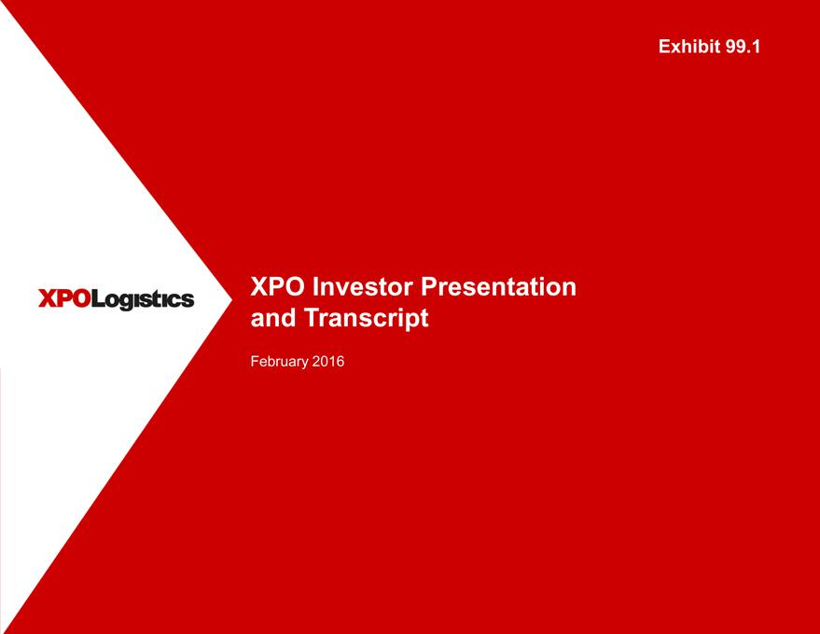

Exhibit 99.1
XPO Investor Presentation and Transcript
February 2016

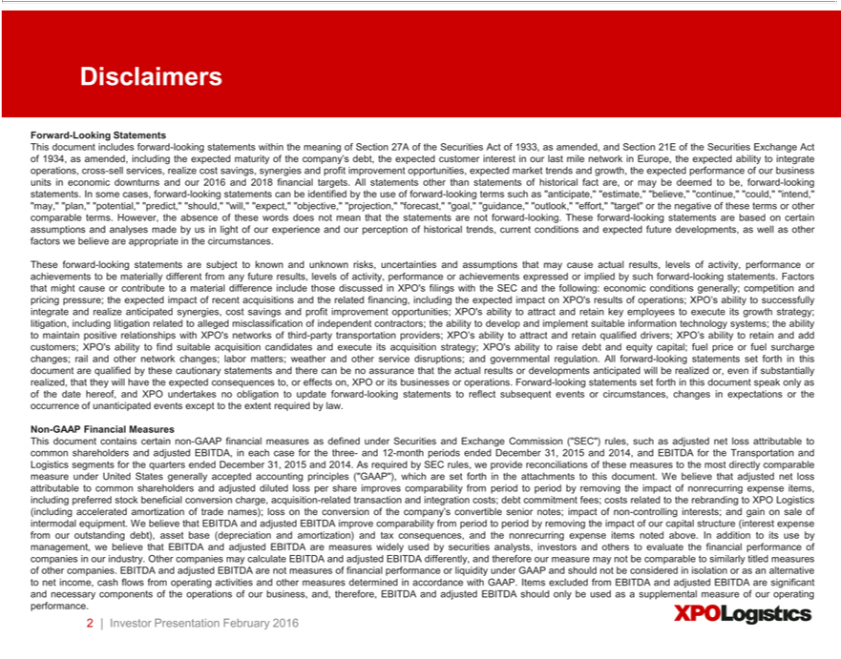

Discl imers
Forward-Looking Statements
This document includes forward-looking statements within the meaning of Section 27A of the Securities Act of 1933, as amended, and Section 21E of the Securities Exchange Act of 1934, as amended, including the
expected maturity of the company’s debt, the expected customer interest in our last mile network in Europe, the expected ability to integrate operations, cross-sell services, realize cost savings, synergies and profit
improvement | expected market trends and growth, the expected performance of our business units in economic downturns and our 2016 and 2018 financial targets. All statements other than statements of
historical fact opportunities,are,maybe deemed to be, forward-looking statements. In some cases, forward-looking statements can be identified by the use of forward-looking terms such as “anticipate,” “estimate,” “believe,”
“continue,” “could,” “intend,” “may,” “plan,” “potential,” “predict,” “should,” “will,” “expect,” “objective,” “projection,” “forecast,” “goal,” “guidance,” “outlook,” “effort,” “target” or the negative of these terms or
other comparable terms. However, the absence of these words does not mean that the statements are not forward-looking. These forward-looking statements are based on certain assumptions and analyses made by us in
light of our experience and our perception of |  |  | trends, current conditions and expected future developments, as well as other factors we believe are appropriate in the circumstances.
These forward-looking statements are subject |  |  | known and unknown risks, uncertainties and assumptions that may cause actual results, levels of activity, performance or achievements to be materially different from
any future results, levels of activity, performancehistoricalachievements expressed or implied by such forward-looking statements. Factors that might cause or contribute to material difference include those discussed in
filings with the SEC and the following: economic conditions generally; competition and pricing pressure; the expected impact of recent acquisitions and the related financing, including the expected impact on
XPO’s results of operations; XPO’s ability to successfully integrate and realize anticipated synergies, cost savings and profit improvement opportunities; XPO’s ability to attract and re ain key emplo ees to execute its
growth strategy; litigation, including litigation related to alleged misclassification of independent con ractors; the ability to develop and implement suitable information technology |  |  |  |  |  |  | the ability to maintain
positive relationships with XPO’s networks of third-party |  |  |  | providers; XPO’s ability to attract and retain qualified driv rs; XPO’s ability to retain and add customers; XPO’systems;ability to find suitable
acquisition | and execute its acquisition strategy;transportationXPO’ability to raise debt and equity capital; fuel price or fuel surcharge changes; rail and other network changes; labor matters; weather and other service
disruptions;candidatesgovernmental regulation. All forward-looking statements set forth in this document are qualified by these cautionary statements and there can be no assurance that the actual results or developments
anticipated will be realized or even if substantially realized, that they will have the expected consequences to, or effects on, XPO or its businesses or operations. Forward-looking statements set forth in this document
speak only as of the date hereof, and XPO undertakes no obligation to update forward-looking statements to reflect subsequent events or circumstances, changes in expectations or the occurrence of unanticipated
events except to the extent required by law.
Non-GAAP Financial Measures
This document contains certain non-GAAP financial measures as defined under Securities and Exchange Commission (“SEC”) rules, such as adjusted net loss attributable to common shareholders and adjusted
EBITDA, in each case for the three- and 12-month periods ended December 31, 2015 and 2014, and EBITDA for the Transportation and Logistics segments for the quarters ended December 31, 2015 and 2014. As
required by SEC rules, we |  | reconciliations of these measures to the most directly comparable measure under United States generally accepted accounting principles (“GAAP”), which are set forth in the
attachments to this document.provideWbelieve that adjusted net loss attributable to common shareholders and adjusted diluted loss per share improves comparability fr m period to period by removing the impact of
nonrecurring expense items, including preferred stock beneficial conversion charge, |  |  |  |  | -related transaction and integration costs; debt commitment fees; costs related to the rebranding to XPO Logistics
(including accelerated amortization of trade names); loss on the conversion of the company’acquisitionconvertible senior notes; impact of non-controlling interests; |  |  |  |  |  | gain on sale of intermodal equipment. We believe that
EBITDA and adjusted EBITDA improve comparability from period to period by removing the impact of our capital structure (interest expense from our outstanding debt), asset base (depreciation and amortization) and tax consequences, and the nonrecurring expense items noted above. In addition to its use by management, we believe that EBITDA and adjusted EBITDA are measures widely used by securities analysts, investors and others to evaluate the financial performance of companies in our industry. Other companies may calculate EBITDA and adjusted EBITDA differently, and therefore our measure may not be comparable to similarly titled measures of other companies. EBITDA and adjusted EBITDA are not measures of financial performance or liquidity under GAAP and should not be considered in isolation or as an alternative to net income, cash flows from operating activities and other measures determined in accordance with GAAP. Items excluded from EBITDA and adjusted EBITDA are significant and necessary components of the operations of our business, and, therefore, EBITDA and adjusted EBITDA should only be used as a supplemental measure of our operating performance.

2 | Investor Presentation February 2016

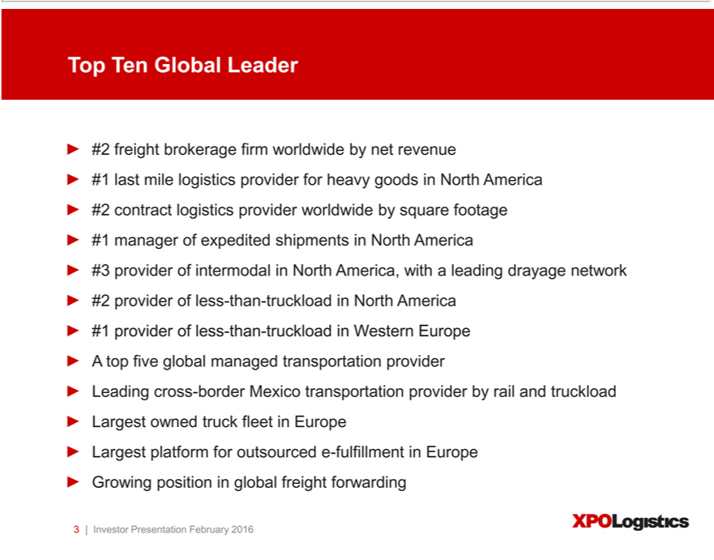

Top Ten Global Leader
¹2 freight brokerage firm worldwide by net revenue
^{#3} last mile logistics provider for heavy goods in North America #2 contract logistics provider worldwide by square footage #1 manager of expedited shipments in North America
provider of intermodal_{Leading}North America, with a leading drayage network #2 provider of less-than-truckload in North America #1 provider of less-than-truckload in Western Europe A top five global managed
transportation provider cross-border Mexico transportation provider by rail and truckload Largest owned truck fleet in Europe Largest platform for outsourced e-fulfillment in Europe Growing position in global freight forwarding
3 | Investor Presentation February 2016

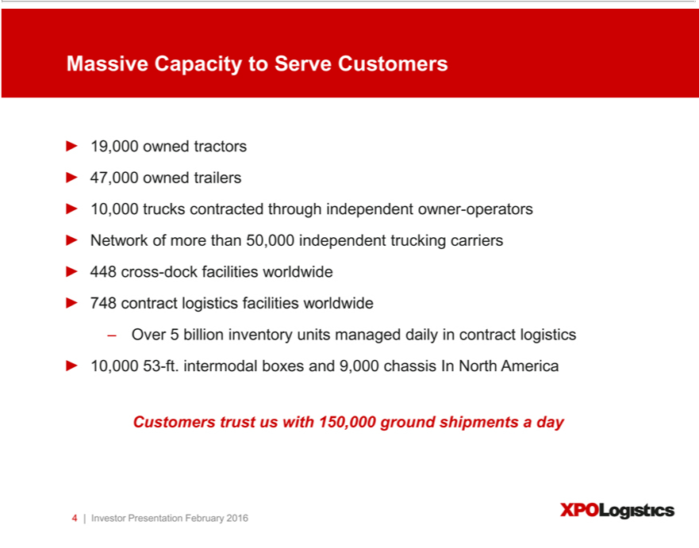

Massive Capacity Serve Customers
10,0009 trucksowned contractedtractors47,000throughownedindependenttrailers owner-operators Network of more than 50,000 independent trucking carriers 448 cross-dock facilities worldwide 748 contract logistics facilities worldwide
10,000Over5 billion53-ft.intermodalinventory unitsboxesmanagedand9,000dailychassisincoIntractNorthlogisticsAmerica
4Customers|Investor trustPresentationuswith 150,000Februaryground2016 shipments a day

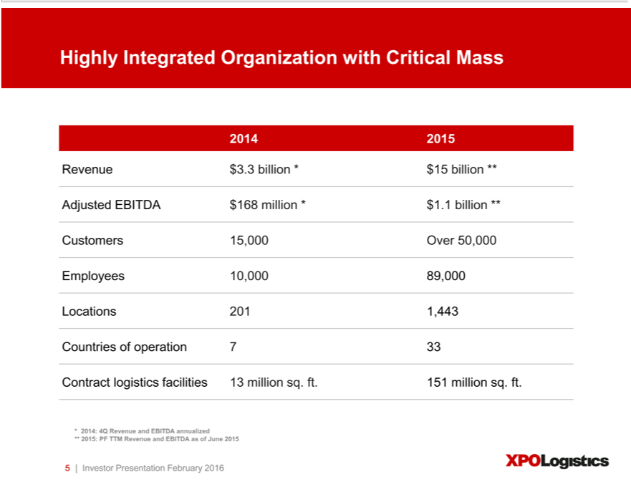

2014Highly2015Integrated Organization with Critical Mass
Revenue $ 3.3 billion * $ 15 billion **
CustomersAdjustedEBITDA15,000 Over$16850,000million * $ 1.1 billion **
Employees 10,000 89,000
_{Contract}Locationsuntries of201operation1,443 7 33
logistics facilities 13 million sq. ft. 151 million sq. ft.
**2014: 4Q Revenue and EBITDA annualized
5 | Investor2015:PFPresentationTTMRevenueFebruaryandEBITDA2016 as of June 2015

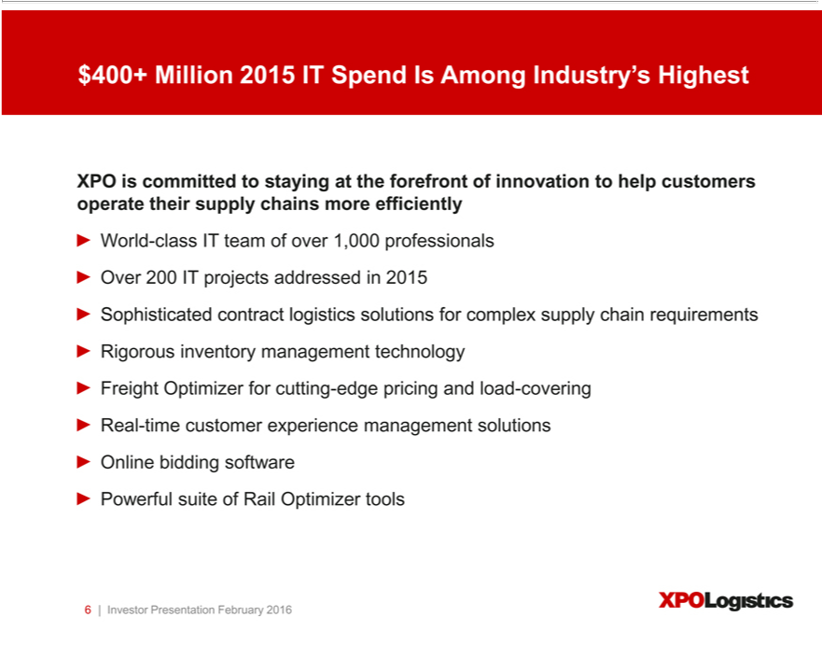

$400+ Million 2015 IT Spend Is Among Industry’s Highest
XPO is committed to staying at the_{professionals}forefrontinnovation to help customers operate their supply chains more efficiently
World-class IT team of over 1,000 Over 200 IT projects addressed in 2015
Sophisticated contract logistics solutions for complex supply chain requirements Rigorous inventory management technology Freight Optimizer for cutting-edge pricing and load-covering Real-time customer experience management solutions Online bidding software Powerful suite of Rail Optimizer tools
6 | Investor Presentation February 2016

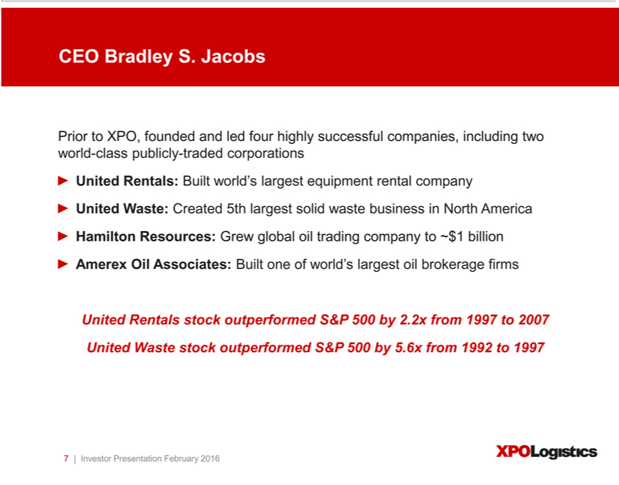

CEO Bradley S. Jacobs
Prior to XPO, founded and led four highly successful companies, including two world-class publicly-traded corporations
United Rentals stock outperformed S&P 500 by 2.2x from 1997 to 2007 United Waste stock outperformed S&P 500 by 5.6x from 1992 to 1997 7 | Investor Presentation February 2016

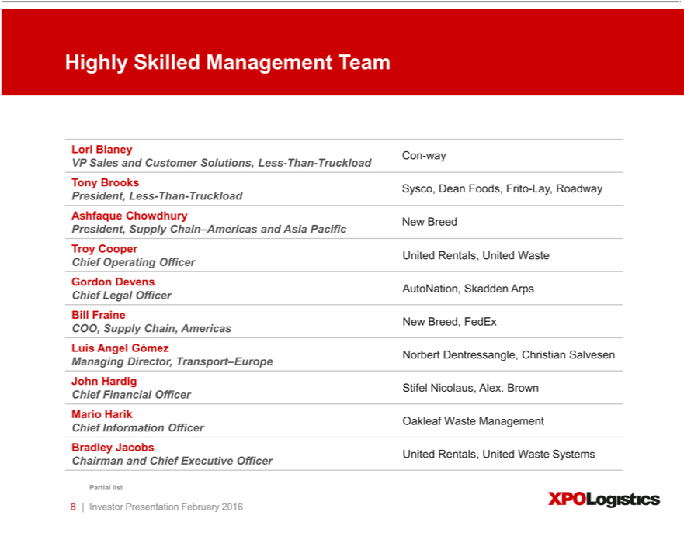

LoriHighlyBlaneySkilledConManagement-way Team
VP Sales and Customer Solutions, Less-Than-Truckload
President,TonyBrooksLessSysco,-ThanDean-TruckloadFoods, Frito-Lay, Roadway
Ashfaque Chowdhury New Breed
TroyPresident,CooperSupply Chain–Americas and Asia Pacific
GordonChiefOperatingDevens Officer United Rentals, United Waste
BillChiefFraineLegal Officer AutoNation, Skadden Arps
LuisCOO,AngelSupplyGómezChain, Americas New Breed, FedEx
JohnManagingHardigDirector, Transport–Europe Norbert Dentressangle, Christian Salvesen
MarioChief FinancialHarik Officer Stifel Nicolaus, Alex. Brown
BradleyChiefInformationJacobs Officer Oakleaf Waste Management
Cha_{Partial}rmanlist and Chief Executive Officer United Rentals, United Waste Systems
8 | Investor Presentation February 2016

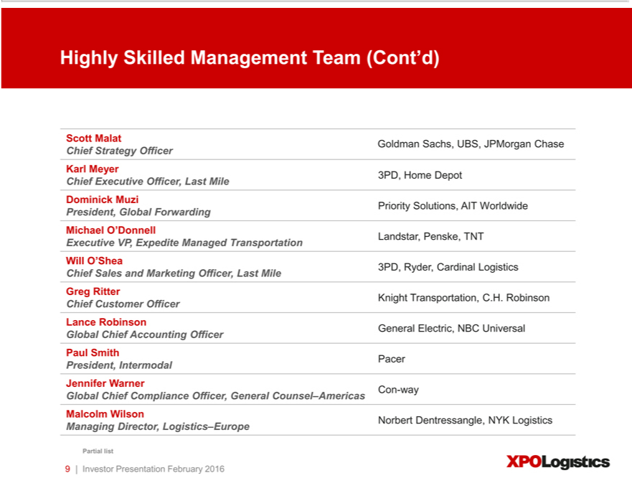

Highly Skilled Management Team (Cont’d)
ChiefScott MalatStrategyGoldmanOfficerSachs, UBS, JPMorgan Chase
Karl Meyer
DominickChiefExecutiveMuzi Officer, Last Mile 3PD, Home Depot
MichaelPresident,O’DonnellGlobalForwarding Priority Solutions, AIT Worldwide
WillExecutiveO’SheaVP, Expedite Managed Transportation Landstar, Penske, TNT
GregChief _{Ritter}Sals and Marketing Officer, Last Mile 3PD, Ryder, Cardinal Logistics
LanceChief CustomerRobinson Officer Knight Transportation, C.H. Robinson
Global Chief Accounting Officer General Electric, NBC Universal
President,^{aulSmith}Intermodal Pacer
Jennifer Warner
_{Managing}GloballcolmChiefWilsonCompliance Officer, General Counsel–Americas Con-way
Partial list Director, Logistics–Europe Norbert Dentressangle, NYK Logistics
9 | Investor Presentation February 2016

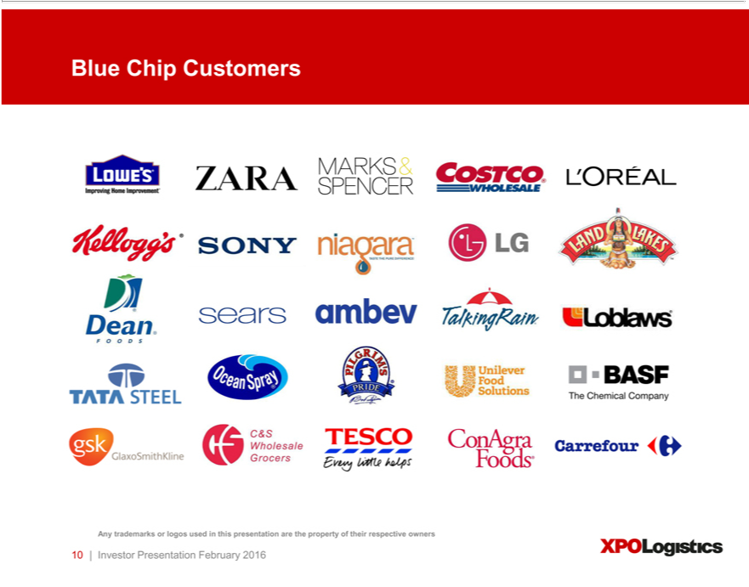

Blue Chip Customers
10Any|InvestortrademarksPresentationorlogosusedFebruaryinthis2016presentation are the property of their respective owners

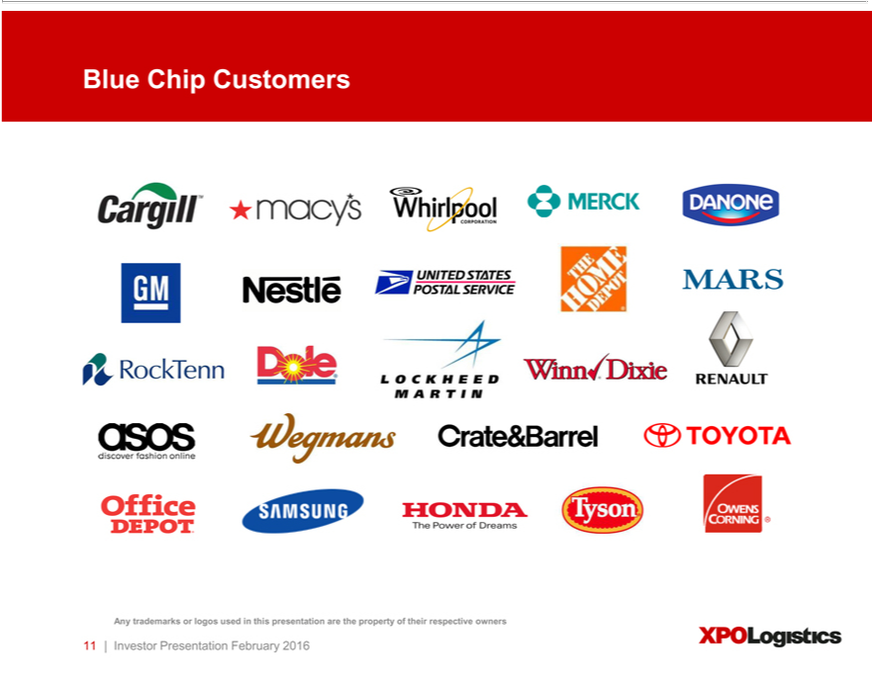

Blue Chip Customers
11Any|InvestortrademarksPresentationorlogos usedFebruaryinthis2016presentation are the property of their respective owners

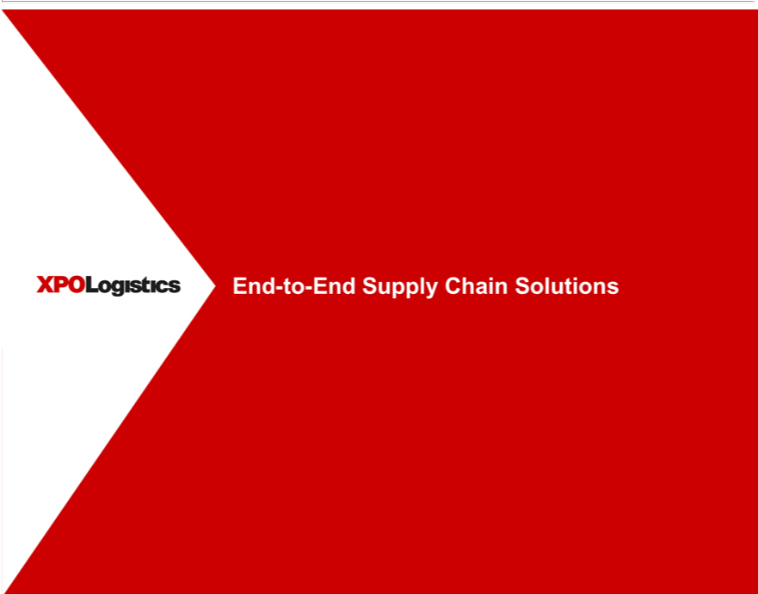

End-to-End Supply Chain Solutions

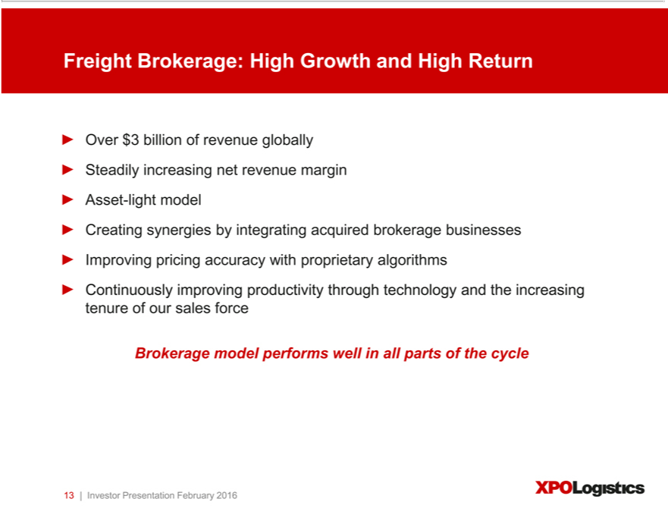

Freight Brokerage: High Growth and High Return
Over $3 billion of revenue globally Steadily increasing net revenue margin Asset-light model
_{Continuously}reatingsynergies by integrating acquired brokerage businesses Improving pricing accuracy with proprietary algorithms improving productivity through technology and the increasing tenure of our sales force

13Brokerage|InvestormodelPresentationperformsFebruarywellinall2016parts of the cycle

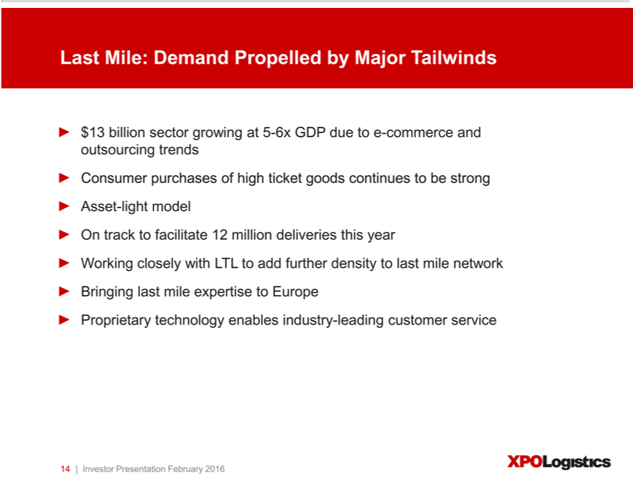

Last Mile: Demand Propelled by Major Tailwinds
$13 billion sector growing at 5-6x GDP due_{density}to-commerce and outsourcing trends Consumer purchases of high ticket goods continues to be strong Asset-light model On track to facilitate 12 million deliveries this year
Working closely with LTL to add further to last mile network Bringing last mile expertise to Europe Proprietary technology enables industry-leading customer service 14 | Investor Presentation February 2016

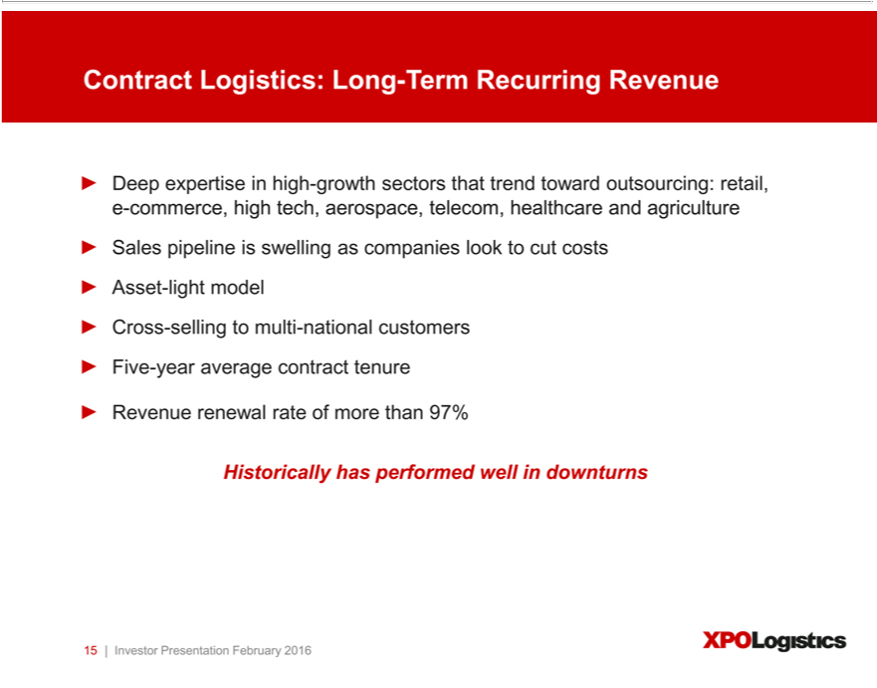

Contract Logistics: Long-Term Recurring Revenue
Deep expertise_{selling}high-growth sectors that trend toward outsourcing: retail, e-commerce, high tech, aerospace, telecom, healthcare and agriculture Sales pipeline is swelling as companies look to cut costs Asset-light
RevenuemodelCrossrenewal- ratetoofmultimore-nationalthan97%customers Five-year average contract tenure
15Historically|InvestorhasPresentationperformedFebruarywellindownturns2016

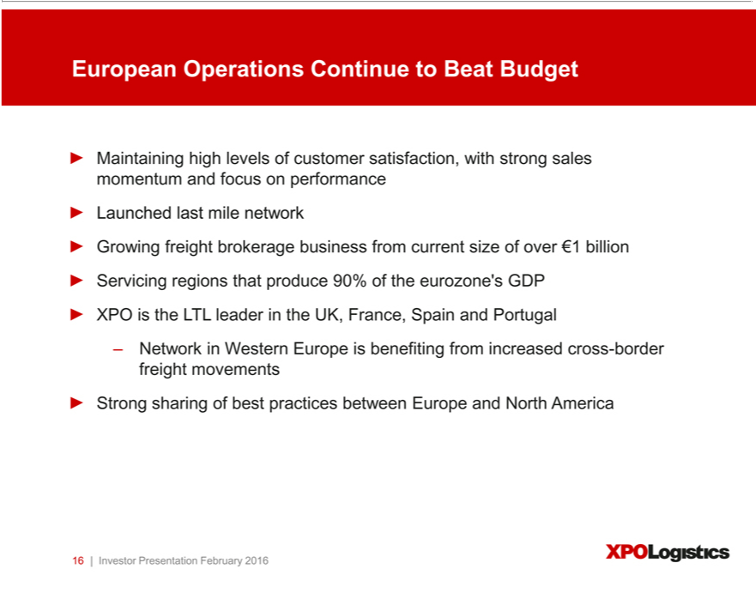

European Operations Continue Beat Budget | with strong sales momentum and focus on performance Launched last mile network Growing freight brokerage business from current size of over ¬1 billion Servicing
Maintaining high levels of customer
regions that produce 90% of the eurozone’satisfaction,GDP
XPO is the LTL leader in the UK, France, Spain and Portugal

NetworksharingWestern Europe is benefiting from increased cross-border freight movements
16Strong|Investor PresentationofbestpracticesFebruarybetween2016 Europe and North America

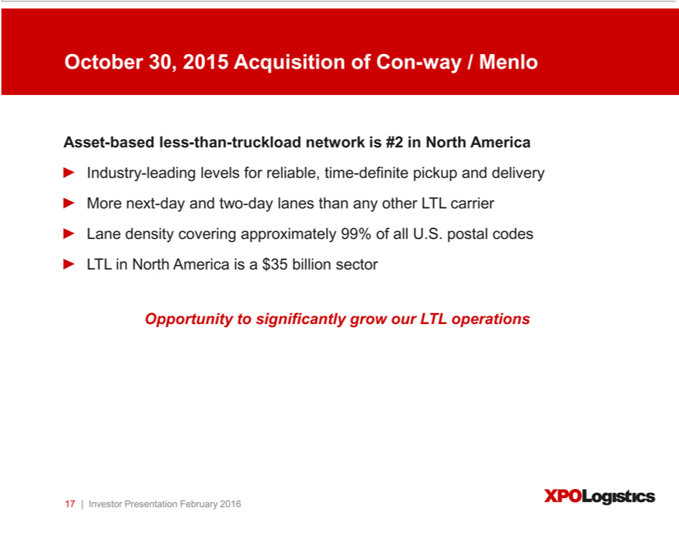

October 30, 2015 Acquisition of Con-way / Menlo
IndustryAsset-based- less-levelsthan-truckloadforreliable,networktime-definiteis#2 NorthpickupAmericaanddelivery More next-day and two-day lanes than any other LTL carrier Lane density covering approximately 99% of all U.S. postal codes LTL in North

America leadingis$35 billion sector
17Opportunity|Investor toPresentationsignificantlyFebruarygrowour2016LTL operations

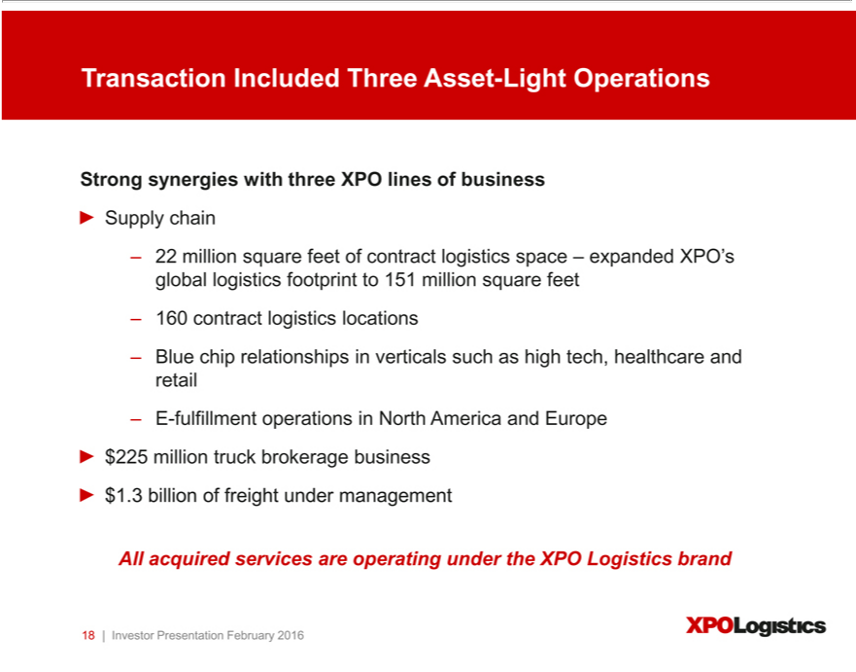

Transaction Included Three Asset-Light Operations
trong synergies with three XPO lines of business
Supply chain | XPO’s global logistics footprint to 151 million square feet 160 contract logistics locations Blue chip relationships in verticals such as high tech, healthcare
22 million square feet of contract logistics space –
and retail E-fulfillment operations_{business}North AmericaexpandedEurope
All$225acquiredmillion servicestruckbrokerageareoperating under$1.3thebillionXPO Logisticsoffreight brandunder management

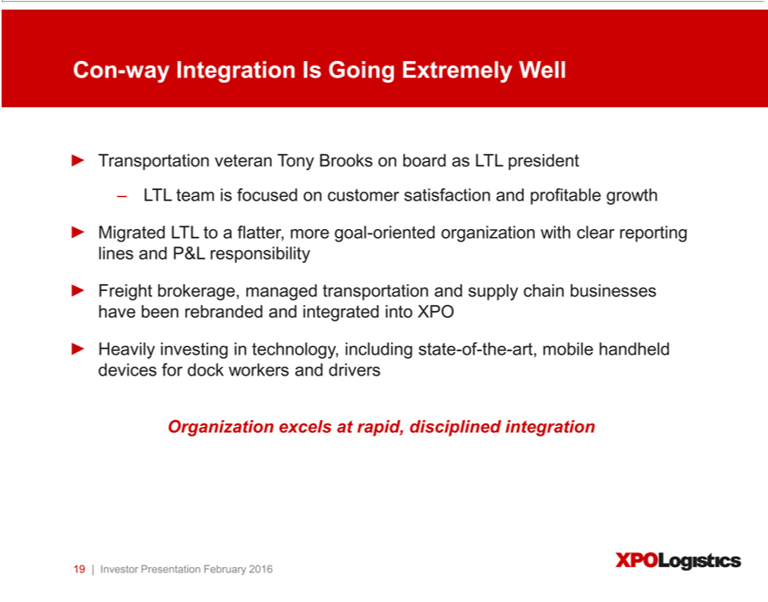

Con-way Integration Is Going Extremely Well
Transportation veteran Tony Brooks board as LTL president
LTL team is focused on customer satisfaction and profitable growth | P&L responsibility
Migrated LTL to flatter, more goal-oriented organization with clear reporting lines | P&L responsibility
Freight brokerage, managed transportation and supply chain businesses have been rebranded and integrated into XPO Heavily investing in technology, including state-of-the-art, mobile handheld devices for dock workers and drivers Organization _{Presentation}excelsrapid, disciplined integration

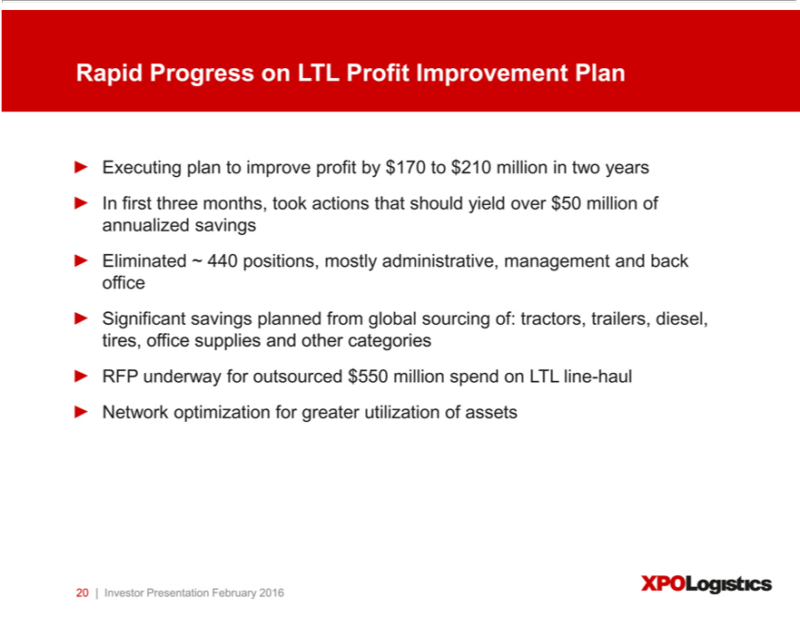

Rapid Progress on LTL Profit Improvement Plan
Executing plan to impr^{of}ve profit by $170 to $210 million in two years In first three months, took actions that should yield over $50 million of annualized savings Eliminated ~ 440 positions, mostly administrative, management and back fice Significant savings planned from global sourcing of: tractors, trailers, diesel, tires, office supplies and other categories RFP underway for outsourced $550 million spend on LTL line-haul Network optimization for greater utilization of assets
20 | Investor Presentation February 2016

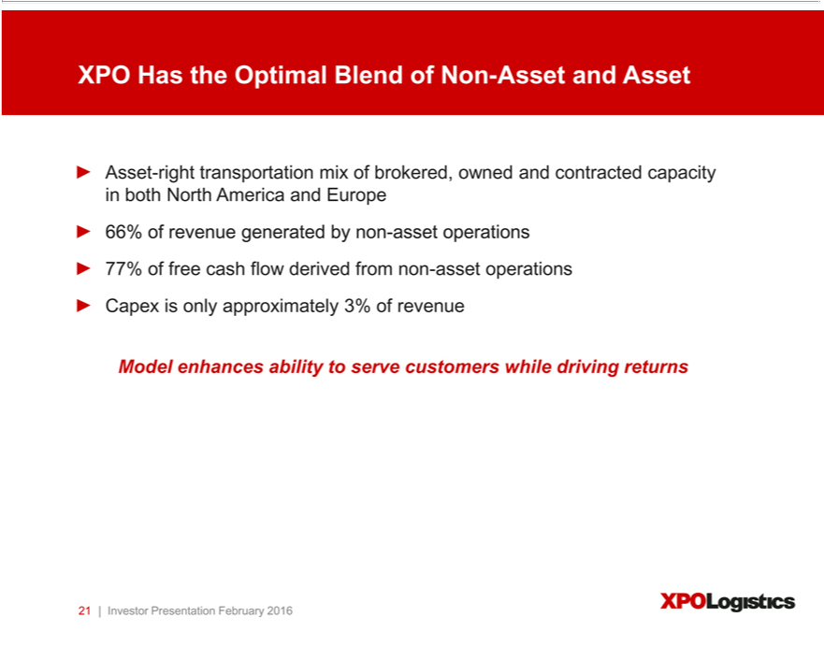

XPO Has the Optimal Blend of Non-Asset and Asset
Asset-right transportation mix of brokered, owned and contracted capacity in both North America and Europe 66% of revenue generated by non-asset operations 77% of free cash flow derived from non-asset operations Capex is only approximately 3% of revenue

21Model|InvestorenhancesPresentationabilityto Februaryservecustomers2016 while driving returns

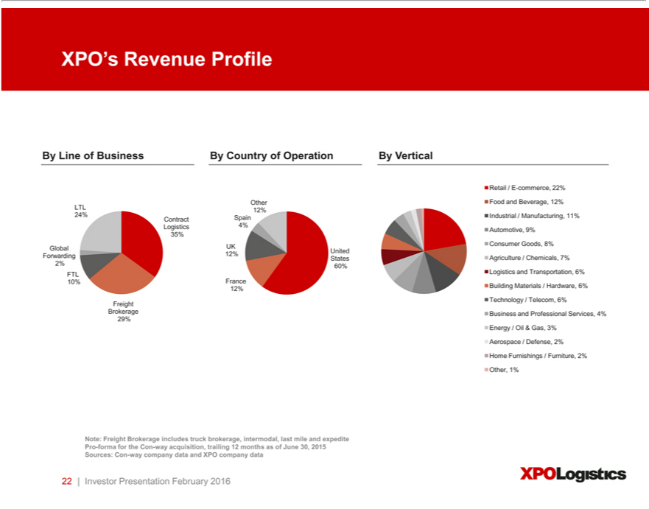

XPO’s Revenue Profile
RetailByLine/Eof-commerce,BusinessBy22%Country of Operation By Vertical
LTLOther12%Food and Beverage, 12%
Logistics24%Contract4%Automotive,SpainIndustrial9% / Manufacturing, 11%
35%
Global UK Consumer Goods, 8%
StatesForwarding 12% United Agriculture / Chemicals, 7%
2% 60%
_{12%}FTL0% LogisticsFrance and Transportation, 6%
FreightBuildingTechnologyMaterials/Telecom,/Hardware,6% 6%
29%Brokerage Business and Professional Services, 4%
Energy / Oil & Gas, 3%
Aerospace / Defense, 2%
Oth_{Note:}Homer, Furnishings1% / Furniture, 2%
data Freight Brokerage includes truck brokerage, intermodal, last mile and expedite Pro-forma for the Con-way acquisition, trailing 12 months as of June 30, 2015 Sources: Con-way company data and XPO company 22 | Investor Presentation February 2016

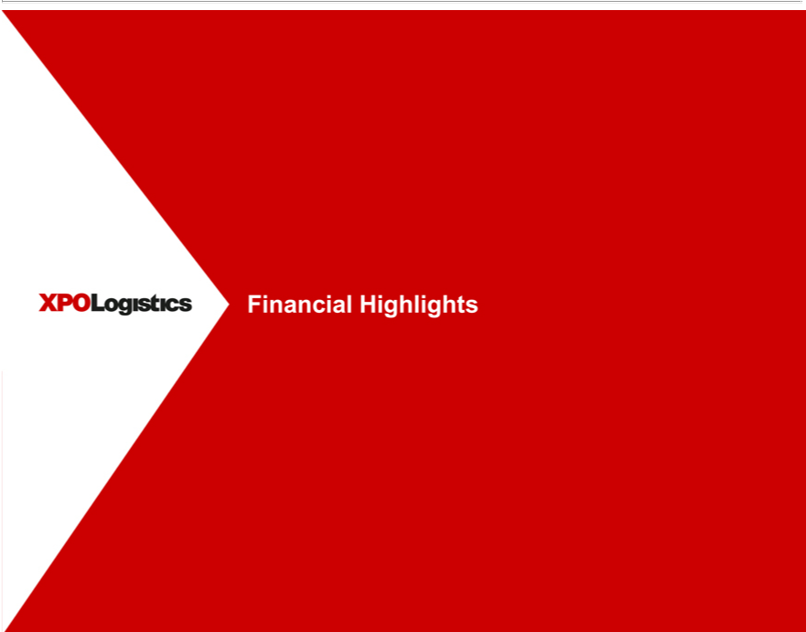

Financial Highlights

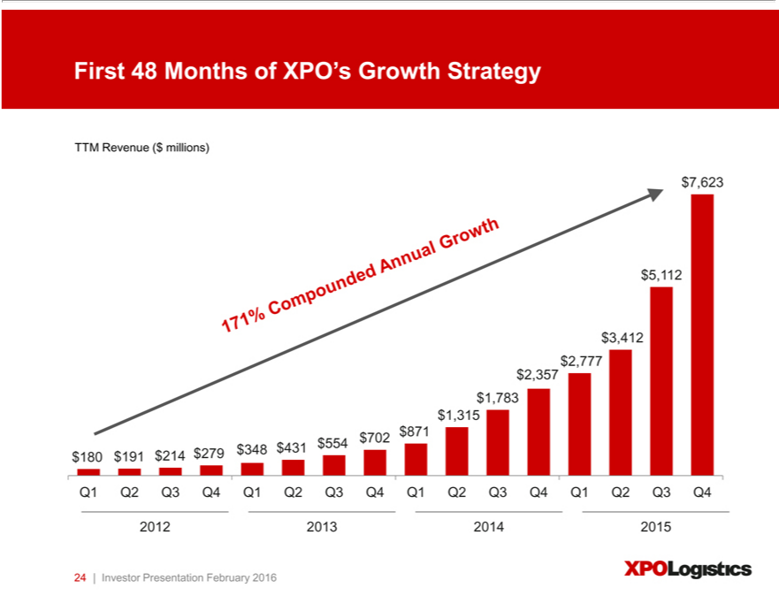

TTMFirst48RevenueMonths($of_{millions)}XPO’Growth Strategy
⁷5 ⁶²³₄₁₂
3 ₇₇₇¹²
2 357
783
1,315
871
$180 $191 $214 $279 $348 $431 $554 $702
Q1 Q2 Q3 Q4 Q1 Q2 Q3 Q4 Q1 Q2 Q3 Q4 Q1 Q2 Q3 Q4
²⁴012 2013 2014 2015
| Investor Presentation February 2016

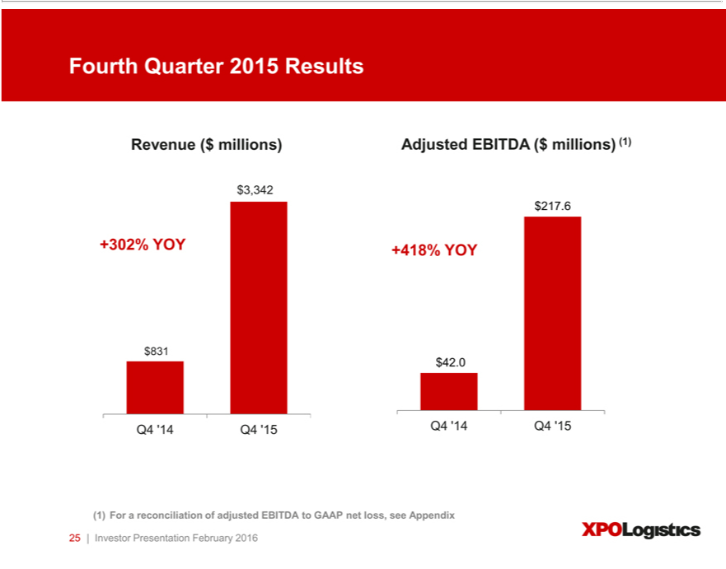

Fourth Quarter 2015 Results
Revenue ($ millions) Adjusted EBITDA ($ millions) (1)
$^{3,342}217.6
+302% YOY +418% YOY
$⁸³¹42.0
Q4 ‘14 Q4 ‘15 Q4 ‘14 Q4 ‘15
25(1) |ForInvestorareconciliationPresentationof Februaryadjusted EBITDA2016 to GAAP net loss, see Appendix

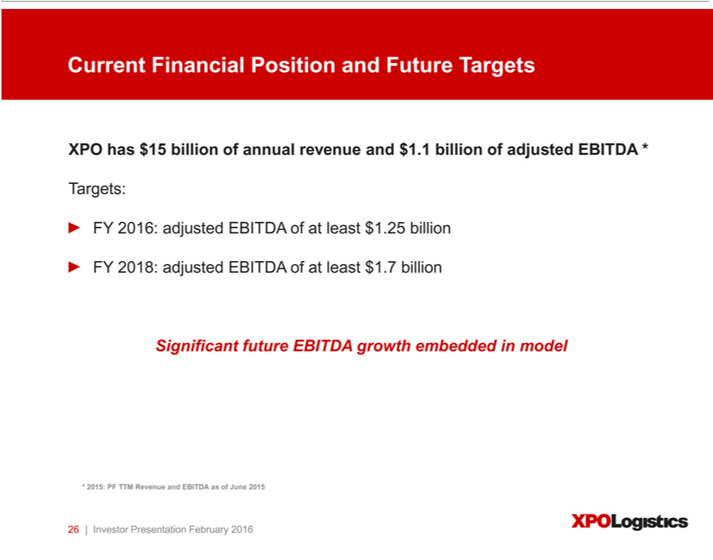

Current Financial Position and Future Targets
Targets:XPOhas $15 billion of annual revenue and $1.1 billion of adjusted EBITDA *
FY 2018:^{6:} adjusted EBITDA of at least $1.7²⁵billion^{billion}
Significant future EBITDA growth embedded in model
26*2015:|InvestorPFTTMPresentationRevenueFebruaryandEBITDA2016 as of June 2015

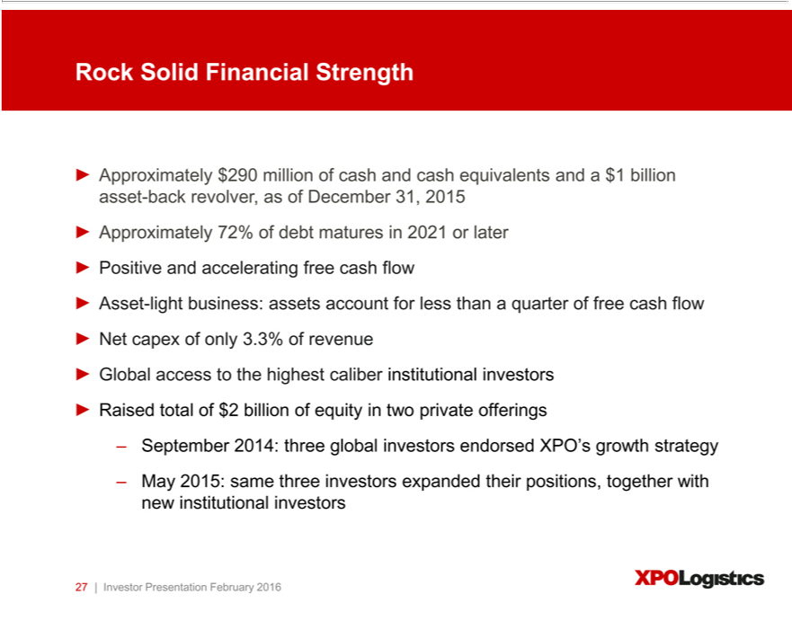

Rock Solid Financial Strength
_{Asset}pproximately $290 million of cash and cash _{equivalents} and a $1 billion asset-back revolver, as of December 31, 2015 Approximately 72% of debt matures in _{investors}2021later Positive and accelerating free cash flow
-light business: assets account for less than quarter of free cash flow Net capex of only 3.3% of revenue Global access to the highest caliber institutional Raised total of $2 billion of equity in two private offerings
September 2014: three global investors endorsed XPO’s growth strategy May 2015: same three investors expanded their positions, together with new institutional investors 27 | Investor Presentation February 2016

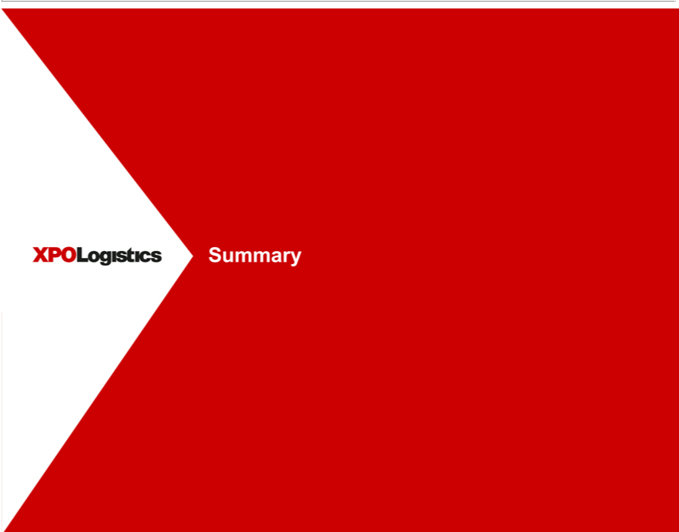

Summary

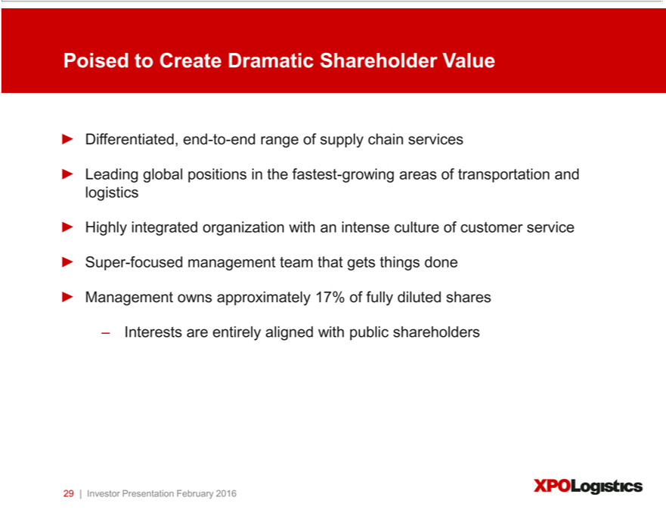

Differentiated,PoisedtoCreateendDramatic-to-end rangeShareholderofsupplyValuechain services
Leading global positions in the fastest-growing areas of transportation and logistics
Highly integrated organization with an intense culture of customer service Super-focused management team that gets things done Management owns approximately 17% of fully diluted shares Interests are entirely aligned with public shareholders
29 | Investor Presentation February 2016

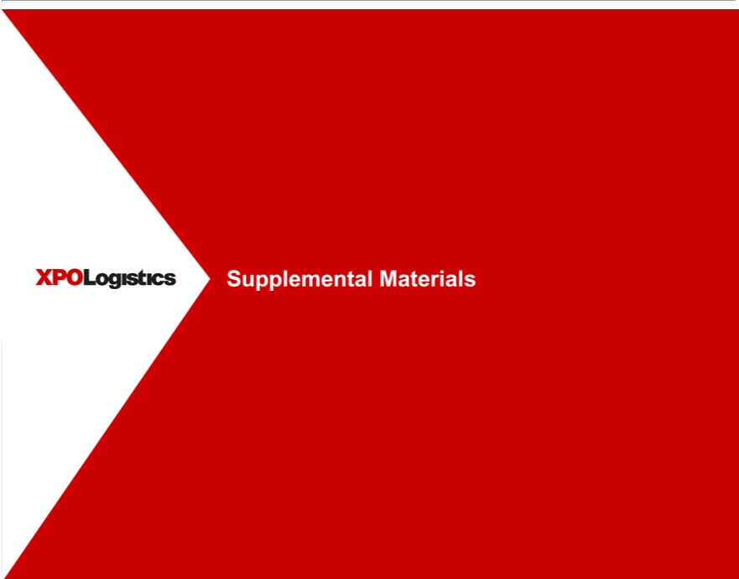

Supplemental Materials

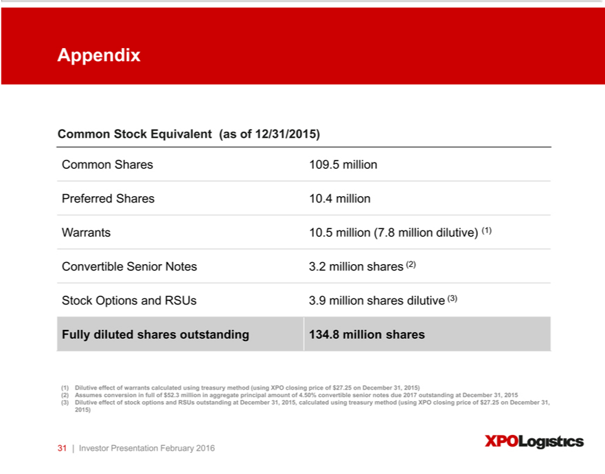

Appendix |  | tock Equivalent (as of 12/31/2015)
Common |  | .5 million
Preferred |  | Shares 109.4 million
Warrants 10.5 million (7.8 million dilutive) (1)
Convertible Senior Notes 3.2 million shares (2)
Stock Options and RSUs 3.9 million shares dilutive (3)
Fully diluted shares outstanding 134.8 million shares
1) | Dilutive effect of warrants calculated using treasury method (using XPO closing price of $27.25 on December 31, 2015)
2) | Assumes conversion in full of $52.3 million |  | principal amount of 4.50% convertible senior notes due 2017 outstanding at December 31, 2015
(3) | Dilutive effect of stock options and RSUs outstandingaggregate December 31, 2015, calculated using treasury method (using XPO closing price of $27.25 on December 31,
2015)
31 | Investor Presentation February 2016

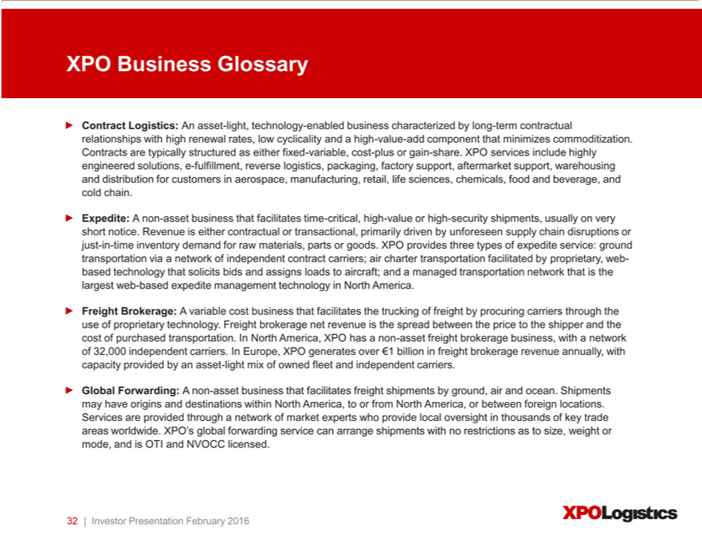

XPO Business Glossary
Contract Logistics: An asset-light, technology-enabled business characterized by long-term contractual relationships with high renewal rates, low cyclicality and a high-value-add component that minimizes
commoditization. Contracts | typically structured as either fixed-variable, cost-plus or gain-share. XPO services include highly engine red solutions, e-fulfillment, reverse logistics, packaging, factory support,
aftermarket support, warehousing and distribution for customers in aerospace, manufacturing, retail, life sciences, chemicals, food and beverage, and cold chain.
Expedite: A non-asset | that facilitates time-critical, high-value or high-security shipments, usually on very short notice. Revenue is either contractual or transactional, primarily driven by unforeseen supply
chain disruptions or justbusiness--time inventory demand for raw materials, parts or goods. XPO provides three types of expedite service: ground transportation via a network of independent contract carriers; air charter
transportation facilitated by proprietary, web-based technology that solicits bids and assigns loads to aircraft; and a managed transportation network that is the largest web-based expedite management technology in
North America. |  | technology. Freight brokerage net revenue is the spread between the price to the
Freight Brokerage: A variable cost business that facilita es the trucking of freight by procuring carriers through the use of
shipper and the cost of purchased transportation. In North America, XPO has a non-asset freight brokerage business, with proprietarynetworkof 32,000 independent carriers. In Europe, XPO generates over ¬1 billion in freight brokerage revenue annually, with capacity provided by an asset-light mix of owned fleet and independent carriers.
Global Forwarding: A non-asset business that facilitates freight shipments by ground, air and ocean. Shipments may have origins and destinations within North America, to or from North America, or between foreign locations. Services are provided through^{and} network of market experts who provide local oversight in thousands of key trade areas worldwide. XPO’s global forwarding service can arrange shipments with no restrictions as to size, weight or mode, and is OTI NVOCC licensed.
32 | Investor Presentation February 2016

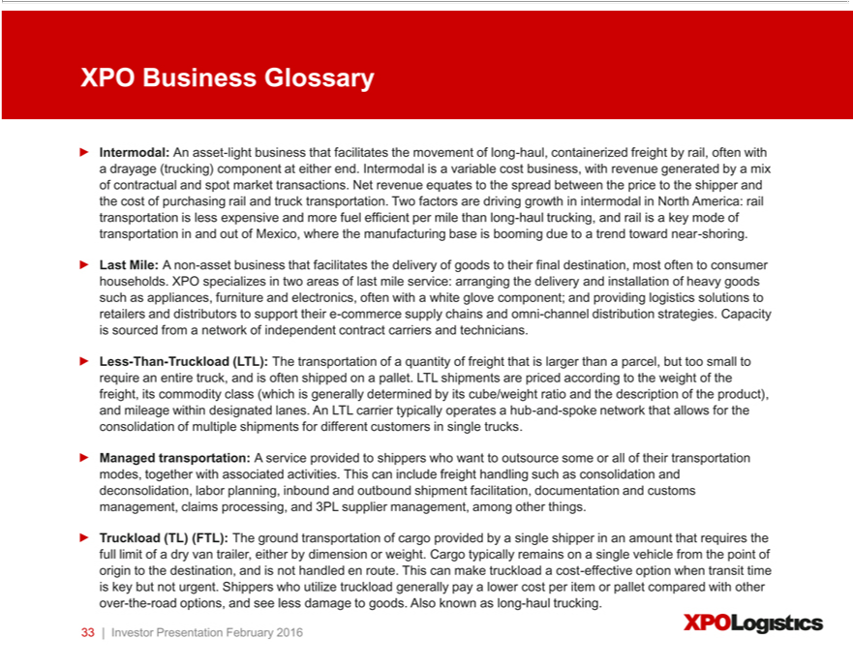

XPO Business Glossary
Intermodal: An asset-light business that facilitates the movement of long-haul, containerized freight by rail, often with a drayage (trucking) component at either end. Intermodal is variable cost business, with revenue
by a mix of contractual and spot market transactions. Net revenue equates to the spread between the price to the shipper and the cost of purchasing rail and truck transportation. Two factors are driving growth
generatedintermodal in North America: rail transportation is less expensive and more fuel efficient per mile than long-haul trucking, and rail is a key mode of transportation in and out of Mexico, where the manufacturing base
is booming due to trend toward near-shoring. |  | most often to consumer households. XPO specializes in two areas of last mile service: arranging the delivery and
Last Mile: A non-asset business that facilitates the delivery of goods to their final
installation of heavy goods such as appliances, furniture and electronics, | withdestination,whiteglove component; and providing logistics solutions to retailers and distributors to support their e-commerce supply chains and
omni-channel distribution strategies. Capacity is sourced from a network oftenindependent |  | carriers and technicians. |  | to the
Less-Than-Truckload (LTL): The transportation of a quantity of freight that is larger thancontractparcel, but too small to require an entire truck, and is often shipped on pallet. LTL shipments are priced |  |  |  | to the
weight of the freight, its commodity class (which is generally determined by its cube/weight ratio and the description of the product), and mileage within designated lanes. An LTL carrier typically operatesaccording hub-and-
spoke network that allows for the consolidation of multiple shipments for different customers in single trucks.
Managed transportation: A service provided to shippers who want to outsource some or all of their transportation modes, together with associated activities. This can include freight handling such as consolidation and
deconsolidation, labor planning, inbound and outbound shipment | documentation and customs management, claims processing, and 3PL supplier management, among other things.
Truckload (TL) (FTL): The ground transportation of cargo providedfacilitation,bysingle shipper in an amount |  |  | requires the full limit of a dry van trailer, either by dimension or weight. Cargo typically remains on a single
vehicle from the point of origin to the destination, and is not handled en route. This can make truckloadthat cost-effective option when transit time is key but not urgent. Shippers who utilize truckload generally pay a lower cost per item or pallet compared with other over-the-road options, and see less damage to goods. Also known as long-haul trucking.
33 | Investor Presentation February 2016

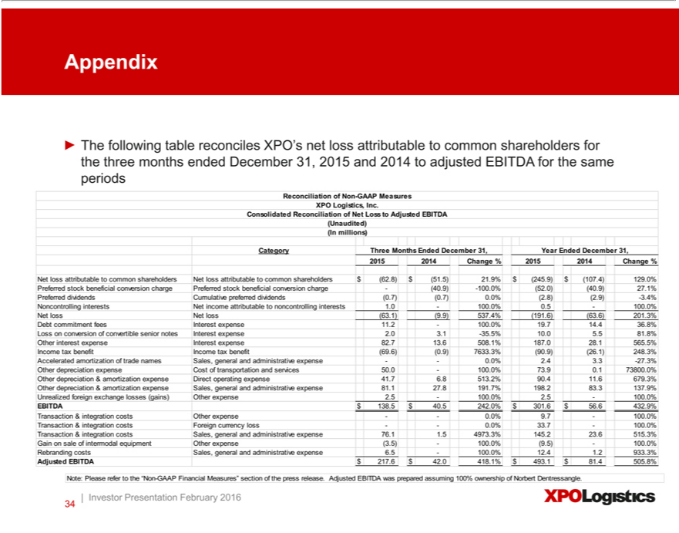

Appendix
The following table reconciles XPO’ net loss attributable to common shareholders for the three months ended December 31, 2015 and 2014 to adjusted EBITDA for the same periods
Reconciliation of Non-GAAP Measures
XPO Logistics, Inc.
Consolidated Reconciliation of Net Loss to Adjusted EBITDA
Unaudited)
(In millions)
Category Three Months Ended December 31, Year Ended December 31,
2015 2014 Change % 2015 2014 Change % |  | $(107.4) 129.0%
Net loss attributable to common shareholders Net loss attributable to common shareholders $(62.8) $(51.5) 21.9% $(245.9) |  | $(107.4) 129.0%
 | stock beneficial conversion charge Preferred stock beneficial conversion charge -(40.9) -100.0%(52.0)(40.9) 27.1%
Preferred dividends Cumulative preferred dividends(0.7)(0.7) 0.0%(2.8)(2.9) -3.4%
 | interests Net income attributable to noncontrolling interests 1.0—100.0% 0.5—100.0%
NoncontrollinglossNetloss(63.1)(9.9) 537.4%(191.6)(63.6) 201.3%
Debt commitment fees Interest expense 11.2—100.0% 19.7 14.4 36.8%
Loss on conversion of convertible senior notes Interest expense 2.0 3.1 -35.5% 10.0 5.5 81.8%
Other interest expense Int rest expense 82.7 13.6 508.1% 187 0 28.1 565.5%
Income tax benefit Income tax b nefit(69.6)(0.9) 7633.3%(90.9)(26.1) 248.3%
Accelerated amortization of trade names Sales, general and administrative expense — 0.0% 2.4 3.3 -27.3%
 | expense Cost of transportation and services 50.0—100.0% 73.9 0.1 73800.0%
 | Direct operating expense 41.7 6.8 513.2% 90.4 11.6 679.3%
Other depreciation & amortization expense Sales, general and administrative expense 81.1 27.8 191.7% 198.2 83.3 137.9%
Unrealized foreign exchange losses (gains) Other expense 2.5—100.0% 2.5—100.0%
EBITDA $ 138.5 $ 40.5 242.0% $ 301.6 $ 56.6 432.9%
 | Other expense — 0.0% 9.7—100.0%
T | Foreign currency loss — 0.0% 33.7—100.0%
T | & integration costs Sales, general and administrative expense 76. 1.5 4973.3% 145.2 23.6 515.3%
Gainransactionsale of intermodal equipment Other expense(3.5)—100.0%(9.5)—100.0%
AdjustedRebrandingEBITDAcostsSales,$217.6general$42.0and418.1%administrative$493.1$expense81.4505.8%6.5—100.0% 12.4 1.2 933.3%
Note: Please refer to the “Non-GAAP Financial Measures” section of the press release. Adjusted EBITDA was prepared assuming 100% ownership of Norbert Dentressangle. | Investor Presentation February 2016 34

Exhibit 99.2

February 24, 2016

Presentation Script

The following script should be read in conjunction with the accompanying slide presentation, which contains, among other information, source data for certain information set forth in the script.

Thank you for joining us. We’ll start with an update on the integration of Con-way Inc., which we acquired on October 30, 2015. After that, we’ll introduce you to our company and our intense focus on world-class service for customers. We’ll explain the strategy that has made XPO a top ten global transportation and logistics companies and continues to drive our plan to create dramatic long-term shareholder value. And we’ll cover the highlights of our fourth quarter results.

First, our integration of Con-way. The acquisition gave XPO new critical mass, with $15 billion of annual revenue and $1.1 billion of EBITDA, pro forma for 2015 acquisitions. It made us the second largest less-than-truckload (LTL) provider in North America. It expanded our global contract logistics, managed transportation and freight brokerage businesses, and added truckload transportation to our range of services in North America. Today, we have approximately 89,000 employees at 1,443 locations in 33 countries operating under the single brand of XPO Logistics. On a typical day we facilitate 150,000 ground shipments and manage over five billion inventory units in our contract logistics facilities.

In addition, the acquisition has given us a blended transportation model of brokered, owned and contracted capacity in North America, similar to the successful blended model we already operate in Europe. We can use our “asset right” model to serve customers consistently in all market conditions and further differentiate our value proposition. Our owned transportation assets include 19,000 tractors, 47,000 trailers, 10,000 intermodal containers and 9,000 container chassis. We also have 448 cross-dock terminals worldwide, and 748 contract logistics facilities. These assets benefit our company and our customers, especially during periods of tight capacity.

We’re still an asset-light company, with assets accounting for about a third of our revenue and less than a quarter of our free cash flow. Our estimated net capex is only about 3.3% of revenue.

All the moving parts of the integration are going extremely well. LTL service levels are up, our on-time pickup is up, our on-time delivery is up, our line-haul productivity is up, and our damages and claims are down. We continue to offer more next-day and two-day lanes than any other LTL provider, and we cover about 99% of all the zip codes in North America.

We’ve assimilated Con-way’s $270 million truck brokerage operation into our brokerage business, and we’re sharing loads and capacity. We’ve integrated the Menlo contract logistics subsidiary into our North American and European supply chain operations, and promoted some of the former Menlo executives into senior leadership positions in the combined organization. Menlo also had $1.3 billion of managed transportation business that we’ve merged with ours. It increased our freight under management to $2.7 billion.

We’re also working on a comprehensive network planning and optimization initiative that will result in more efficient utilization of our capacity. We’re analyzing lane-by-lane where our rates are too high or too low, and we’re making appropriate adjustments. We’re diving deep into the types of freight, the cost of that freight, the profitability of the freight, the accessorials associated with it, and the likelihood of damages.

We’ve appointed a 30-year career transportation and logistics executive as president of our new LTL operations. Tony Brooks is a high impact player who’s run three of the largest fleets in North America. He’s managed complex networks for major companies, including 11 years with LTL long-haul carrier Roadway Express, Inc. Tony has brought urgency and passion to the table. Morale is very high.

We’re currently adding salespeople and strategic account managers to grow the LTL business. In addition to new account development, we have an exciting opportunity to cross-sell LTL to our full customer base in North America and serve these customers even more completely. There’s a lot of valuable dialogue taking place between our LTL teams in North America and Europe, with best practices being shared on both sides.

We’re also heavily investing in technology – rolling out state-of-the-art mobile, handheld devices for dockworkers and drivers. And we’ve started a project to develop cutting-edge pick-up and delivery optimization software. The Con-way teams for shared systems, security and EDI have been integrated into our XPO IT organization. And we’ve already renegotiated a number of IT vendor contracts where there was overlap.

One major reason for the transaction was that we see a concrete opportunity to increase annual operating profit by $170 million to $210 million, while improving on customer levels that are already extremely high. We’re achieving this through cost savings and operational improvements executed over the first two years after the acquisition. In the first 100 days since the acquisition, we’ve already taken actions that should result in over $50 million of annualized savings.

We expect to realize our full profit improvement target through global sourcing efficiencies; leveraging our combined technology infrastructure; eliminating duplicative back office and public company costs; sharing capacity and data in our combined freight brokerage business; reducing our $3.6 billion combined spend on purchased transportation; and using our $2.7 billion of freight under management to identify carriers, assign loads and fill backhauls more efficiently.

That’s the update on LTL, and we’re very pleased with the progress. Now, turning to the company overall – we run our business on a global basis, with two segments: logistics and transportation. Within each of these segments, we’ve built robust service offerings in the areas customers value most strongly.

In our logistics segment, our contract logistics business is a major provider of e-commerce fulfillment, cold chain solutions and other high-value-add services. In our transportation segment, we’re the largest provider of last mile logistics for heavy goods in North America, the largest manager of expedite shipments, the second largest LTL provider, the second largest freight broker, and the third largest provider of intermodal services, with a full truckload transportation offering. In Europe, we operate the largest owned truck fleet as part of our ground

2

transportation network, and we have leading LTL positions in the United Kingdom, France, Spain and Portugal. We also have a growing position in freight forwarding across our global footprint.

We’ll start by taking a look at contract logistics, which is a $120 billion combined market in North America and Europe. We’re already a major player in both of these regions.

Our logistics segment, which we call supply chain, includes a range of contract logistics services such as highly engineered and customized solutions, value-added warehousing and distribution, and other inventory solutions. We perform e-commerce fulfillment, reverse logistics, storage, factory support, aftermarket support, integrated manufacturing, packaging, labeling, distribution and transportation, as well as optimization services such as supply chain consulting and production flow management.

We operate approximately 151 million square feet (14 million square meters) of facility space devoted to our contract logistics operations, with about 65 million square feet (6.1 million square meters) of that capacity in the United States.

Contract logistics is compelling for a lot of reasons. In North America and Europe, it’s growing at about two to three times GDP as companies continue to outsource segments of their supply chain to gain efficiencies. Large parts of it are non-commoditized. And there’s a low cyclicality to the business because our services are high-value-add and critical to our customers’ business operations. Our average contractual agreement is five years, and our contracts have a historical renewal rate of over 97%. When we establish these relationships, it can lead to a wider use of our services, such as inbound and outbound logistics. And even though we have a multi-billion dollar contract logistics business, we still have only a small share of the industry.

Our contract logistics customers are the preeminent global names in aerospace, technology, manufacturing, e-commerce, retail, life sciences, wireless, chemical, healthcare, cold chain and other industries where outsourcing is taking root. Food and beverage storage is a specialty of ours – about €1.5 billion of our annual logistics revenue in Europe is related directly or indirectly to food and beverage or other critical-care commodities.

One of the most exciting parts of our contract logistics range is e-fulfillment. We’ve built a major platform in e-commerce through contract logistics services in both North America and Europe. Our North American contract logistics business provides highly customized solutions for omni-channel distribution. In Europe, our €2.2 billion contract logistics business includes about €240 million of e-fulfillment revenue within a €5 billion e-fulfillment market opportunity. In 2014, we grew our e-fulfillment revenue with B2B and B2C customers by a total of 31% year-over-year.

That’s our logistics segment. Our other segment – transportation – includes our businesses for LTL, truck brokerage, last mile, intermodal, expedite, truckload and global forwarding.

We’ve already covered our growth plans for our LTL business and the profit opportunity it represents. We also have a full truckload business that gives us a large presence in the high-growth, cross-border Mexico corridor.

Brokerage and last mile logistics are two asset-light businesses that are on the fast track. Brokerage is a $3 billion business for us worldwide. Looking at our two largest markets: we’re the number two freight brokerage firm in North America – a sector that’s growing at two to three times GDP. And in Europe, we generate over €1 billion of brokerage business annually, which is a tiny fraction of the addressable market. We’re experienced in facilitating industrial flows of raw materials and finished goods, consumer goods, sensitive freight, high-value freight, high-security freight, and government shipments.

3

Freight brokerage is part of a global ground transportation industry that’s both fragmented and diverse. Truck capacity is critically important to shippers – and it will become even more of a priority as the driver shortage worsens and more regulatory constraints are brought to bear in coming years. Our assets give us a bigger seat at the table with large shippers, where we can also offer them our leading brokerage services and other solutions.

Last mile logistics is another major opportunity for us. It involves the final stage of the delivery of goods to homes and businesses. Last mile is a fragmented sector where we’re number one in the logistics for home delivery of heavy goods in the U.S., but hold less than 7% share of the $13 billion market. There are two tailwinds driving sector growth at five to six times GDP: the trend toward outsourcing and, again, the growth in e-commerce.

There are about 30 big-box retailers in North America, and XPO is the main outsourced provider for the last mile of heavy goods for nearly all of them. Last year we facilitated over ten million last mile deliveries, and this year we expect that number to be over 12 million. Our independent contractors often take the goods inside the home, where they perform white glove services such as assembly and installation.

Given the projected demand for e-fulfillment, and our foothold along the e-commerce supply chain, we believe that e-commerce is an area of tremendous potential. Online commerce is expected to grow at a compound annual rate of 18% to 21% worldwide through at least 2018. We’re well positioned to expand our last mile operations in North America and our e-fulfillment platform in Europe to capture this growth.

In North America, in addition to our ongoing business development, we’ve been successful in securing a very large, multi-year last mile contract that we’re uniquely qualified to handle. And in Europe, where last mile logistics is a fragmented landscape with many regional providers, there’s a large opportunity for us to apply our technology and expertise. We’ve launched a last mile network in Europe, and have already signed our first large customer.

Intermodal in North America is another growth opportunity for us. Intermodal rail and drayage is a $22 billion sector that’s growing at about three to five times GDP. Here again, there are a couple of secular trends working in our favor. First, intermodal – a combination of rail transport and drayage trucking – is usually a more cost-effective way for shippers to move long-haul freight, versus straight trucking. And second, the near-shoring of manufacturing in Mexico is driving up the volume of cross-border freight. XPO is positioned to capitalize on both of these dynamics.

Several factors are driving the shift to near-shoring. For companies with North American market interests, Mexico’s competitively priced labor force and greater speed-to-market measure up favorably against overseas alternatives such as China. In addition, the railroads and the Mexican government have invested heavily in transportation infrastructure, attracting billions of dollars in new plant construction by global manufacturers.

We have a 30-year history in Mexico, and deep relationships with the railroads. We’re on the front lines of near-shoring production for automotive, industrial goods, machinery and consumer goods. Even at the current level of cross-border activity, it’s estimated that there are approximately 2.8 million truck movements across the U.S.-Mexico border each year, so there’s considerable potential for us to convert truck to rail.

4

Our expedite business is also number one in a fast-growing space that’s benefitting from outsourcing. Expedite shipments are time-critical goods or raw materials that have to get somewhere very quickly, typically on very little notice. It’s a $5 billion sector in North America, growing at an estimated rate of three to four times GDP. One secular driver of expedite demand is the trend toward just-in-time urgent shipments or JIT.

JIT is a supply chain strategy that requires third party logistics (3PL) support for both manufacturing production and inventory management. As the largest facilitator of expedited shipments, we have the resources to respond and pivot very quickly. We have a network of contracted owner operators who handle ground transportation; an air charter logistics service that assigns loads through an online bid platform; and managed transportation, where our technology holds an auction on the internet every 12 minutes. Expedite carriers bid on freight, and we take a fair markup for handling the logistics: the track-and-trace and back office. We’re the largest managed transportation provider of expedite in North America.

Not only does our expedite team serve customers with time-critical needs; they serve our other businesses as well. For example, if a rail track repair stalls a container into Mexico, we can put those goods on a chartered aircraft, or off-load them to an expedite ground carrier in our network. Our ability to find solutions to almost any challenge – often saving our customers thousands of dollars in manufacturing downtime – is a major advantage of our integrated organization.

The seventh component of our transportation segment is global forwarding. While we’re still a relatively small player at only around $425 million of annual revenue in a $150 billion sector, we’re beginning to see the benefits of our growing footprint. Global forwarding requires domestic, cross-border and international expertise. The shipments we manage may have origins and destinations within the same country, or move between countries or continents. They may travel by ground, air, ocean, or some combination of these modes. XPO has a network of independent market experts who provide local oversight in thousands of key trade areas worldwide, and we hold OTI and NVOCC licenses. We believe that we can use our growing volume to purchase transportation more effectively for our global forwarding customers.

And finally, we’re a top five global provider of managed transportation, with approximately $2.7 billion of freight under management. Managed transportation is a service provided to shippers who want to outsource some or all of their transportation modes, together with associated activities. This can include freight handling such as consolidation and deconsolidation, labor planning, inbound and outbound shipment facilitation, documentation and customs management, claims processing, and 3PL supplier management, among other things. We have the advantages of global scale and big data to shine in every area of managed transportation. These are customer relationships built on trust, where we can be a hero to customers every day.

That’s an overview of our end-to-end range of supply chain solutions. It’s worth noting that the great bulk of logistics and transportation is still being handled in-house – but that’s changing. One 2015 industry study reported that 67% percent of responding U.S. companies plan to outsource more transportation and logistics. We’re positioning XPO to capitalize on outsourcing in every form – whether a customer wants its provider to have control of assets or prefers an asset-light solution.

5

In addition to outsourcing, another umbrella trend in our favor is the growing preference of companies to consolidate their supply chain relationships. Many large companies, in particular, want to winnow down their relationships to fewer, larger supply chain providers. Furthermore, if a company is multinational, a single provider such as XPO can help customers operate their supply chains more consistently, leading to greater efficiency.

We believe there are good reasons why this trend toward multi-modal will continue. Our integrated service offering can potentially reduce a customer’s freight spending and inventory holding costs; we offer flexible solutions that adapt as supply chains change; we can help with structuring an optimal supply chain; we provide technology solutions that use the power of big data to inform supply chain decisions; and we have the resources and infrastructure to provide world-class customer service.

So on both sides of the Atlantic, the fundamentals for value creation are very favorable: a large, growing, fragmented industry with underpenetrated market sectors; trends toward outsourcing in both transportation and logistics; more large companies turning to multi-modal providers; a boom in e-commerce that touches multiple lines of our service; and sector-specific drivers of growth, such as Mexico near-shoring and just-in-time production and inventory management.

As more customers turn to XPO for supply chain solutions, we empower our employees to deliver world-class service through our information technology. We place massive importance on innovation, because we believe that technology – in the hands of well-trained, outstanding employees – is the ultimate differentiator in our industry. We have a global team of over 1,000 IT professionals who understand how to drive innovation for the benefit of our customers.

Our freight brokerage operations are integrated on our Freight Optimizer system, which is continually being enhanced. On the contract logistics side, we use proprietary technology to facilitate omni-channel distribution, reverse logistics, lean manufacturing support, aftermarket support, supply chain optimization and transportation management. Our logistics technology tracks over two billion inventory units at any given time in North America alone.

In our last mile business, we hold the patents on industry-leading software for real-time workflow visibility and customer experience management. This gives us a competitive advantage in the last mile space, because it documents our ability to deliver superior end-customer satisfaction ratings. It also allows us to move quickly to address any sub-par carrier performance.

We have a combined IT budget of over $400 million this year – and we’re happy to make that investment. We see the ongoing development of our proprietary technology as being critical to our ability to continually improve customer service and leverage our scale.

As we focus on leveraging our scale to serve customers, we’re also building resilience into our business model. Both our customer base and our footprint have a very healthy diversification. We serve more than 50,000 customers of all sizes and types. They operate in every major industry, and have thousands of different end markets. We’re not reliant on the economy of any one country, region or industry, and our largest customer is just 1.4% of revenue.

As part of our strategy, we’re working diligently to raise our profile in front of every prospective customer that could benefit from our capabilities. One of the ways we do this is by providing comprehensive solutions to our largest customers – our strategic accounts – through cross-selling. Our penetration opportunity with strategic accounts is huge, and it’s three-fold. We can expand our existing customer relationships by earning a greater share of spend in the services they currently buy from us. We can become increasingly valuable to these large customers by solving more of their supply chain requirements with multiple XPO services. And third, we can continue to expand our capacity for both transportation and logistics to attract new business.

6

Our experience tells us that the common denominator across all areas of transportation and logistics is that customers want results. Our company’s roots are in expedite, dating back more than 25 years, so a do-or-die mindset of meeting customer expectations is embedded in our DNA. Anything less than stellar service is not an option for us.

Transportation customers want on-time pickup and delivery, and contract logistics customers want their goods to flow smoothly through the supply chain process. If a disruption does occur, customers want to know about it right away and they want to see a solution. If you walk into any XPO office or facility, you’ll see that our people are trained to be professional, efficient and on top of things. They understand the importance of communication. And they know what it means to have a zero-fail mentality. We see an opportunity to continue to differentiate XPO on the basis of phenomenal customer service in each of our lines of business.

That sums up our many avenues for value creation. Now it comes down to operational excellence and management. So let’s spend a few minutes on our senior management team.

Our CEO, Brad Jacobs, has a unique track record in the business world. He started four companies from scratch prior to XPO, including two publicly traded corporations, and built each into a billion or multi-billion dollar enterprise. Brad and the management teams he led created dramatic shareholder value. In the process, they acquired and integrated approximately 500 acquisitions and opened about 250 greenfield cold-start locations.

The two most recent companies Brad led prior to XPO were United Waste Systems, which he built into the fifth largest solid waste management company in North America, and United Rentals, which he grew to be the largest construction equipment rental company in the world. From 1992, when Brad took United Waste public, to 1997, when he sold it for $2.5 billion to Waste Management, the earnings compounded at about 55% CAGR and the stock price outperformed the S&P 500 by 5.6 times. At United Rentals, over the 10 years he led the company, the stock outperformed the Index by 2.2 times.

Underlying this history is Brad’s ability to assemble world-class management talent to execute a business plan with great discipline. One of our most important competitive advantages at XPO is that we have a leadership team whose collective skill set matches our ambitious strategy. For a competitor to successfully copy our business plan, it would need to replicate our deep bench of talent – not only at the senior level, but in every key position. Here are just a few examples:

Troy Cooper is our chief operating officer and global head of XPO’s two operating segments: transportation and logistics. Troy previously worked with Brad to help build two public companies. As a vice president for United Rentals, he helped integrate over 200 acquisitions in the United States, Canada and Mexico. For United Waste Systems, he helped build an integrated network of 86 truck-based collection companies and 119 facilities in 25 states. Earlier, Troy was with OSI Specialties, Inc. (formerly a division of Union Carbide, Inc.).

John Hardig, our chief financial officer, has been a significant presence in the transportation industry for nearly two decades. Before joining XPO, John was a managing director in the Transportation & Logistics group at Stifel Nicolaus Weisel, and an investment banker in the Transportation and Telecom groups at Alex. Brown and Sons. Over the course of his career, he has completed over 60 M&A transactions and his teams have raised billions of dollars of capital for many of the industry’s leading logistics companies, including IPOs for C.H. Robinson and Hub Group, and follow-ons for Forward Air, Inc., Heartland Express, Inc. and Knight Transportation, Inc.

7

Scott Malat is our chief strategy officer. Scott is responsible for our company’s strategy and capital structure, as well as analyzing potential acquisition opportunities and managing our technology organization. Prior to joining XPO, he was the senior transportation analyst covering air, rail, trucking and shipping at Goldman Sachs. Earlier he was an analyst with UBS, and served as an internal strategy manager with JPMorgan Chase, where he worked with several of the bank’s business units. As a global advisor for The Sharma Group, he specialized in M&A opportunities.

Gordon Devens is our chief legal officer, responsible for executing our acquisition strategy as well as all corporate legal matters, governance and compliance, and legal interests relating to the company’s growth initiatives. After working at Skadden, Arps, Gordon spent 15 years with AutoNation, where he was associate general counsel, and later led AutoNation’s deal team. He has completed over 250 M&A transactions during his career.

Lance Robinson is our global chief accounting officer, responsible for the financial strategy, risk management, administration and control systems of our global accounting operations. He has extensive senior financial experience, including 10 years as global controller–mergers and acquisitions for General Electric, and positions as chief accounting officer and vice president of business development for NBC Universal. Earlier, he was senior manager–assurance practice with Arthur Andersen. Lance is a certified public accountant, chartered accountant and chartered global management accountant.

Mario Harik is our chief information officer. He was previously the CIO at Oakleaf Waste Management, a logistics provider that was sold in 2011. Mario has been tapped over the years by Fortune 100 companies for his expertise in building comprehensive IT organizations and proprietary platforms, similar to what we’re doing here at XPO. He’s put together a superstar team that uses technology in innovative ways tied directly to customer service.

Ashfaque Chowdhury leads our contract logistics business as president of supply chain, Americas and Asia Pacific. Ashfaque joined XPO upon the acquisition of New Breed Logistics, where he spent more than 20 years delivering solutions to complex supply chain requirements. He initially served as XPO’s executive vice president and chief information officer for contract logistics in the Americas, leading the technology services and advanced solutions organizations. Ashfaque has implemented more than 100 logistics operations for some of the most preeminent companies in the world.

Malcolm Wilson is managing director of XPO’s logistics business in Europe. Malcolm has two decades of international experience in contract logistics management, including eight years with Norbert Dentressangle, where he served in a similar position and was a member of the executive board. Under Malcolm’s leadership, ND’s contract logistics business achieved global scale through a mix of organic growth and the integration of the Christian Salvesen and TDG acquisitions in the United Kingdom. He has been instrumental in developing ND’s global logistics operations into the company’s largest revenue-producing unit. Prior to ND, Malcolm held executive positions with Christian Salvesen, TDG and NYK Logistics.

Luis Angel Gomez is managing director of XPO’s transport business in Europe. Luis joined XPO with 15 years of transportation expertise, including eight years with Norbert Dentressangle, where he led the Iberian, then global, transport operations, and served on the executive board. His leadership has been key in developing value-added services as part of the company’s international growth strategy for transport, including LTL and palletized cross-border services in Europe and brokerage services. Luis is highly experienced in the dynamics of European markets – he joined ND as managing director of the company’s transport operations in Spain,

8

and grew the business to become a top three geography for ND’s transport network. Prior to ND, Luis held executive positions with transportation companies Christian Salvesen Gerposa and Transportes Gerposa.

Tony Brooks leads our less-than-truckload business. He’s a 30-year career transportation and logistics executive who has run three of the largest fleets in North America, and spent 11 years with LTL long-haul carrier Roadway Express. Tony joined XPO from multinational food distributor Sysco, where he was responsible for North American field operations. Prior to Sysco, he served as senior vice president of logistics for Dean Foods, with responsibility for logistics, delivery, warehousing and fleet management. Earlier, over a decade in national operations with Sears, he drove significant cost efficiencies and improved safety performance. For PepsiCo/Frito-Lay, he held executive responsibility for regional transportation, fleet, warehousing and inventory management.

Karl Meyer leads our last mile business as its chief executive officer. XPO entered the last mile sector with the platform acquisition of 3PD – a company Karl founded and built into the premier U.S. last mile logistics provider, with a national network that facilitated millions of deliveries a year. His commitment to innovation produced some of the last mile industry’s most groundbreaking mobile technologies for real-time visibility and customer experience management. Karl began his logistics career on the shipper side. He led Home Depot’s multi-billion dollar delivery business and successfully transitioned these operations from an in-house to an outsourced model.

Jennifer Warner leads the company’s global ethics and compliance function as global chief compliance officer, and oversees U.S. legal operations as general counsel–Americas. She most recently served as vice president of compliance and deputy general counsel of Con-way, which was acquired by XPO in 2015. Earlier, Jen served as associate counsel for energy company NW Natural, and had a litigation, investigations, and labor and employment practice at Stoel Rives LLP and at Davis Wright Tremaine LLP.

Ludovic Oster is senior vice president of human resources for XPO Logistics Europe. Ludovic joined Norbert Dentressangle in 2008 as head of human resources and played a central role in the successful integration of all acquisitions made by ND from 2007 through its sale to XPO. He is a former member of the Norbert Dentressangle executive board, and previously held positions with Delphi and Valeo.

Greg Ritter is chief customer officer, responsible for developing integrated supply chain solutions for some of the largest companies in North America. Greg has more than three decades of sales and management experience in multi-modal transportation logistics. Prior to XPO, he served as president of Knight Brokerage, a subsidiary of one of the top ten transportation logistics providers in North America. Earlier, Greg spent 22 years with C.H. Robinson Worldwide.

Lori Blaney is vice president of sales and customer solutions for our less-than-truckload business. She’s responsible for the development and execution of our LTL growth strategy and customer care model. Lori was with Con-way for more than 20 years before it was acquired by XPO, most recently as vice president of national account sales. Earlier, she served in management positions in sales operations, business development, marketing and human resources.

That gives you a sampling of the caliber of our management team. Now let’s turn to the fourth quarter.

9

We closed out 2015 with a strong fourth quarter, reporting $218 million of adjusted EBITDA, with only two months’ contribution from the October acquisition. In addition, we generated year-over-year organic adjusted EBITDA growth of 33% in the quarter, and organic revenue growth of 8.4%, excluding the impact of lower fuel prices.

In our transportation segment, EBITDA growth was led by our asset-light freight brokerage business, which continues to improve productivity through technology and the increasing tenure of our sales force. For freight brokerage, last mile, expedite and global forwarding combined, we grew organic net revenue margin by over 280 basis points to 21.7%.

In our logistics segment, we realized higher-than-expected EBITDA and operating income in the quarter, led by our European logistics business. We’re winning multi-year contracts with world-class customers in Europe, some of which can use our new last mile network. Our global transportation and logistics segments both have deep roots in e-commerce, the single biggest growth trend in retail.

As of December 31, 2015, the company had approximately $290 million of cash and cash equivalents, and a $1 billion asset-back revolver. Approximately 72% of the company’s debt will mature in 2021 or later.

We have reaffirmed the following financial targets:

- For 2016, full year adjusted EBITDA of at least $1.25 billion.

- For 2018, full year adjusted EBITDA of at least $1.7 billion.

We have a clear line of sight to our EBITDA targets. In our LTL business, we’re executing on an expected $170 million to $210 million of annualized cost savings. We’ll also improve our pricing strategies and run the business more efficiently overall. We want to delight our customers with our ability to help them run their supply chains more cost effectively.

In all of our operations, we’ll address unprofitable locations, customers and lanes around the world. We’re not interested in growing our top line unless there’s underlying EBITDA growth. That’s our focus. And we’ll continue to cross-sell our service range to our 50,000 customers. Cross-selling is a huge lever for growth that’s right on our doorstep.

We’re also unifying our shared services to fit the global company we’ve become. This entails redesigning the entire organization with one global sales force, one global IT system, one global HR department, one global procurement team, and one global back office. It’s not just about efficiency, although that’s a significant benefit. It’s going to give us a much more cohesive organization with “eyes on the world” so that we can detect trends in supply chain innovation, and turn them into profit opportunities for our company and customers.

So to sum it up:

XPO is a top ten global transportation and logistics company, providing cutting-edge supply chain solutions to the most successful companies in the world. We offer these solutions through our highly integrated, multi-modal organization and blended transportation model.

Today, we’re a $15 billion company with adjusted EBITDA of $1.1 billion. We have significant future EBITDA growth embedded in our business model, in addition to the $170 million to $210 million of profit improvement we expect to realize from the Con-way operations from cost synergies and operational improvements.

10

Our interests are entirely aligned with those of our public shareholders – that is, to meaningfully increase EBITDA and create substantial long-term value. XPO management owns approximately 17% of the company’s fully diluted shares.

Our team is highly energetic and focused on results. We get things done.

Thank you for your interest!

Forward-Looking Statements

This document includes forward-looking statements within the meaning of Section 27A of the Securities Act of 1933, as amended, and Section 21E of the Securities Exchange Act of 1934, as amended, including the expected maturity of the company’s debt, the expected customer interest in our last mile network in Europe, the expected ability to integrate operations, cross-sell services, realize cost savings, synergies and profit improvement opportunities, expected market trends and growth, the expected performance of our business units in economic downturns and our 2016 and 2018 financial targets. All statements other than statements of historical fact are, or may be deemed to be, forward-looking statements. In some cases, forward-looking statements can be identified by the use of forward-looking terms such as “anticipate,” “estimate,” “believe,” “continue,” “could,” “intend,” “may,” “plan,” “potential,” “predict,” “should,” “will,” “expect,” “objective,” “projection,” “forecast,” “goal,” “guidance,” “outlook,” “effort,” “target” or the negative of these terms or other comparable terms. However, the absence of these words does not mean that the statements are not forward-looking. These forward-looking statements are based on certain assumptions and analyses made by us in light of our experience and our perception of historical trends, current conditions and expected future developments, as well as other factors we believe are appropriate in the circumstances.

These forward-looking statements are subject to known and unknown risks, uncertainties and assumptions that may cause actual results, levels of activity, performance or achievements to be materially different from any future results, levels of activity, performance or achievements expressed or implied by such forward-looking statements. Factors that might cause or contribute to a material difference include those discussed in XPO’s filings with the SEC and the following: economic conditions generally; competition and pricing pressure; the expected impact of recent acquisitions and the related financing, including the expected impact on XPO’s results of operations; XPO’s ability to successfully integrate and realize anticipated synergies, cost savings and profit improvement opportunities; XPO’s ability to attract and retain key employees to execute its growth strategy; litigation, including litigation related to alleged misclassification of independent contractors; the ability to develop and implement suitable information technology systems; the ability to maintain positive relationships with XPO’s networks of third-party transportation providers; XPO’s ability to attract and retain qualified drivers; XPO’s ability to retain and add customers; XPO’s ability to find suitable acquisition candidates and execute its acquisition strategy; XPO’s ability to raise debt and equity capital; fuel price or fuel surcharge

11

changes; rail and other network changes; labor matters; weather and other service disruptions; and governmental regulation. All forward-looking statements set forth in this document are qualified by these cautionary statements and there can be no assurance that the actual results or developments anticipated will be realized or, even if substantially realized, that they will have the expected consequences to, or effects on, XPO or its businesses or operations. Forward-looking statements set forth in this document speak only as of the date hereof, and XPO undertakes no obligation to update forward-looking statements to reflect subsequent events or circumstances, changes in expectations or the occurrence of unanticipated events except to the extent required by law.

Non-GAAP Financial Measures

This document contains certain non-GAAP financial measures as defined under Securities and Exchange Commission (“SEC”) rules, such as adjusted net loss attributable to common shareholders and adjusted EBITDA, in each case for the three- and 12-month periods ended December 31, 2015 and 2014, and EBITDA for the Transportation and Logistics segments for the quarters ended December 31, 2015 and 2014. As required by SEC rules, we provide reconciliations of these measures to the most directly comparable measure under United States generally accepted accounting principles (“GAAP”), which are set forth in the attachments to the Investor Presentation. We believe that adjusted net loss attributable to common shareholders and adjusted diluted loss per share improves comparability from period to period by removing the impact of nonrecurring expense items, including preferred stock beneficial conversion charge, acquisition-related transaction and integration costs; debt commitment fees; costs related to the rebranding to XPO Logistics (including accelerated amortization of trade names); loss on the conversion of the company’s convertible senior notes; impact of non-controlling interests; and gain on sale of intermodal equipment. We believe that EBITDA and adjusted EBITDA improve comparability from period to period by removing the impact of our capital structure (interest expense from our outstanding debt), asset base (depreciation and amortization) and tax consequences, and the nonrecurring expense items noted above. In addition to its use by management, we believe that EBITDA and adjusted EBITDA are measures widely used by securities analysts, investors and others to evaluate the financial performance of companies in our industry. Other companies may calculate EBITDA and adjusted EBITDA differently, and therefore our measure may not be comparable to similarly titled measures of other companies. EBITDA and adjusted EBITDA are not measures of financial performance or liquidity under GAAP and should not be considered in isolation or as an alternative to net income, cash flows from operating activities and other measures determined in accordance with GAAP. Items excluded from EBITDA and adjusted EBITDA are significant and necessary components of the operations of our business, and, therefore, EBITDA and adjusted EBITDA should only be used as a supplemental measure of our operating performance.

12

