UNITED STATES

SECURITIES AND EXCHANGE COMMISSION
Washington, D.C. 20549

SCHEDULE 14A

Proxy Statement Pursuant to Section 14(a) of the

Securities Exchange Act of 1934

Filed by the Registrant ☒ Filed by a Party other than the Registrant ☐

Check the appropriate box:

- Preliminary Proxy Statement

- Confidential, For Use of the Commission Only (as permitted by Rule 14a-6(e)(2))

- Definitive Proxy Statement

- Definitive Additional Materials

- Soliciting Material Pursuant to Section 240.14a-12

XPO Logistics, Inc.

(Name of Registrant as Specified In Its Charter)

N/A

(Name of Person(s) Filing Proxy Statement, if other than the Registrant)

Payment of Filing Fee (Check the appropriate box):

- No fee required.

- Fee computed on table below per Exchange Act Rules 14a-6(i)(1) and 0-11.

  - Title of each class of securities to which transaction applies:

  - Aggregate number of securities to which transaction applies:

  - Per unit price or other underlying value of transaction computed pursuant to Exchange Act Rule 0-11 (set forth the amount on which the filing fee is calculated and state how it was determined):

  - Proposed maximum aggregate value of transaction:

  - Total fee paid:

- Fee paid previously with preliminary materials.

- Check box if any part of the fee is offset as provided by Exchange Act Rule 0-11(a)(2) and identify the filing for which the offsetting fee was paid previously. Identify the previous filing by registration statement number, or the Form or Schedule and the date of its filing.

  - Amount previously paid:

  - Form, Schedule or Registration Statement No.:

  - Filing Party:

  - Date Filed:

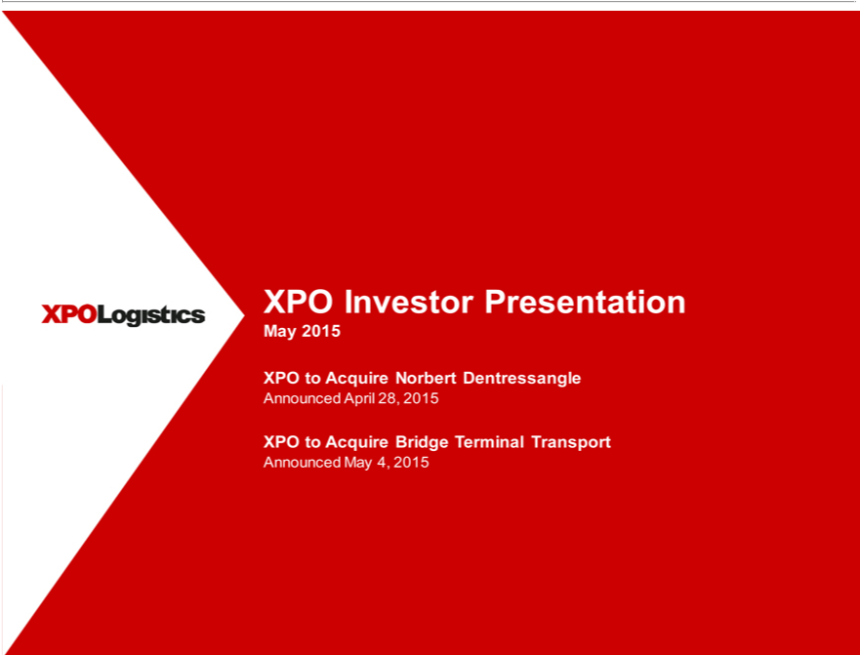

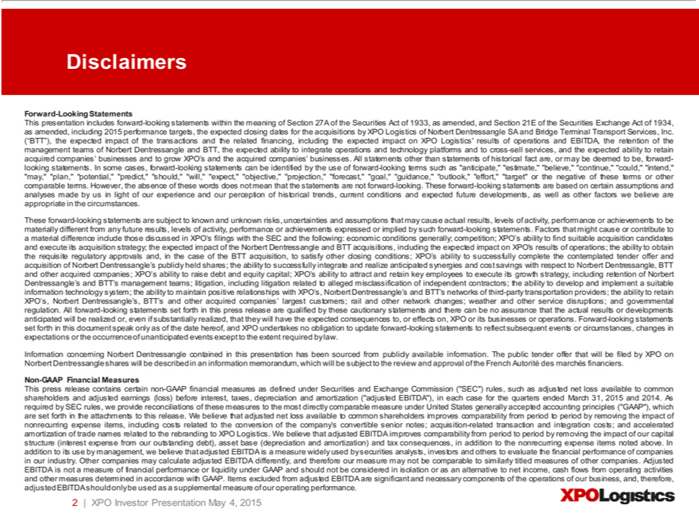

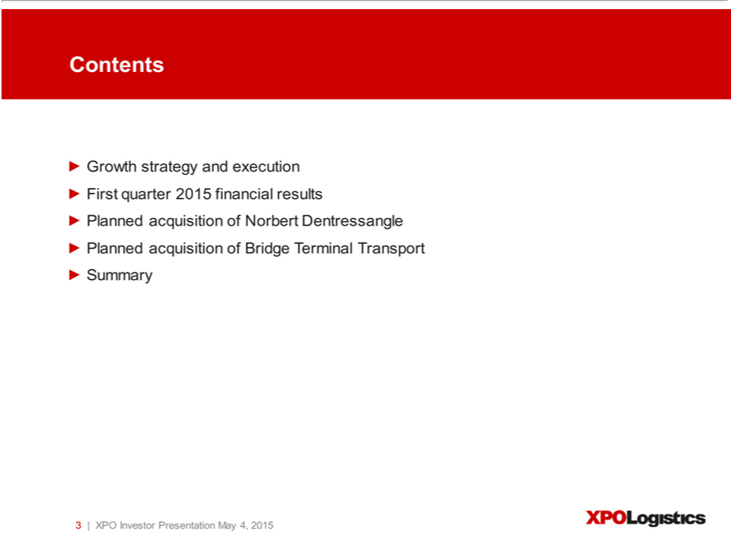

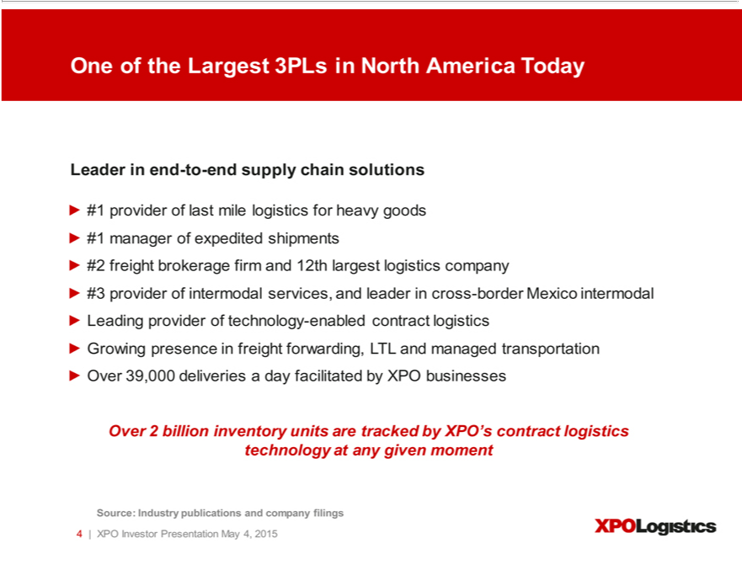

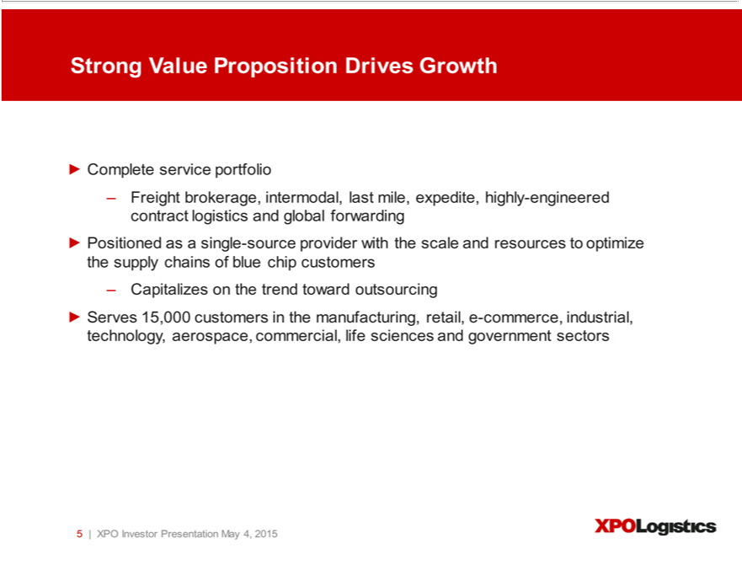

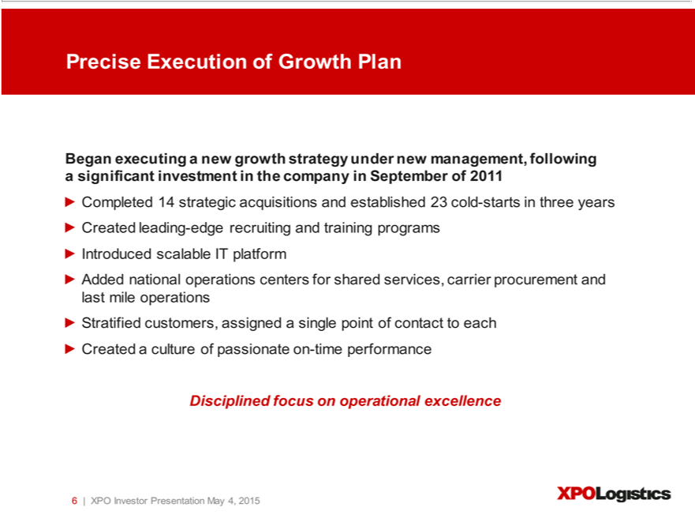

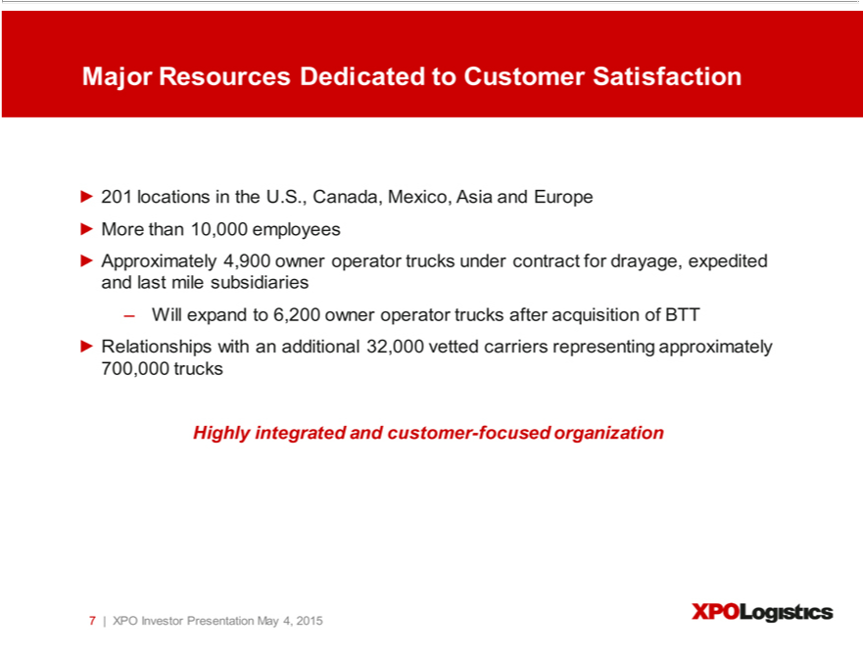

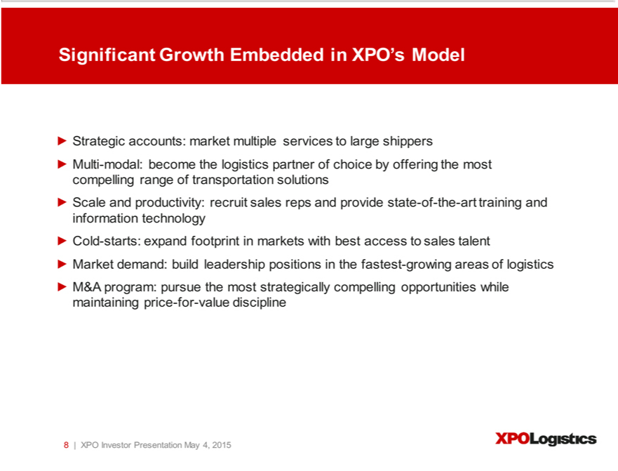

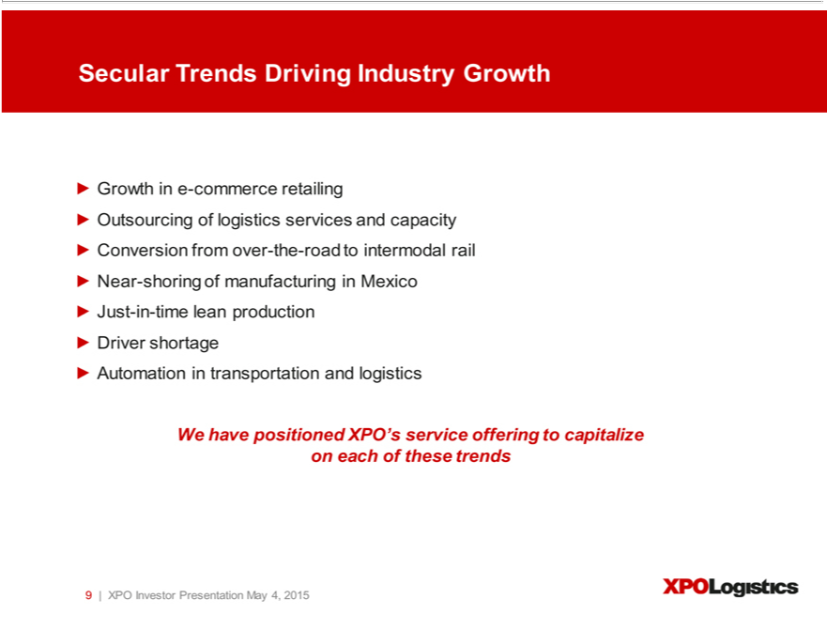

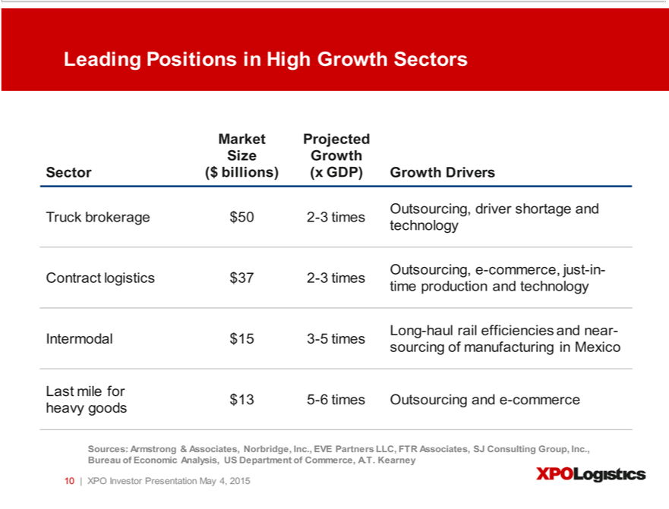

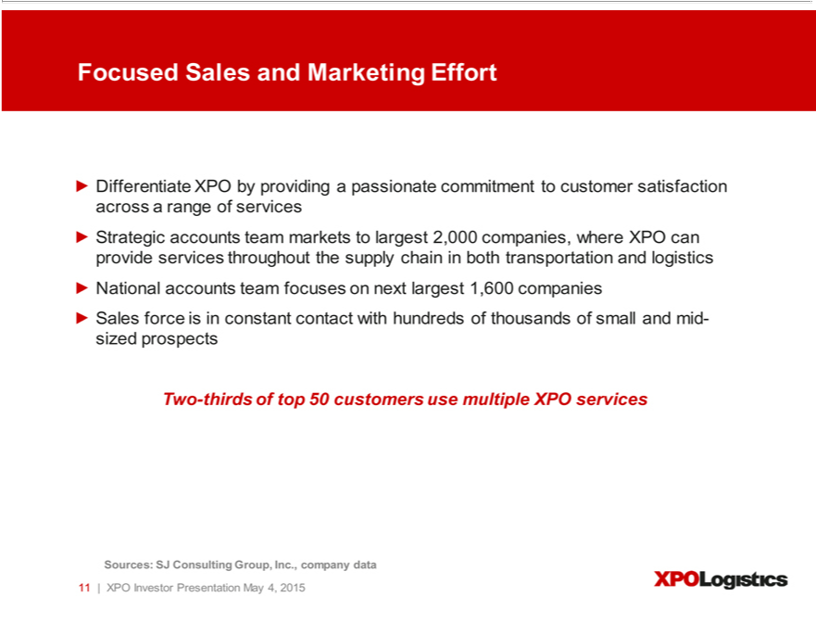

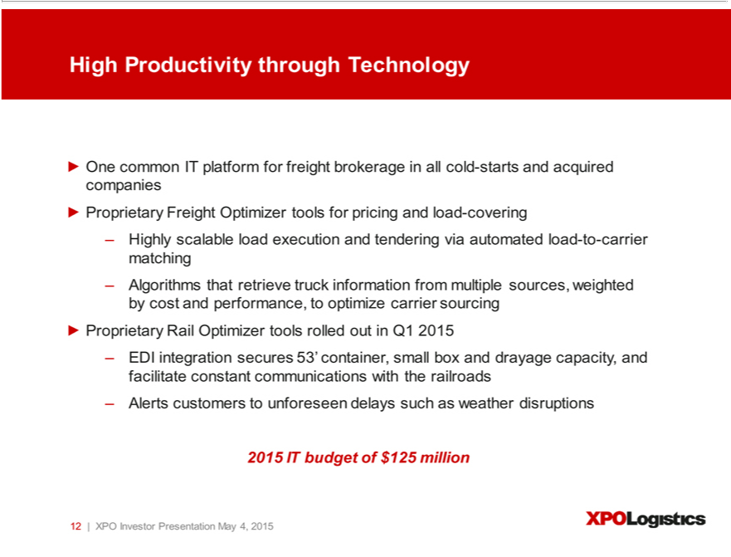

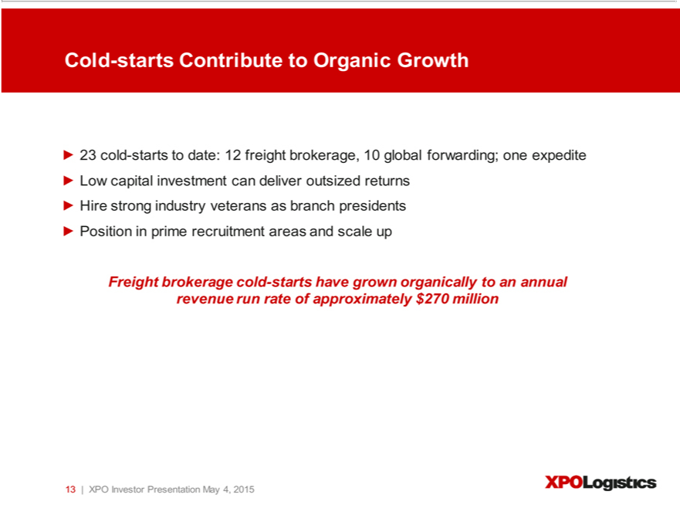

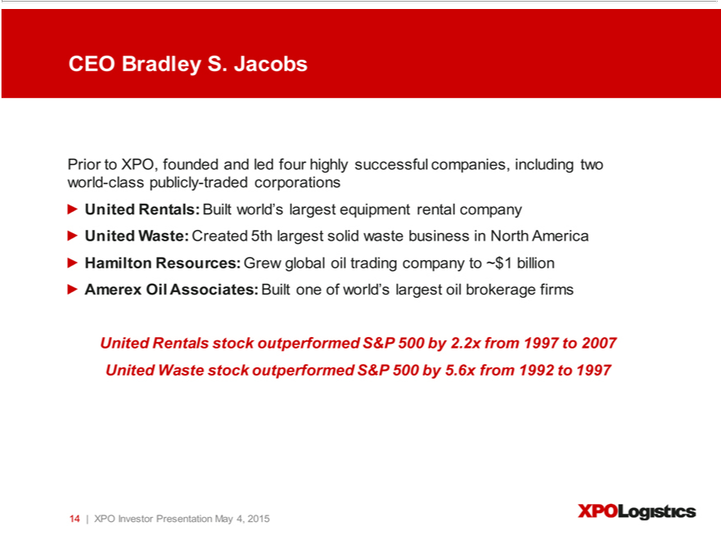

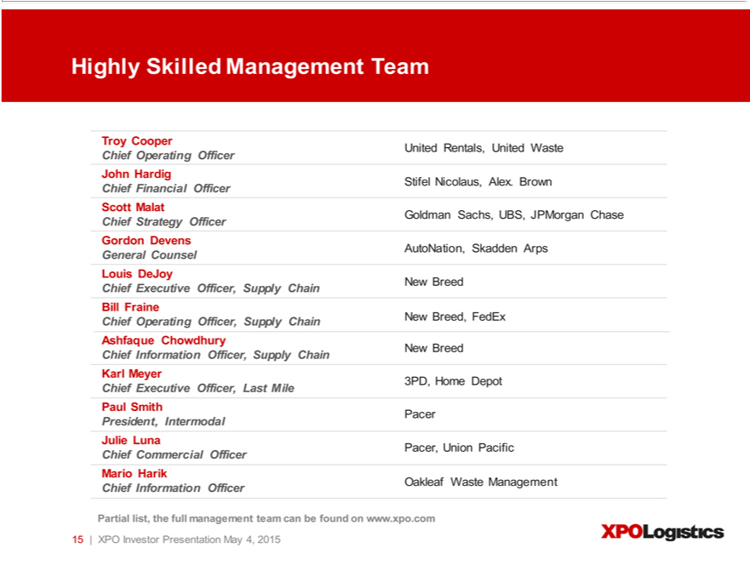

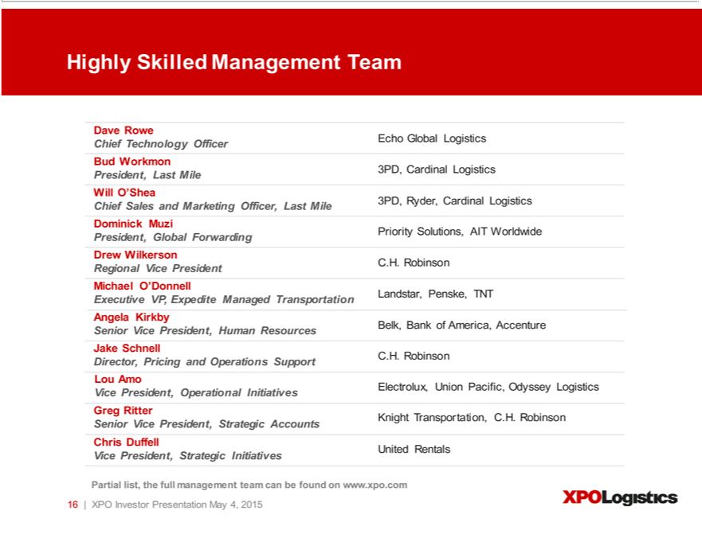

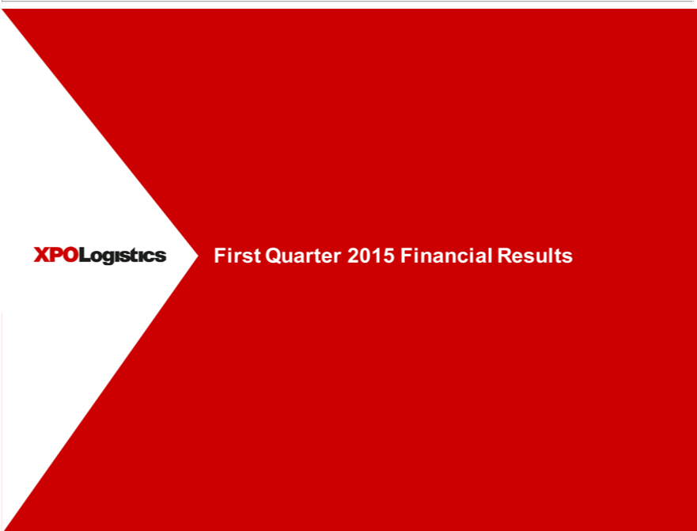

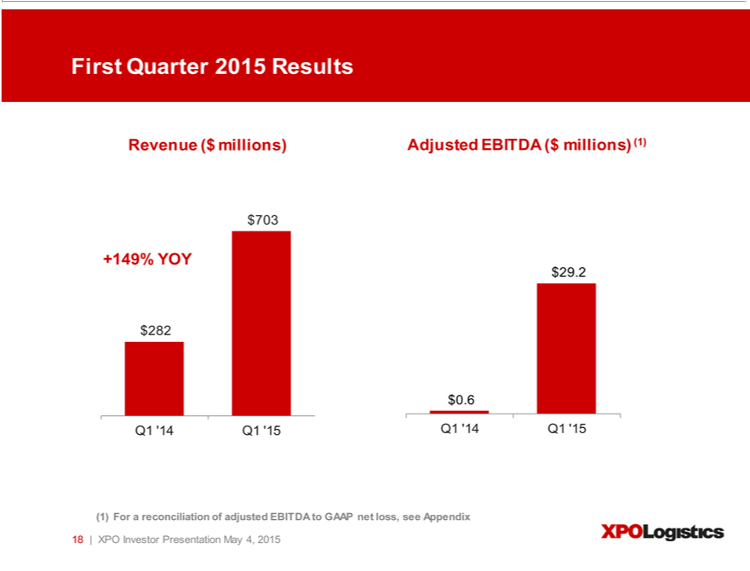

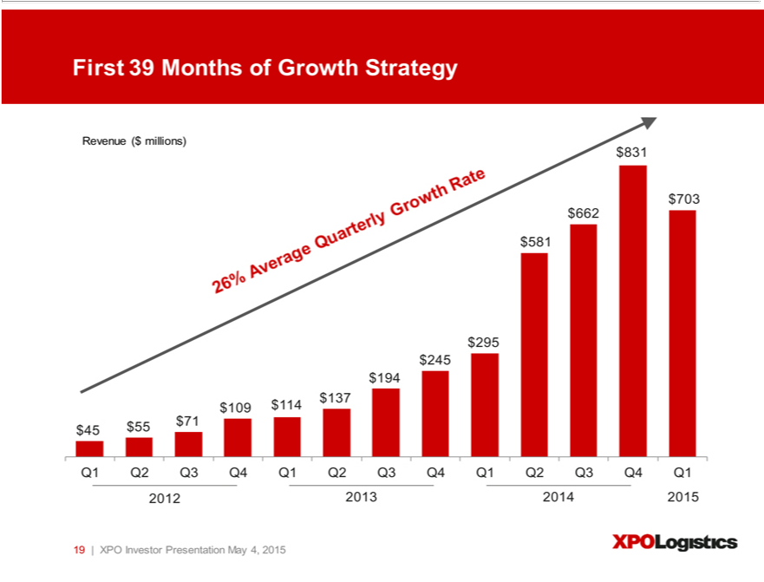

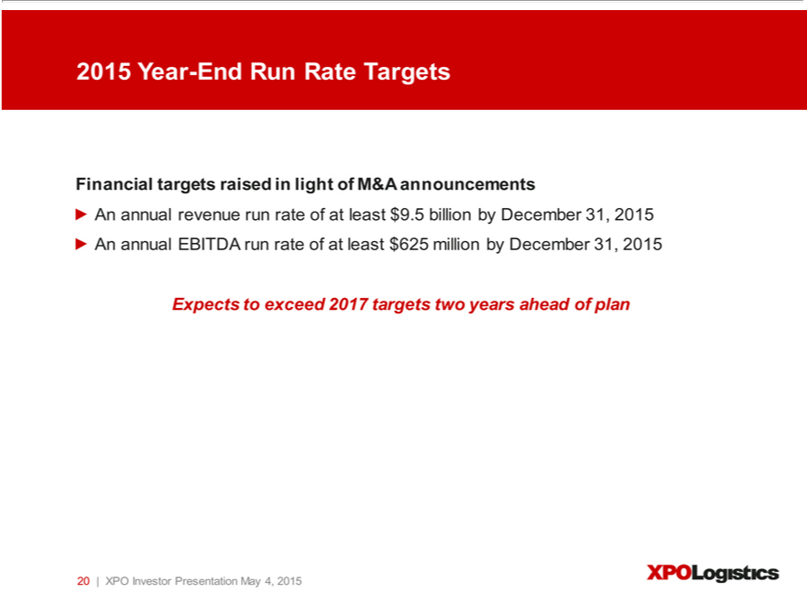

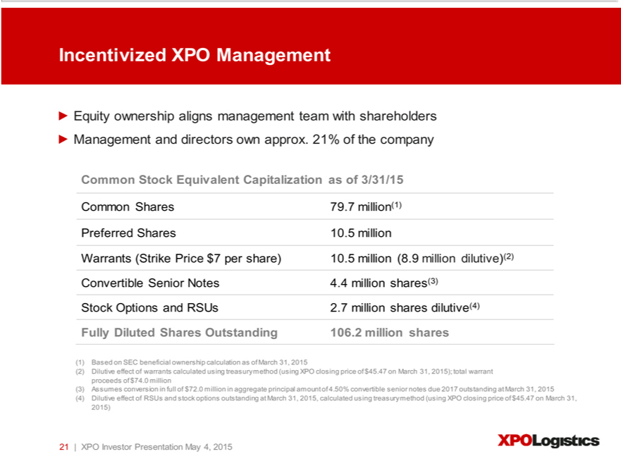

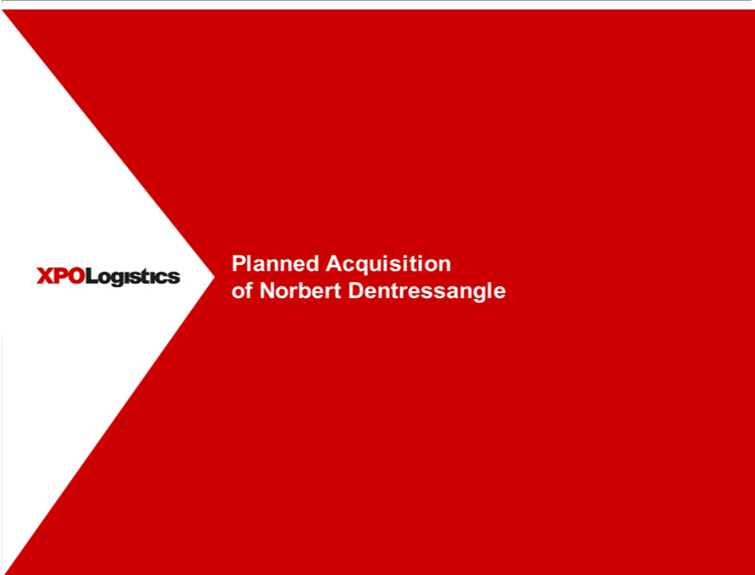

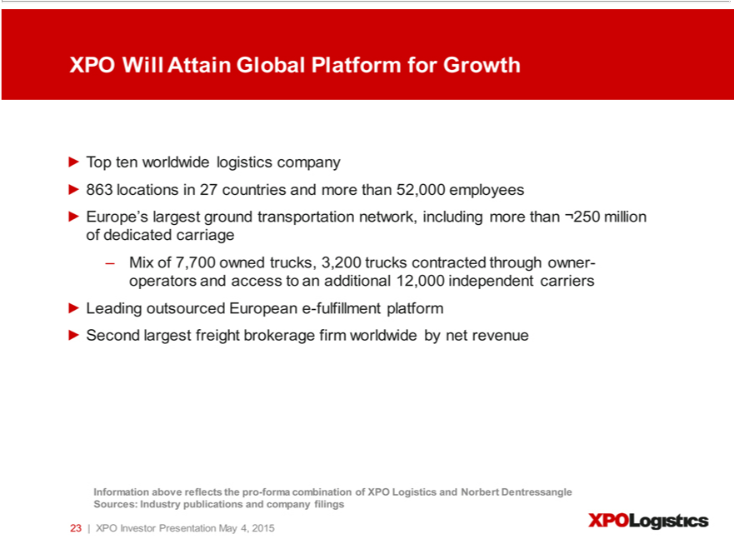

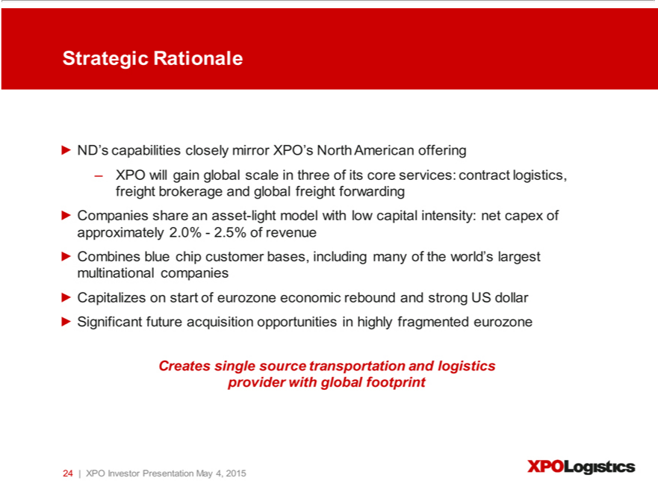

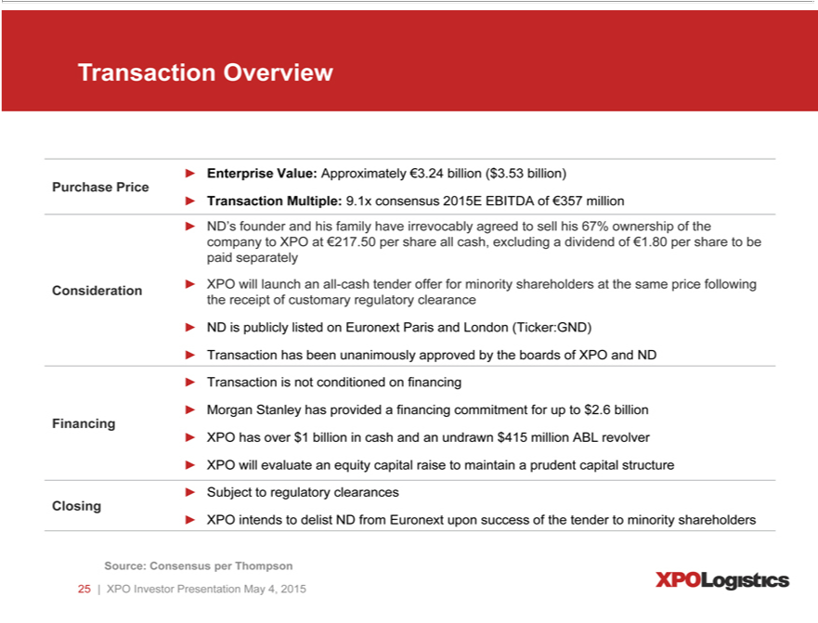

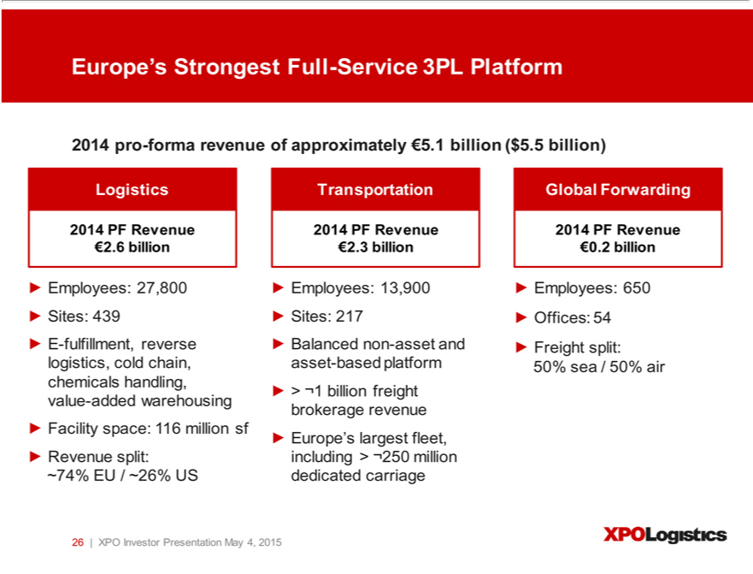

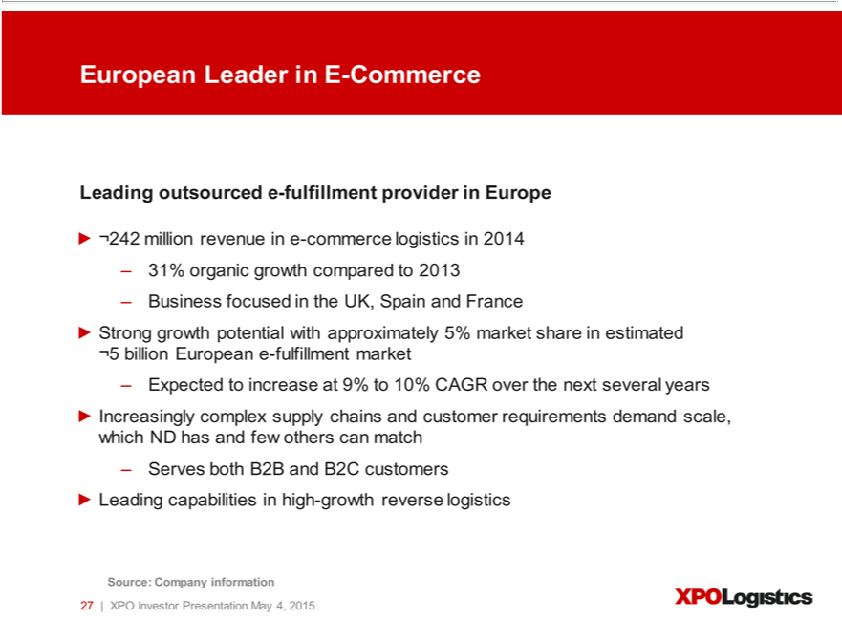

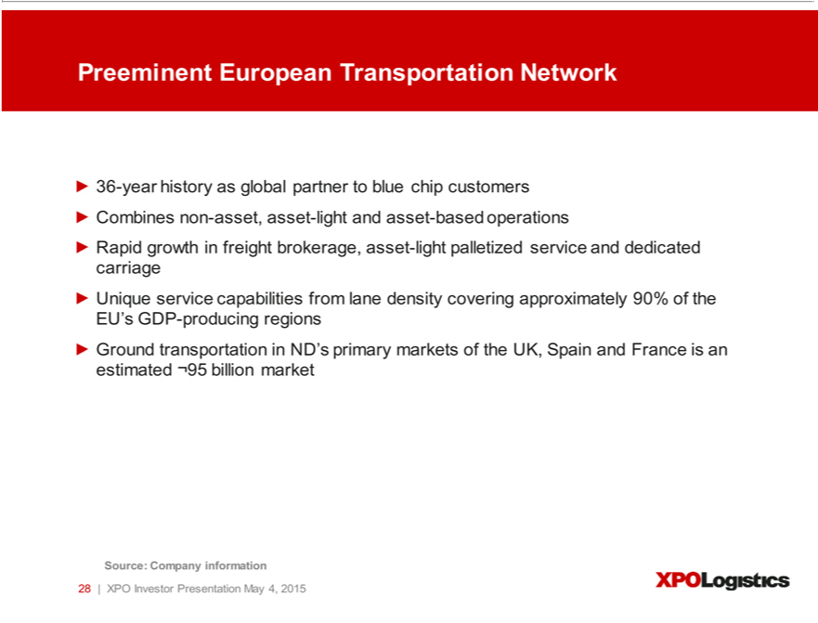

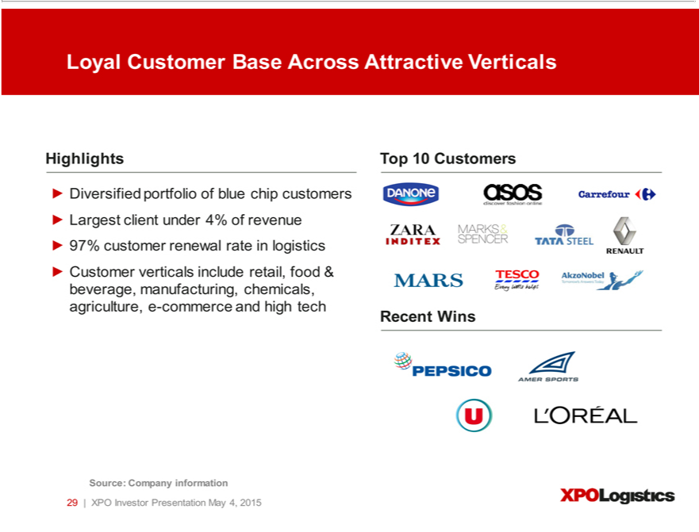

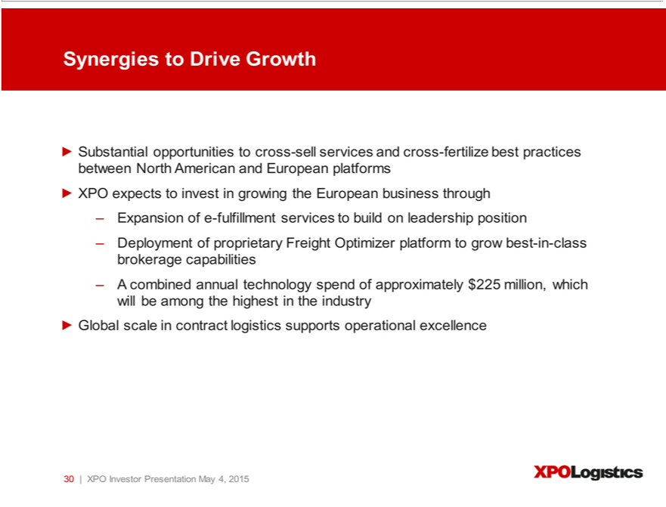

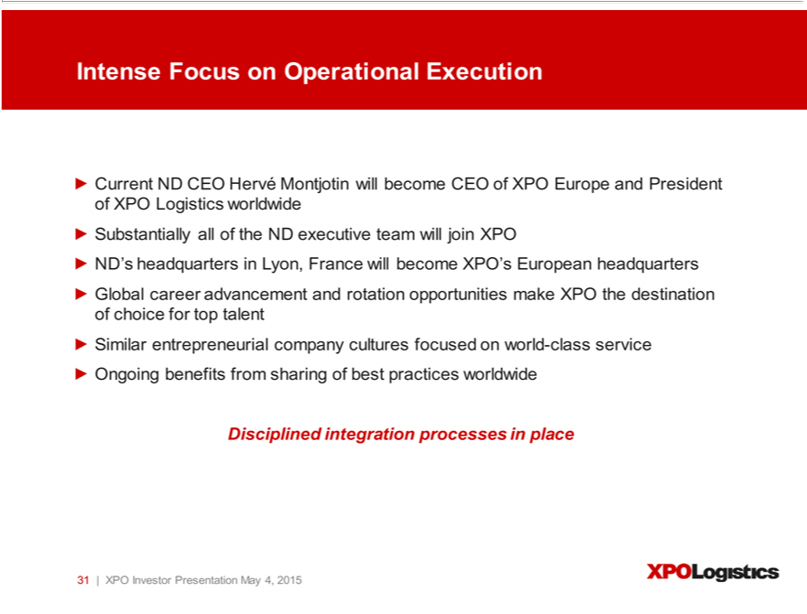

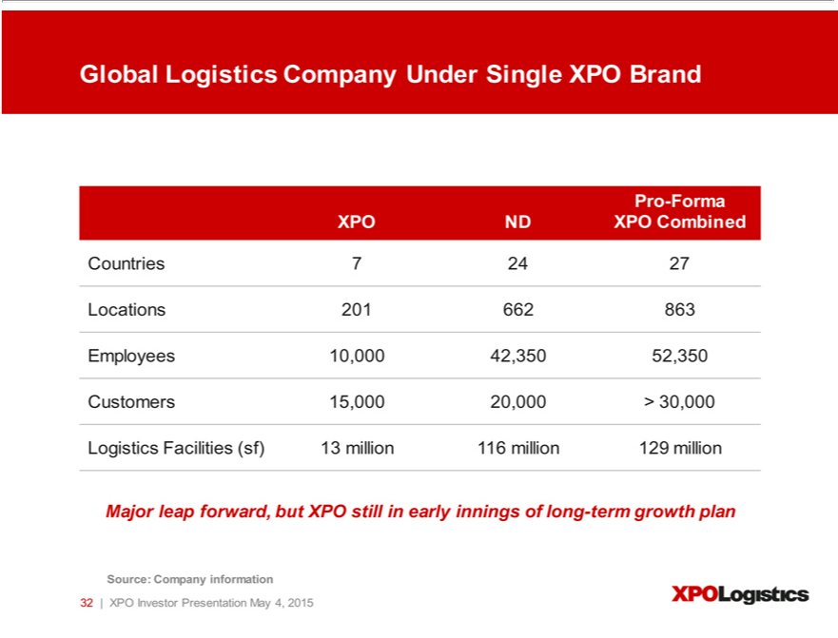

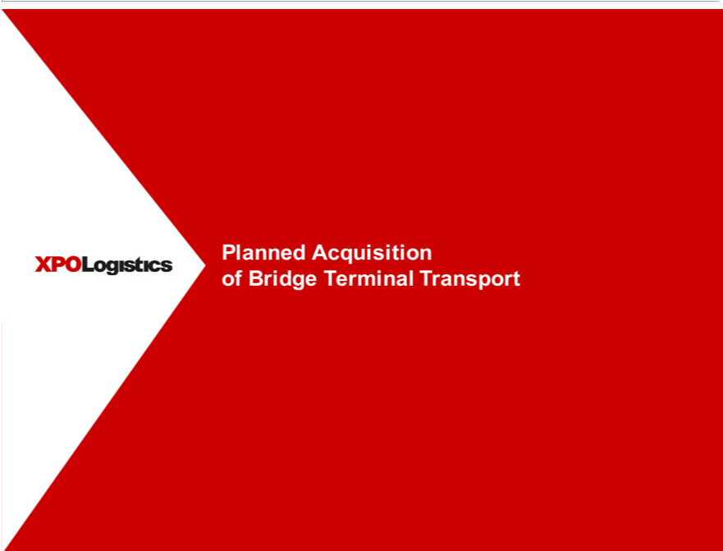

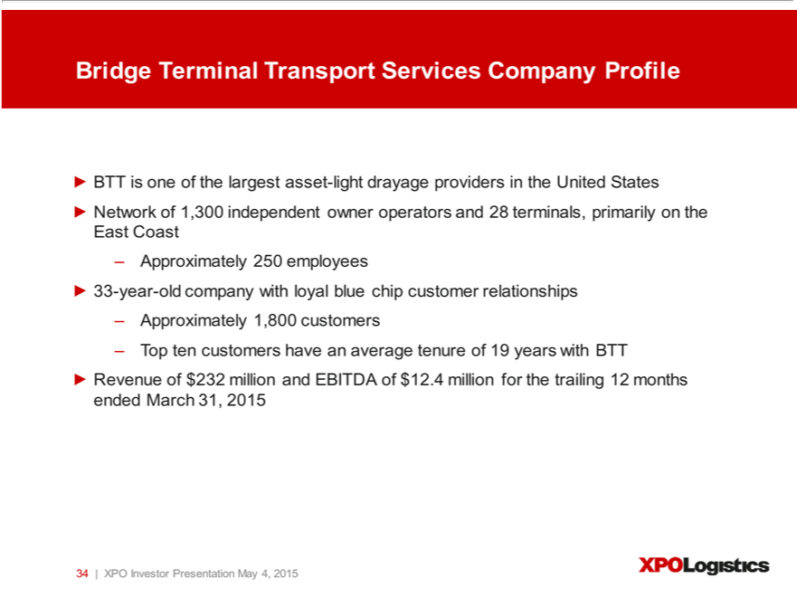

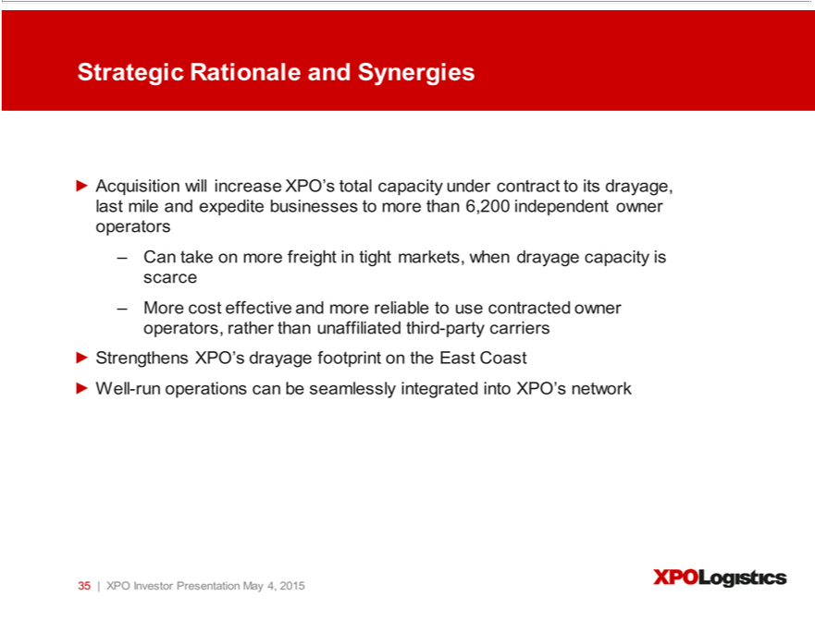

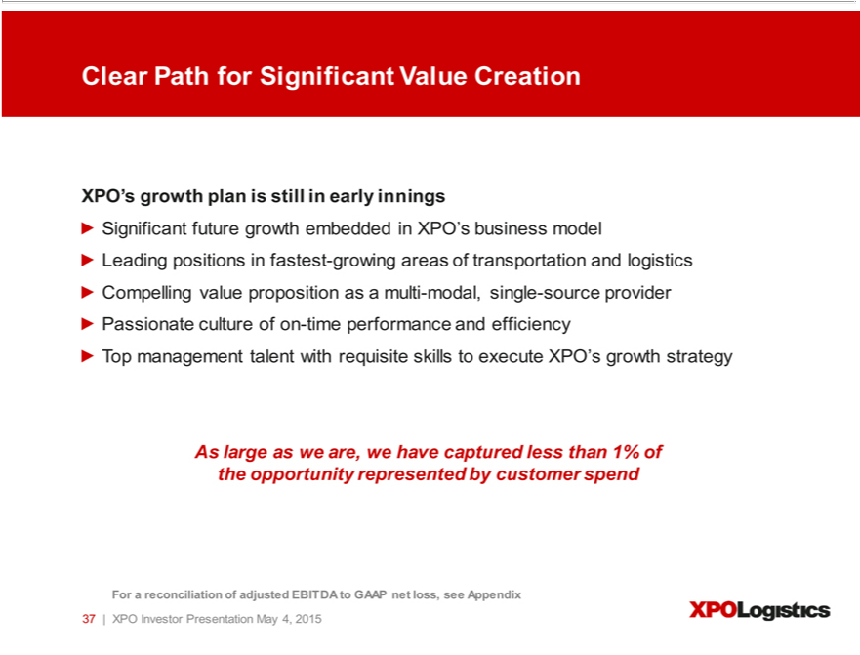

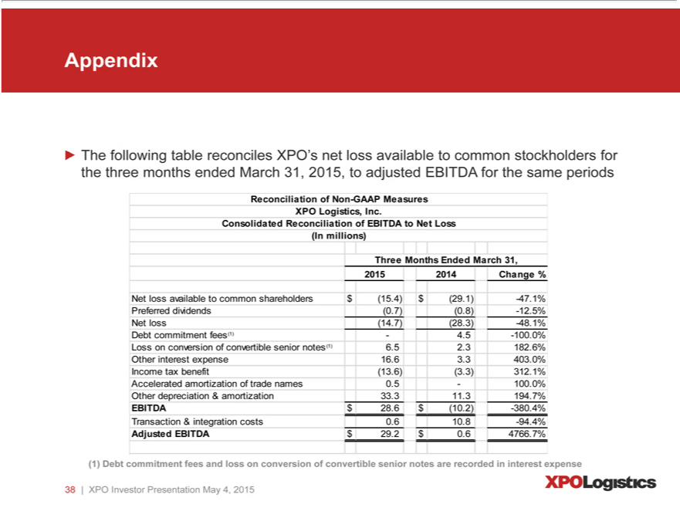

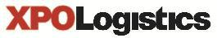
May 4, 2015

Presentation Script

The following script should be read in conjunction with the accompanying slide presentation, which contains, among other information, source data for certain information set forth in the script.

Thank you for joining us today. We’ll start with our three most recent announcements: our planned acquisitions of Bridge Terminal Transport and Norbert Dentressangle, as well as our company-wide rebranding. Then we’ll introduce you to XPO and our differentiated supply chain offering. We’ll explain the strategy that drives our growth. And we’ll give you the highlights of our first quarter 2015 financial results, as well as our new 2015 outlook, which sets significantly higher year-end targets for revenue and EBITDA.

First, our agreement to acquire Bridge Terminal Transport, or BTT. We’re acquiring BTT to expand our drayage capacity. BTT is a quality, 33-year-old business that is one of the largest asset-light drayage providers in the United States. It’s an extremely well-run operation concentrated on the East Coast, with a network of 28 terminals and about 1,300 independent owner operators. They’ve built up a lot of customer loyalty – their top 10 customers have been doing business with BTT for an average of 19 years.

There are three important synergies to the BTT acquisition. There are significant cross-selling opportunities. There’s the ability to say “yes” to customers more often – to take on more intermodal freight when drayage capacity is tight. And it’s both more cost effective and more reliable for us to use contracted owner operator capacity, rather than utilizing non-contracted third parties.

We’re buying BTT for $100 million, which is 8.1 times EBITDA. This will almost triple our drayage capacity to over 2,000 independent owner operators. And it will bring our total network of independent owner operators to more than 6,200, under contract to our intermodal, last mile and expedite businesses. We’ll integrate BTT with our intermodal business and rebrand the operations as XPO Logistics when we close the transaction, which we expect will be in the second quarter following customary clearances.

Our other acquisition news is truly transformational for XPO. On April 28, we announced a definitive agreement to acquire Norbert Dentressangle, one of the most important transportation and logistics companies in the world. The transaction has an enterprise value of approximately €3.24 billion ($3.53 billion), which equates to a multiple of 9.1 times consensus 2015 EBITDA of €357 million. There are seven compelling reasons why our purchase of Norbert Dentressangle will be a defining moment in our growth:

- First, the acquisition is going to make XPO a truly global provider of supply chain solutions. We’ll have over 52,000 employees at 863 locations in 27 countries. And we’ll serve more than 30,000 customers. There are only a handful of companies in our industry worldwide who operate at this level, and we’ll to be in the top ten.

- Second, Norbert Dentressangle’s service range closely mirrors our own, and our geographies are complementary. We both hold leading positions in contract logistics and freight brokerage in our respective geographies. And we both have well-established global freight forwarding businesses. The combined forwarding businesses will be close to $430 million in revenue, and that volume should allow us to buy transportation more effectively with sea and air carriers.

- Third, contract logistics is about a $2.8 billion business for Norbert Dentressangle. We already have a highly successful contract logistics business in the United States. It’s a business we love for a lot of reasons. There are significant barriers to entry. It’s non-commoditized. And it has a high value-add component. In the case of Norbert Dentressangle, they do a lot of specialized logistics services in cold chains and chemicals, for example. It’s obvious that they’re doing an excellent job in pleasing these customers, since they have a 97% customer renewal rate.

- Fourth, within contract logistics, Norbert Dentressangle has a vibrant and growing business in e-commerce fulfillment, including reverse logistics. Their Red Online service is a leader in outsourced e-commerce fulfillment in Europe. Red Online does about a quarter billion dollars of revenue with B2B and B2C customers, inside of a €5 billion market opportunity. They grew this business organically by 31% last year. We’re very tuned in to e-commerce logistics in our U.S. operations, and we’re excited about the growth potential in Europe.

- Fifth is freight brokerage, which is part of their transportation program. Norbert Dentressangle has a non-asset freight brokerage business with annual revenue of over €1 billion. We see a significant opportunity to take our best-in-class proprietary Freight Optimizer technology and turbocharge the growth in Europe. The other components of their transportation program are an asset-light palletized service offering, and a capacity mix of owned and dedicated fleet.

- Sixth, we’re bullish on this combination because it will be very positive for our customers. We’re going to be able to cross-sell globally in both directions. Many of our current customers have a major presence in Europe that we’ll be able to serve with our new platform. They’ve been asking us to do more for them in other parts of the world, and soon we’ll be able to do that.

- And seventh, the transaction will open all kinds of doors for career advancement and geographic rotation for people within our combined company. We’ll become even more of a magnet to attract top talent in the industry. We’ll have many of our European colleagues spending time in the States and vice versa, learning different approaches to the business and sharing best practices.

In addition, Norbert Dentressangle has superb employees, including a stellar management team. This is a company that has been meticulously built, and it shows in the caliber of their people. That’s very important to us, because we’re going to be growing shoulder-to-shoulder with our new European colleagues. We’re particularly pleased that Hervé Montjotin, the chairman of the executive board and CEO of Norbert Dentressangle, will be joining XPO as CEO of our European operations and president of the parent company.

We also want to share our thinking on Europe, and the timing of this acquisition. We believe that we’re buying at an opportunistic time, when Europe is starting to grow again. It’s been a tough few years for the eurozone, but it seems to be bottoming out and is starting to rebound. Also, the dollar is strong against the euro right now – this deal would have cost XPO 20% more a couple of years ago.

Those are both positive aspects to deal, but they aren’t our reasons for expansion. Europe has twice the population of the United States, and European supply chains need quality companies to help them operate at top efficiency. Norbert Dentressangle does a great job at that. They’re riding a long-term outsourcing tailwind in Europe that’s driving outsourcing growth at 27% or more a year. We’re seeing the same thing in the U.S., at around 18%. Even so, the great bulk of transportation and logistics – about 70% or so – is still handled in-house. So on both sides of the Atlantic, the fundamentals for growth are very evident: low penetration, multiple service offerings, and a shift toward outsourcing as a supply chain strategy.

Now we’d like to tell you more about our company, starting with our rebranding under the global name of XPO Logistics. This was an important step for us, because it reflects our ability to serve customers with a complete range of supply chain solutions, and to do it as one cohesive organization. In conjunction with the rebranding, we launched an integrated web presence at www.xpo.com. Our new website serves as the online point of contact for customers, carriers, job seekers and anyone who simply wants to learn more about our company.

Let’s step back to the start of XPO.

We took control of the company in September of 2011 with the objective of building a world-class transportation and logistics provider. Today, we’re one of the largest and fastest-growing logistics companies in North America – and soon to be one of the top ten logistics companies in the world. In barely three years, we’ve grown XPO from 200 employees and less than $180 million in annual revenue, to a multi-billion dollar industry leader with over 10,000 employees.

Our trajectory is being driven by our disciplined execution of our growth strategy. We’ve completed 14 acquisitions to date – 16 when we close BTT and Norbert Dentressangle. We have 23 cold-start locations operating under experienced leadership: 12 in freight brokerage, 10 in freight forwarding and one in expedite. And most important, we’ve integrated these operations into a cohesive organization with complementary lines of service and a single-minded focus on helping our customers run their supply chains more efficiently.

Our service range is categorized in two segments: logistics and transportation.

In our logistics segment, we’re a leading provider of highly engineered, technology-enabled contract logistics for blue chip customers. Contract logistics is a broad term that refers to the outsourcing of warehousing, distribution and other inventory management responsibilities to a third-party provider. It can include storing, distributing and transporting raw materials, finished goods and spare parts, reverse logistics, and value-added services such as supply chain consultation and production flow management.

Contract logistics is a $37 billion market opportunity in North America alone, growing at an estimated rate of two to three times GDP. We operate in the highest echelon of this space – customized, high value-added services with low cyclicality and strong contractual revenue renewal rates. Our customers are the preeminent global names in aerospace, manufacturing, retail, life sciences and other industries where outsourcing is taking root.

In our transportation segment, we’re the largest provider of last mile logistics for heavy goods, the largest manager of expedite shipments, the second largest freight brokerage firm, and the third largest provider of intermodal services, with growing positions in managed transportation,

global forwarding and less-than-truckload brokerage. We’re also a leader in cross-border Mexico intermodal, where demand is booming due to the manufacturing trend toward near-shoring.

Mexico’s share of global production is rising across a range of industrial goods such as automotive, as well as machinery and consumer goods, including furniture, plastics and packaged commodities. There are a number of factors driving this, including Mexico’s competitively priced labor force and greater speed-to-market than overseas locales such as China. In addition, the railroads and the Mexican government have invested heavily in transportation infrastructure. The projected growth in near-shoring should serve XPO well because of our 30-year track record in Mexico. Even at the current level of cross-border activity, it’s estimated that approximately 2.8 million trucks move across the U.S.-Mexico border each year, so there’s a large potential universe for us to convert truck to rail.

Now let’s talk about scale and optimization. In our logistics segment, scale is largely a function of square footage. We currently lease over 12 million square feet of high-value-add facilities that house our supply chain solutions for customers. This will increase to more than 129 million square feet when Norbert Dentressangle becomes part of XPO. And we expect to build on this platform, both in the United States and abroad.

In our transportation segment, scale starts with industry fundamentals. The transportation industry in the United States alone is about a trillion dollars annually. Over-the-road trucking is about $350 billion of that spend, with an estimated 15% penetration rate by brokers. This equates to a $50 billion opportunity that’s growing at about two to three times GDP. Currently, we have more than 15,000 customers, primarily in manufacturing, industrial, retail, technology, aerospace, commercial, life sciences and governmental accounts – yet we serve less than 2% of the addressable market. Europe gives us another underpenetrated arena for brokerage.

One thing that’s likely to drive increased penetration in transportation is an outsourcing trend with both shippers and carriers. It makes good economic sense for carriers to find loads through brokers instead of carrying the costs of an internal sales team. And shippers – including those with direct carrier relationships – are increasingly seeing the advantages of 3PL relationships that solve more than just one or two of their transportation needs. We’ve positioned our company to benefit from this long-term trend.

In addition to being large and growing, the transportation industry is highly fragmented. There are more than 10,000 licensed brokers in the U.S., but only about 25 brokerage firms with more than $200 million in revenue. Fragmentation gives us a dual benefit: it supports the acquisition leg of our strategy, and creates a competitive advantage for XPO as the second largest brokerage firm.

Two other fast-growing segments within our transportation segment are intermodal, which we talked about earlier, and last mile logistics. The home delivery of heavy goods is a $13 billion sector of last mile that’s growing at five to six times GDP. XPO is the leader in this highly desirable space, where we cater primarily to blue chip retailers.

In addition, last mile is a major beneficiary of the growth in e-commerce, which is expected to continue to show robust expansion for the foreseeable future. We’re steadily gaining business in the e-commerce space based on our growing network of independent owner operators. We expect to continue to invest in scaling up our last mile platform to support both retailers and e-commerce companies.

We’re working diligently to raise our profile in front of every prospective customer with a supply chain that can utilize our services. Many blue chip companies have supply chains that require both transportation and logistics services – we can facilitate the movement of their freight domestically and abroad, and also furnish customized contract logistics solutions.

One of the ways we do this is through cross-selling our services to customers. Our cross-selling efforts are gaining a lot of traction. Because we offer a complete range of solutions, we’re in a strong position to leverage an important industry trend: many customers, particularly large shippers, want to winnow down their relationships to fewer, larger 3PLs like XPO that have deep capacity across a range of services.

We’ve identified the 2,000 largest companies in North America as strategic account targets. The next largest 1,600 companies are our national account targets. In addition, there are hundreds of thousands of small and medium-sized customers who can use our services. Our branch network reaches out to them every day.

We see great growth potential in strategic accounts. In 2013, we launched a dedicated team of strategic account managers, each with deep industry experience and a successful track record with large companies. They’re very attentive to the nuanced needs of large shippers. The team includes a number of high-profile industry veterans, including Greg Ritter, Dennis McCaffrey, Jim Commiskey and Jeff Battle.

Greg was previously president of Knight Brokerage, and before that he was with C.H. Robinson for 22 years. Dennis has 20 years in the industry, and most recently ran the outside sales organization for our expedited transportation group. Jim came to us from Pacer; he has more than 20 years of transportation experience, including management positions with UPS and Menlo Worldwide. And Jeff is one of the key executives who led the growth of Turbo Logistics over the last two decades.

Our strategic accounts group is getting a good reception from large prospects. Some of this is because XPO’s profile is much higher now than it was a year or two ago. We’ve also shown a strong commitment to growing our capacity, which is important to shippers given the driver shortage. Our drayage, expedited and last mile subsidiaries have more than 4,900 owner-operator trucks under contract. BTT will increase that number to about 6,200. And our capacity procurement hubs in Charlotte, Chicago and Atlanta manage relationships with an additional 32,000 carriers, representing capacity of approximately 700,000 trucks on the road.

Our penetration opportunity is huge, and it’s three-fold. First, we can expand many of our existing customer relationships to multiples of their current size by earning a greater share of spend. In a short time, we’re already generating revenue from multiple lines of business with about two-thirds of our top 50 customers. Second, we can capitalize on our higher profile and broad resources to gain new business. And third, we can leverage our leading positions in fast-growing areas of logistics to capture share as our end-markets expand.

Beyond strategic accounts, we’re focused on leveraging our broader multi-modal offering with customers of all sizes, both new business and existing accounts. We’re doing this in a disciplined and organized manner – all of our salespeople are on salesforce.com, and we’ve assigned a single point of contact for each customer. We have a compelling value proposition: we offer integrated, end-to-end logistics solutions for any shipper, of any size, with any combination of transportation needs.

Less-than-truckload is another revenue stream that’s on our doorstep. LTL is a $32 billion industry sector. Currently, less than $25 million of our company’s annual revenue comes from LTL – yet almost all of our full truckload customers ship LTL freight. A 2013 acquisition brought us deep LTL expertise, as well as an LTL technology platform that we’ve rolled out in all of our sales offices. We’re excited about the magnitude of the LTL opportunity.

Our experience tells us that the common denominator across all these areas of transportation and logistics is that customers want results. Our company’s roots are in expedited transportation, which requires picking up and delivering freight very quickly, with a goal of zero service failures. Our expedite business dates back more than 20 years – so a do-or-die mindset of meeting customer needs is embedded in our DNA.

Anything less than stellar service is not an option for us. Customers want on-time pickup and delivery. They want their goods to arrive safely. If a problem does occur, they want to know about it right away and they want to see a solution. If you walk into one of our branch offices, you’ll see that our people are trained to be professional, efficient and on top of things.

To maintain a high level of responsiveness, we’ve instilled a performance-driven culture focused on delivering world-class service to customers. Our sales and operations people know how to deal with customers on a professional basis. They understand our goal of zero service failures. We see an opportunity to differentiate XPO on the basis of phenomenal customer service in each of our lines of business.

One of the ways we empower our employees to deliver world-class service is through our information technology. We place massive importance on innovation, because we believe that technology is the ultimate differentiator in our industry. We have an IT team of over 600 talented professionals that focuses solely on driving innovation and the effectiveness of our systems. We design our systems to make sure they can accommodate huge scale and complex automation. They create the discipline that helps us manage rapid growth.

Here are some examples of our intense focus on innovation. Our contract logistics business uses proprietary technology to serve large customers with complex supply chain requirements. This software is used for omni-channel distribution, reverse logistics, lean manufacturing support, aftermarket support, supply chain optimization and transportation management.

In our freight brokerage business, we’ve developed a proprietary software platform that provides actionable pricing information as well as timely access to carrier capacity. And in our last mile business, we hold the patents on industry-leading software for real-time workflow visibility and customer experience management. This gives us a strong competitive advantage in the last mile space, in that it documents our ability to deliver superior end-customer satisfaction ratings. It also allows us to move quickly to address any sub-par carrier performance.

We see the ongoing development of our technology platforms as being critical to our ability to continually improve customer service and leverage our scale. We currently have more than 200 projects under development and a 2015 IT budget of $125 million. We expect this budget to increase to $225 upon completion of the Norbert Dentressangle transaction.

That sums up our growth strategy. Now it comes down to operational excellence and management. So let’s spend a few minutes on our senior management team.

Our CEO, Brad Jacobs, started four highly successful companies from scratch prior to XPO Logistics, and built each of those companies into a billion or multi-billion dollar enterprise. Brad and the management teams he led created dramatic shareholder value. In the process, they completed nearly 500 acquisitions and opened approximately 250 cold-starts.

The two most recent companies Brad led were United Waste Systems, which he built into the fifth largest solid waste management company in North America, and United Rentals, which he grew to be the largest construction equipment rental company in the world. From 1992, when Brad took United Waste public, to 1997, when he sold it for $2.5 billion to Waste Management, the earnings compounded at about 55% CAGR and the stock price outperformed the S&P 500 by 5.6 times. At United Rentals, over the 10 years he led the company, United Rentals stock outperformed the Index by 2.2 times.

Brad spent the better part of his first year with XPO assembling a team whose collective skill set is the perfect fit for our company’s ambitious growth strategy. For a competitor to successfully copy our business plan, it would need the deep bench of talent that we have – not just at the senior executive level, but in every key position. Here are just a few examples of our talent:

Troy Cooper is our chief operating officer. Troy’s been instrumental in helping our company realize its growth strategy from the earliest days of XPO Logistics, with senior positions in operations and finance. Prior to XPO, as a vice president for United Rentals, Inc. under CEO Brad Jacobs, he helped to integrate over 200 acquisitions in the United States, Canada and Mexico. For United Waste Systems, Inc., he worked with Brad to build an integrated organization of 86 collection companies and 119 facilities in 25 states. Earlier, Troy was with OSI Specialties, Inc. (formerly a division of Union Carbide, Inc.).

John Hardig, our chief financial officer, has been a significant presence in the transportation industry for nearly two decades. Before joining XPO, John was a managing director in the Transportation & Logistics group at Stifel Nicolaus Weisel, and an investment banker in the Transportation and Telecom groups at Alex. Brown and Sons. Over the course of his career, he has completed over 60 M&A transactions and his teams have raised billions of dollars of capital for many of the industry’s leading logistics companies, including IPOs for C.H. Robinson and Hub Group, and follow-ons for Forward Air, Inc., Heartland Express, Inc. and Knight Transportation, Inc.

Scott Malat is our chief strategy officer. Scott’s responsible for our company’s strategy and capital structure, analyzing potential acquisition opportunities, and managing our technology organization. Prior to joining XPO, he was the senior transportation analyst covering air, rail, trucking and shipping at Goldman Sachs. Earlier he was an analyst with UBS, and served as an internal strategy manager with JPMorgan Chase, where he worked with several of the bank’s business units. As a global advisor for The Sharma Group, he focused on M&A opportunities.

Gordon Devens is XPO’s general counsel, responsible for executing our acquisition strategy as well as all corporate legal matters, governance and compliance, and legal interests relating to the company’s growth initiatives. Gordon is more than just a talented corporate lawyer. After working at Skadden, Arps, he spent 15 years with AutoNation, where he was associate general counsel, and later led AutoNation’s deal team. Gordon has completed over 250 M&A transactions during his career, and he brings that experience to XPO’s growth strategy.

Mario Harik is our chief information officer. He was previously the CIO at Oakleaf Waste Management, a logistics provider that was sold in 2011. Mario has been tapped over the years by Fortune 100 companies for his expertise in building comprehensive IT organizations and proprietary platforms, similar to what we’re doing here at XPO. He’s put together a superstar team that is using technology in innovative ways that tie directly to customer service. They’ve accomplished a huge amount in a short period of time.

Dave Rowe is our chief technology officer. Dave is responsible for infrastructure services, operating platforms and integration of XPO’s acquisitions. He has 23 years of senior technology experience, including positions as chief technology officer for Echo Global Logistics and chief information officer for Equis/United Group Limited (now UGL Limited), in charge of North American systems. For Echo, Dave led the design and development of Echo’s information systems for customer and carrier services, and integrated 11 acquisitions.

Taken in its entirety, our organization is unique in the industry because it includes top talent from virtually every other major 3PL in North America. Not only do we have deep bench strength, we have a rich diversity of industry experience.

Moving on to our first quarter 2015 financial results: we reported $703 million of revenue for the quarter, which was an increase of 149% year-over-year, and $29.2 million of adjusted EBITDA. We generated organic revenue growth company-wide of 10%, or 18% excluding the impact of lower fuel costs.

One of the biggest takeaways from our first quarter performance is that it reflects the resilience of our diversified service offering. We generated strong results in our last mile and expedite businesses, and in our logistics business we had better-than-expected levels of activity from our aerospace and telecom customers. These gains were offset by a weak spot market for freight brokerage, and by the disruption of our intermodal business from the West Coast port slowdowns.

In light of our M&A announcements, we raised our year-end targets to:

- An annual revenue run rate of at least $9.5 billion by December 31, 2015; and

- An annual EBITDA run rate of at least $625 million by December 31, 2015.

Finally, it’s worth noting that XPO management owns approximately 21% of the company’s fully diluted shares, based on SEC beneficial ownership rules. Our interests are entirely aligned with our public shareholders to create substantial long-term value.

So to sum it up: We’ve built a complete range of supply chain services anchored by a leadership position in highly-engineered contract logistics. We’ve established leading positions in some of the fastest-growing areas of transportation – truck brokerage, intermodal, last mile and expedite – and we’re capitalizing on major trends in our operating environments. We’re getting bigger, faster and more efficient in the way we run our operations. We see significant growth ahead in intermodal across North America, including cross-border Mexico. We’re building on our industry-leading position in expedite with our integrated ground, air and managed transportation offering. We’re expanding our last mile presence in exactly the right way to capture the burgeoning demand from e-commerce growth. And our intense commitment to world-class service is now reflected in the single brand of XPO Logistics across our complete range of supply chain solutions.

Our upcoming acquisition of Norbert Dentressangle will be a defining moment in our growth – but nevertheless, it’s just a midterm step in our trajectory. We’re still in the early innings of our plan, with a clear line of sight to further growth. We’re excited about the future for our company and our customers!

Thank you for your interest.

Forward-Looking Statements

This document includes forward-looking statements within the meaning of Section 27A of the Securities Act of 1933, as amended, and Section 21E of the Securities Exchange Act of 1934, as amended, including our year-end 2015 financial targets, the expected closing dates for the acquisitions by XPO Logistics of Norbert Dentressangle SA and Bridge Terminal Transport Services, Inc., the expected impact of the transactions and the related financing, including the expected impact on XPO Logistics’ results of operations and EBITDA, the retention of the management teams of Norbert Dentressangle and BTT, the expected ability to integrate operations and technology platforms and to cross-sell services, and the expected ability to retain acquired companies’ businesses and to grow XPO’s and the acquired companies’ businesses. All statements other than statements of historical fact are, or may be deemed to be, forward-looking statements. In some cases, forward-looking statements can be identified by the use of forward-looking terms such as “anticipate,” “estimate,” “believe,” “continue,” “could,” “intend,” “may,” “plan,” “potential,” “predict,” “should,” “will,” “expect,” “objective,” “projection,” “forecast,” “goal,” “guidance,” “outlook,” “effort,” “target” or the negative of these terms or other comparable terms. However, the absence of these words does not mean that the statements are not forward-looking. These forward-looking statements are based on certain assumptions and analyses made by us in light of our experience and our perception of historical trends, current conditions and expected future developments, as well as other factors we believe are appropriate in the circumstances.

These forward-looking statements are subject to known and unknown risks, uncertainties and assumptions that may cause actual results, levels of activity, performance or achievements to be materially different from any future results, levels of activity, performance or achievements expressed or implied by such forward-looking statements. Factors that might cause or contribute to a material difference include those discussed in XPO’s filings with the SEC and the following: economic conditions generally; competition; XPO’s ability to find suitable acquisition candidates and execute its acquisition strategy; the expected impact of the Norbert Dentressangle and BTT acquisitions, including the expected impact on XPO’s results of operations; the ability to obtain the requisite regulatory approvals and, in the case of the BTT acquisition, to satisfy other closing conditions; XPO’s ability to successfully complete the contemplated tender offer and the squeeze out of Norbert Dentressangle’s publicly held shares; the ability to successfully integrate and realize anticipated synergies and cost savings with respect to Norbert Dentressangle, BTT and other acquired companies; XPO’s ability to raise debt and equity capital; XPO’s ability to attract and retain key employees to execute its growth strategy, including retention of Norbert Dentressangle’s and BTT’s management teams; litigation, including litigation related to alleged misclassification of independent contractors; the ability to develop and implement a suitable information technology system; the ability to maintain positive relationships with XPO’s, Norbert Dentressangle’s and BTT’s networks of third-party transportation providers; the ability to retain XPO’s, Norbert Dentressangle’s, BTT’s and other acquired companies’ largest customers; rail and other network changes; weather and other service disruptions; and governmental regulation. All forward-looking statements set forth in this document are qualified by these cautionary statements and there can be no assurance that the actual results or developments anticipated will be realized or, even if substantially realized, that they will have the expected consequences to, or effects on, XPO or its businesses or operations. Forward-looking statements set forth in this document speak only as of the date hereof, and XPO undertakes no obligation to update forward-looking statements to reflect subsequent events or circumstances, changes in expectations or the occurrence of unanticipated events except to the extent required by law.

Information concerning Norbert Dentressangle contained in this document has been sourced from publicly available information. The public tender offer that will be filed by XPO on Norbert Dentressangle shares will be described in an information memorandum, which will be subject to the review and approval of the French Autorité des marchés financiers.

Non-GAAP Financial Measures

This presentation contains certain non-GAAP financial measures as defined under Securities and Exchange Commission (“SEC”) rules, such as adjusted earnings (loss) before interest, taxes, depreciation and amortization (“adjusted EBITDA”) for the quarter ended March 31, 2015. As required by SEC rules, we provide a reconciliation of this measure to the most directly comparable measure under United States generally accepted accounting principles (“GAAP”), which are set forth in this presentation. We believe that adjusted EBITDA improves comparability from period to period by removing the impact of our capital structure (interest expense from our outstanding debt), asset base (depreciation and amortization) and tax consequences, in addition to certain nonrecurring expense items, such as costs related to the conversion of the company’s convertible senior notes; acquisition-related transaction and integration costs; and accelerated amortization of trade names related to the rebranding to XPO Logistics. In addition to its use by management, we believe that adjusted EBITDA is a measure widely used by securities analysts, investors and others to evaluate the financial performance of companies in our industry. Other companies may calculate adjusted EBITDA differently, and therefore our measure may not be comparable to similarly titled measures of other companies. Adjusted EBITDA is not a measure of financial performance or liquidity under GAAP and should not be considered in isolation or as an alternative to net income, cash flows from operating activities and other measures determined in accordance with GAAP. Items excluded from adjusted EBITDA are significant and necessary components of the operations of our business, and, therefore, adjusted EBITDA should only be used as a supplemental measure of our operating performance.

