UNITED STATES
SECURITIES AND EXCHANGE COMMISSION
Washington, D.C. 20549

FORM 8-K

CURRENT REPORT
Pursuant to Section 13 or 15(d) of the
Securities Exchange Act of 1934

Date of Report (Date of earliest event reported): July 30, 2026

XPO, INC.
(Exact name of registrant as specified in its charter)

Delaware |  | 001-32172 |  | 03-0450326
(State or other jurisdiction of  incorporation) |  | (Commission File Number) |  | (I.R.S. Employer  Identification No.)

Five American Lane, Greenwich, Connecticut 06831
(Address of principal executive offices)

(855) 976-6951
(Registrant’s telephone number, including area code)

Check the appropriate box below if the Form 8-K filing is intended to simultaneously satisfy the filing obligation of the registrant under any of the following provisions:

☐ | Written communications pursuant to Rule 425 under the Securities Act (17 CFR 230.425)
☐ | Soliciting material pursuant to Rule 14a-12 under the Exchange Act (17 CFR 240.14a-12)
☐ | Pre-commencement communications pursuant to Rule 14d-2(b) under the Exchange Act (17 CFR 240.14d-2(b))
☐ | Pre-commencement communications pursuant to Rule 13e-4(c) under the Exchange Act (17 CFR 240.13e-4(c))

Securities registered pursuant to Section 12(b) of the Act:

Title of each class |  | Trading symbol(s) |  | Name of each exchange on which registered
Common stock, par value $0.001 per share |  | XPO |  | New York Stock Exchange

Indicate by check mark whether the registrant is an emerging growth company as defined in Rule 405 of the Securities Act of 1933 (§230.405 of this chapter) or Rule 12b-2 of the Securities Exchange Act of 1934 (§240.12b-2 of this chapter).
Emerging growth company ☐
If an emerging growth company, indicate by check mark if the registrant has elected not to use the extended transition period for complying with any new or revised financial accounting standards provided pursuant to Section 13(a) of the Exchange Act. ☐

Item 7.01. Regulation FD Disclosure.

On July 30, 2026, XPO, Inc. (the “Company”) released a slide presentation expected to be used by the Company in connection with certain future investor presentations. A copy of the presentation is attached as Exhibit 99.1 to this Current Report on Form 8-K.

The slide presentation should be read together and with the Company’s filings with the Securities and Exchange Commission, including the Quarterly Report on Form 10-Q for the fiscal quarter ended June 30, 2026.

The information furnished in this Item 7.01, including Exhibit 99.1, shall not be deemed “filed” for purposes of Section 18 of the Securities Exchange Act of 1934, as amended (the “Exchange Act”), or otherwise subject to the liabilities of that Section, and shall not be deemed to be incorporated by reference into any filing of the Company under the Exchange Act or the Securities Act of 1933, as amended, except to the extent that the registrant specifically incorporates any such information by reference.

Item 9.01. Financial Statements and Exhibits.

(d) Exhibits

Exhibit No. |  | Exhibit Description
99.1 |  | Investor Presentation, dated July 30, 2026
104 |  | Cover Page Interactive Data File (embedded within the Inline XBRL document)

SIGNATURE

Pursuant to the requirements of the Securities Exchange Act of 1934, the registrant has duly caused this report to be signed on its behalf by the undersigned hereunto duly authorized.

Date: July 30, 2026 | XPO, INC.
 | By: | /s/ Kyle Wismans
 |  | Kyle Wismans
 |  | Chief Financial Officer

Exhibit 99.1

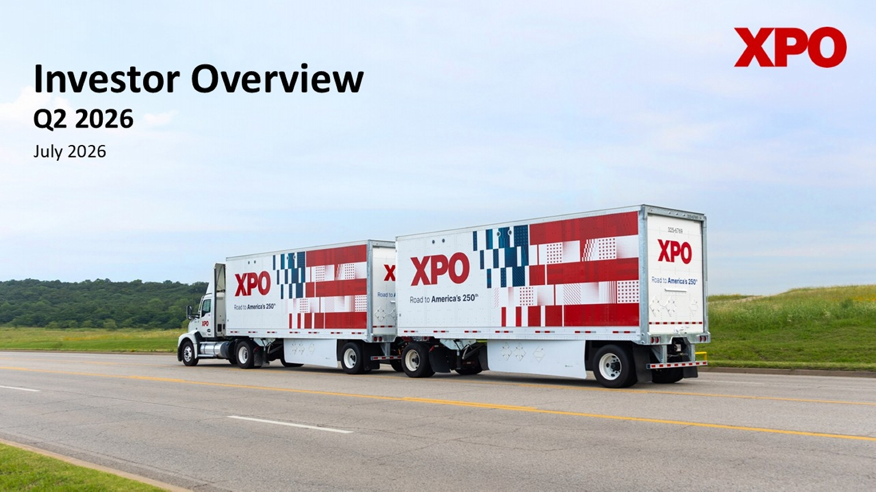
Investor Overview Q2 2026 July 2026

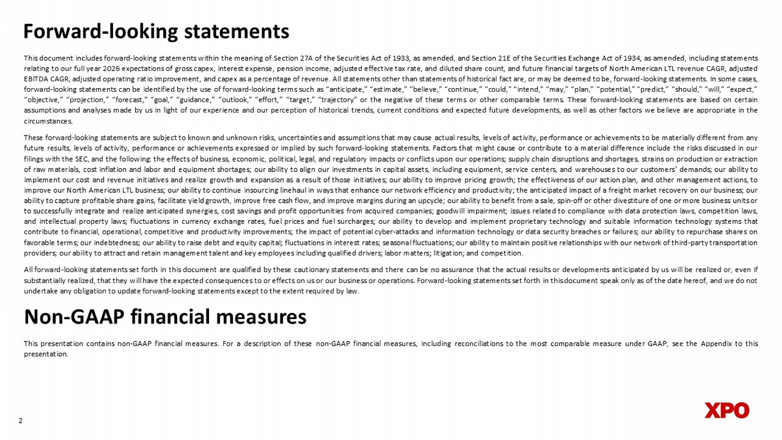
2 Forward - looking statements This document includes forward - looking statements within the meaning of Section 27 A of the Securities Act of 1933 , as amended, and Section 21 E of the Securities Exchange Act of 1934 , as amended, including statements relating to our full year 2026 expectations of gross capex, interest expense, pension income, adjusted effective tax rate, and diluted share count, and future financial targets of North American LTL revenue CAGR, adjusted EBITDA CAGR, adjusted operating ratio improvement, and capex as a percentage of revenue . All statements other than statements of historical fact are, or may be deemed to be, forward - looking statements . In some cases, forward - looking statements can be identified by the use of forward - looking terms such as “anticipate,” “estimate,” “believe,” “continue,” “could,” “intend,” “may,” “plan,” “potential,” “predict,” “should,” “will,” “expect,” “objective,” “projection,” “forecast,” “goal,” “guidance,” “outlook,” “effort,” “target,” “trajectory” or the negative of these terms or other comparable terms . These forward - looking statements are based on certain assumptions and analyses made by us in light of our experience and our perception of historical trends, current conditions and expected future developments, as well as other factors we believe are appropriate in the circumstances . These forward - looking statements are subject to known and unknown risks, uncertainties and assumptions that may cause actual results, levels of activity, performance or achievements to be materially different from any future results, levels of activity, performance or achievements expressed or implied by such forward - looking statements . Factors that might cause or contribute to a material difference include the risks discussed in our filings with the SEC, and the following : the effects of business, economic, political, legal, and regulatory impacts or conflicts upon our operations ; supply chain disruptions and shortages, strains on production or extraction of raw materials, cost inflation and labor and equipment shortages ; our ability to align our investments in capital assets, including equipment, service centers, and warehouses to our customers’ demands ; our ability to implement our cost and revenue initiatives and realize growth and expansion as a result of those initiatives ; our ability to improve pricing growth ; the effectiveness of our action plan, and other management actions, to improve our North American LTL business ; our ability to continue insourcing linehaul in ways that enhance our network efficiency and productivity ; the anticipated impact of a freight market recovery on our business ; our ability to capture profitable share gains, facilitate yield growth, improve free cash flow, and improve margins during an upcycle ; our ability to benefit from a sale, spin - off or other divestiture of one or more business units or to successfully integrate and realize anticipated synergies, cost savings and profit opportunities from acquired companies ; goodwill impairment ; issues related to compliance with data protection laws, competition laws, and intellectual property laws ; fluctuations in currency exchange rates, fuel prices and fuel surcharges ; our ability to develop and implement proprietary technology and suitable information technology systems that contribute to financial, operational, competitive and productivity improvements ; the impact of potential cyber - attacks and information technology or data security breaches or failures ; our ability to repurchase shares on favorable terms ; our indebtedness ; our ability to raise debt and equity capital ; fluctuations in interest rates ; seasonal fluctuations ; our ability to maintain positive relationships with our network of third - party transportation providers ; our ability to attract and retain management talent and key employees including qualified drivers ; labor matters ; litigation ; and competition . All forward - looking statements set forth in this document are qualified by these cautionary statements and there can be no assurance that the actual results or developments anticipated by us will be realized or, even if substantially realized, that they will have the expected consequences to or effects on us or our business or operations . Forward - looking statements set forth in this document speak only as of the date hereof, and we do not undertake any obligation to update forward - looking statements except to the extent required by law . Non - GAAP financial measures This presentation contains non - GAAP financial measures . For a description of these non - GAAP financial measures, including reconciliations to the most comparable measure under GAAP, see the Appendix to this presentation .

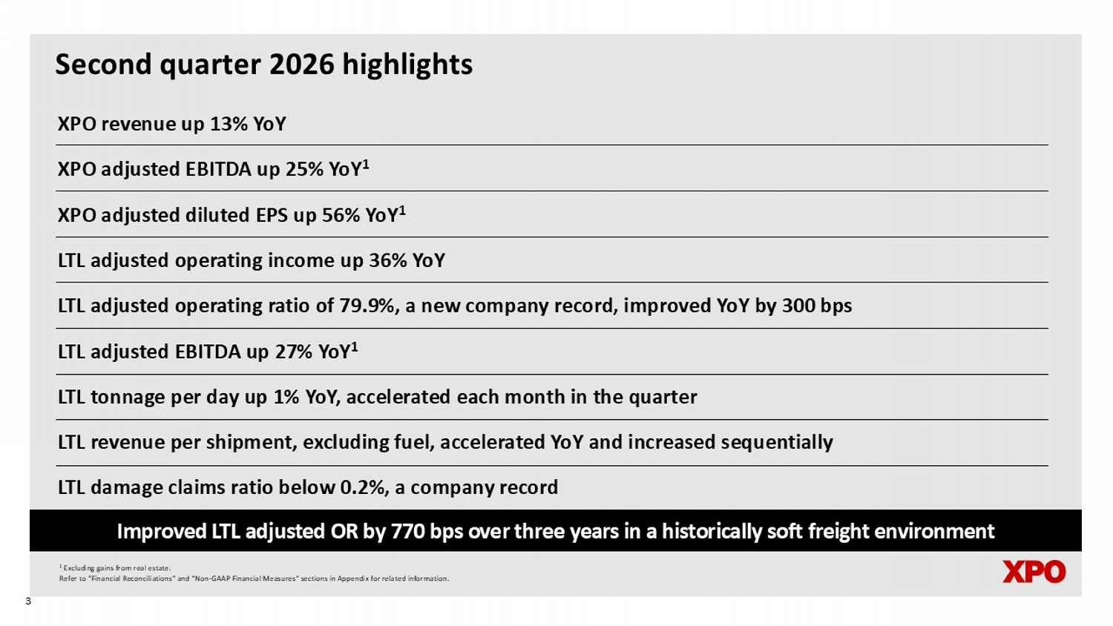
Second quarter 2026 highlights XPO revenue up 13% YoY XPO adjusted EBITDA up 25% YoY 1 XPO adjusted diluted EPS up 56% YoY 1 LTL adjusted operating income up 36% YoY LTL adjusted operating ratio of 79.9%, a new company record, improved YoY by 300 bps LTL adjusted EBITDA up 27% YoY 1 LTL tonnage per day up 1% YoY, accelerated each month in the quarter LTL revenue per shipment, excluding fuel, accelerated YoY and increased sequentially LTL damage claims ratio below 0.2%, a company record Improved LTL adjusted OR by 770 bps over three years in a historically soft freight environment 1 Excluding gains from real estate. Refer to “Financial Reconciliations” and “Non - GAAP Financial Measures” sections in Appendix for related information. 3

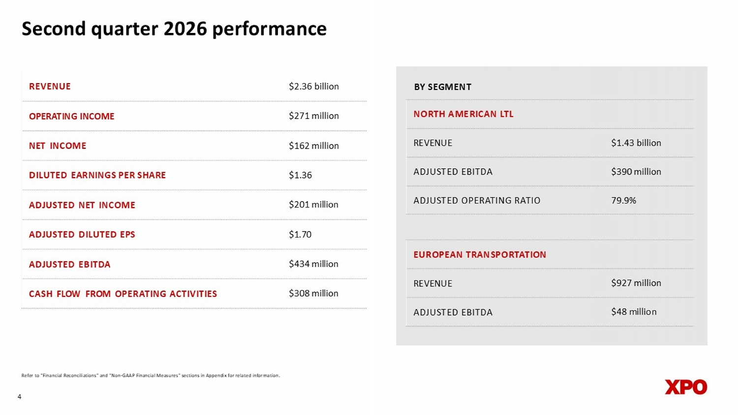
4 Second quarter 2026 performance $2.36 billion REVENUE $271 million OPERATING INCOME $162 million NET INCOME $1.36 DILUTED EARNINGS PER SHARE $201 million ADJUSTED NET INCOME $1.70 ADJUSTED DILUTED EPS $434 million ADJUSTED EBITDA $308 million CASH FLOW FROM OPERATING ACTIVITIES NORTH AMERICAN LTL $1.43 billion REVENUE $390 million ADJUSTED EBITDA 79.9% ADJUSTED OPERATING RATIO Refer to “Financial Reconciliations” and “Non - GAAP Financial Measures” sections in Appendix for related information. EUROPEAN TRANSPORTATION $927 million REVENUE $48 million ADJUSTED EBITDA BY SEGMENT

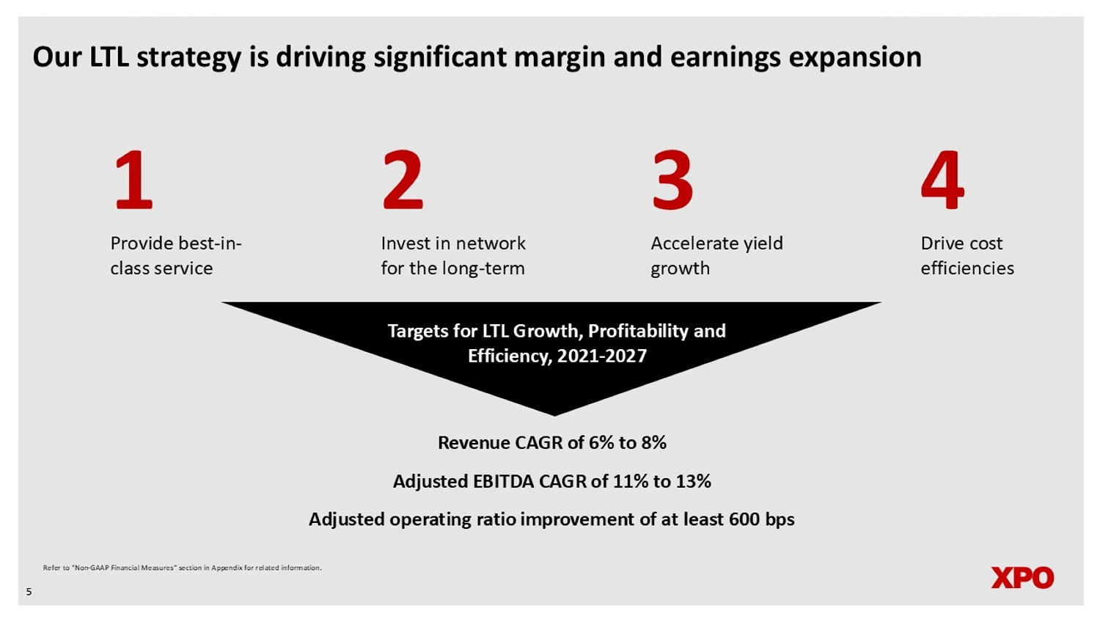
Our LTL strategy is driving significant margin and earnings expansion 5 Provide best - in - class service 2 3 4 Invest in network for the long - term Accelerate yield growth Drive cost efficienci es Targets for LTL Growth, Profitability and Efficiency, 2021 - 2027 1 Revenue CAGR of 6% to 8% Adjusted EBITDA CAGR of 11% to 13% Adjusted operating ratio improvement of a t least 600 bps Refer to “Non - GAAP Financial Measures” section in Appendix for related information.

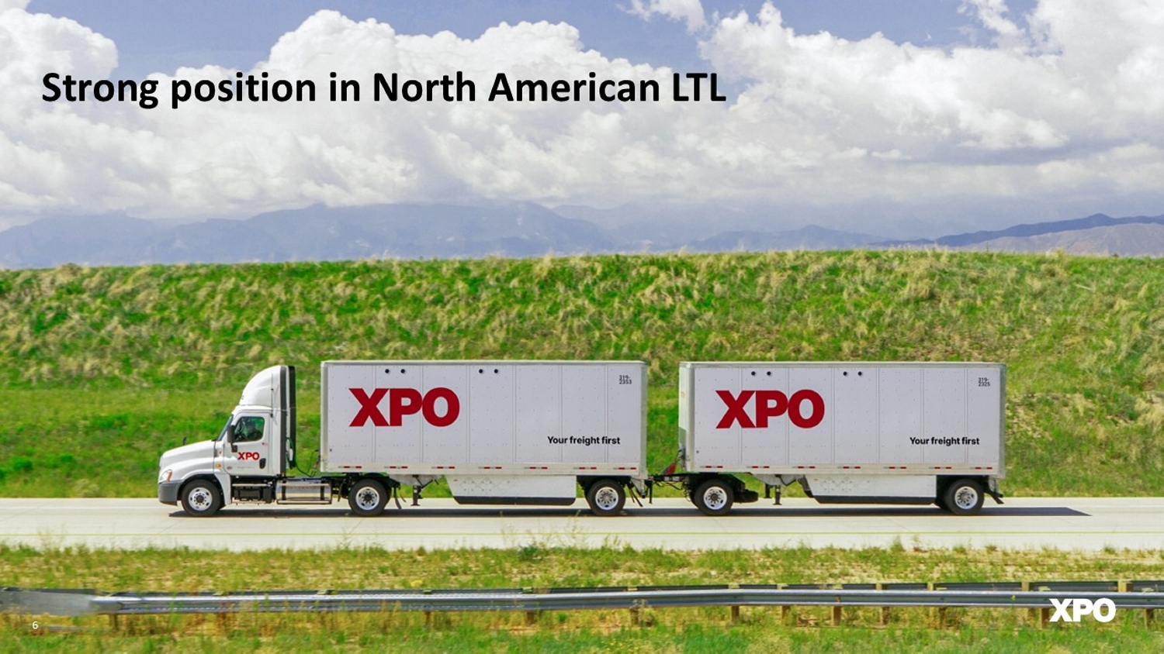
Strong position in North American LTL 6

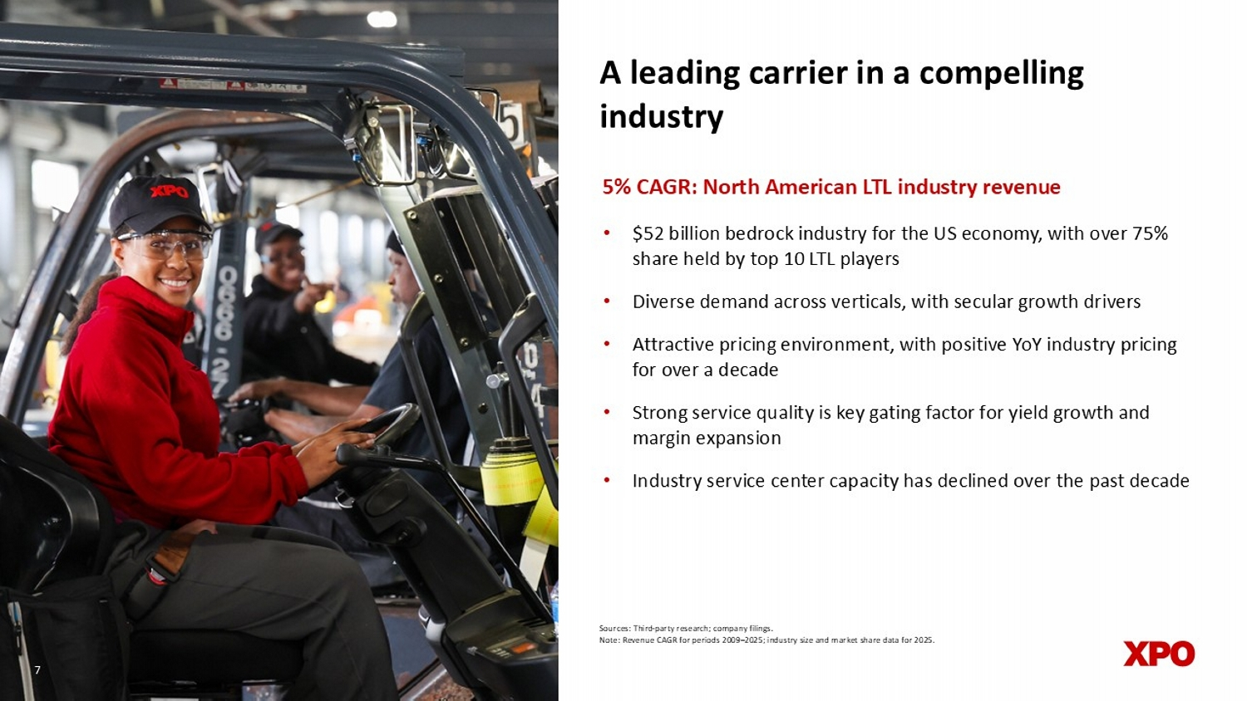
A leading carrier in a compelling industry • $52 billion bedrock industry for the US economy, with over 75% share held by top 10 LTL players • Diverse demand across verticals, with secular growth drivers • Attractive pricing environment, with positive YoY industry pricing for over a decade • Strong service quality is key gating factor for yield growth and margin expansion • Industry service center capacity has declined over the past decade 5% CAGR: North American LTL industry revenue Sources: Third - party research; company filings. Note: Revenue CAGR for periods 2009 – 2025; industry size and market share data for 2025. 7

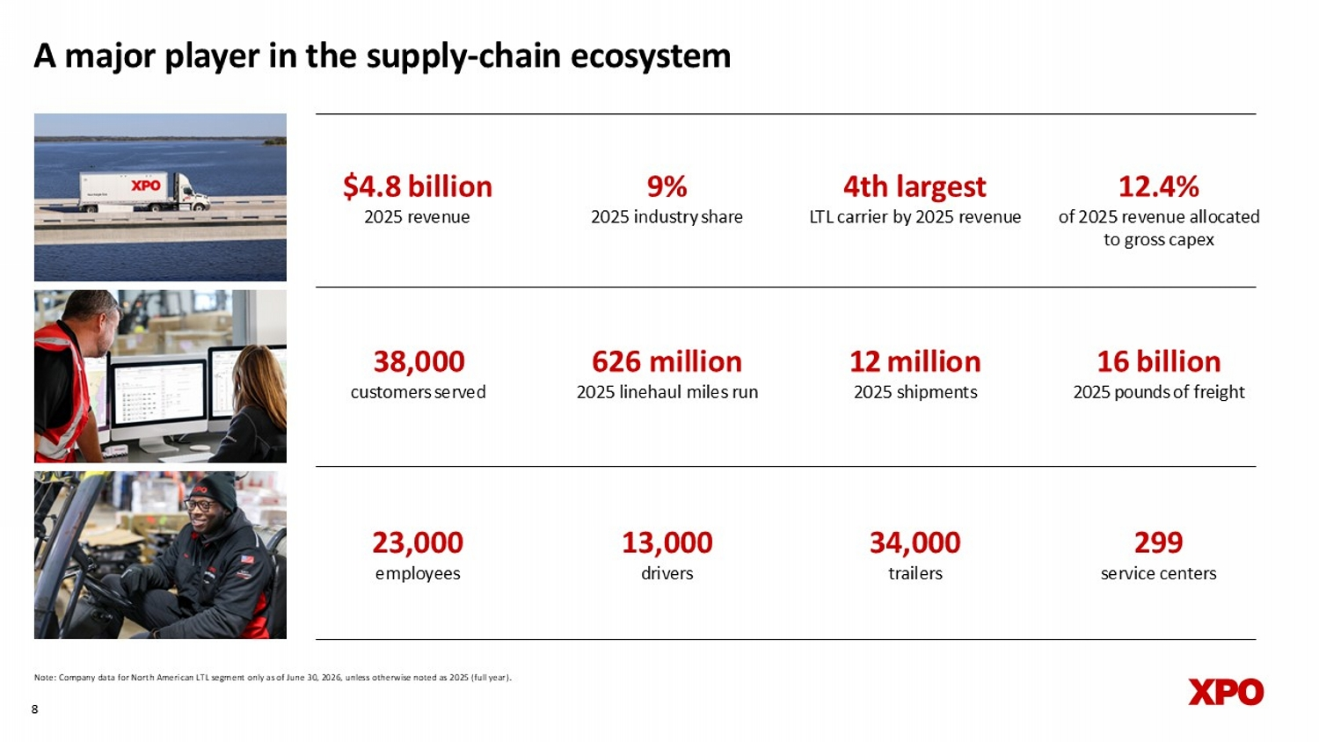
A major player in the supply - chain ecosystem Note: Company data for North American LTL segment only as of June 30, 2026, unless otherwise noted as 2025 (full year). 4th largest LTL carrier by 2025 revenue 12.4% of 2025 revenue allocated to gross capex 12 million 2025 s hipments 38,000 customers served $4.8 billion 2025 revenue 9 % 2025 industry share 8 13,0 0 0 d rivers 34,0 0 0 t railers 1 6 billion 2025 pounds of freight 626 million 2025 l inehaul miles run 2 3 ,0 0 0 e mployees 299 service centers quarterly (bring back

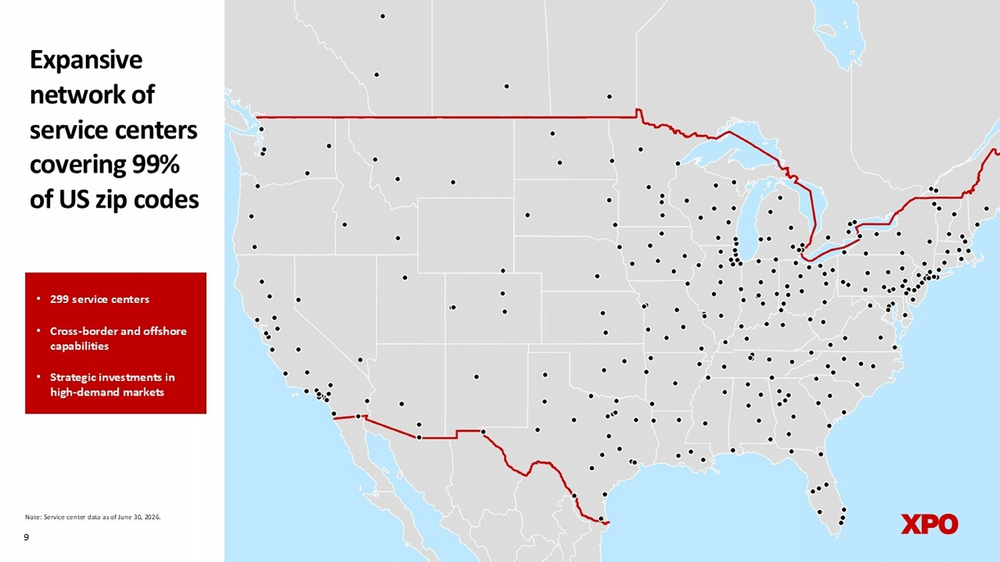
9 • 299 service centers • Cross - border and offshore capabilities • Strategic investments in high - demand markets Note: Service center data as of June 30, 2026. Expansive network of service centers covering 99% of US zip codes

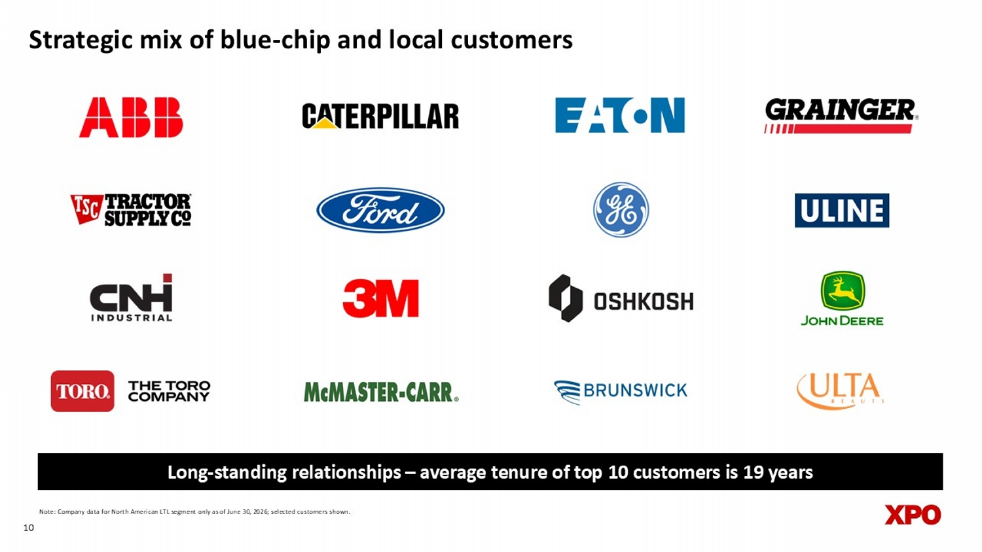
Strategic mix of blue - chip and local customers 10 Note: Company data for North American LTL segment only as of June 30, 2026; selected customers shown. Long - standing relationships – average tenure of top 10 customers is 19 years

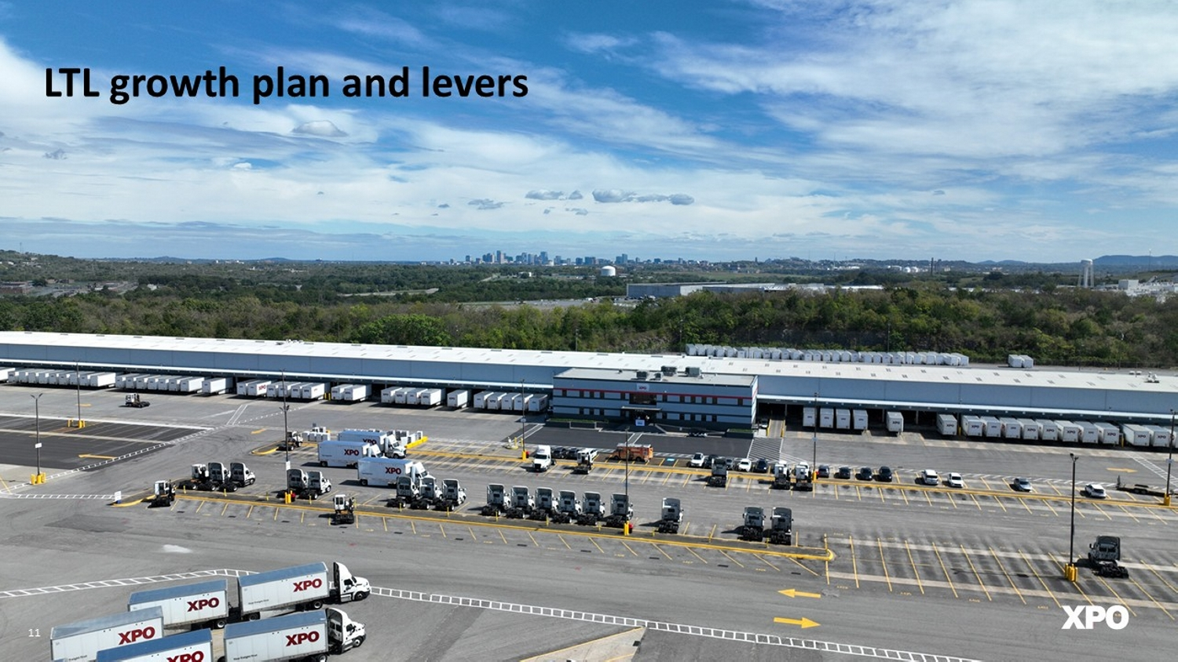
LTL growth plan and levers 11

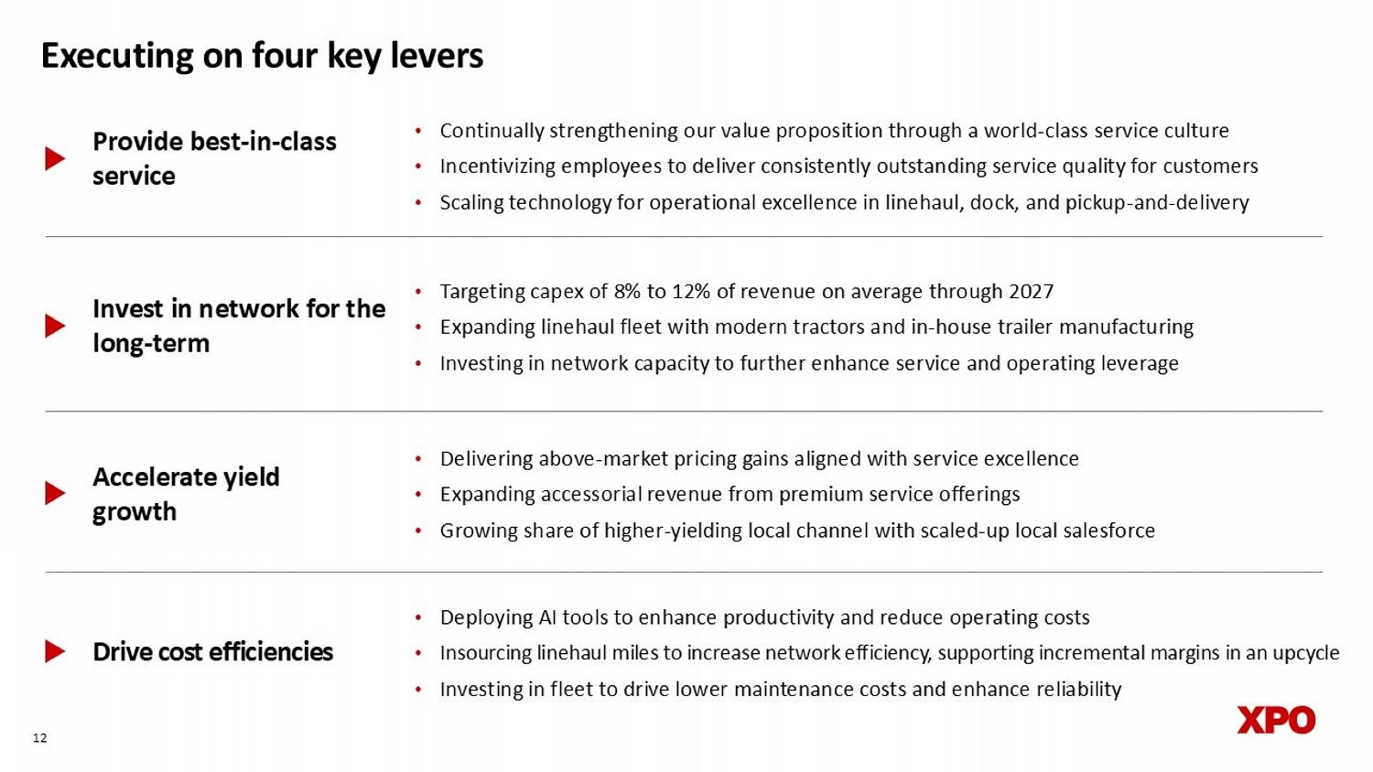
Provide best - in - class service Accelerate yield growth Drive cost efficiencies • Delivering above - market pricing gains aligned with service excellence • Expanding accessorial revenue from premium service offerings • Growing share of higher - yielding local channel with scaled - up local salesforce • Deploying AI tools to enhance productivity and reduce operating costs • Insourcing linehaul miles to increase network efficiency, supporting incremental margins in an upcycle • Investing in fleet to drive lower maintenance costs and enhance reliability 12 Executing on four key levers • Continually strengthening our value proposition through a world - class service culture • Incentivizing employees to deliver consistently outstanding service quality for customers • Scaling technology for operational excellence in linehaul, dock, and pickup - and - delivery Invest in network for the long - term • Targeting capex of 8% to 12% of revenue on average through 2027 • Expanding linehaul fleet with modern tractors and in - house trailer manufacturing • Investing in network capacity to further enhance service and operating leverage

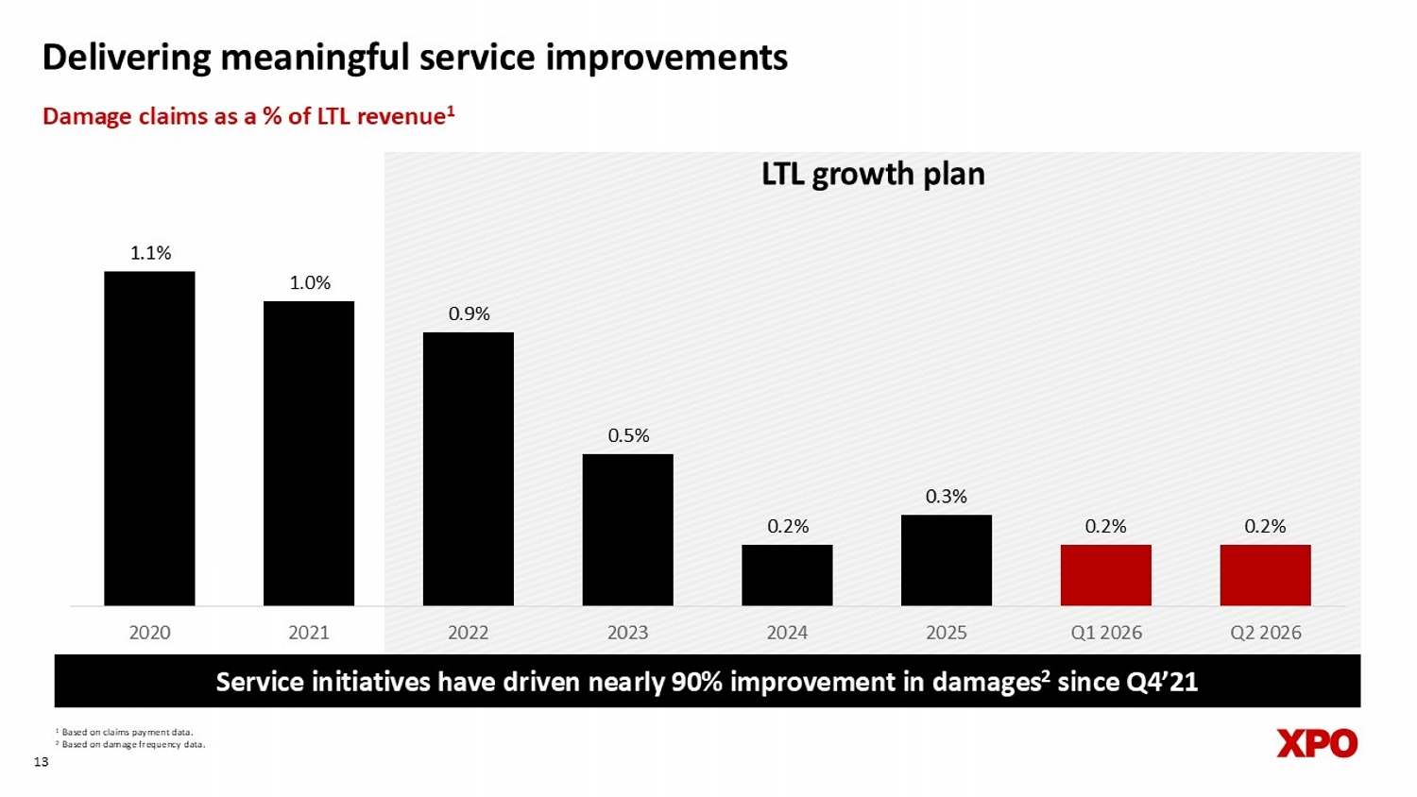
1 Based on claims payment data. 2 Based on damage frequency data. 13 Service initiatives have driven nearly 90% improvement in damages 2 since Q4’21 Delivering meaningful service improvements Damage claims as a % of LTL revenue 1 LTL growth plan 1.1% 1.0% 0.9% 0.5% 0.2% 0.3% 0.2% 0.2% 2020 2021 2022 2023 2024 2025 Q1 2026 Q2 2026

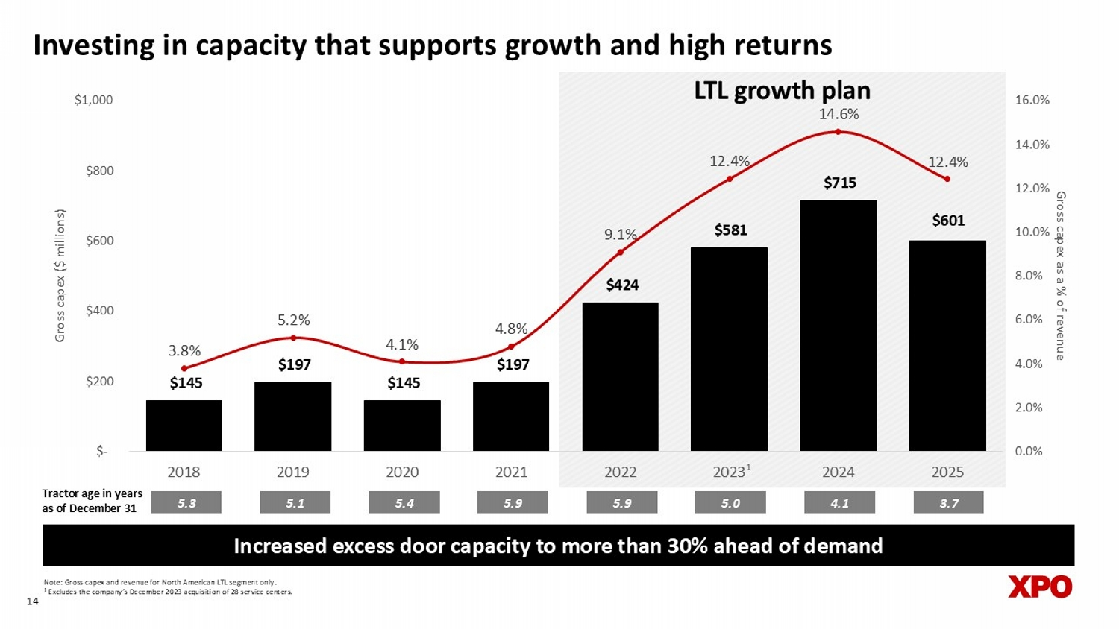
Investing in capacity that supports growth and high returns 14 Tractor age in years as of December 31 5.3 5.1 5.4 5.9 5.9 Note: Gross capex and revenue for North American LTL segment only. 1 Excludes the company’s December 2023 acquisition of 28 service centers. 5.0 1 Increased excess door capacity to more than 30% ahead of demand 4.1 LTL growth plan $601 $145 $197 $145 $197 $424 $581 $715 3.8% 5.2% 4.1% 4.8% 9.1% 12.4% 14.6% 12.4% 0.0% 2.0% 4.0% 6.0% 8.0% 10.0% 12.0% 14.0% 16.0% $- $200 $400 $600 $800 $1,000 2018 2019 2020 2021 2022 2023 2024 2025 Gross capex as a % of revenue Gross capex ($ millions) 3.7

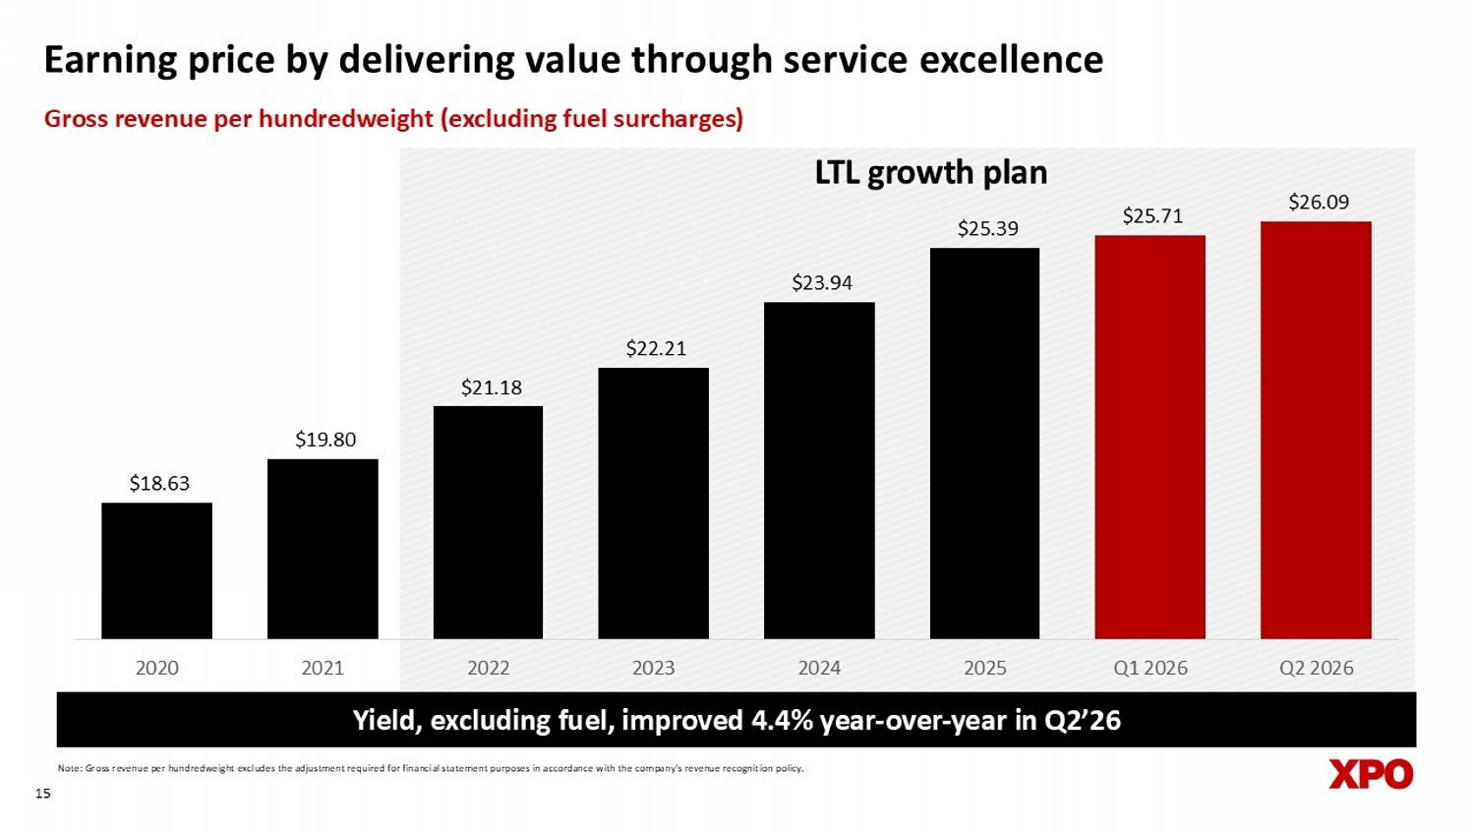
Earning price by delivering value through service excellence 15 Note: Gross revenue per hundredweight excludes the adjustment required for financial statement purposes in accordance with th e c ompany's revenue recognition policy. Yield, excluding fuel, improved 4.4% year - over - year in Q2’26 Gross revenue per hundredweight (excluding fuel surcharges) LTL growth plan $18.63 $19.80 $21.18 $22.21 $23.94 $25.39 $25.71 $26.09 2020 2021 2022 2023 2024 2025 Q1 2026 Q2 2026

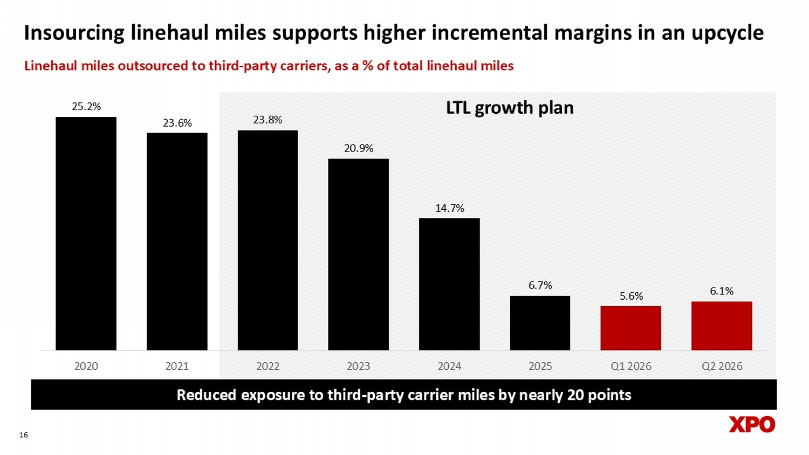
Insourcing linehaul miles supports higher incremental margins in an upcycle 16 Reduced exposure to third - party carrier miles by nearly 20 points Linehaul miles outsourced to third - party carriers, as a % of total linehaul miles LTL growth plan 25.2% 23.6% 23.8% 20.9% 14.7% 6.7% 5.6% 6.1% 2020 2021 2022 2023 2024 2025 Q1 2026 Q2 2026

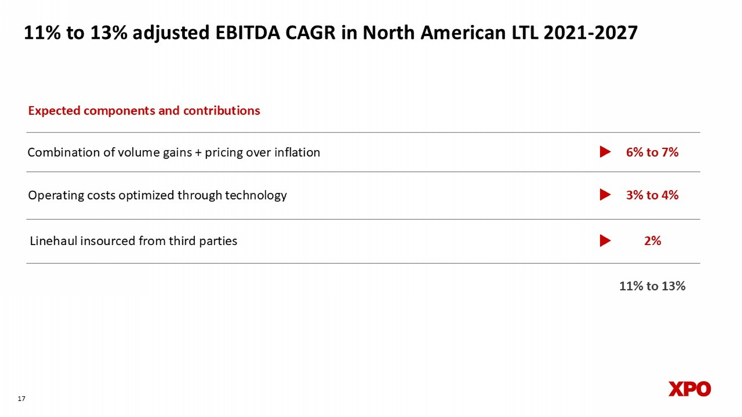
17 11% to 13% adjusted EBITDA CAGR in North American LTL 2021 - 2027 Combination of volume gains + pricing over inflation 6% to 7% 3% to 4% 2% Operating costs optimized through technology Linehaul insourced from third parties Expected components and contributions 11% to 13%


Appendix 18

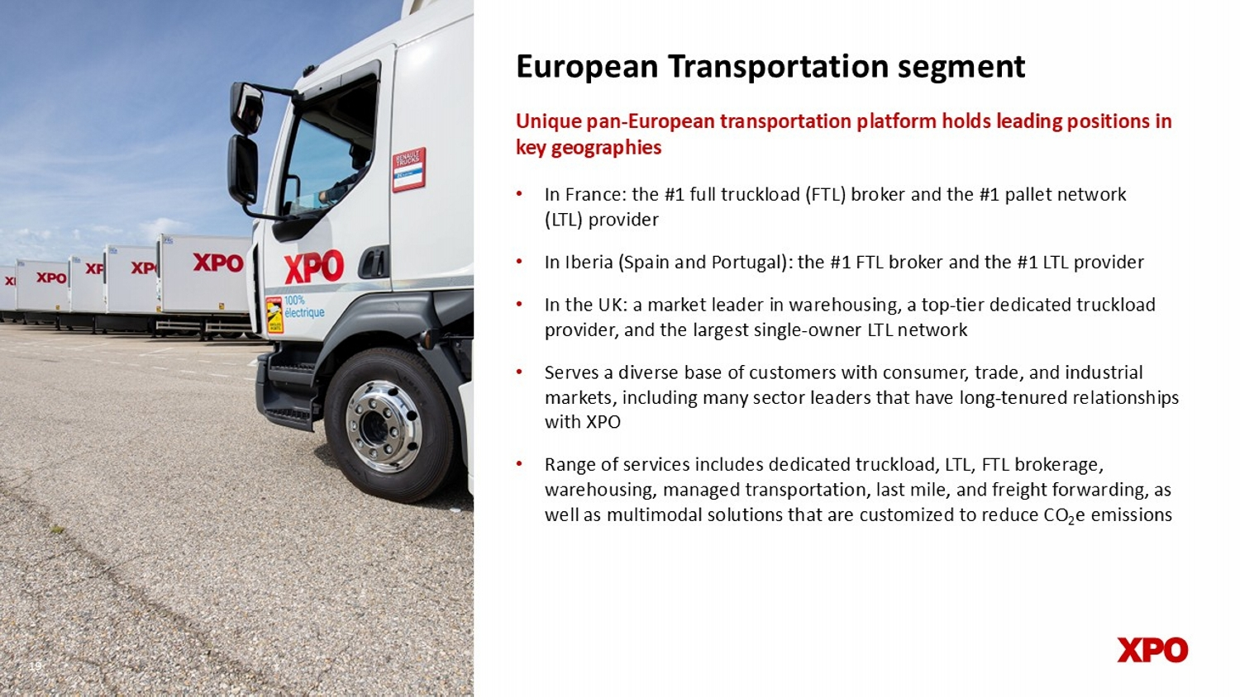
European Transportation segment • In France: the #1 full truckload (FTL) broker and the #1 pallet network (LTL) provider • In Iberia (Spain and Portugal): the #1 FTL broker and the #1 LTL provider • In the UK: a market leader in warehousing, a top - tier dedicated truckload provider, and the largest single - owner LTL network • Serves a diverse base of customers with consumer, trade, and industrial markets, including many sector leaders that have long - tenured relationships with XPO • Range of services includes dedicated truckload, LTL, FTL brokerage, warehousing, managed transportation, last mile, and freight forwarding, as well as multimodal solutions that are customized to reduce CO 2 e emissions Unique pan - European transportation platform holds leading positions in key geographies 19 19

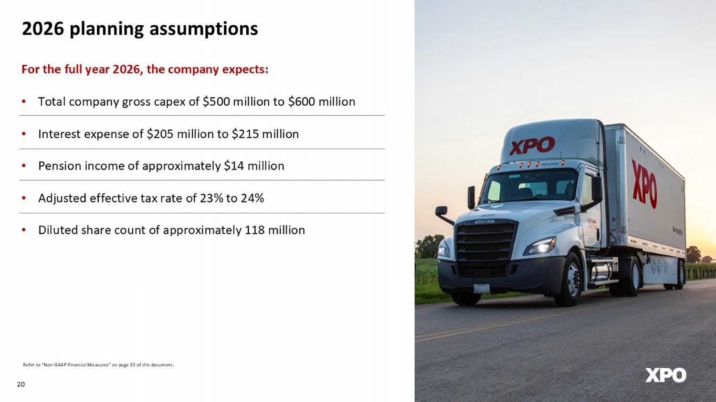
20 For the full year 2026, the company expects: • Total company gross capex of $500 million to $600 million • Interest expense of $205 million to $215 million • Pension income of approximately $14 million • Adjusted effective tax rate of 23% to 24% • Diluted share count of approximately 118 million 2026 planning assumptions Refer to “Non - GAAP Financial Measures” on page 25 of this document.

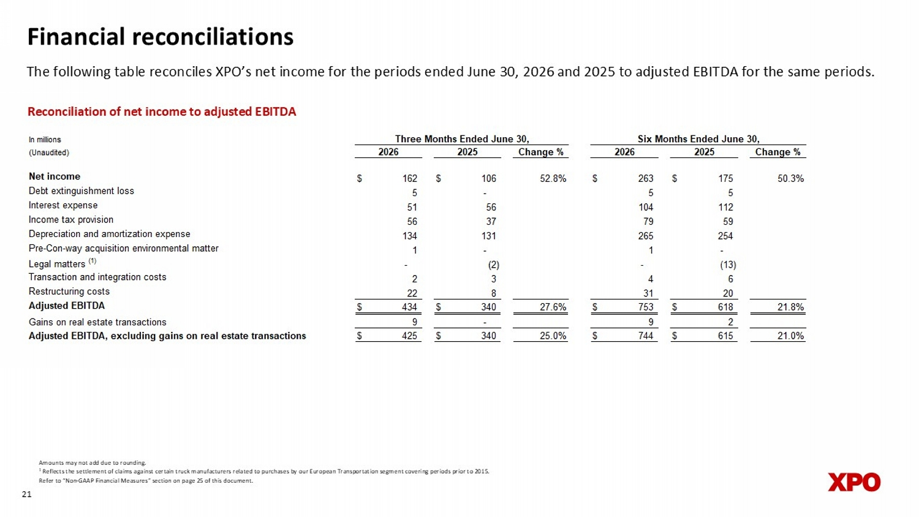
Financial reconciliations The following table reconciles XPO’s net income for the periods ended June 30, 2026 and 2025 to adjusted EBITDA for the same periods. 21 Reconciliation of net income to adjusted EBITDA Amounts may not add due to rounding. 1 Reflects the settlement of claims against certain truck manufacturers related to purchases by our European Transportation seg me nt covering periods prior to 2015. Refer to “Non - GAAP Financial Measures” section on page 25 of this document. In millions (Unaudited) Change % Change % Net income $ 162 $ 106 52.8% $ 263 $ 175 50.3% Debt extinguishment loss 5 - 5 5 Interest expense 51 56 104 112 Income tax provision 56 37 79 59 Depreciation and amortization expense 134 131 265 254 Pre-Con-way acquisition environmental matter 1 - 1 - Legal matters (1) - (2) - (13) Transaction and integration costs 2 3 4 6 Restructuring costs 22 8 31 20 Adjusted EBITDA $ 434 $ 340 27.6% $ 753 $ 618 21.8% Gains on real estate transactions 9 - 9 2 Adjusted EBITDA, excluding gains on real estate transactions $ 425 $ 340 25.0% $ 744 $ 615 21.0% Six Months Ended June 30, 2026 2025 Three Months Ended June 30, 2026 2025

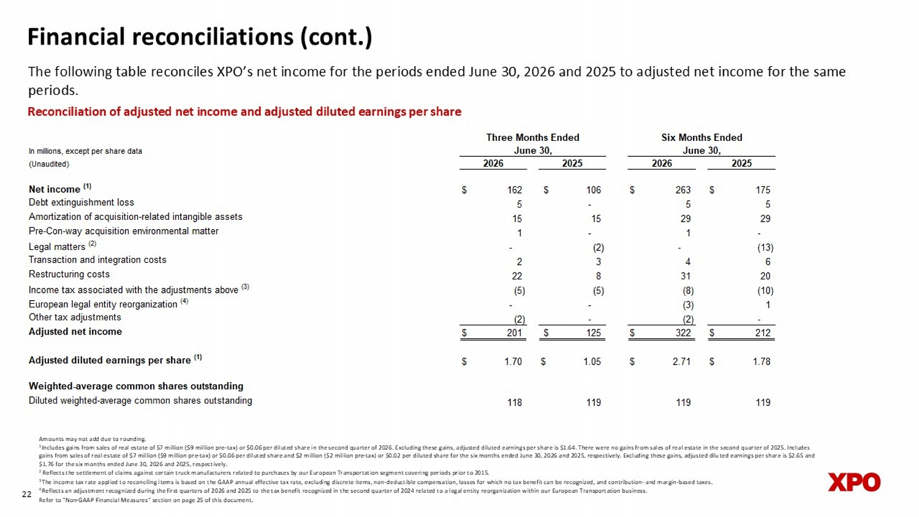
Financial reconciliations (cont.) The following table reconciles XPO’s net income for the periods ended June 30, 2026 and 2025 to adjusted net income for the same periods. 22 Amounts may not add due to rounding. 1 Includes gains from sales of real estate of $7 million ($9 million pre - tax) or $0.06 per diluted share in the second quarter of 2026. Excluding these gains, adjusted diluted earnings per share is $1.64. There were no gains from sales of real estate in the second quarter of 2025. Includes gains from sales of real estate of $7 million ($9 million pre - tax) or $0.06 per diluted sha re and $2 million ($2 million pre - tax) or $0.02 per diluted share for the six months ended June 30, 2026 and 2025, respectively. Excluding these gains, adjusted diluted earnings per share is $2.65 and $1.76 for the six months ended June 30, 20 26 and 2025, respectively. 2 Reflects the settlement of claims against certain truck manufacturers related to purchases by our European Transportation seg me nt covering periods prior to 2015. 3 The income tax rate applied to reconciling items is based on the GAAP annual effective tax rate, excluding discrete items, no n - d eductible compensation, losses for which no tax benefit can be recognized, and contribution - and margin - based taxes. 4 Reflects an adjustment recognized during the first quarters of 2026 and 2025 to the tax benefit recognized in the second quar ter of 2024 related to a legal entity reorganization within our European Transportation business. Refer to “Non - GAAP Financial Measures” section on page 25 of this document. Reconciliation of adjusted net income and adjusted diluted earnings per share In millions, except per share data (Unaudited) Net income (1) $ 162 $ 106 $ 263 $ 175 Debt extinguishment loss 5 - 5 5 Amortization of acquisition-related intangible assets 15 15 29 29 Pre-Con-way acquisition environmental matter 1 - 1 - Legal matters (2) - (2) - (13) Transaction and integration costs 2 3 4 6 Restructuring costs 22 8 31 20 Income tax associated with the adjustments above (3) (5) (5) (8) (10) European legal entity reorganization (4) - - (3) 1 Other tax adjustments (2) - (2) - Adjusted net income $ 201 $ 125 $ 322 $ 212 Adjusted diluted earnings per share (1) $ 1.70 $ 1.05 $ 2.71 $ 1.78 Weighted-average common shares outstanding Diluted weighted-average common shares outstanding 118 119 119 119 2026 2025 Three Months Ended June 30, Six Months Ended June 30, 2026 2025

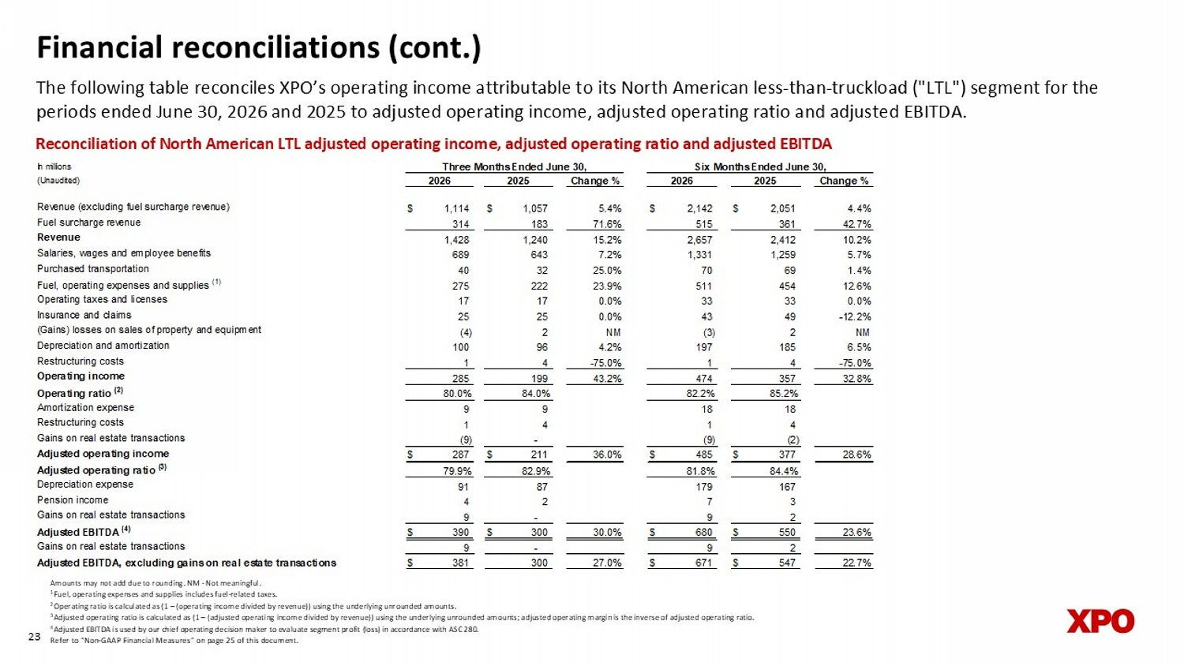
In millions (Unaudited) Change % Change % Revenue (excluding fuel surcharge revenue) $ 1,114 $ 1,057 5.4% $ 2,142 $ 2,051 4.4% Fuel surcharge revenue 314 183 71.6% 515 361 42.7% Revenue 1,428 1,240 15.2% 2,657 2,412 10.2% Salaries, wages and employee benefits 689 643 7.2% 1,331 1,259 5.7% Purchased transportation 40 32 25.0% 70 69 1.4% Fuel, operating expenses and supplies (1) 275 222 23.9% 511 454 12.6% Operating taxes and licenses 17 17 0.0% 33 33 0.0% Insurance and claims 25 25 0.0% 43 49 -12.2% (Gains) losses on sales of property and equipment (4) 2 NM (3) 2 NM Depreciation and amortization 100 96 4.2% 197 185 6.5% Restructuring costs 1 4 -75.0% 1 4 -75.0% Operating income 285 199 43.2% 474 357 32.8% Operating ratio (2) 80.0% 84.0% 82.2% 85.2% Amortization expense 9 9 18 18 Restructuring costs 1 4 1 4 Gains on real estate transactions (9) - (9) (2) Adjusted operating income $ 287 $ 211 36.0% $ 485 $ 377 28.6% Adjusted operating ratio (3) 79.9% 82.9% 81.8% 84.4% Depreciation expense 91 87 179 167 Pension income 4 2 7 3 Gains on real estate transactions 9 - 9 2 Adjusted EBITDA (4) $ 390 $ 300 30.0% $ 680 $ 550 23.6% Gains on real estate transactions 9 - 9 2 Adjusted EBITDA, excluding gains on real estate transactions $ 381 300 27.0% $ 671 $ 547 22.7% 2026 2025 Three Months Ended June 30, Six Months Ended June 30, 2026 2025 Financial reconciliations (cont.) The following table reconciles XPO’s operating income attributable to its North American less - than - truckload ("LTL") segment for the periods ended June 30, 2026 and 2025 to adjusted operating income, adjusted operating ratio and adjusted EBITDA. 23 Reconciliation of North American LTL adjusted operating income, adjusted operating ratio and adjusted EBITDA Amounts may not add due to rounding. NM - Not meaningful. 1 Fuel, operating expenses and supplies includes fuel - related taxes. 2 Operating ratio is calculated as (1 – (operating income divided by revenue)) using the underlying unrounded amounts. 3 Adjusted operating ratio is calculated as (1 – (adjusted operating income divided by revenue)) using the underlying unrounded am ounts; adjusted operating margin is the inverse of adjusted operating ratio. 4 Adjusted EBITDA is used by our chief operating decision maker to evaluate segment profit (loss) in accordance with ASC 280. Refer to “Non - GAAP Financial Measures” on page 25 of this document.

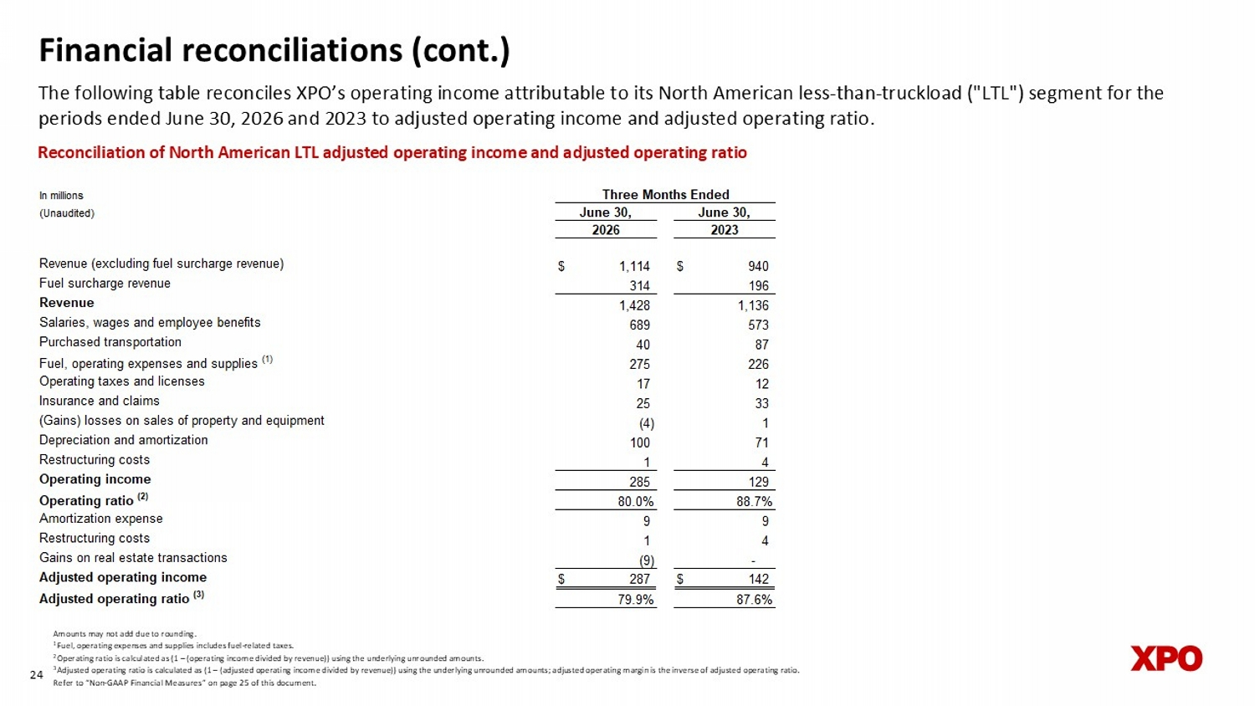
Financial reconciliations (cont.) The following table reconciles XPO’s operating income attributable to its North American less - than - truckload ("LTL") segment for the periods ended June 30, 2026 and 2023 to adjusted operating income and adjusted operating ratio. 24 Reconciliation of North American LTL adjusted operating income and adjusted operating ratio Amounts may not add due to rounding. 1 Fuel, operating expenses and supplies includes fuel - related taxes. 2 Operating ratio is calculated as (1 – (operating income divided by revenue)) using the underlying unrounded amounts. 3 Adjusted operating ratio is calculated as (1 – (adjusted operating income divided by revenue)) using the underlying unrounded am ounts; adjusted operating margin is the inverse of adjusted operating ratio. Refer to “Non - GAAP Financial Measures” on page 25 of this document. In millions (Unaudited) Revenue (excluding fuel surcharge revenue) $ 1,114 $ 940 Fuel surcharge revenue 314 196 Revenue 1,428 1,136 Salaries, wages and employee benefits 689 573 Purchased transportation 40 87 Fuel, operating expenses and supplies (1) 275 226 Operating taxes and licenses 17 12 Insurance and claims 25 33 (Gains) losses on sales of property and equipment (4) 1 Depreciation and amortization 100 71 Restructuring costs 1 4 Operating income 285 129 Operating ratio (2) 80.0% 88.7% Amortization expense 9 9 Restructuring costs 1 4 Gains on real estate transactions (9) - Adjusted operating income $ 287 $ 142 Adjusted operating ratio (3) 79.9% 87.6% Three Months Ended June 30, June 30, 2026 2023

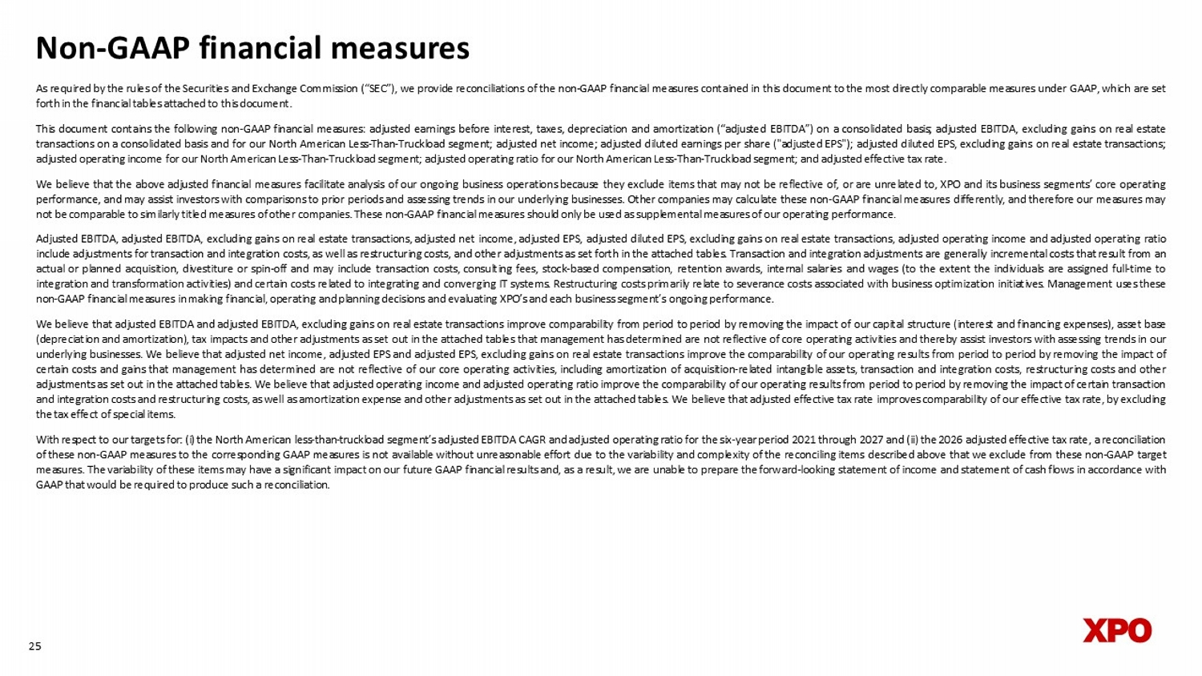
Non - GAAP financial measures As required by the rules of the Securities and Exchange Commission (“SEC”), we provide reconciliations of the non - GAAP financial measures contained in this document to the most directly comparable measures under GAAP, which are set forth in the financial tables attached to this document . This document contains the following non - GAAP financial measures : adjusted earnings before interest, taxes, depreciation and amortization (“adjusted EBITDA”) on a consolidated basis ; adjusted EBITDA, excluding gains on real estate transactions on a consolidated basis and for our North American Less - Than - Truckload segment ; adjusted net income ; adjusted diluted earnings per share ("adjusted EPS") ; adjusted diluted EPS, excluding gains on real estate transactions ; adjusted operating income for our North American Less - Than - Truckload segment ; adjusted operating ratio for our North American Less - Than - Truckload segment ; and adjusted effective tax rate . We believe that the above adjusted financial measures facilitate analysis of our ongoing business operations because they exclude items that may not be reflective of, or are unrelated to, XPO and its business segments’ core operating performance, and may assist investors with comparisons to prior periods and assessing trends in our underlying businesses . Other companies may calculate these non - GAAP financial measures differently, and therefore our measures may not be comparable to similarly titled measures of other companies . These non - GAAP financial measures should only be used as supplemental measures of our operating performance . Adjusted EBITDA, adjusted EBITDA, excluding gains on real estate transactions, adjusted net income, adjusted EPS, adjusted diluted EPS, excluding gains on real estate transactions, adjusted operating income and adjusted operating ratio include adjustments for transaction and integration costs, as well as restructuring costs, and other adjustments as set forth in the attached tables . Transaction and integration adjustments are generally incremental costs that result from an actual or planned acquisition, divestiture or spin - off and may include transaction costs, consulting fees, stock - based compensation, retention awards, internal salaries and wages (to the extent the individuals are assigned full - time to integration and transformation activities) and certain costs related to integrating and converging IT systems . Restructuring costs primarily relate to severance costs associated with business optimization initiatives . Management uses these non - GAAP financial measures in making financial, operating and planning decisions and evaluating XPO’s and each business segment’s ongoing performance . We believe that adjusted EBITDA and adjusted EBITDA, excluding gains on real estate transactions improve comparability from period to period by removing the impact of our capital structure (interest and financing expenses), asset base (depreciation and amortization), tax impacts and other adjustments as set out in the attached tables that management has determined are not reflective of core operating activities and thereby assist investors with assessing trends in our underlying businesses . We believe that adjusted net income, adjusted EPS and adjusted EPS, excluding gains on real estate transactions improve the comparability of our operating results from period to period by removing the impact of certain costs and gains that management has determined are not reflective of our core operating activities, including amortization of acquisition - related intangible assets, transaction and integration costs, restructuring costs and other adjustments as set out in the attached tables . We believe that adjusted operating income and adjusted operating ratio improve the comparability of our operating results from period to period by removing the impact of certain transaction and integration costs and restructuring costs, as well as amortization expense and other adjustments as set out in the attached tables . We believe that adjusted effective tax rate improves comparability of our effective tax rate, by excluding the tax effect of special items . With respect to our targets for : ( i ) the North American less - than - truckload segment’s adjusted EBITDA CAGR and adjusted operating ratio for the six - year period 2021 through 2027 and (ii) the 2026 adjusted effective tax rate, a reconciliation of these non - GAAP measures to the corresponding GAAP measures is not available without unreasonable effort due to the variability and complexity of the reconciling items described above that we exclude from these non - GAAP target measures . The variability of these items may have a significant impact on our future GAAP financial results and, as a result, we are unable to prepare the forward - looking statement of income and statement of cash flows in accordance with GAAP that would be required to produce such a reconciliation . 25

