UNITED STATES

SECURITIES AND EXCHANGE COMMISSION
Washington, D.C. 20549

FORM 8-K

CURRENT REPORT

Pursuant to Section 13 or 15(d)
of the Securities Exchange Act of 1934

Date of Report (Date of earliest event reported): July 18, 2016

XPO LOGISTICS, INC.

(Exact name of registrant as specified in its charter)

Delaware

001-32172

03-0450326

(State or other jurisdiction
of incorporation)

(Commission
File Number)

(I.R.S. Employer
Identification No.)

Five Greenwich Office Park, Greenwich, Connecticut 06831

(Address of principal executive offices)

(855) 976-6951

(Registrant’s telephone number, including area code)

N/A

(Former name or former address, if changed since last report)

Check the appropriate box below if the Form 8-K filing is intended to simultaneously satisfy the filing obligation of the registrant under any of the following provisions:

- Written communications pursuant to Rule 425 under the Securities Act (17 CFR 230.425)

- Soliciting material pursuant to Rule 14a-12 under the Exchange Act (17 CFR 240.14a-12)

- Pre-commencement communications pursuant to Rule 14d-2(b) under the Exchange Act (17 CFR 240.14d-2(b))

- Pre-commencement communications pursuant to Rule 13e-4(c) under the Exchange Act (17 CFR 240.13e-4(c))

Item 7.01. Regulation FD Disclosure.

On July 18, 2016, XPO Logistics, Inc. (the “Company”) released a slide presentation expected to be used by the Company in connection with certain future investor presentations, together with a corresponding script. Copies of the slide presentation and script are attached as Exhibit 99.1 and Exhibit 99.2, respectively, to this Current Report on Form 8-K.

The slide presentation and script should be read together and with the Company’s filings with the Securities and Exchange Commission, including the Quarterly Report on Form 10-Q for the quarter ended March 31, 2016.

The information furnished in this Item 7.01, including Exhibit 99.1 and Exhibit 99.2, shall not be deemed “filed” for purposes of Section 18 of the Securities Exchange Act of 1934, as amended (the “Exchange Act”), or otherwise subject to the liabilities of that Section, and shall not be deemed to be incorporated by reference into any filing of the Company under the Exchange Act or the Securities Act of 1933, as amended, except to the extent that the registrant specifically incorporates any such information by reference.

Item 9.01. Financial Statements and Exhibits.

(d) Exhibits

Exhibit
No. |  | Exhibit Description
99.1 |  | Investor Presentation, dated July 18, 2016
99.2 |  | Investor Presentation Script, dated July 18, 2016

SIGNATURE

Pursuant to the requirements of the Securities Exchange Act of 1934, the registrant has duly caused this report to be signed on its behalf by the undersigned hereunto duly authorized.

Date: July 18, 2016 XPO LOGISTICS, INC.

By: /s/ Gordon E. Devens

Gordon E. Devens

Chief Legal Officer

EXHIBIT INDEX

Exhibit
No. |  | Exhibit Description
99.1 |  | Investor Presentation, dated July 18, 2016
99.2 |  | Investor Presentation Script, dated July 18, 2016

Exhibit 99.1
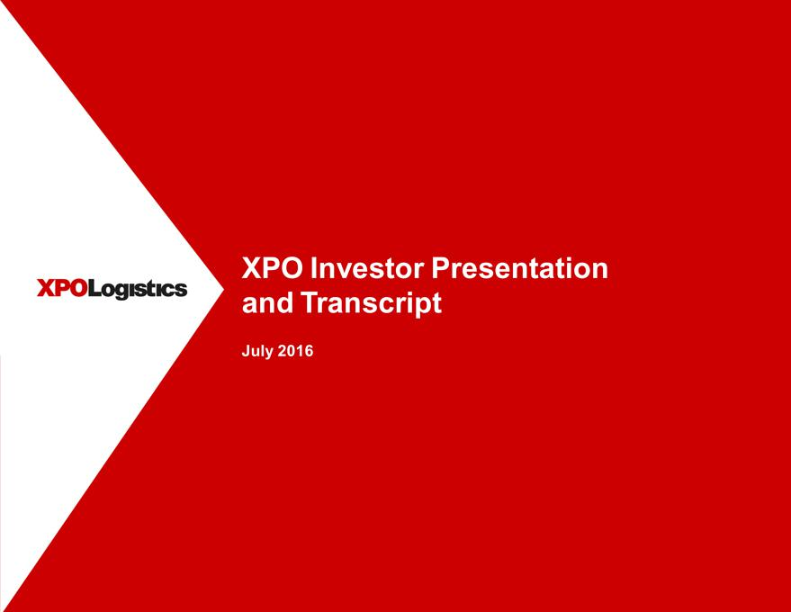

XPO Logistics XPO Investor Presentation and Transcript July 2016

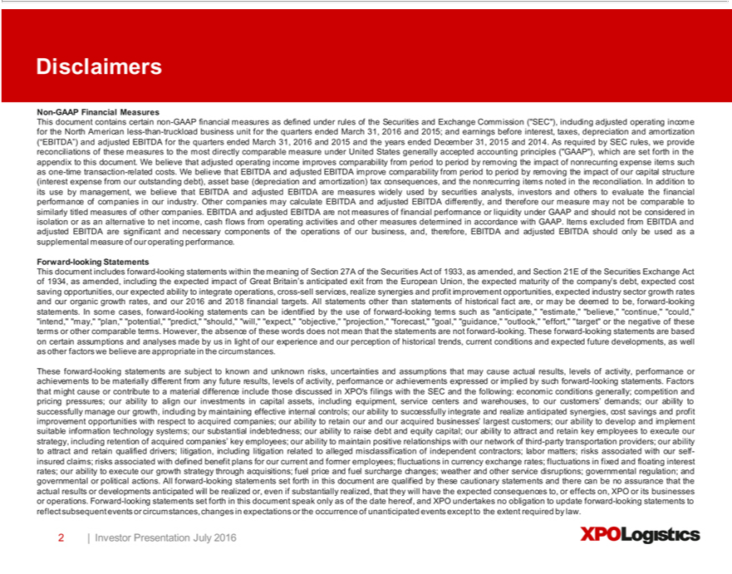

Disclaimers Non-GAAP Financial Measures This document contains certain non-GAAP financial measures as defined under rules of the Securities and Exchange Commission (“SEC”), including adjusted operating
income for the North American less-than-truckload business unit for the quarters ended March 31, 2016 and 2015; and earnings before interest, taxes, depreciation and amortization (“EBITDA”) and adjusted EBITDA
for the quarters ended March 31, 2016 and 2015 and the years ended December 31, 2015 and 2014. As required by SEC rules, we provide reconciliations of these measures to the most directly comparable measure
under United States generally accepted accounting principles (“GAAP”), which are set forth in the |  |  |  | to this document. W believe that adjusted operating income improves comparability from period to period
by removing the impact of nonrecurring expense items such as one-time transaction-related costs. Wappendixbelieve that EBITDA and adjusted EBITDA improve comparability from period to period by removing the impact
of our capital structure (interest expense from our outstanding debt), asset base (depreciation and amortization) tax consequences, and the nonrecurring items noted in the reconciliation. In addition to its use by
nagement, we believe that EBITDA and adjusted EBITDA are measures widely used by securities analysts, investors and others to evaluate the financial performance of companies in our industry. Other companies
may calculate EBITDA and adjusted EBITDA differently, and therefore our measure may not be comparable to similarly titled measures of other companies. EBITDA and adjusted EBITDA are not measures of
financial performance or liquidity under GAAP and should not be considered in isolation or as an alternative to net income, cash flows from operating activities and other measures determined in accordance with
GAAP. Items excluded from EBITDA and adjusted EBITDA are significant and necessary components of the operations of our business, and, therefore, EBITDA and adjusted EBITDA should only
supplemental measure of our operating performance. Forward-looking Statements This document includes forward-looking statements within the meaning of Section 27A of the Securities Act of 1933,beusedasaamended, and
Section 21E of the Securities Exchange Act of 1934, as amended, including the expected impact of Great Britain’s anticipated exit from the European Union, the expected maturity of the company’s debt, expected cost
saving opportunities, our expected ability to integrate operations, cross-sell services, realize synergies and profit improvement opportunities, expected industry sector growth rates and our organic growth rates, and our
2016 and 2018 financial targets. All statements other than statements of historical fact are, or may be deemed to be, forward- ooking statements. In some cases, forward-looking statements can be identified by the use
of forward-looking terms such as “anticipate,” “estimate,” “believe,” “continue,” “could,” “intend,” “may,” “plan,” “potential,” “predict,” “should,” “will,” “expect,” “objective,” “projection,” “forecast,” “goal,”
“guidance,” “outlook,” “effort,” “target” or the negative of these terms or other comparable terms. However, the absence of these words does not mean that the statements are not forward-looking. These forward-
looking statements are based on |  | assumptions and analyses made by us in light of our experience and our perception of historical trends, current conditions and expected future developments, as well as other
factors we believe are appropriatecertainthe circumstances. These forward-looking statements are subject to known and unknown risks, uncertainties and assumptions that may cause actual results, levels of activity,
performance or achievements to be materially different from any future results, levels of activity, performance or achievements expressed or implied by such forward-looking statements. |  |  |  |  | that might cause or
ontribute to a material difference include those discussed in XPO’ filings with the SEC |  |  | the following: economic conditions generally; competition and pricing pressures; our ability Factorsalign our investments in
capital assets, including equipment, service centers and warehouses, to our customers’ demands; our ability to successfully manage our growth, including by maintaining effective internal controls; our ability
successfully integrate and realize anticipated synergies, cost savings and profit improvement opportunities with respect to acquired companies; our ability to retain our and our acqu red businesses’ largest customers;
our ability to develop and implement suitable information technology systems; our substantial indebtedness; our ability to raise debt and equity capital; our ability to attract and retain key employees to execute our
strategy, including retention of acquired companies’ key employees; our ability to maintain positive relationships with our network of third-party transportation providers; our ability to attract and retain qualified
driv rs; litigation, including litigation related to alleged misclassification of |  |  | contractors; labor matters; risks associated with our self-insured claims; risks associated with defined benefit plans for our
urrent and former employees; fluctuations in currency exchange rates; fluctuationsindependentfixed and floating interest rates; our ability to execute our growth strategy through acquisitions; fuel price and fuel surcharge
changes; weather and other service disruptions; governmental regulation; and governmental or political actions. All forward-looking statements set forth in this document are qualified by these cautionary statements
and there can be no assurance that the actual results or developments anticipated will be realized or even if substantially realized, that they will have the expected consequences to, or effects on, XPO or its businesses
or operations.Forward- | statements set forthin this document speak only as of the date hereof, and XPO undertakes no obligation to update forward-looking statements to reflect subsequent events or
circumstances, changeslookingexpectations or the occurrence of unanticipated events except to the extent required by law. 2 | Investor Presentation July 2016 XPO Logistics

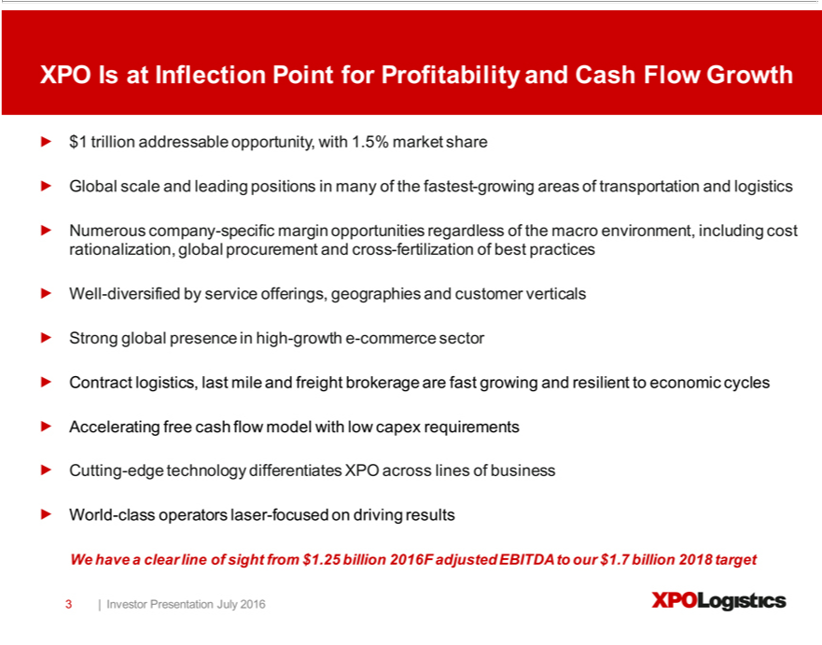

XPO Is at Inflection Point for Profitability and Cash Flow Growth $1 trillion addressable opportunity, with 1.5% market share Global scale and leading positions in many of the fastest-growing areas of transportation and logistics Numerous company-specific margin opportunities regardless of the macro _{environment,} including cost rationalization, global procurement and cross-fertilization of best practices Well-diversified by service offerings, geographies and customer verticals Strong global presence in high-growth -commerce sector Contract logistics, last mile and freight brokerage are fast growing and _{resilient} to economic cycles Accelerating free cash flow model with low capex requirements Cutting-edge technology differentiates XPO across lines of business World-class operators laser-focused on driving results W have a clear line of sight from $1.25 billion 2016F adjusted EBITDA to our $1.7 billion 2018 target 3 | Investor Presentation July 2016 XPO Logistics

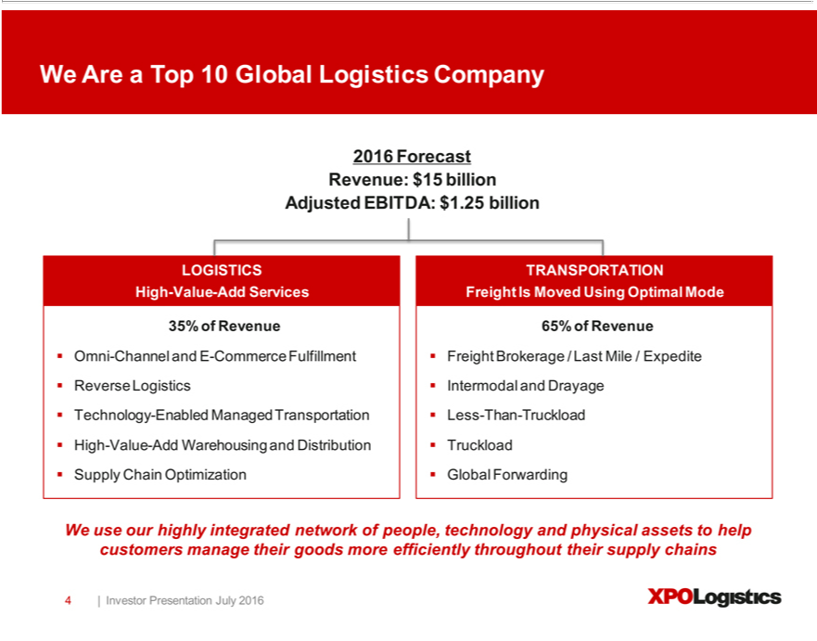

W_{Revenue}Area Top 10 Global Logistics Company 2016 Forecast Revenue: $15 billion Adjusted EBITDA: $1.25 billion LOGISTICS High-Value-Add Services 35% of Revenue Omni-Channel and E-Commerce Fulfillment rse Log_{Freight}stics Technology-Enabled Managed Transportation High-Value-Add Warehousing and Distribution Supply Chain Optimization TRANSPORTATION Freight Is Moved Using Optimal Mode 65% of

Brokerage / Last Mile / Expedite Intermodal and Drayage Less-Than-Truckload Truckload Global Forwarding We use our highly integrated network of people, technology and physical assets to help customers manage their goods more efficiently throughout their supply chains 4 | Investor Presentation July 2016 XPO Logistics

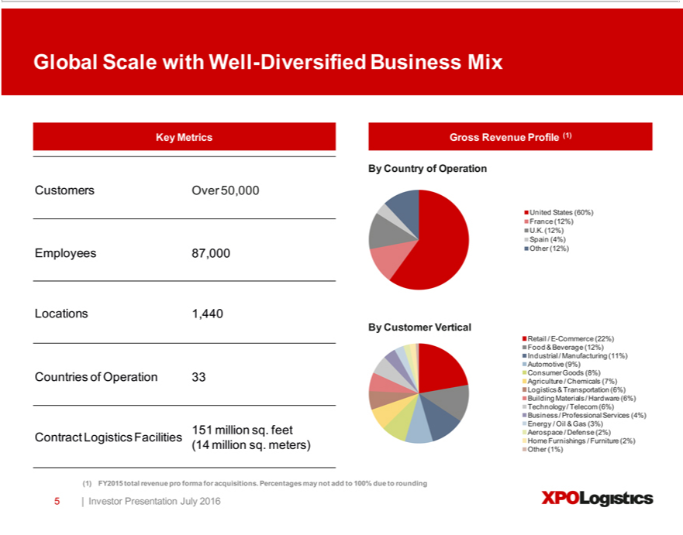

Global Scale with Well-Diversified Business Mix Key Metrics Customers Over 50,000 Employees 87,000 Locations 1,440 Countries of Operation 33 151 million sq. feet Contract Logistics Facilities (14 million sq. meters) Gross Revenue Profile (1) By Country of Operation United States (60%) France (12%) U.K. (12%) Spain (4%) Other (12%) By Customer Vertical Retail / E-Commerce (22%) Food & Beverage

^{(6%)}12%) Industrial / Manufacturing (11%) Automotive (9%) Consumer Goods (8%) Agriculture / Chemicals (7%) Logistics & Transportation (6%) Building Materials / Hardware (6%) Technology / Telecom Business / Professional Services (4%) Energy / Oil & Gas (3%) Aerospace / Defense (2%) Home Furnishings / Furniture (2%) Other (1%) (1) FY2015 total revenue pro forma for acquisitions. Percentages may
not add to 100% due to rounding 5 | Investor Presentation July 2016 XPO Logistics

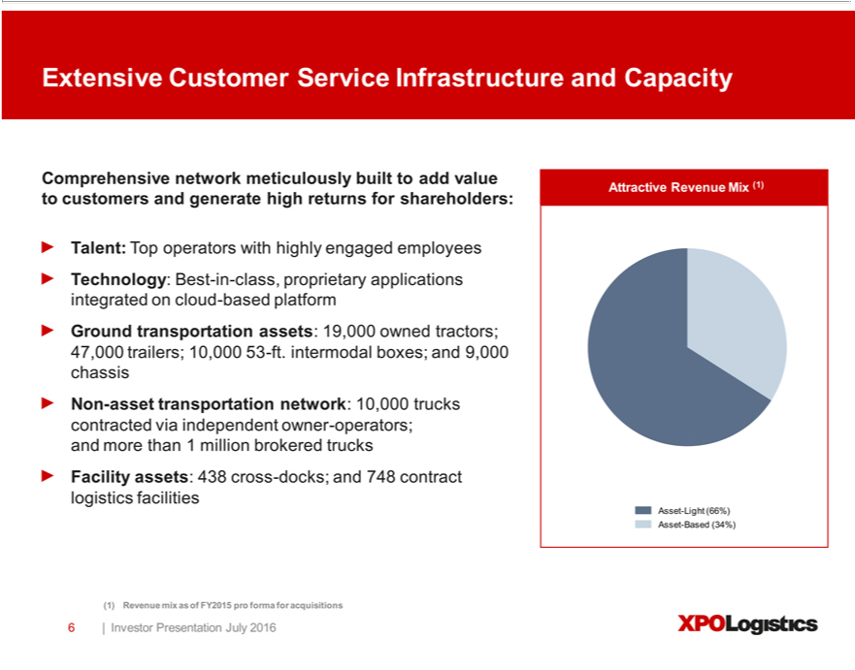

operatorsExtensive withCustomerhighlyServiceengagedInfrastructureemployeesTechnology:andCapacityBestComprehensive-in-class,proprietarynetworkapplicationsmeticulouslyintegratedbuilttoaddon valuecloud-(1)basedAttractiveplatformRevenueGroundMixtransportationtocustomersassets:and generate19,000ownedhighreturnstractors;for47,000shareholders:trailers; Talent:10,000 Top53-ft.
intermodal boxes; and 9,000 chassis Non-asset transportation network: 10,000 trucks contracted via independent owner-operators; and more than 1 million brokered trucks Facility assets: 438 cross-docks; and 748 contract logistics facilities Asset-Light (66%) Asset-Based (34%) (1) Revenue mix as of FY2015 pro forma for acquisitions 6 | Investor Presentation July 2016 XPO Logistics

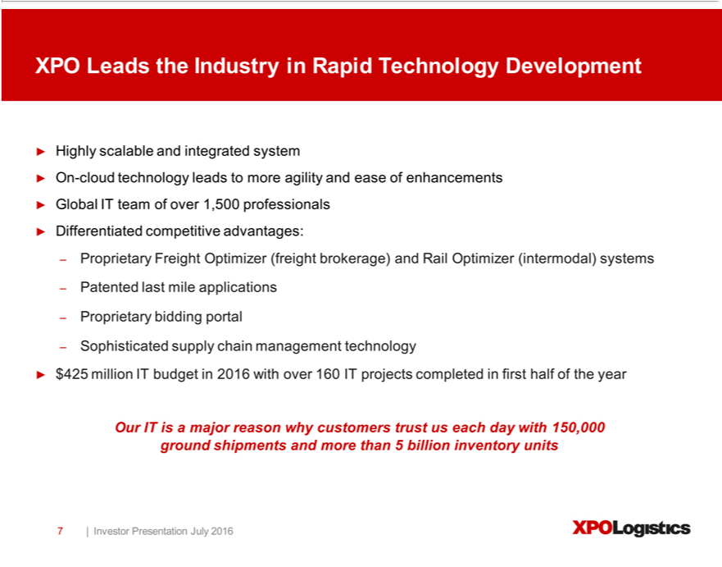

XPO Leads the Industry in Rapid Technology Development Highly scalable and integrated system On-cloud technology leads to more agility and ease of enhancements Global IT team of over 1,500 professionals Differentiated competitive advantages: – Proprietary Freight Optimizer (freight brokerage) and Rail Optimizer (intermodal) systems ^{Patented} last mile applications – Proprietary bidding portal – Sophisticated supply chain management technology $425 million IT budget in 2016 with over 160 IT projects completed in first half of the year Our IT is major reason why customers trust us each day with 150,000 ground shipments and more than 5 billion inventory units 7 | Investor Presentation July 2016 XPO Logistics

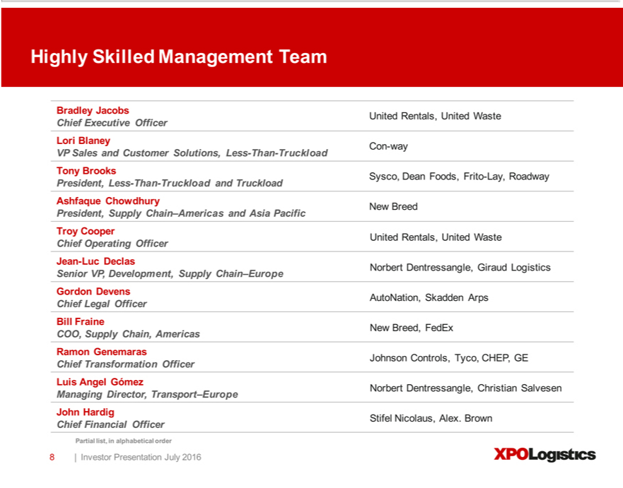

Highly Skilled Management Team Bradley Jacobs United Rentals, United Waste Chief Executive Officer Lori Blaney Con-way VP Sales and Customer Solutions, Less-Than-Truckload Tony Brooks Sysco, Dean Foods, Frito-Lay, Roadway President, Less-Than-Truckload and Truckload Ashfaque Chowdhury New Breed President, Supply Chain–Americas and Asia Pacific Troy Cooper United Rentals, United Waste Chief Operating^{COO,}fficer Jean-Luc Declas Senior VP, Development, Supply Chain–Europe Norbert Dentressangle, Giraud Logistics Gordon Devens AutoNation, Skadden Arps Chief Legal Officer Bill Fraine New Breed,
FedEx Supply Chain, Americas Ramon Genemaras Chief Transformation Officer Johnson Controls, Tyco, CHEP, GE Luis Angel Gómez Norbert Dentressangle, Christian Salvesen Managing Director, Transport–Europe John Hardig Stifel Nicolaus, Alex. Brown Chief Financial Officer Partial list, in alphabetical order 8 | Investor Presentation July 2016 XPO Logistics

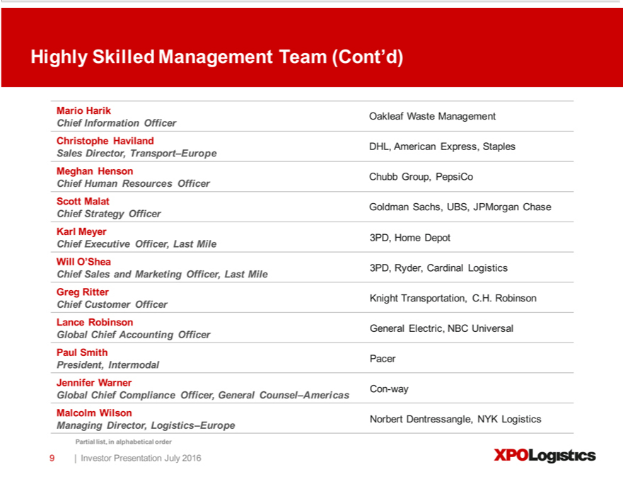

HensonighlySkilledChubb ManagementGroup,PepsiCoTeamChief(Cont’d)HumanMarioResourcesHarik OfficerOakleafScottWasteMalatnagementGoldmanChiefSachs,InformationUBS,JPMorganOfficerChaseChristopheChief StrategyHavilandOfficerDHL, AmericanKarlMeyerExpress,3PD,HomeStaplesDepotSalesChiefDirector,ExecutiveTransport–EuropeOfficer,Last MeghanMileWill O’Shea Chief Sales and Marketing Officer, Last Mile 3PD, Ryder, Cardinal Logistics Greg Ritter Chief Customer Officer Knight Transportation,Counsel.H.Robinson Lance Robinson General Electric, NBC Universal
LogisticsGlobalChiefManagingAccountingDirector,OfficerLogistics–EuropePaulSmithPresident,Partial list,IntermodalinalphabeticalPacerJenniferorder9 Warner|InvestorConPresentation-wayGlobalJulyChief2016ComplianceXPOLogisticsOfficer General –Americas Malcolm Wilson Norbert Dentressangle, NYK

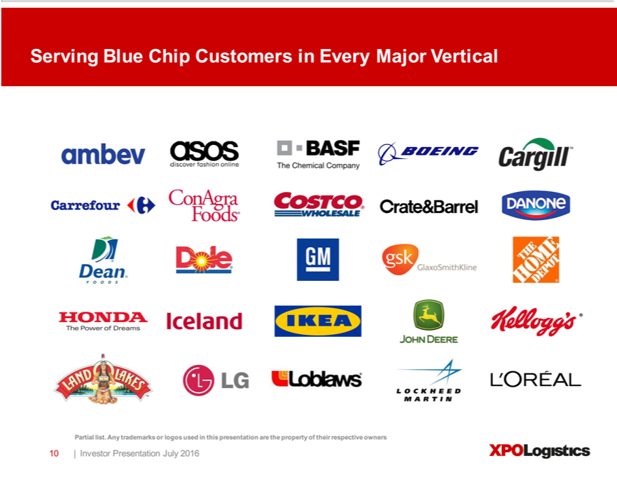

Serving Blue Chip Customers in Every Major Vertical Partial list. Any trademarks or logos used in this presentation are the property of their respective owners 10 | Investor Presentation July 2016 XPO Logistics

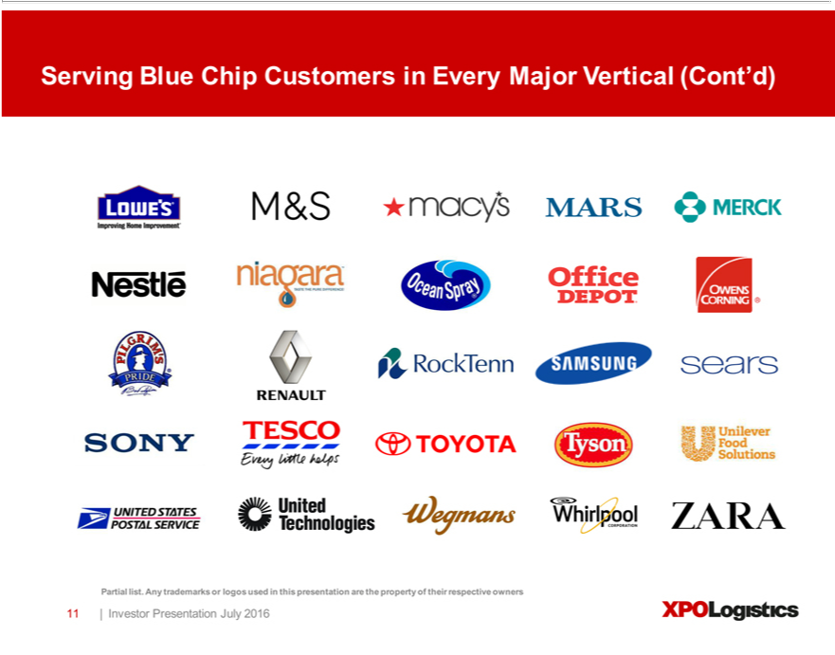

Serving Blue Chip Customers in Every Major Vertical (Cont’d) Partial list. Any trademarks or logos used in this presentation are the property of their respective owners 11 | Investor Presentation July 2016 XPO Logistics

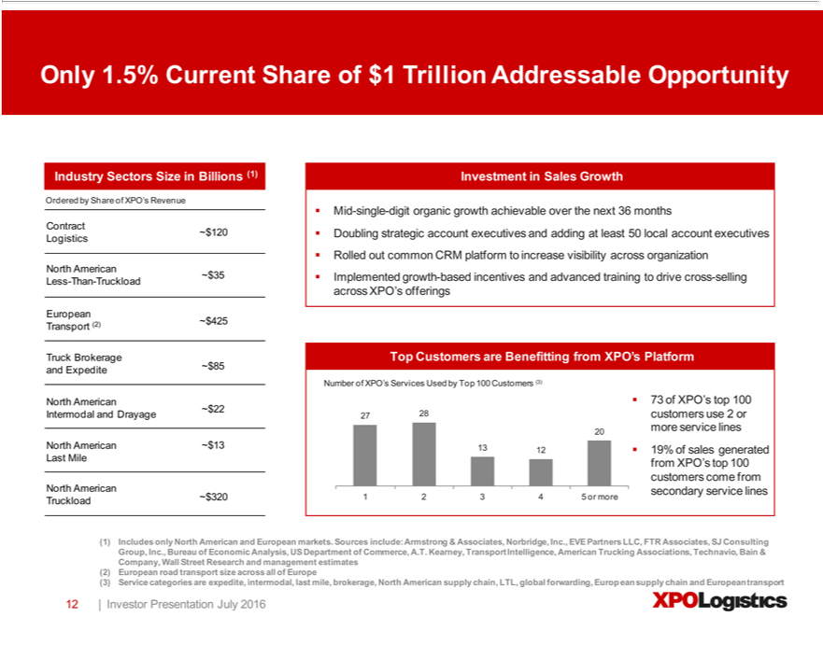

Only 1.5% Current Share of $1 Trillion Addressable Opportunity Industry Sectors Size in Billions (1) Ordered by Share of XPO’s Revenue Contract ~$120 Logistics North American ~$35 Less-Than-Truckload
singleEuropean-digit(2)organic~$425growthTransportachievableTruckBrokerageoverthenextand Expedite36months~$Doubling85North strategicAmericanaccount~$22Intermodalexecutives andand DrayageaddingatNorthleast 50Americanlocalaccount~$13LastexecutivesMileNorthRolledAmericanoutcommonTruckloadCRM ~platform$320Investmenttoincreasein visibilitySalesGrowthacrossMid-organization Implemented growth-based incentives and advanced training to drive cross-selling across XPO’s offerings Top Customers are Benefitting from XPO’secondaryPlatform Number of XPO’ Services Used by Top
100nlyCustomersNorth (3) 73 andofXPO’sEuropeantop 100markets.2728Sourcescustomersinclude:use2 Armstrongor20more&serviceAssociates,lines13Norbridge,1219%ofInc.,salesEVEgeneratedPartnersfromLLC,XPO’FTR topAssociates,100customersSJConsultingcomefromGroup, Inc., BureauserviceoflinesEconomic12345Analysis,ormore (1)USIncludesDepartment
of Commerce,American.T.Kearney, Transport Intelligence, American Trucking Associations, Technavio, Bain & Company, Wall Street Research and management estimates (2) European road transport size across all of Europe (3) Service categories are expedite, intermodal, last mile, brokerage, North American supply chain, LTL, global forwarding, European supply chain and European transport 12 | Investor Presentation July 2016 XPO Logistics

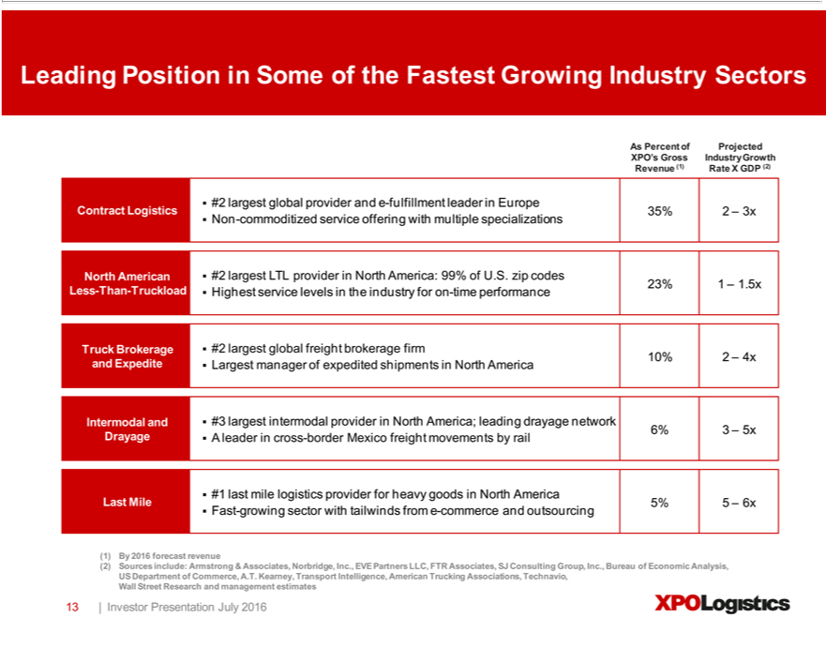

Leading Position in Some of the Fastest Growing Industry Sectors As Percent of Projected XPO’s Gross Industry Growth Revenue (1) Rate X GDP (2) #2 largest global provider and e-fulfillment leader in Europe
Contract Logistics 35% 2 – 3x Non-commoditized service offering with multiple specializations North American #2 largest LTL provider in North America: 99% of U.S. zip codes 23% 1 – 1.5x Less-Than-Truckload
Highest service levels the industry for on-time performance Truck Brokerage #2 largest global freight brokerage firm 10% 2 – 4x and Expedite Largest manager of expedited shipments in North America Intermodal
and #3 largest intermodal provider in North America; leading drayage | 6% 3 – 5x Drayage A leader in cross-border Mexico freight movements by rail #1 last mile logistics provider for heavy goods in North
America Last Mile 5% 5 – 6x Fast-growing sector with tailwinds from network-commerce and outsourcing (1) By 2016 forecast revenue (2) Sources include: Armstrong & Associates, Norbridge, Inc., EVE Partners LLC, FTR Associates, SJ Consulting Group, Inc., Bureau of Economic Analysis, US Department of Commerce, A.T. Kearney, Transport Intelligence, American Trucking Associations, Technavio, Wall Street Research and management estimates 13 | Investor Presentation July 2016 XPO Logistics

Clear Path to $1.7 Billion EBITDA Target by 2018 Well Defined Bridge from $1.25 Billion 2016 Forecast Cost Rationalization, Global Procurement and Productivity Gains At least $300 million of identified annual run-rate cost savings to be implemented over the next 36 months, representing 200bps of margin improvement across XPO’s ~$14 billion of addressable spend Continued execution on $170 million—$210 million of LTL profit improvement opportunities ($90 million ^{already} achieved) Benefiting from established fixed-cost infrastructure, driving margin expansion alongside revenue growth Mid-Single-Digit Organic Revenue Growth Differentiated growth driven in part by leading -commerce platform Intensified global selling organization promoting increased customer penetration and cross-selling Cross-Fertilization of Best _{Practices} Continuous improvement and knowledge-sharing across all service offerings and geographies Large impact in areas like warehouse operations, cross dock operations, maintenance, safety, training and HR XPO’ Chief Transformation Officer, Ramon Genemaras, has previously led $1 billion+ cost-outs at General Electric, Tyco and Johnson Controls 14 | Investor Presentation July 2016 XPO Logistics

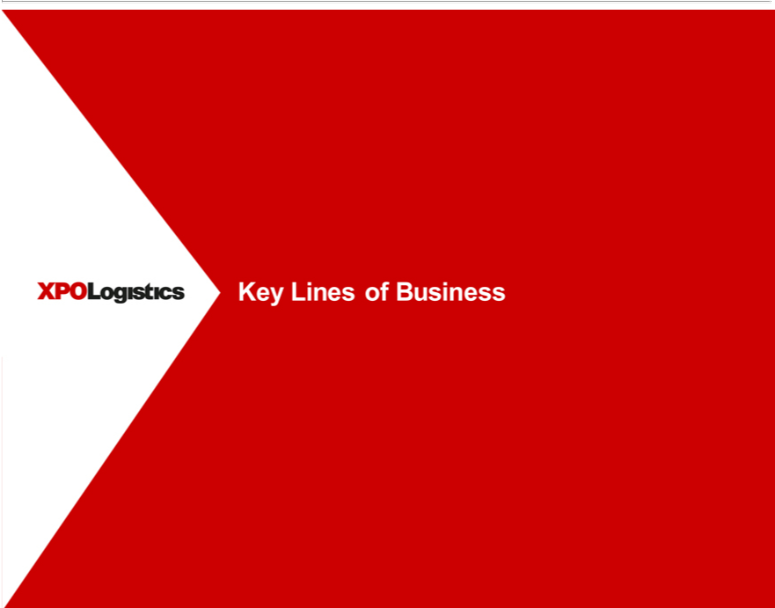

XPO Logistics
Key Lines of Business

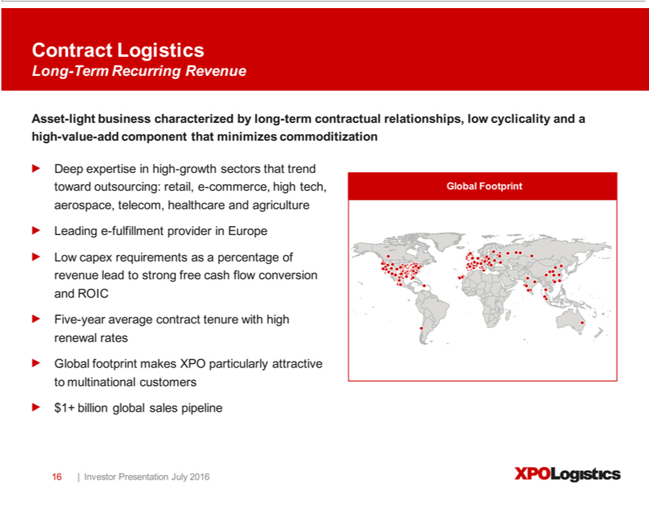

Contract Logistics Long Term Recurring Revenue Asset-light business characterized by long-term contractual relationships, low cyclicality andandhigh-value-add component that minimizes commoditization Deepexpertiseinhigh-growthsectorsthattrendoutsourcing:retail,-commerce,hightech,GlobalFootprintaerospace,telecom,healthcareagricultureLeading-fulfillmentproviderinEuropeLowcapex
requirements as a percentage of revenue leadtowardstrong free cash flow conversion and ROIC Five-year average contract tenure with high renewal rates Global footprint makes XPO particularly attractive to multinational customers $1+ billion global sales pipeline 16 | Investor Presentation July 2016 XPO Logistics

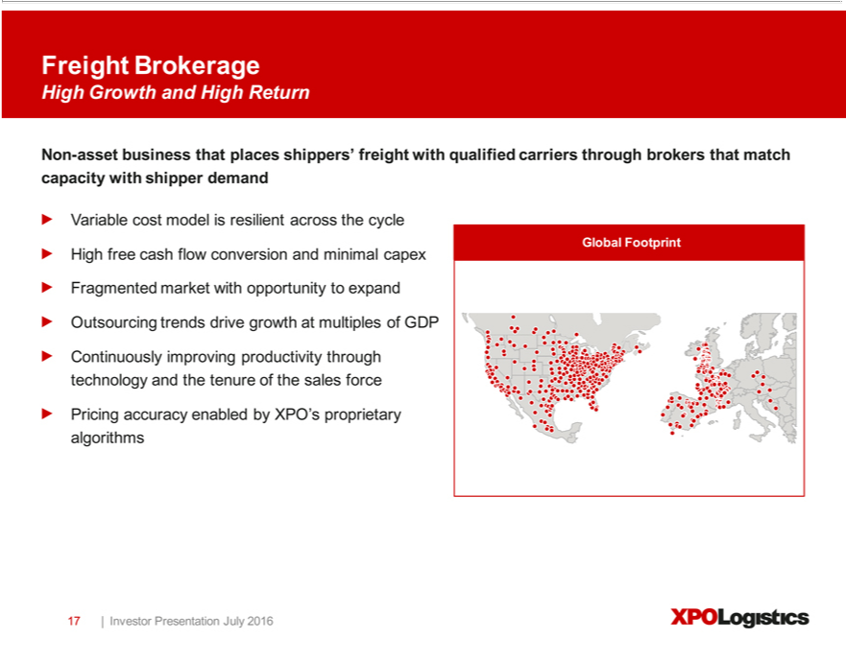

Freight Brokerage High Growth and High Return Non-asset business that places shippers’ freight with qualified carriers through brokers that match capacity with shipper demand Variable cost model is resilient acrosscycleGlobalFootprintHighfreecashflowconversionandminimalcapexFragmentedmarketwithopportunityexpandOutsourcingtrendsdrivegrowthatmultiplesofGDPContinuouslyimproving through Investor productivitytechnologyandthetenureofthesalesforcePricingaccuracyenabledbyXPO’sproprietaryalgorithms17|PresentationJuly2016XPOLogistics

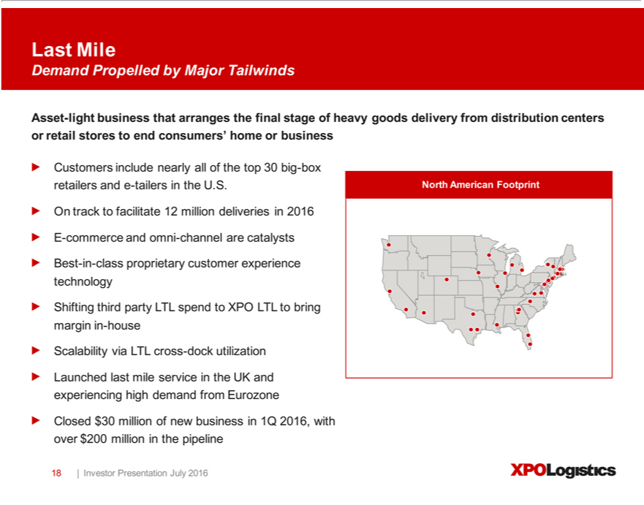

Last Mile Demand Propelled by Major Tailwinds -light business that arranges the final stage of heavy goods delivery from distribution centers or retail stores to end consumers’ home or business Customers
include nearly all of the top 30 big-box retailers andAsset-tailers in the U.S. North American Footprint On track to facilitate 12 million deliveries in 2016 E-commerce and omni-channel are catalysts Best_{experiencing}--class
proprietary customer experience technology Shifting third party LTL spend to XPO LTL to bring margin_{pipeline}-house Scalability via LTL cross-dock utilization Launched last mile service in the UK and high
demand from Eurozone Closed $30 million of new business in 1Q 2016, with over $200 million in the 18 | Investor Presentation July 2016 XPO Logistics

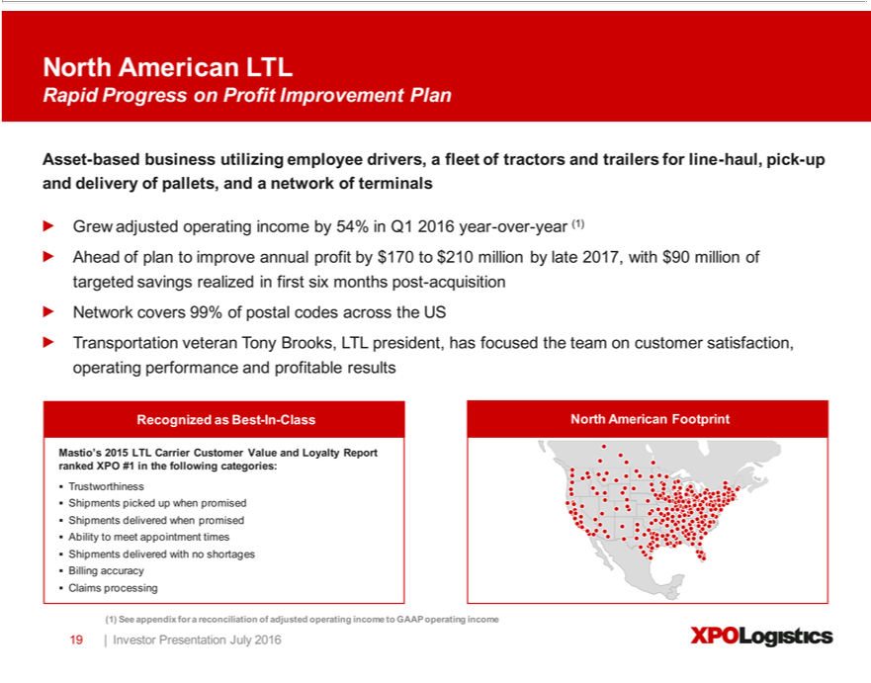

North American LTL Rapid Progress on Profit Improvement Plan Asset-based business utilizing employee drivers, a fleet of tractors and trailers for line-haul, pick-up and delivery of pallets, and a network of terminals Grew adjusted operating income by 54% in Q1 2016 year-over-year (1) Ahead of plan to improve annual profit by $170 to $210 million by late 2017, with $90 million of targeted savings realized in first six months post-acquisition Network covers 99% of postal codes across the US Transportation veteran Tony Brooks, LTL president, has focused the team on customer satisfaction, operating performance and profitable results Recognized as Best-In-Class North American Footprint • Mastio’s 2015 LTL Carrier Customer_{delivered}Valueand Loyalty Report ranked XPO #1 in the following categories: Trustworthiness Shipments picked up when
promised Shipments delivered when promised Ability to meet appointment times Shipments with no shortages Billing accuracy Claims processing (1) See appendix for a reconciliation of adjusted operating income to GAAP operating income 19 | Investor Presentation July 2016 XPO Logistics

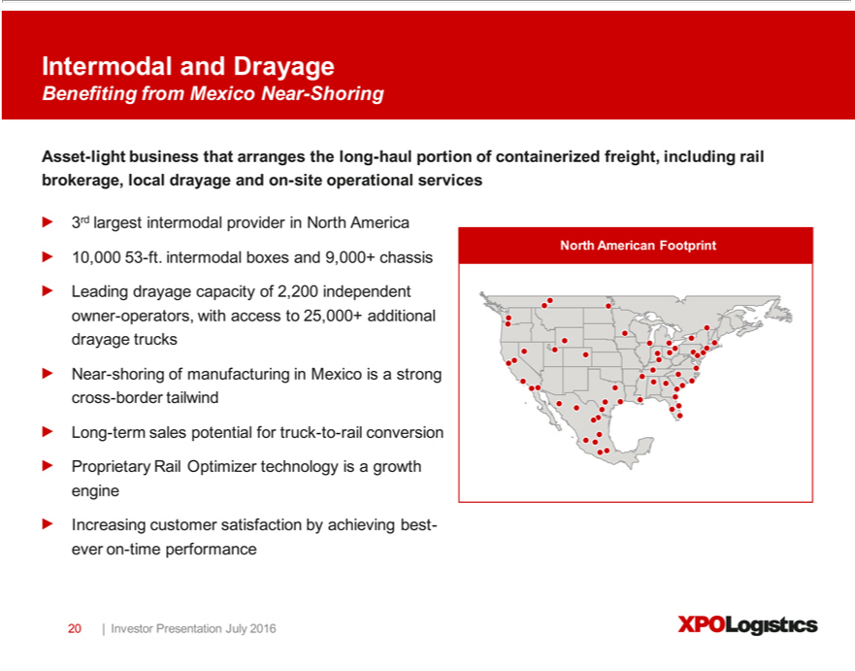

Intermodal and Drayage from Mexico Near Shoring Asset-light business that arranges the long-haul portion of containerized freight, including rail brokerage, local drayage and on-site operational services
3rd largest intermodal providerBenefitingNorth America North American Footprint 10,000 53-ft. intermodal boxes and 9,000+ chassis Leading drayage capacity of 2,200 independent owner-operators, with access to 25,000+ additional drayage trucks_{satisfaction}Near-shoring of manufacturing in Mexico_{performance}isstrong cross-border tailwind Long-term sales potential for truck-to-rail conversion Proprietary Rail Optimizer technology is a growth engine
Increasing customer by achieving best-ever on-time 20 | Investor Presentation July 2016 XPO Logistics

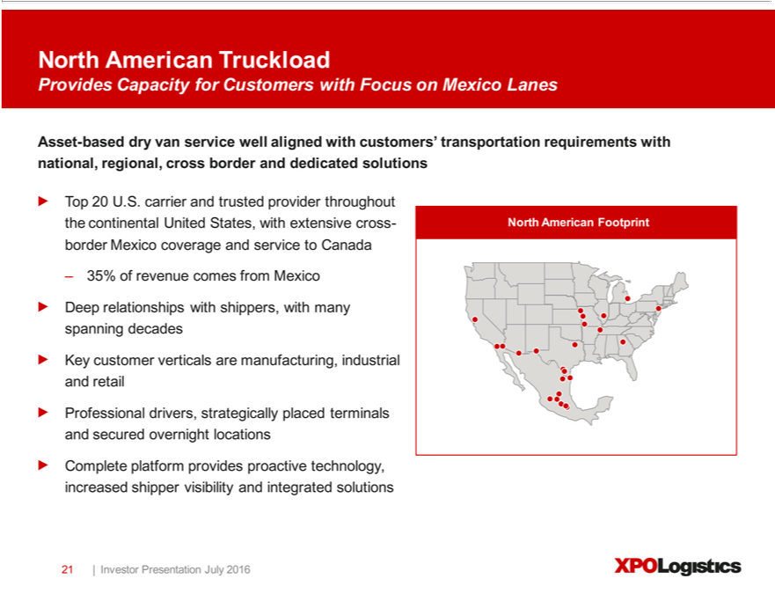

North American Truckload Provides Capacity for Customers with Focus on Mexico Lanes Asset-based dry van service well aligned with customers’ transportation requirements with national, regional, cross border and dedicated solutions Top 20 U.S. carrier and trusted provider throughout the continental United States, with extensive cross- North American Footprint border Mexico coverage and service to Canada – 35% of revenue comes from Mexico Deep relationships with shippers, with many spanning decades Key customer verticals are manufacturing, industrial and retail Professional drivers, strategically placed terminals and secured overnight locations Complete platform provides proactive technology, increased shipper visibility and integrated solutions 21 | Investor Presentation July 2016 XPO Logistics

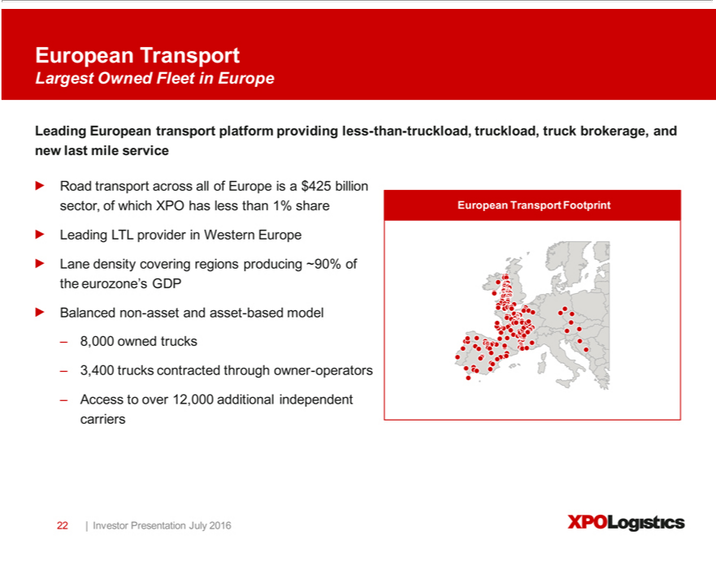

European Transport Largest Owned Fleet in Europe Leading European transport platform providing less-than-truckload, truckload, truck brokerage, and new last mile service Road transport ^{across} all of Europe is a
$425 billion sector, of which XPO has less than 1% share European Transport Footprint Leading LTL provider in Western Europe Lane density covering regions producing ~90% of the eurozone’ GDP Balanced non-asset and asset-based model – 8,000 owned trucks – 3,400 trucks contracted through owner-operators – Access to over 12,000 additional independent carriers 22 | Investor Presentation July 2016 XPO Logistics

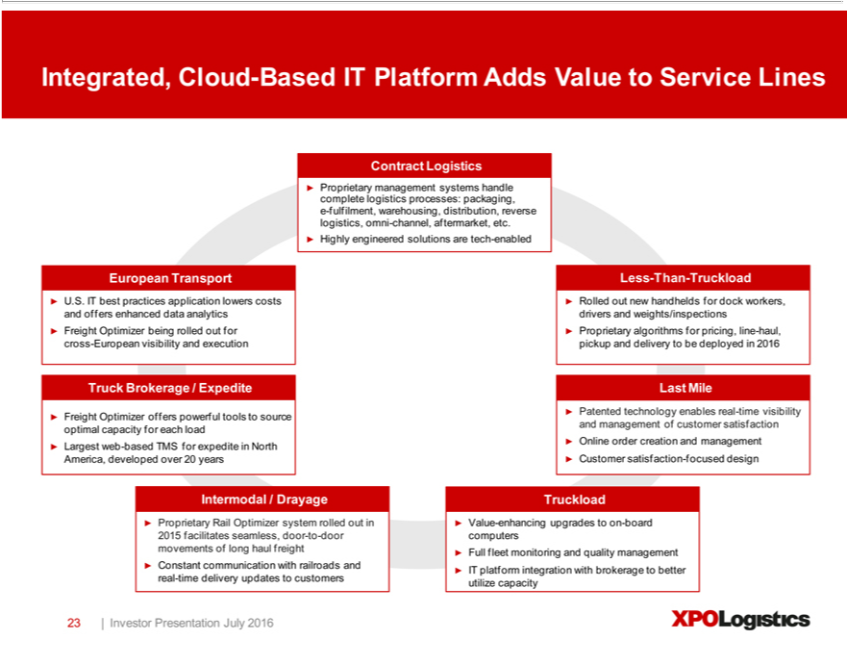

Integrated, Cloud-Based IT Platform Adds Value to Service Lines Contract Logistics Proprietary management systems handle complete logistics processes: packaging,^{enhanced}-fulfilment, warehousing, distribution, reverse
logistics, omni-channel, aftermarket, etc. Highly engineered solutions are tech-enabled European Transport U.S. IT best practices application lowers costs and offers data analytics Freight Optimizer being rolled out for cross-European visibility and execution Truck Brokerage / Expedite Freight Optimizer offers powerful tools to source optimal capacity for each load Largest web-based TMS for expedite in North America, developed over 20 years Less-Than-Truckload Rolled out new handhelds for dock workers, drivers and weights/inspections Proprietary algorithms for pricing, line-haul, pickup and delivery to be deployed in 2016 Last Mile Patented technology enables real-time_{seamless,}visibility and management of customer satisfaction Online order creation and management Customer satisfaction-focused design Intermodal / Drayage Proprietary

Rail Optimizer system rolled out in 2015 facilitates door-to-door movements of long haul freight Constant communication with railroads and real-time delivery updates to customers Truckload Value-enhancing upgrades to on-board computers Full fleet monitoring and quality management IT platform integration with brokerage to better utilize capacity 23 | Investor Presentation July 2016 XPO Logistics

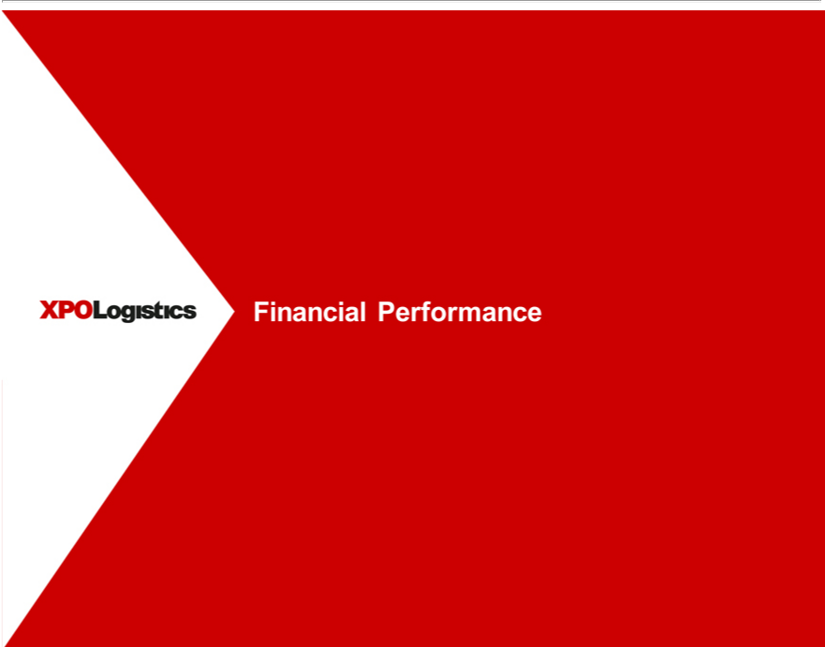

FinancialXPOLogisticsPerformance

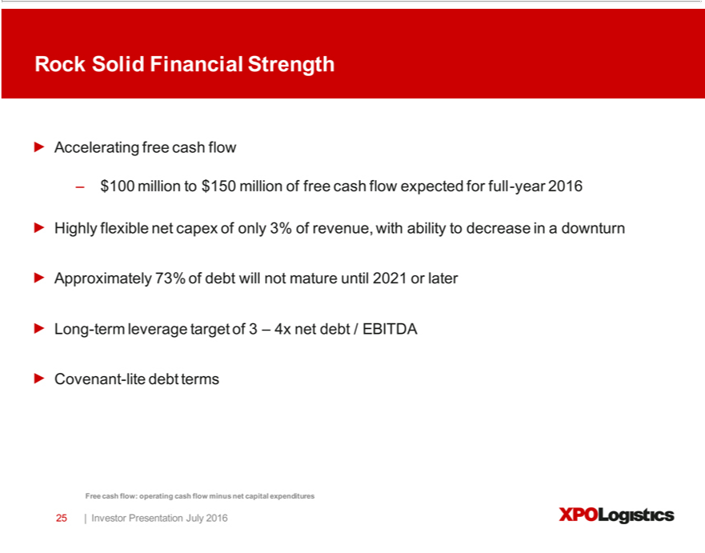

Rock Solid Financial Strength Accelerating free cash flow – $100 million to $150 million of free cash flow expected for full-year 2016 Highly flexible net capex of only 3% of revenue, with ability to decrease in a downturn Approximately 73% of debt will not mature until 2021 or later Long-term leverage target of 3 – 4x net debt / EBITDA Covenant-lite debt terms Free cash flow: operating cash flow minus net capital expenditures 25 | Investor Presentation July 2016 XPO Logistics

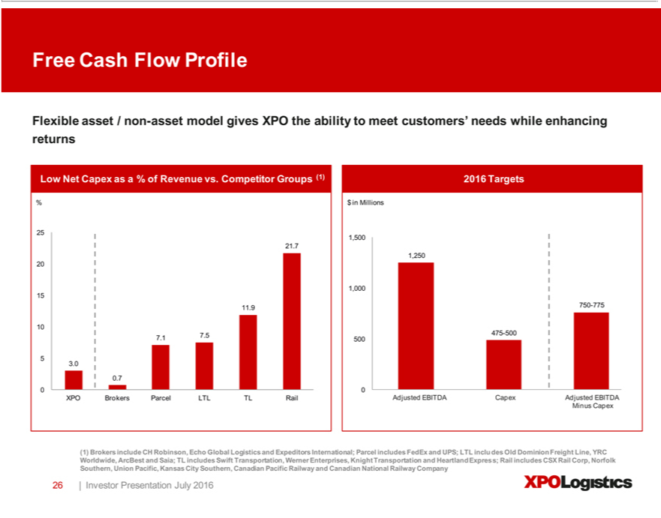

Free Cash Flow Profile Flexible asset / non-asset model gives XPO the ability to meet customers’ needs while enhancing returns Low Net Capex as^{Capex}%of Revenue vs. Competitor Groups (1) 2016 Targets % $ in
Millions 25 1,500 21.7 1,250 20 1,000 15 11.9 750-775 10 475-500 7.1 7.5 500 5 3.0 0.7 0 0 XPO Brokers Parcel LTL TL Rail Adjusted EBITDA Adjusted EBITDA Minus Capex (1) Brokers include CH Robinson, Echo Global Logistics and Expeditors International; Parcel includes FedEx and UPS; LTL includes Old Dominion Freight Line, YRC Worldwide, ArcBest and Saia; TL includes Swift Transportation, Werner Enterprises, Knight Transportation and Heartland Express; Rail includes CSX Rail Corp, Norfolk Southern, Union Pacific, Kansas City Southern, Canadian Pacific Railway and Canadian National Railway Company 26 | Investor Presentation July 2016 XPO Logistics

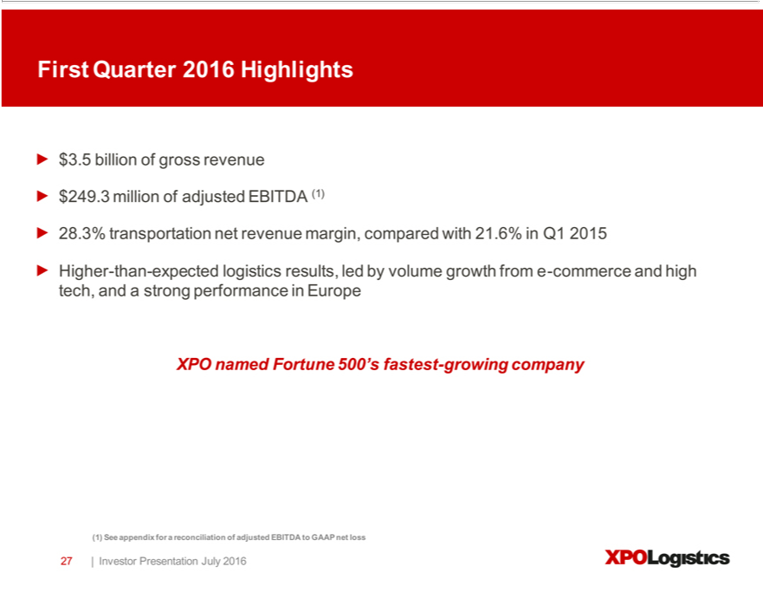

First Quarter 2016 Highlights $3.5 billion of gross revenue $249.3 million of adjusted EBITDA (1) 28.3% net revenue margin, compared with 21.6% in Q1 2015 Higher-than-expected logistics results,
_{loss}edby volume growth_{Presentation}from-commerce and high tech, and a strong performance in Europe XPO named Fortunetransportation500’fastest-growing company (1) See appendix for a reconciliation of adjusted EBITDA to GAAP net
27 | Investor July 2016 XPO Logistics

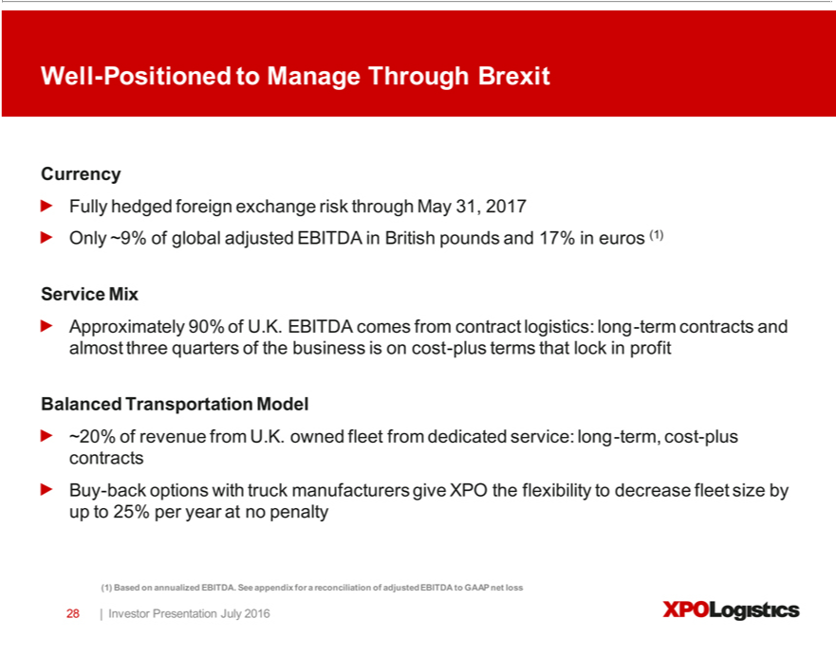

Well-Positioned to Manage Through Brexit Currency Fully hedged foreign exchange risk through May 31, 2017 Only ~9% of global adjusted EBITDA in British pounds and 17% in euros (1) Service Mix Approximately 90% of U.K. EBITDA comes from contract logistics: long-term contracts and almost three quarters of the business is on cost-plus terms that lock in profit Balanced Transportation Model ~20% of revenue from U.K. owned fleet from dedicated service: long-term, cost-plus contracts Buy-back options with truck manufacturers give XPO the flexibility to decrease fleet size by up to 25% per year at no penalty
(1) Based on annualized EBITDA. See appendix for a reconciliation of adjusted EBITDA to GAAP net loss 28 | Investor Presentation July 2016 XPO Logistics

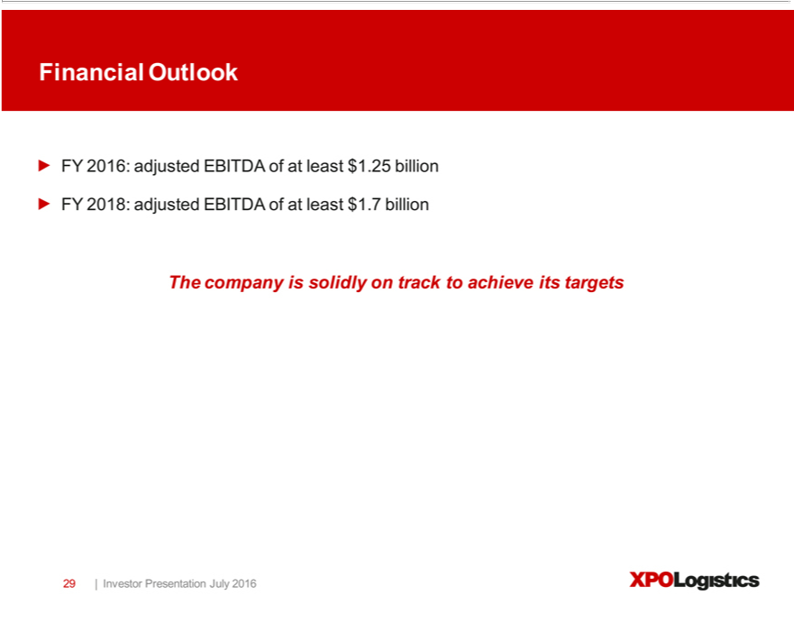

Financial Outlook FY 2016: adjusted EBITDA of at least $1.25 billion FY 2018: adjusted EBITDA of at least $1.7 billion The company is solidly on track to achieve its targets 29 | Investor Presentation July 2016 XPO Logistics

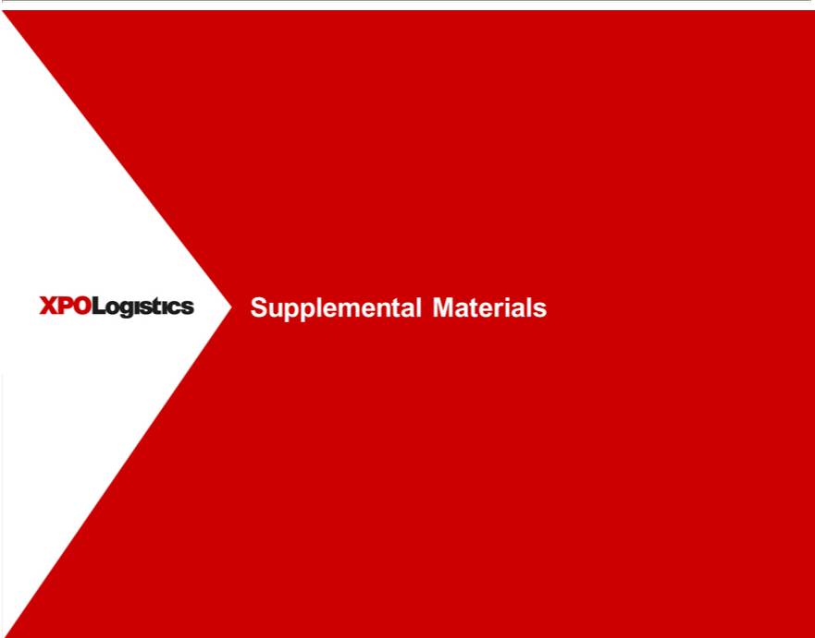

SupplementalXPOLogisticsMaterials

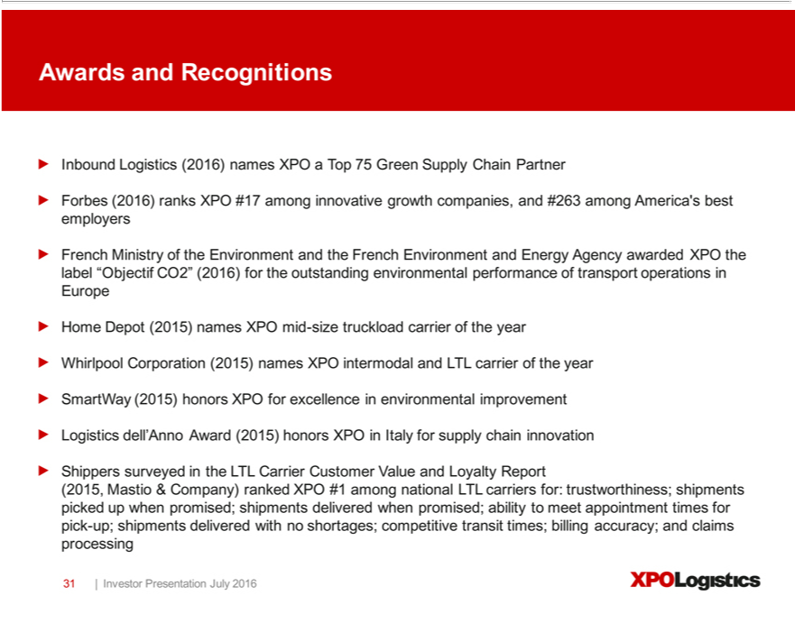

Awards and Recognitions Inbound Logistics (2016) names XPO a Top 75 Green Supply Chain Partner Forbes (2016) ranks XPO #17 among innovative growth companies, and #263 among America’operationsbest employersFrenchMinistryoftheEnvironmentandtheFrenchEnvironmentandEnergyAgencyawardedXPOthelabel“ObjectifCO2”(2016)fortheoutstandingenvironmentalperformanceoftransportinEurope Home Depot (2015) names XPO mid-size truckload carrier of the year Whirlpool Corporation (2015) names XPO intermodal and LTL carrier of the year SmartWay (2015) honors XPO for excellence in environmentalimprovementdell’AnnoAward(2015)honorsXPOnItalyforsupplychaininnovationShipperssurveyedtheLTLCarrierCustomerValueandLoyaltyReport(2015,Mastio&Company)rankedXPO#1
among nationalLogisticsTLcarriers for: trustworthiness; shipments picked up when promised; shipments delivered when promised; ability to meet appointment times for pick-up; shipments delivered with no shortages; competitive transit times; billing accuracy; and claims processing 31 | Investor Presentation July 2016 XPO Logistics

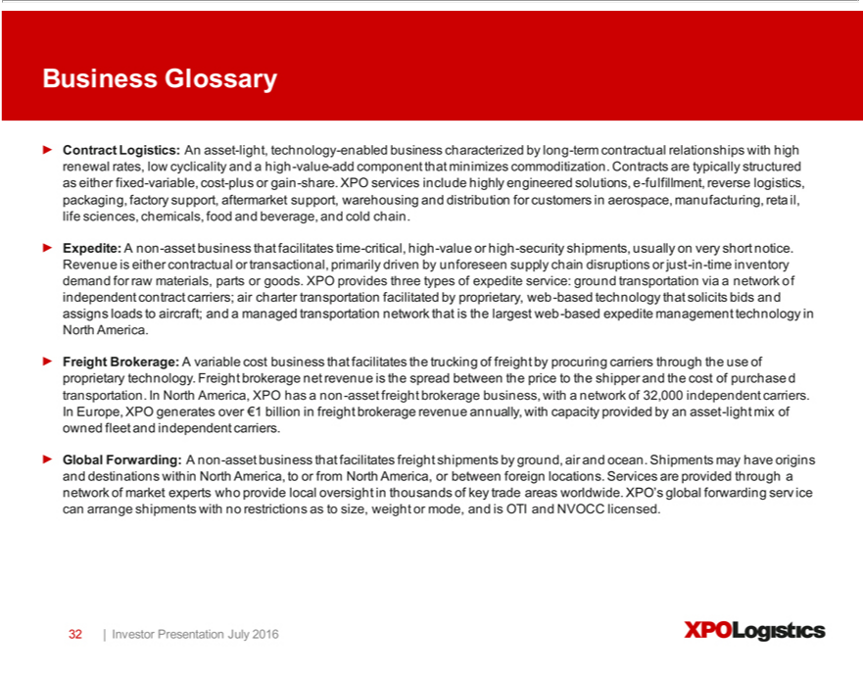

BusminimizesnessGlossary Contract Logistics: An asset-light, technology-enabled business characterized by long-term contractual relationships with engineeredhihrenewal rates, low cyclicality and a high-value-add component that
support, aftermarketcommoditization.support, Contractswarehousingare andtypicallydistributionstructuredfor customersaseitherfixedinaerospace,-variabl manufacturing,cost-plusorgainretail,-share.lifeXPOsciences,serviceschemicals,includehighlyfoodand beverage,solutions,andcoldechain.-fulfillment,Expedite:reverseAnonlogistics,-assetbusinesspackaging,thatfactoryfacilitates time-critical, high-value high-security shipments, usually on very short notice. Revenue is either contractualnetworktransactional, primarily driven by unforeseen supply chain disruptions or just-in-time inventory demand
businesstechforrawologymaterials,thatfacilitatessolicitsparts bidsgoods.andassignsXPOprovidesloadsto threeaircraft;typesandcarriersofexpeditemanagedservice:transportationground networktransportationthatisviathe largest webof-basedindependentexpeditecontractmanagementcarriers;technologyaircharterintransportationNorthAmerica.facilitatedFreightbyBrokerage:proprietary,A variableweb-basedcost that the trucking of freight by procuring through the use of proprietary technology. Freight brokerage net revenue is the spread between the price to the shipper and the cost of purchased
capacitytransportation.providedInNorthbyan America,asset-lightXPOmix hasofownedanon-fleetasset andfreightindependentbrokeragecarriers.business,Globalwith Forwarding:networkof A32,000non-assetindependentbusinesscarriers.facilitatesInEurope,freightXPOshipmentsgeneratesbyoverground,€1billionairandinocean.freightShipmentsbrokerage mayrevenuehaveannually,originsandwith
destinations within North America, to or from North America, or between fo_{restrictions}ignlocations. Services are provided through thatnetwork of market experts who provide local oversight in thousands of key trade areas
worldwide. XPO’s global forwarding service can arrange shipments with no as to size, weight or mode, and is OTI and NVOCC licensed. 32 | Investor Presentation July 2016 XPO Logistics

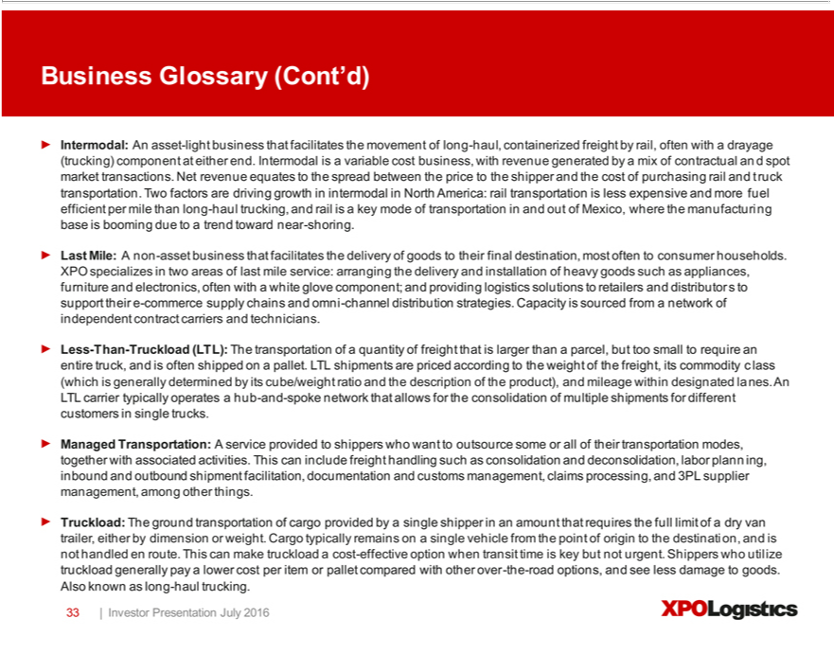

Business Glossary (Cont’d) Intermodal: An asset-light business that facilitates the movement of long-haul, containerized freight by rail, often with a drayage (trucking) component at either end. Intermodal is variable
cost business, with revenue generated by mix of contractual and spot market transactions. Net revenue equates to the spread between the price to the shipper and the cost of purchasing rail and truck transportation.
Two factors are driving growth |  |  | intermodal | North | rail transportation is less expensive and more fuel efficient per mile than long-haul trucking, and rail is a key mode of transportation in and out of
Mexico, where the manufacturing base is booming dueAmerica:totrend toward near-shoring. Last Mile: A non-asset business that facilitates the delivery of goods to their final destination, most often to consumer households.
XPO specializes in two areas of last mile service: arranging the delivery and installation of heavy goods such as appliances, furniture and electronics, often with a white glove component; and providing logistics
solutions to retailers and distributors to support their e-commerce supply chains and omni-channel distribution strategies. Capacity is sourced from a network of independent contract carriers and technicians. Less-
Than-Truckload (LTL): The transportation of |  |  |  | quantity of freight that is larger than a parcel, but too small to require an entire truck, and is often shipped on a pallet. L shipments are priced |  | to the weight
of the freight, its commodity class (which is generally determined by its cube/weight ratio and the description of the product), and mileage within designated lanes. AnTLTL carrier typically operatesaccordinghub-and-spoke
network that allows for |  | consolidation of multiple shipments for different customers single trucks. Managed Transp rtation: A service provided to shippers who want to outsource some or all of their
transportation modes, together with associated activities. This can include freight handling such as consolidation and deconsolidation, labor planning, inbound and outbound shipment facilitation, documentation
customs | claims processing, and 3PL supplier |  |  |  | among other things. Truckload: The ground transportation of cargo provided by a single shipper in an amount that requires the full limit ofand dry
van trailermanagement,eitherbydimension or weight. Cargo typically remainsmanagement,onsingle vehicle from the point of origin to the destination, and is not handled en route. This can make truckload a cost-effective option when transit
time is key but not urgent. Shippers who utilize truckload generally pay a lower cost per item or pallet compared with other over-the-road options, and see less damage to goods. Also known as long-haul trucking. 33 |
Investor | Presentation July 2016 XPO Logistics

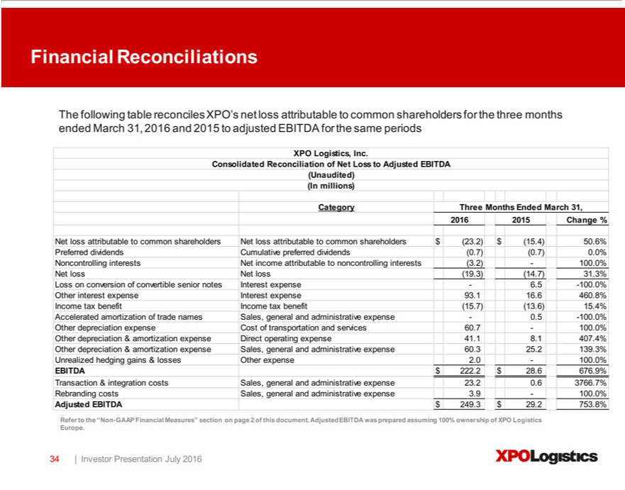

Financial Reconciliations The following table reconciles XPO’ net loss attributable to common shareholders for the three months ended March 31, 2016 and 2015 to adjusted EBITDA for the same periods XPO
Logistics, Inc. Consolidated Reconciliation of Net Loss to Adjusted EBITDA (Unaudited) (In millions) Category Three Months Ended March 31, 2016 2015 Change % Net loss attributable to common shareholders
Net loss attributable to common shareholders $ (23.2) $ (15.4) 50.6% Preferred dividends Cumulative preferred dividends (0.7) (0.7) 0.0% Noncontrolling interests Net income attributable to noncontrolling interests
(3.2) —100.0% Net loss Net loss (19.3) (14.7) 31.3% Loss | conversion of convertible senior notes Interest expense — 6.5 - |  | .0% Other interest expense Interest expense 93.1 16.6 460.8% Income tax benefit
Income tax benefit (15.7) (13.6) 15.4% Accelerated amortization of trade names Sales, general and administrative expense — |  |  | 100.5 -100.0% Other depreciation expense Cost of transportation and services 60.7 —100.0%
Other depreciation & amortization expense Direct operating expense |  | 41.1 8.1 407.4% Other depreciation & amortization expense Sales, general and administrative expense 60.3 25.2 139.3% Unrealized hedging
gains & losses Other expense 2. —100.0% EBITDA $ 222. $ 28.6 |  | 676.9% Transaction & integration costs Sales, general and administrative expense 23.2 0.6 3766.7% Rebranding costs Sales, general and
administrative expense 3.9 —100.0% Adjusted EBITDA $ | 249.3 $ 29. 753.8% Refer to the “Non-GAAP Financial Measures” section on page 2 of this document. Adjusted EBITDA was prepared assuming 100%
ownership of XPO Logistics Europe. 34 | Investor Presentation July 2016 XPO Logistics

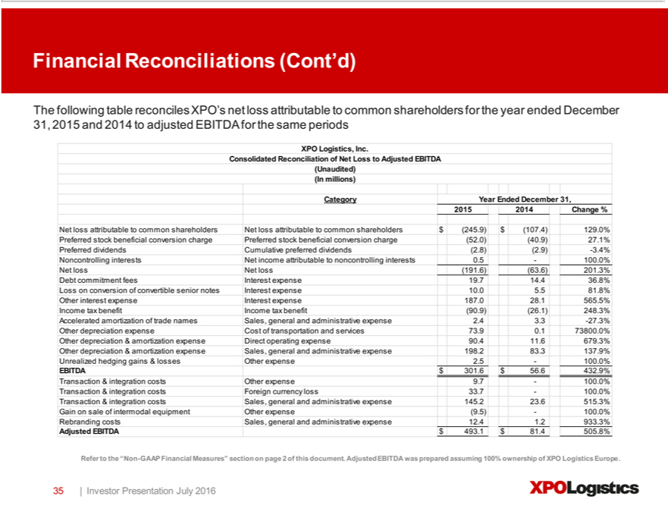

Logistics,Financial ReconciliationsInc.Consolidated(Cont’d)ReconciliationThefollowingofNettableLoss reconcilestoAdjustedXPO’sEBITDAnetloss(Unaudited)attributable(In tomillions)commonCategoryshareholdersYear Endedforthe Decemberyearended31,December2015201431, Change2015and% 2014NetlosstoadjustedattributableEBITDAtocommonfortheshareholderssameperiodsNetXPOloss attributable to common shareholders $ (245.9) $ (107.4) 129.0% Preferred stock beneficial conversion charge Preferred stock beneficial conversion char (52.0) (40.9) 27.1% Preferred dividends Cumulative preferred
Lossamortizationdividendsconversion(2.8)(2.9)of-3.4%convertibleNoncontrollingseniornotesinterestsInterestNetexpenseincome10.0attributable5.581.8% noncontrollingOtherOthererestexpenseinterestsInt0.5expenserest—100.0%expenseNet187.0loss28.1Net 565.5%loss(191.6)Income(63.6)tax 201.3%benefit IncomeDebtcommitmenttaxbenefit fees(90.9)Interest(26.1)expense248.3%19.7Accelerated14.436.8% of trade names Sales, general and administrative expense 2.4 3.3 -27.3% depreciation Cost of transportation and services 73.9 0.1 73800.0% Other depreciation & amortization expense
EBITDADirectoperating$301.6expense$56.6432.9%90.411.6Transaction679.3%Other& depreciationcosts& Otheramortizationexpenseexpense9.7—100.0%Sales, generalTransactionand administrative&integration costsexpenseForeign198.2currency83.3137.9%loss33.7Unrealized—100.0%hedgingTransactiongains&&lossesintegrationOther costsexpenseSales,2.5 general—100.0%and
administrative expense 145.2 23.6 515.3% Gainintegrationsaleof intermodal equipment Other expense (9.5) —100.0% Rebranding costs Sales, general and administrative expense 12.4 1.2 933.3% Adjusted EBITDA $ 493.1 $ 81.4 505.8% Refer to the “Non-GAAP Financial Measures” section on page 2 of this document. Adjusted EBITDA was prepared assuming 100% ownership of XPO Logistics Europe. 35 | Investor Presentation July 2016 XPO Logistics

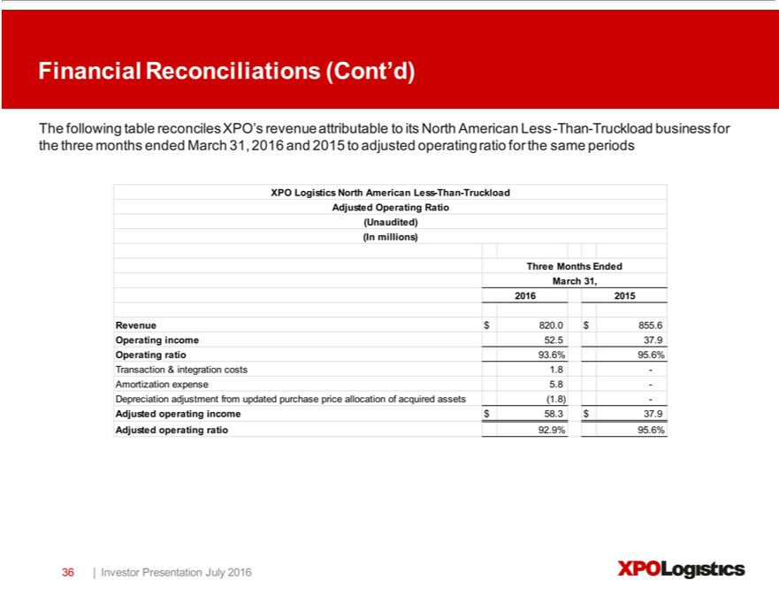

Financial Reconciliations (Cont’d) The following table reconciles XPO’^{Less} revenue attributable to its North American Less-Than-Truckload business for the three months ended March 31, 2016 and 2015 to adjusted
operating ratio for the same periods XPO Logistics North American -Than-Truckload Adjusted Operating Ratio (Unaudited) (In millions) illio Three Months Ended March 31, 2016 2015 Revenue $820.0 $855.6 Operating income 52.5 37.9 Operating ratio 93.6% 95.6% Transaction & integration costs 1.8 -Amortization expense 5.8 -Depreciation adjustment from updated purchase price allocation of acquired assets (1.8) — Adjusted operating income $ 58.3 $ 37.9 Adjusted operating ratio 92.9% 95.6% 36 | Investor Presentation July 2016 XPO Logistics

Exhibit 99.2

July 18, 2016

Presentation Script

The following script should be read in conjunction with the accompanying slide presentation, which contains, among other information, source data for certain information set forth in the script.

Thank you for joining us. We’ll start with an overview of XPO Logistics today – our scale, our diversification, and most important, the dynamics that have brought XPO to an inflection point for accelerating profitability and cash flow growth. Then we’ll discuss our service offerings in depth. And we’ll summarize our first quarter financial results.

XPO is a top ten global logistics company with approximately $15 billion of revenue and $1.25 billion of adjusted EBITDA forecast for this year. Our adjusted EBITDA target for 2018 is $1.7 billion.

There are nine main drivers moving us toward our EBITDA and cash flow targets:

- We currently have just 1.5% share of a $1 trillion addressable opportunity;

- We have global scale and leading positions in many of the fastest-growing areas of transportation and logistics;

- We have numerous company-specific margin opportunities regardless of the macro environment, including cost rationalization, global procurement and cross-fertilization of best practices;

- Our business is well-diversified by service offerings, geographies and customer verticals;

- We have a strong global presence in the high-growth e-commerce sector;

- Within our service range, three fast-growing lines of business– contract logistics, last mile and truck brokerage – are resilient to economic cycles;

- We have low capex requirements and a free cash flow profile that’s accelerating;

- Our cutting-edge technology differentiates XPO across all lines of business by serving customers more efficiently; and

- We have world-class operators who are laser-focused on driving results.

Let’s look at each of these points more closely in terms of how they relate to our EBITDA bridge.

Our plan over the next 30 months is to generate organic revenue growth in the mid-single-digits, and achieve at least $300 million of annual run rate profit improvement through company-specific margin opportunities. These two levers alone get us from our expected $1.25 billion of adjusted EBITDA this year to our target of $1.7 billion of adjusted EBITDA for 2018.

1

We’re looking at a total addressable opportunity of $1 trillion or more, of which we currently hold just a 1.5% share. That’s the magnitude of the opportunity on our doorstep – $985 billion out of a trillion dollar industry that has many fast-growing sectors.

We expect our near-term organic revenue growth to come primarily from gains in share of wallet with our existing customers. We want to make sure we’re serving our customers as completely as possible, giving them the benefits of a single source. This is something that’s happening naturally – 73% of our top 100 customers already use multiple XPO service lines – and we have numerous initiatives underway to expand on that. We’re doubling our strategic account executives and adding at least 50 local account executives this year; leveraging the company-wide CRM platform we recently put in place; and implementing growth-based incentives and advanced training to drive sales growth, especially cross-selling.

That’s the revenue component of our EBITDA growth. The other driver is margin improvement. Our plan includes more than 200 basis points of margin improvement from cost savings and productivity gains, as well as operational improvements from the cross-fertilization of best practices. This equates to at least $300 million in incremental profit, out of an addressable spend of about $14 billion. Our fixed-cost infrastructure that we built over the past five years is now substantially complete, and the operating leverage will drive margin expansion alongside revenue growth.

Over the past few months, we’ve looked at our operations from every angle in terms of global sourcing and operational excellence. We’re targeting savings from several large cost buckets, including $3.7 billion in the cost of purchased transportation; $5 billion of direct labor; $0.9 billion of SG&A labor, and $4.5 billion in purchased services, which include temporary labor, real estate, maintenance, trucks, tractors, tires, office supplies and other spends. Ramon Genemaras, our chief transformation officer, is leading these efforts in a methodical manner. Ramon previously led successful cost-outs of more than a billion dollars at General Electric, Tyco and Johnson Controls.

In addition, we have a large opportunity to increase our profitability through the cross-fertilization of best practices. This is already paying dividends, given the high caliber of our operations on both sides of the Atlantic. We’re sharing knowledge across all service offerings and geographies, with an emphasis on large-impact areas such as customer service, sales, safety, warehouse operations, cross-dock operations, maintenance, training and HR.

We expect our free cash flow to be in the range of $100 million to $150 million for full year 2016. Now that we’ve reached a key inflection point in the evolution of our business, we expect our free cash flow to accelerate significantly. We have a flexible asset/non-asset model that gives us the ability to meet customers’ needs while enhancing return on capital. We’ll expand on this and other points in the company section of this presentation.

Business Update

Here’s a snapshot of some recent business developments at XPO.

Our truck brokerage line is gaining share with our existing brokerage customers this year, driven by a mix of outsourcing, supplier consolidation and cross-selling. Most customers in our other lines of business need brokerage services. As one example, our largest brokerage customer in the last holiday season didn’t use us at all for brokerage 12 months earlier; we cross-sold brokerage to that company through our logistics business.

2

Our last mile business is also taking share. First quarter organic revenue growth was up 28% from a year ago, and margins are expanding. Last mile is one of our businesses that benefits from e-commerce, which is predicted to grow globally at 13% to 19% through at least 2018. Given the projected demand for e-fulfillment, and our foothold along the e-commerce supply chain, we see this as an area of tremendous potential. We’ve already closed $30 million of new last mile business in the first quarter of this year, and we have another $200 million in the pipeline.

Our LTL business is exceeding expectations. In the first full quarter, we grew our adjusted operating income in LTL by a resounding 54%, compared with a year ago. Our head of LTL is transportation veteran Tony Brooks. Tony has instilled a culture of accountability that has the team focused on customer satisfaction and profitable growth.

We’re ahead of plan to improve annual profit in LTL by $170 million to $210 million by late 2017. We achieved $90 million of profit improvement run rate in the first six months post-acquisition, and raised our customer service levels. Line haul productivity has already improved, and we’re heavily investing in technology, including the launch of mobile handheld devices for dockworkers and drivers. We’re also adding salespeople and strategic account managers and have a wide-open opportunity to sell LTL to our full customer base in North America, to serve these customers even more completely.

In logistics, we’ve steadily added vertical expertise, salespeople, CRM capabilities, and resources such as engineering. The large, multi-year contracts we signed in 2015 and early this year will continue to drive revenue growth through 2016. These include agreements with premier customers such as Heineken, Iceland and Renault. We’re working with a very active pipeline on both sides of the Atlantic and expect to accelerate growth in 2017 and again in 2018.

Our global logistics pipeline for new business is approximately $1 billion. The European pipeline of over half a billion euros is up about 25% from first quarter last year. There’s a lot of interest in e-fulfillment, where we’re the leader in Western Europe. In North America, our pipeline contains over $400 million of potential logistics business, up significantly from about $150 million at the beginning of this year. These are active bids, mostly in consumer packaged goods, chemicals, food and beverage, high tech and healthcare.

Cutting-Edge Technology

As customers increasingly turn to XPO for supply chain solutions, we empower our employees to deliver world-class service through our information technology. We place massive importance on innovation, because we believe that technology – in the hands of well-trained, outstanding employees – is the ultimate differentiator in our industry. We have a global team of over 1,500 IT professionals who understand how to drive innovation for the benefit of our customers.

We’ll invest $425 million in our IT this year – and we’re happy to make that investment. Technology is a huge differentiator for XPO. We’ve built a highly scalable and integrated system using on-cloud technology that gives us agility and facilitates enhancements. This enables us to lead the industry in rapid technology development. We see the ongoing enhancement of our technology as being critical to our ability to continually improve customer service and leverage our scale.

3

Our commitment to technology is pervasive across the company. We’re constantly enhancing our Freight Optimizer and Rail Optimizer systems. On the contract logistics side, we use proprietary technology to facilitate omni-channel distribution, reverse logistics, lean manufacturing support, aftermarket support, supply chain optimization and transportation management.

In our last mile business, we hold the patents on industry-leading software for real-time workflow visibility and customer experience management. This gives us a competitive advantage in the last mile space, because it documents our ability to deliver superior end-customer satisfaction ratings. It also allows us to move quickly to address any sub-par carrier performance.

Company Overview

XPO is one, highly integrated network of people, technology and physical assets. We use our network to help customers manage their goods more efficiently throughout their supply chains.

As context, we have two reporting segments: transportation and logistics. We sometimes refer to our logistics operations as “supply chain” or “contract logistics.” We run our business on a highly integrated basis under the single brand of XPO Logistics.

We’re not reliant on the economy of any one country, region or industry. About 60% of our revenue is generated in the United States, 12% comes from France and 12% from the UK. Of the balance, Spain is the next largest at 4% of revenue. In total, we operate in 33 countries, with over 87,000 employees and 1,440 locations.

Our customer base is also highly diversified. The more than 50,000 customers we serve are in every major industry and have thousands of different end markets.

Retail and e-commerce accounts for the largest portion of our revenue at 22%, followed by food and beverage at 12%.

About 65% of our revenue comes from transportation, and the other 35% is in logistics. We’re the second largest provider of contract logistics services globally, which puts us at the forefront of this $120 billion sector that’s projected to grow at two to three times GDP.

Our service range also includes leading positions in four other sectors. One is truck brokerage – an $85 billion opportunity in North America and Europe that’s growing fast at two to four times GDP. We’re the second largest brokerage firm worldwide, and the largest manager of expedite shipments in North America. Expedite is a type of truck brokerage for urgent freight, and includes e-commerce home deliveries that are larger than parcel in major metro areas. Another area is less-than-truckload (LTL) transportation in North America, a $35 billion sector, where we’re the second largest provider.

There’s also intermodal/drayage, a $22 billion opportunity in North America where we’re the number three provider. This puts us in a strong position to capitalize on truck-to-rail conversions. Last mile logistics is a $13 billion U.S. sector where we’re the largest provider in the heavy goods space. Intermodal/drayage and last mile are growing at three to five times GDP, and five to six times GDP, respectively.

Together with the $425 billion European transport industry, where we offer less-than-truckload, truckload, truck brokerage and last mile, we’re looking at a total addressable opportunity of $1 trillion or more.

4

Earlier, we mentioned that XPO functions as a single global network. We’ve meticulously built this network to generate high returns for shareholders while providing exceptional value for our customers. The components are:

- An intense customer service culture and a highly engaged employee base;

- Best-in-class, proprietary technology integrated on a cloud-based platform across all business offerings;

- Ground transportation assets of 19,000 owned tractors; 47,000 trailers; 10,000 53-ft. intermodal boxes; and 9,000 chassis;

- A non-asset transportation network of 10,000 trucks contracted via independent owner-operators, and more than 1 million brokered trucks; and

- 438 cross-docks and 748 contract logistics facilities.

Our company overall is asset-light, with assets accounting for about a third of our revenue. Our estimated net capex is only about 3% of revenue.

With that in mind, let’s take a deeper look into XPO, starting with our logistics segment.

Logistics is an asset-light business characterized by long-term contractual relationships, low cyclicality and a high-value-add component that minimizes commoditization. It has low capex requirements as a percentage of revenue, which leads to strong free cash flow conversion and ROIC.

We operate approximately 151 million square feet (14 million square meters) of facility space devoted to our contract logistics operations, with about 65 million square feet (6 million square meters) of that capacity in the United States. This global footprint makes XPO particularly attractive to multinational customers. Once we secure a contract, the average tenure is approximately five years, and these relationships can lead to a wider use of our services, such as inbound and outbound logistics.

Our supply chain teams provide a range of services to customers, including highly engineered solutions and high-value-add contract logistics. We perform e-commerce fulfillment, reverse logistics, factory and aftermarket support, packaging and labeling, distribution and managed transportation. We also collaborate with our larger customers to optimize their production flows.

Our logistics customers are the preeminent names in aerospace, technology, manufacturing, retail and e-tail, life sciences, wireless, chemical, healthcare, cold chain and other industries where outsourcing is taking root. Food and beverage storage is a specialty of ours – about €1.5 billion of our €2.3 billion annual logistics revenue in Europe is related directly or indirectly to food and beverage or other critical-care commodities.

One of the most attractive parts of our contract logistics range is e-fulfillment. We’re the largest e-fulfillment provider in Europe, with less than 10% share of the €5 billion e-fulfillment opportunity. Many of our e-commerce customers are household names. We also have a major platform for e-commerce logistics in North America, where we provide highly customized solutions for retailers and manufacturers, including reverse logistics and omni-channel services.

Our other segment – transportation – includes our businesses for LTL, truck brokerage, last mile, intermodal, drayage, expedite, truckload and global forwarding. 5

We utilize a blended transportation model of brokered, owned and contracted capacity in North America and Europe. Our owned assets benefit our company and our customers, especially during periods of tight capacity, while the non-asset portion of our model is variable cost and gives us extensive flexibility. This “asset right” model serves our customers more consistently in all market conditions and further differentiates our value proposition.

Our truck brokerage line is high growth and high return. It’s a non-asset business that places freight with qualified carriers through brokers that match capacity with shipper demand. Reliable and long-term access to truck capacity is critically important to shippers, and we provide it with our network of about a million trucks. Capacity could become even more of a priority if the driver shortage worsens or more regulatory constraints are imposed in the coming years.

Brokerage is compelling to us for a number of other reasons: it uses a variable cost model and is resilient across the cycle. It has high free cash flow conversion and minimal capex. We’ve been continuously improving the productivity of this business through technology and the tenure of our sales reps, as well as ongoing enhancement of our Freight Optimizer technology. Freight Optimizer drives our brokerage operations in North America, and we’re rolling it out in Europe this year.

Brokerage is part of a global ground transportation industry that’s both fragmented and diverse. It’s a $3 billion business for us worldwide. This includes Europe, where we generate over €1 billion of brokerage business annually – a tiny fraction of the addressable opportunity. We have experienced teams on both sides of the Atlantic facilitating industrial flows of raw materials and finished goods, consumer goods, sensitive freight, and freight that is high-value or high-security.

Last mile logistics is an asset-light business that’s being propelled by major tailwinds, primarily from e-commerce and outsourcing. It’s an outsized performer in our service range, and we’ve just scratched the surface. We’re the number one provider of logistics services for the home delivery of heavy goods in the U.S. – but we hold less than 7% share.

XPO is the main outsourced provider for the last mile of heavy goods for nearly all of the top 30 big-box retailers in North America. Last year, we facilitated over 10 million last mile deliveries, and this year we expect that number to be over 12 million. Our contract carriers often take the goods inside the home, where they perform white glove services such as assembly and installation.

In North America, we’re achieving an even greater level of scalability by multi-purposing our LTL cross-docks for last mile as well. And in Europe, another fragmented landscape with many regional providers, there’s a large opportunity for us to apply our technology and best practices. We’ve just started exporting our last mile expertise overseas.

Moving on to our LTL business, this is a home run in both North America and Europe. LTL is an asset-based business that utilizes employee drivers, a fleet of tractors and trailers for line-haul, pick-up and delivery of pallets, and a network of terminals. We’re the second largest U.S. provider, covering about 99% of all zip codes – and we offer more next-day and two-day lanes than any other LTL network. We’re also the leading provider in Western Europe, where LTL service is known as “palletized.” We provide this service in regions that produce approximately 90% of the eurozone’s GDP.

In 2016, in our U.S. operations, our LTL on-time pickup is up year-over-year, on-time delivery is up, line-haul productivity is up, and our damages and claims are down. That’s saying a lot – because the 2015 Mastio LTL Carrier Customer Value and Loyalty Report found that shippers ranked our LTL business number one among national LTL carriers in the categories of:

- Trustworthiness;

6

- Shipments picked up when promised;

- Shipments delivered when promised;

- Ability to meet appointment times for pick-up;

- Shipments delivered with no shortages;

- Competitive transit times;

- Billing accuracy; and

- Claims processing.

So we had a high bar to surpass!

Intermodal and drayage is an additional growth opportunity for us in North America. Both are asset-light businesses that are involved in the long-haul portion of containerized freight, including rail brokerage, local drayage by independent trucking contractors, and on-site operational services. XPO has one of the largest drayage networks in the U.S., with about 2,200 independent owner-operators and access to another 25,000 drayage trucks.

Despite a sluggish intermodal environment, due to low fuel prices and loose truck capacity, we’ve been able to increase our bidding activity and our sales trends have been improving. Our proprietary Rail Optimizer technology is a growth engine and a differentiator – it was recently instrumental in helping us achieve our best-ever intermodal on-time performance. This improved customer satisfaction, and our on-time performance is now at a record high. We’ve also taken a lot of unnecessary costs out of the network.

The near-shoring trend of manufacturing in Mexico has been a boon to intermodal. It’s driving up the volume of cross-border freight. For companies with North American trade interests, Mexico’s competitively priced labor force and greater speed-to-market measure up favorably against overseas alternatives such as China. In addition, the railroads and the Mexican government have invested heavily in transportation infrastructure, attracting billions of dollars in new plant construction by global manufacturers.

We have a 30-year history in Mexico, and deep relationships with the railroads. We’re on the front lines of near-shoring production for automotive, industrial goods, machinery and consumer goods. Even at the current level of cross-border activity, it’s estimated that there are approximately 2.8 million truck movements across the U.S.-Mexico border each year, so there’s considerable potential for us to convert truck to rail.

Our North American truckload business provides capacity for customers in the U.S.-Mexico corridor. It’s an asset-based dry van service that aligns well with customers’ transportation requirements for national, regional, cross border and dedicated solutions. About 35% of our truckload revenue comes from Mexico freight movements.

We’re a top 20 U.S. truckload carrier with deep relationships with shippers; some that span decades. Our largest customer verticals for truckload are manufacturing, industrial and retail. We use company drivers and our own trucks, strategically placed terminals, secure overnight locations, and a robust technology platform to differentiate our service.

7

We’re also the largest provider of expedited transportation in North America. Expedite shipments are time-critical goods or raw materials that have to get somewhere very quickly, typically on very little notice. One secular driver of expedite demand is the trend toward just-in-time urgent shipments (JIT).

JIT is a supply chain strategy that requires 3PL support for both manufacturing production and inventory management. As the largest manager of expedited shipments in North America, we have the resources to respond and pivot very quickly. We have a network of contracted owner operators who handle ground transportation; an automated air charter logistics service that assigns loads through an electronic bid platform; and managed transportation, where our technology initiates a new auction on the internet every 12 minutes. Expedite carriers bid on freight, and we take a fair markup for facilitating the entire process.

Not only does our expedite team serve customers with time-critical needs; they serve our other businesses as well. For example, if a rail track repair stalls a container into Mexico, we can put those goods on a chartered aircraft, or off-load them to an expedite ground carrier in our network. Our ability to find solutions to almost any challenge – often saving our customers from disastrous monetary loss – is a major advantage of our integrated organization.

Another component of our transportation segment is global forwarding, a non-asset business. Global forwarding is a $150 billion sector where customers depend on our domestic, cross-border and international expertise.

The shipments we forward may have origins and destinations within the same country, or move between countries or continents. They may travel by ground, air, ocean, or some combination of these modes. XPO has a network of independent market experts who provide local oversight in thousands of key trade areas worldwide, and we hold OTI and NVOCC licenses. We believe that we can use our growing volume to purchase transportation more effectively for our global forwarding customers.

And finally, we’re a top five global provider of managed transportation, with approximately $2.7 billion of freight under management. Managed transportation is a non-asset service provided to shippers who want to outsource some or all of their transportation modes, together with associated activities. This can include freight handling such as consolidation and deconsolidation, labor planning, inbound and outbound shipment facilitation, documentation and customs management, claims processing, and 3PL supplier management, among other things. We have the global scale and big data to shine in these customer relationships, and be a hero to our customers every day.

More universally, the secular tailwinds in transportation and logistics are very favorable: a large, growing, fragmented industry with underpenetrated market sectors and trends toward outsourcing, specifically with multi-modal providers. Many companies are seeking to consolidate their supply chain relationships. This is particularly true of large companies with multiple end-markets or multinational footprints. It plays directly to our strengths of scale, lane density, service range and technology.

As one, integrated source for multi-modal solutions, we usually can reduce – sometimes very significantly – a customer’s freight spend and inventory holding costs. We have the resources and infrastructure to provide world-class customer service, with the flexibility to adapt quickly as circumstances change. And we have the expertise to optimize supply chains from A to Z, with the technology to inform critical management decisions.

8

Global Sales and Service

As another part of our strategy, we’re working diligently to increase our share of wallet with our existing customer base, as well as penetrate our high-growth sectors. Our penetration opportunity with large accounts is huge as we add more value to their supply chains with multiple XPO services.

Our experience tells us that the common denominator across all areas of transportation and logistics, around the globe, is that customers want results. Our company’s roots are in expedite, dating back more than 25 years, so a do-or-die mindset of meeting customer expectations is embedded in our DNA. Anything less than stellar service is not an option for us.

Transportation customers want on-time pickup and delivery, and contract logistics customers want their goods to flow smoothly through the supply chain process. They want visibility into their flows, accurate documentation and damage-free handling. If a disruption does occur, customers want to know about it right away and they want to see a solution. If you walk into any XPO office or facility, you’ll see that our people are trained to be professional, efficient and on top of things. They understand the importance of communication. And they know what it means to have a zero-fail mentality.

We see an opportunity to continue to differentiate XPO on the basis of phenomenal customer service in each of our lines of business. In every case, the litmus test is our customer. Is the customer thrilled to have chosen XPO? Are we constantly improving on the value we deliver? When we receive awards for operational excellence and performance from world-class companies such as Diebold, Nissan, Navistar and Whirlpool, we know that we’re doing our job.

We also see opportunities to expand our leadership in areas of corporate responsibility, such as environmental awareness. We’re proud to have received several environmental recognitions this year, including being named one of 75 Green Supply Chain Partners by Inbound Logistics. In France, we’ve been awarded the label “Objectif CO2” by the French Ministry of the Environment and the French Environment and Energy Agency – this recognizes the outstanding environmental performance of our transport operations in Europe.

We have several exciting developments going on in Europe right now on the “green” front. In March, we announced a collaborative agreement to set up France’s first urban rail shuttle. This landmark project in urban logistics is designed to provide economical and environmentally responsible service to the heart of Paris. Each Eurorail train shuttle will be able to transport 60 container cars of products. The products will then be distributed on XPO Logistics trucks that use alternative fuels such as natural gas instead of diesel. It will contribute to the reduction of diesel use in Paris for the transportation of merchandise, with fewer trucks on the streets of the city.

XPO is an environmental leader in Spain as well with the launch of government-approved mega-trucks. Mega-trucks use linked trailers that total 25.25 meters (82.84 feet) in length with a payload capacity of 39 tons. These trucks can reduce CO2 emissions by over 25% and can potentially generate cost savings of over 20%.

9

That sums up our many avenues for value creation. Now it comes down to operational excellence and management. You’ll find some information of interest about our leadership talent at the end of this presentation.

Financial Highlights

2016 is off to a very strong start. We generated $249 million of adjusted EBITDA on $3.5 billion of gross revenue in the first quarter, our seasonally slowest quarter. Our freight brokerage and last mile businesses continued to lead our growth in North America, while in Europe, our transportation and logistics segments exceeded expectations for both sales and margins.

Our transportation segment improved net revenue margin to 28.3%, up significantly from 21.6% in the first quarter a year ago. Our logistics segment delivered adjusted EBITDA and operating income that were both higher than expected, led by volume growth in e-commerce and high tech, and a strong performance in Europe.

As of March 31, 2016, the company had approximately $280 million of cash and cash equivalents. Approximately 73% of our debt doesn’t mature until 2021 or later, and all of our debt is covenant-light. We have a conservative long-term leverage target of three to four times net debt over EBITDA.

Our operations are meeting, or in many cases, beating plan. We remain solidly on track to achieve our financial targets:

- For 2016, full year adjusted EBITDA of at least $1.25 billion.

- For 2018, full year adjusted EBITDA of at least $1.7 billion.

As a global player, we sometimes get asked about Brexit. We’re well positioned to manage through the UK transition for three main reasons: currency, service mix and our balanced transportation model.

We’ve fully hedged our foreign exchange risk through May 31, 2017. Only about 9% of our global adjusted EBITDA is in British pounds and 17% is in euros.

Approximately 90% of our UK EBITDA comes from contract logistics. These are mostly long-term customer relationships with multi-year contracts. About three quarters of the business is on cost-plus terms that lock in profit. We can use our global expertise across the supply chain to help our customers navigate any volatility in their own operations.

Our balanced transportation model adds even more stability: about 20% of revenue from our owned fleet in the UK is used for dedicated service. Like contract logistics, dedicated transport is based on long-term, cost-plus contracts. And we have buy-back options in place with truck manufacturers that give us the flexibility to decrease our fleet size by up to 25% per year at no penalty.

Inflection Point for Value Creation

So in summary, XPO Logistics is on the radar in every industry that requires transportation or logistics. Our significant investments in technology, and our leading positions in so many parts of the supply chain, are clearly resonating with customers. We’re not just selling brokerage or

10

contract logistics or expedite. We’re working closely with customers to look at their entire supply chains, with all modes, from point of origin to the end-consumer, to help our customers operate more efficiently and take out costs. We look at the entire flow of goods, both holistically and in segments, to identify the opportunities. This collaborative approach, paired with our innovative IT, are major reasons why customers trust us with an average of 150,000 shipments and over five billion inventory units every day.

We have a strong franchise in each of our service offerings, which include leading positions in fast-growing areas such as e-fulfillment. We’re well diversified by geographies, by verticals and types of service. Most important, we’ve hired top shelf talent – seasoned operators and executives who know how to achieve results.

We’re also benefiting from many opportunities that are unique to XPO. These include numerous synergies and cost savings from the two major acquisitions we did last year. We have internal initiatives underway around the world to serve our customers even better, continuously improve our performance, compensate and motivate our people, lower our procurement costs, and expand our global sales efforts. The potential is dramatic: we have a $1 trillion addressable opportunity, of which we hold just a 1.5% share.

This year, we not only made the Fortune 500 list for the first time, we were named the fastest-growing Fortune 500 company. In addition, Forbes ranked us #17 among innovative growth companies, and #263 among America’s best employers. It’s rewarding to get these accolades for what we’ve accomplished to date, and we’re excited to be at a dramatic inflection point for global profitability and cash flow growth.

Thank you for your interest!

Appendix: Leadership Team (Partial List)

Our CEO, Brad Jacobs, has a unique track record in the business world. He‘s started five companies from scratch, including three publicly traded ones, and built each into a billion or multi-billion dollar enterprise. Brad and the management teams he led created dramatic shareholder value. In the process, they acquired and integrated approximately 500 companies and opened about 250 greenfield cold-start locations.

The two most recent companies Brad led prior to XPO were United Waste Systems, which he built into the fifth largest solid waste management company in North America, and United Rentals, which he grew to be the largest construction equipment rental company in the world. From 1992, when Brad took United Waste public, to 1997, when he sold it for $2.5 billion to Waste Management, the earnings grew at about 55% CAGR and the stock price outperformed the S&P 500 by 5.6 times. At United Rentals, over the 10 years he led the company, the stock outperformed the Index by 2.2 times.

Underlying this history is Brad’s ability to assemble world-class management talent to execute a business plan with great discipline. One of our most important competitive advantages at XPO is that we have a leadership team whose collective skill set matches our ambitious strategy. For a competitor to successfully do what we do, it would need to do more than add services – it would need to replicate our deep bench of talent, not only at the senior level, but in every key position. Here are just a few examples:

Troy Cooper is our chief operating officer and global head of XPO’s two operating segments: transportation and logistics. Troy previously worked with Brad to help build two public companies. As a vice president for United Rentals, he helped integrate over 200 acquisitions in the United States, Canada and Mexico. For United Waste Systems, he helped build an integrated network of 86 truck-based collection companies and 119 facilities in 25 states. Earlier, Troy was with OSI Specialties, Inc. (formerly a division of Union Carbide, Inc.).

11

John Hardig, our chief financial officer, has been a significant presence in the transportation industry for nearly two decades. Before joining XPO, John was a managing director in the Transportation & Logistics group at Stifel Nicolaus Weisel, and an investment banker in the Transportation and Telecom groups at Alex. Brown and Sons. Over the course of his career, he has completed over 60 M&A transactions and his teams have raised billions of dollars of capital for many of the industry’s leading logistics companies, including IPOs for C.H. Robinson and Hub Group, and follow-ons for Forward Air, Inc., Heartland Express, Inc. and Knight Transportation, Inc.

Scott Malat is our chief strategy officer. Scott is responsible for our company’s strategy and capital structure, as well as analyzing potential acquisition opportunities and managing our technology organization. Prior to joining XPO, he was the senior transportation analyst covering air, rail, trucking and shipping at Goldman Sachs. Earlier he was an analyst with UBS, and served as an internal strategy manager with JPMorgan Chase, where he worked with several of the bank’s business units.

Gordon Devens is our chief legal officer, responsible for all corporate legal matters, governance and compliance. He also serves as the vice chairman of the Supervisory Board of XPO Logistics Europe. Prior to XPO, Gordon was vice president–corporate development with AutoNation, following positions there as associate general counsel and senior counsel for the retail automotive group. Earlier, he was an associate at Skadden, Arps, Slate, Meagher & Flom LLP.

Mario Harik is our chief information officer. He was previously the CIO at Oakleaf Waste Management, an innovator in logistics for environmental management. Mario has been tapped over the years by Fortune 100 companies for his expertise in building comprehensive IT organizations and proprietary platforms, similar to what we’re doing here at XPO. He’s put together a superstar team that uses technology in innovative ways tied directly to customer service.

Meghan Henson leads our global human resources organization as chief human resources officer. She has 15 years of senior experience leading domestic and international HR operations. Prior to XPO, Meghan served as CHRO for the Chubb Group of Insurance Companies, with global responsibility for workforce support in 54 countries. Earlier, over eight years with PepsiCo, she held executive roles that included CHRO for global functions; senior vice president of HR for the $10 billion Gatorade, Tropicana and Quaker product businesses; and head of HR in the Greater China Region for PepsiCo’s multi-product direct sales business unit.

Ramon Genemaras is our chief transformation officer – he leads the ongoing transformation of our global business processes by rationalizing our cost structure and cross-fertilizing best practices. Ramon has nearly three decades of senior experience in operations excellence, network optimization, strategic sourcing management and Lean Six Sigma with Fortune 500 companies. Prior to XPO, he served as chief operating officer for a $4.5 billion division of

12

Johnson Controls; vice president–operational excellence for an $8 billion division of Tyco International; and senior vice president–global operations and supply chain for CHEP, a logistics company of the Brambles Group. Earlier, he spent 17 years with General Electric Company, including executive roles with GE Motors Manufacturing, GE Commercial Transformers and GE Industrial Solutions.

Ashfaque Chowdhury leads our contract logistics business as president of supply chain, Americas and Asia Pacific. Ashfaque joined XPO upon the acquisition of New Breed Logistics, where he spent more than 20 years delivering solutions to complex supply chain requirements. He initially served as XPO’s executive vice president and chief information officer for contract logistics in the Americas, leading the technology services and advanced solutions organizations. Ashfaque has implemented more than 100 logistics operations for some of the most preeminent companies in the world.

Malcolm Wilson is managing director of XPO’s logistics business in Europe. Malcolm has two decades of international experience in contract logistics management, including eight years with Norbert Dentressangle, where he served in a similar position and was a member of the executive board. Under Malcolm’s leadership, ND’s contract logistics business achieved global scale through a mix of organic growth and the integration of the Christian Salvesen and TDG acquisitions in the United Kingdom. He has been instrumental in developing ND’s global logistics operations into the company’s largest revenue-producing unit. Prior to ND, Malcolm held executive positions with Christian Salvesen, TDG and NYK Logistics.

Luis Angel Gomez is managing director of XPO’s transport business in Europe. Luis joined XPO with 15 years of transportation expertise, including eight years with Norbert Dentressangle, where he led the Iberian, then global, transport operations, and served on the executive board. His leadership has been key in developing value-added services as part of the company’s international growth strategy for transport, including LTL and palletized cross-border services in Europe and brokerage services. Luis is highly experienced in the dynamics of European markets – he joined ND as managing director of the company’s transport operations in Spain, and grew the business to become a top three geography for ND’s transport network. Prior to ND, Luis held executive positions with transportation companies Christian Salvesen Gerposa and Transportes Gerposa.

Tony Brooks leads our truckload and less-than-truckload business in North America. He’s a 30-year career transportation and logistics executive who has run three of the largest fleets in North America, and spent 11 years with LTL long-haul carrier Roadway Express. Tony joined XPO from multinational food distributor Sysco, where he was responsible for North American field operations. Prior to Sysco, he served as senior vice president of logistics for Dean Foods, with responsibility for logistics, delivery, warehousing and fleet management. Earlier, over a decade in national operations with Sears, he drove significant cost efficiencies and improved safety performance. For PepsiCo/Frito-Lay, he held executive responsibility for regional transportation, fleet, warehousing and inventory management.

Jennifer Warner leads the company’s global ethics and compliance function as global chief compliance officer, and oversees U.S. legal operations as general counsel–Americas. She most recently served as vice president of compliance and deputy general counsel of Con-way, which was acquired by XPO in 2015. Earlier, Jen served as associate counsel for energy company NW Natural, and had a litigation, investigations, and labor and employment practice at Stoel Rives LLP and at Davis Wright Tremaine LLP.

13

Ludovic Oster is senior vice president of human resources for XPO Logistics Europe. Ludovic joined Norbert Dentressangle in 2008 as head of human resources. In 2015, he was instrumental in the successful integration of ND following its sale to XPO. He is a former member of the Norbert Dentressangle executive board, and previously held positions with Delphi and Valeo.

Greg Ritter is chief customer officer, responsible for developing integrated supply chain solutions for some of the largest companies in North America. Greg has more than three decades of sales and management experience in multi-modal transportation logistics. Prior to XPO, he served as president of Knight Brokerage, a subsidiary of one of the top ten transportation logistics providers in North America. Earlier, Greg spent 22 years with C.H. Robinson Worldwide.

Jean-Luc Declas is senior vice president of development for our supply chain business in Europe. He previously served in a similar role with Norbert Dentressangle, which he joined in 2004. Jean-Luc has nearly 20 years of logistics management experience, including five years with multinational Giraud Logistics, where he served first as managing director of Central Europe, and then as managing director of France.

Christophe Haviland is head of sales for our transport business in Europe. Christophe has over 25 years of senior business development experience, including 11 years at DHL where he led market penetration efforts in the technology and banking sectors, and was responsible for cross-region global account development in the Americas, Asia-Pacific, Europe, Middle East and Africa. More recently, Christophe served as sales director for large markets and director of multinational accounts at American Express, and was director of business development for Staples in France.

Lori Blaney is vice president of sales and customer solutions for our less-than-truckload business. She’s responsible for the development and execution of our LTL growth strategy. Lori was with Con-way for more than 20 years before it was acquired by XPO, most recently as vice president of national account sales. Earlier, she served in management positions in sales operations, business development, marketing and human resources.

Lance Robinson is our global chief accounting officer, responsible for the financial strategy, risk management, administration and control systems of our global accounting operations. He has extensive senior financial experience, including 10 years as global controller–mergers and acquisitions for General Electric, and positions as chief accounting officer and vice president of business development for NBC Universal. Earlier, he was senior manager–assurance practice with Arthur Andersen. Lance is a certified public accountant, chartered accountant and chartered global management accountant.

Non-GAAP Financial Measures

This document contains certain non-GAAP financial measures as defined under rules of the Securities and Exchange Commission (“SEC”), including adjusted operating income for the North American less-than-truckload business unit for the quarters ended March 31, 2016 and 2015; and earnings before interest, taxes, depreciation and amortization (“EBITDA”) and adjusted EBITDA for the quarters ended March 31, 2016 and 2015 and the years ended December 31, 2015 and 2014. As required by SEC rules, we provide reconciliations of these measures to the most directly comparable measure under United States generally accepted accounting principles (“GAAP”), which are set forth in the appendix to this document. We

14

believe that adjusted operating income improves comparability from period to period by removing the impact of nonrecurring expense items such as one-time transaction-related costs. We believe that EBITDA and adjusted EBITDA improve comparability from period to period by removing the impact of our capital structure (interest expense from our outstanding debt), asset base (depreciation and amortization) tax consequences, and the nonrecurring items noted in the reconciliation. In addition to its use by management, we believe that EBITDA and adjusted EBITDA are measures widely used by securities analysts, investors and others to evaluate the financial performance of companies in our industry. Other companies may calculate EBITDA and adjusted EBITDA differently, and therefore our measure may not be comparable to similarly titled measures of other companies. EBITDA and adjusted EBITDA are not measures of financial performance or liquidity under GAAP and should not be considered in isolation or as an alternative to net income, cash flows from operating activities and other measures determined in accordance with GAAP. Items excluded from EBITDA and adjusted EBITDA are significant and necessary components of the operations of our business, and, therefore, EBITDA and adjusted EBITDA should only be used as a supplemental measure of our operating performance.

Forward-looking Statements

This document includes forward-looking statements within the meaning of Section 27A of the Securities Act of 1933, as amended, and Section 21E of the Securities Exchange Act of 1934, as amended, including the expected impact of Great Britain’s anticipated exit from the European Union, the expected maturity of the company’s debt, expected cost saving opportunities, our expected ability to integrate operations, cross-sell services, realize synergies and profit improvement opportunities, expected industry sector growth rates and our organic growth rates, and our 2016 and 2018 financial targets. All statements other than statements of historical fact are, or may be deemed to be, forward-looking statements. In some cases, forward-looking statements can be identified by the use of forward-looking terms such as “anticipate,” “estimate,” “believe,” “continue,” “could,” “intend,” “may,” “plan,” “potential,” “predict,” “should,” “will,” “expect,” “objective,” “projection,” “forecast,” “goal,” “guidance,” “outlook,” “effort,” “target” or the negative of these terms or other comparable terms. However, the absence of these words does not mean that the statements are not forward-looking. These forward-looking statements are based on certain assumptions and analyses made by us in light of our experience and our perception of historical trends, current conditions and expected future developments, as well as other factors we believe are appropriate in the circumstances.

These forward-looking statements are subject to known and unknown risks, uncertainties and assumptions that may cause actual results, levels of activity, performance or achievements to be materially different from any future results, levels of activity, performance or achievements expressed or implied by such forward-looking statements. Factors that might cause or contribute to a material difference include those discussed in XPO’s filings with the SEC and the following: economic conditions generally; competition and pricing pressures; our ability to align our investments in capital assets, including equipment, service centers and warehouses, to our customers’ demands; our ability to successfully manage our growth, including by maintaining effective internal controls; our ability to successfully integrate and realize anticipated synergies, cost savings and profit improvement opportunities with respect to acquired companies; our ability to retain our and our acquired businesses’ largest customers; our ability to develop and implement suitable information technology systems; our substantial indebtedness; our ability to raise debt and equity capital; our ability to attract and retain key employees to execute our strategy, including retention of acquired companies’ key employees; our ability to maintain positive relationships with our network of third-party transportation providers; our ability to attract and retain qualified drivers; litigation, including litigation related to alleged misclassification of

15

independent contractors; labor matters; risks associated with our self-insured claims; risks associated with defined benefit plans for our current and former employees; fluctuations in currency exchange rates; fluctuations in fixed and floating interest rates; our ability to execute our growth strategy through acquisitions; fuel price and fuel surcharge changes; weather and other service disruptions; governmental regulation; and governmental or political actions. All forward-looking statements set forth in this document are qualified by these cautionary statements and there can be no assurance that the actual results or developments anticipated will be realized or, even if substantially realized, that they will have the expected consequences to, or effects on, XPO or its businesses or operations. Forward-looking statements set forth in this document speak only as of the date hereof, and XPO undertakes no obligation to update forward-looking statements to reflect subsequent events or circumstances, changes in expectations or the occurrence of unanticipated events except to the extent required by law.

16

